Promoting your RTPI membership

Contents
- Promoting your RTPI membership

- Post-nominals and member designations

- Member logos
  - Member logo categories
  - How to use your member logo
  - Chartered
  - Fellow
  - Legal Associate
  - Associate
  - Clear space
  - Size
  - Colour

4.0 Examples
4.1 Website
4.2 Email
4.3 Letterhead
4.4 Business cards

Contact us

1.0 Promoting your RTPI membership
Whether it's your membership designation, post-nominal letters or displaying a member logo, promoting your RTPI membership gives you a competitive edge.
Your designation, post-nominal letters and RTPI member logo are versatile tools which can be applied to your everyday communications including your email signature, website and stationery to communicate your professional status. By leveraging your membership in your marketing materials and stationery, you’ll be able to demonstrate your professional knowledge, expertise and commitment to working to the highest standards.

We encourage you to use these tools to promote your professional status and reap the full benefit of your association with the RTPI.

2.0 Post-nominals and member designations
We encourage you to use your post-nominals to showcase your achievements and expertise on your email signature website, business cards, CV, LinkedIn and other profiles.
Your member designation can be used as a descriptor in marketing materials to indicate that you have achieved a certain level of professional status and showcase your expertise.
Members may use the following member designations and post-nominals:
- Chartered town planner - MRTPI
- Fellow of the RTPI – FRTPI
- Legal member of the RTPI - LMRTPI
- Legal Associate of the RTPI – LARTPI
- Associate of the RTPI – AssocRTPI
- Honorary member of the RTPI – HonMRTPI

- Member logos

3.1 Member logo categories
The RTPI member logos are an effective mark of quality which can give you, and your practice, a valuable point of difference. There are specific logos available to promote your membership status:
- Chartered
- Fellow
- Legal Associate
- Associate

Welsh and English bilingual versions of these logos are available from marketing@rtpi.org.uk

3.2 How to use your member logo

When using the RTPI member logo there are some fundamental rules which need to be followed to ensure that we maintain the look and impression of a professional membership body. Correct usage of the logos will allow your colleagues and clients to instantly know what your relationship with the RTPI is and the high standards they can expect in working with you.

You must always use the RTPI member logo which has been supplied to you without alteration.

The RTPI member logo and your practice logo must not be positioned next to each other as if to indicate a partnership between the two.

If you or your practice is organising an event or publishing a document, which is not being held on behalf of or endorsed by the RTPI, the main RTPI logo must not be used, and the member designation logo must not be positioned as if to indicate that the event or publication is organised by or endorsed by the RTPI.

You must use the member logo supplied to you, not the general RTPI logo, unless it has been provided to you for a specific purpose.

If you are working on our behalf, hosting an RTPI event or a document endorsed by RTPI, please contact marketing@rtpi.org.uk to discuss logo usage.

3.3. Chartered



This is the logo that chartered members can display to mark their professional commitment to professional standards and an ongoing investment in expertise through continuing professional development. It represents the gold standard of planning practice.
There are different colour variations and a Welsh and English bilingual version is available.

3.4 Fellow



Fellow is the highest professional grade offered by RTPI, and this logo can be used to mark this milestone in professional recognition.
There are different colour variations and a Welsh and English bilingual version is available.

3.5 Legal Associate



Legal Associate membership is awarded in recognition of achievement and demonstrable competence in planning law, and this mark can be used to demonstrate this professional achievement.

There are different colour variations and a Welsh and English bilingual version is available.

3.6 Associate



Associate membership indicates a partial professional qualification in your chosen planning field. Associate members can use this logo to showcase their knowledge and expertise.
There are different colour variations and a Welsh and English bilingual version is available.

3.7 Clear space
It is essential to leave plenty of clear space around your logo. The space should be clear of images, other icons, text or other logos. The minimum clear space around the logo is equal to half the height of the logo.

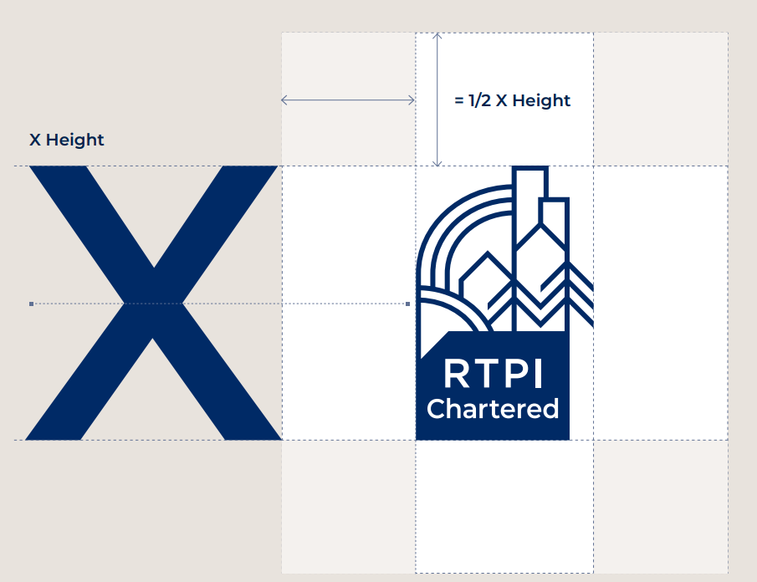

3.8 Size
You may change the size of the RTPI member logo; however, it must maintain its correct proportions and remain legible at all times. Please do not use the mark any smaller than 23mm in height for print or 65px for digital applications.
Where it is not possible to display the logo, you can use the appropriate text line. For example: Chartered Town Planner or Chartered Town Planners.

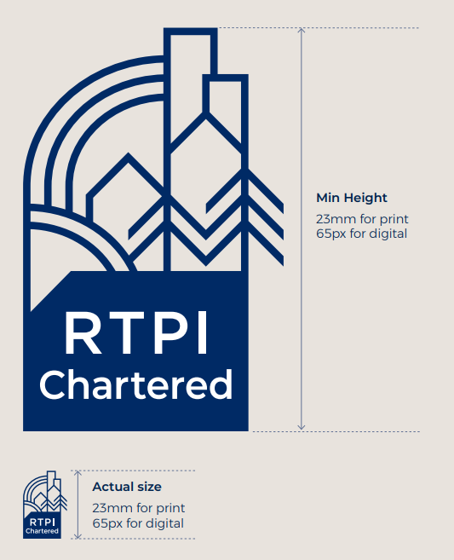

3.9 Colour
The preferred logo is designed in one colour midnight (colour codes PMS 534 / CMYK 100, 71, 0, 51 / RGB 1,46,100).
There is also a white version for use on dark backgrounds, which may align better with your brand’s identity. Either is acceptable to use.
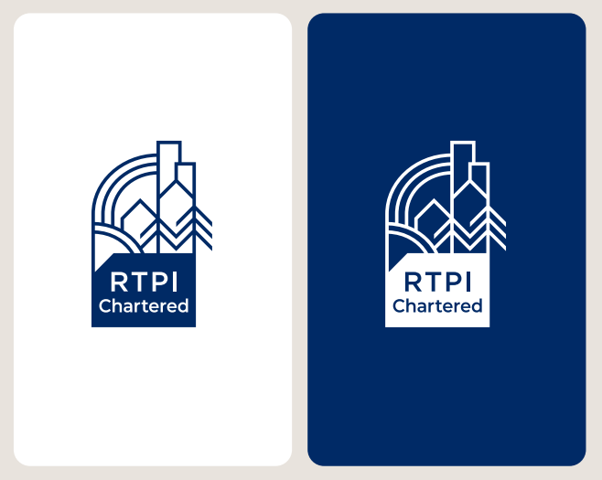

4.0 Examples

4.1 Website

On websites, we prefer that the logo be placed in the footer and not adjacent to other logos, as this suggests a partnership between the two.

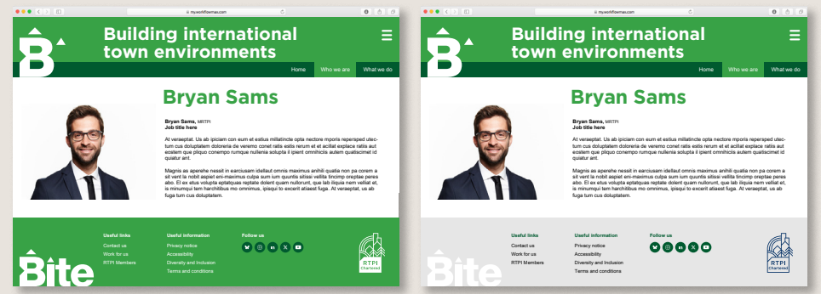

4.2 Email signature

On email signatures, we prefer that the logo be placed underneath your contact details and not positioned next to any other logos, as this suggests a partnership between the two.

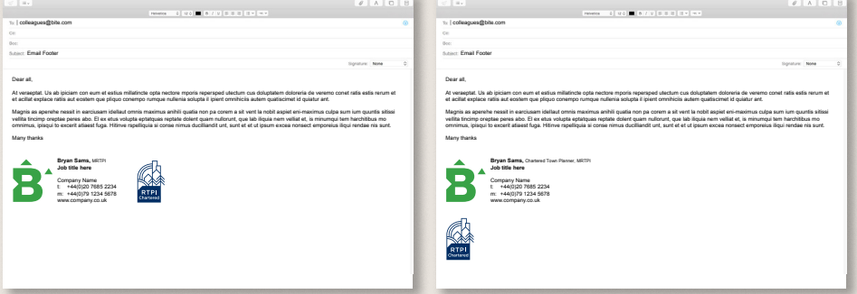

4.3 Business card

On business cards, we prefer that the logo not be positioned next to any other logos to avoid suggesting a partnership between the two.

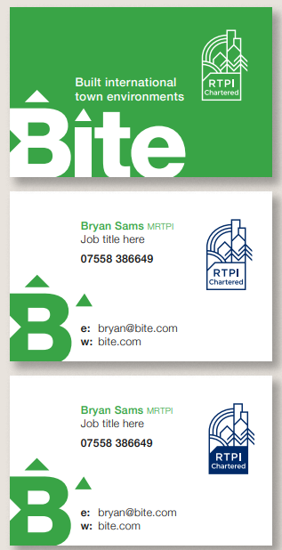

4.4 Letterhead

On letterheads, we prefer that the logo be placed in the footer and not positioned next to any other logos to avoid suggesting a partnership between the two.

Contact us
If you have any queries, please email us:
Brand and marketing enquiries: marketing@rtpi.org.uk
Membership enquiries: membership@rtpi.org.uk
General enquiries: contact@rtpi.org.uk

