Futureproof New Towns: Planning is Global 4 – How to build a new generation of flexible and adaptable new settlements around the world
Published February 2026

The Royal Town Planning Institute (RTPI)
The RTPI champions the power of planning to create prosperous places and vibrant communities. We have over 27,000 members in the private, public, academic and voluntary sectors. Using our expertise and research we bring evidence and thought leadership to shape planning policies and thinking, putting the profession at the heart of society's big debates. We set the standards of planning education and professional behaviour that give our members, wherever they work in the world, a unique ability to meet complex economic, social and environmental challenges. We are the only body in the United Kingdom that confers Chartered status to planners, the highest professional qualification, sought after by employers in both private and public sectors.

Report authors
This report was commissioned by the RTPI. It was authored by the Futureproof New Towns project team, which comprised:
- Professor John Sturzaker FRTPI, University of Hertfordshire;
- Professor Alex Lord, University of Liverpool;
- Dr Phil O’Brien, University of Glasgow;
- Associate Professor Susan Parham MRTPI, University of Hertfordshire; and
- Ellie Pritchard, University of Hertfordshire.
The RTPI Practice and Research and International teams provided input and edited the report. For correspondence please contact research@rtpi.org.uk.

Contents
The Royal Town Planning Institute (RTPI) 1
Report authors 1
Contents 2
Foreword and executive summary 3
1. Introduction 7
2. Case study: Almere 15
3. Case study: Freiburg 29
4. Case study: The Paris region 42
5. Case study: Chandigarh 60
6. Case study: Daybreak 74
7. Case study: Curitiba 87
8. Synthesis of cross-cutting findings from case studies 101
9. Conclusions and recommendations for policy makers 109

Foreword and executive summary

The Royal Town Planning Institute’s Planning is Global series
Planning is Global is a series of internationally focussed publications from the Royal Town Planning Institute (RTPI). The purpose of this series is to highlight the role of planning and the profession worldwide. It promotes the value of planning internationally as a lever to create healthy, socially inclusive, economically and environmentally sustainable places in alignment with key international agreements on sustainable development and climate change.
This report, Futureproof New Towns: Planning is Global 4 – How to build a new generation of flexible and adaptable new settlements around the world, is the latest edition of this series, and part of the RTPI’s Futureproof New Towns research project. It explores of the development of new towns around the world to inform fresh thinking on new settlements, with a focus on planning for adaptability and flexibility over time.
This international focus reflects the RTPI’s global role in promoting planning knowledge and practice through the production of original research. It provides valuable new evidence that demonstrates the key role of planning in addressing rapid urbanisation, global development, and the climate and biodiversity emergencies, and in so doing advance fair, sustainable and inclusive outcomes for all - as set out in the Institute’s International Strategy.
This research also equips our members to deliver positive impact and understand the global implications of their work for climate change and global sustainable development.
Planning is Global is part of our mission to establish planning as a positive force for sustainable development. It is also part of our commitment to developing planning skills and evidence and make them available globally, particularly where planning capacity is limited.

Futureproof New Towns in an international context
Urbanisation continues at pace in many regions of the world, including South America, Africa, the Middle East and parts of Asia, and new settlements are being planned and built to respond to the needs of existing and new communities. This report brings new evidence and learning that informs a set of recommendations relevant in this international context.
The research shows that embedding good planning principles and practice at the inception of new development is critical for the long-term adaptability and flexibility of new communities. Drawing from the examples of six existing new settlements, the report focuses on what we can learn from this international evidence and its transferability to other contexts.

This report – lessons in flexibility and adaptability from around the world
This report sits alongside Futureproof New Towns: International lessons on how to build flexible and adaptable new towns in England, which makes high-level recommendations to planners and policy makers in England on how to ensure that the new generation of new towns proposed by the UK Government and New Towns Taskforce are able to meet the changing needs of their residents over time.
This report presents six case studies of new towns from around the world. Each example has been considered through the lens of adaptability and flexibility. The researchers looked at how these settlements have evolved over time, and what factors and decisions have enabled them to successfully respond to new challenges or opportunities.
Those case studies - Almere in the Netherlands, Freiburg in Germany, the Paris region in France, Chandigarh in India, Daybreak in Utah (USA), and Curitiba in Brazil - provide a rich repository of lessons, highlighting that planners and planning are key to delivering successful, flexible and adaptable new communities.
These cases provide powerful narratives and learning in their own rights, and can be read as standalone contributions.

Key findings
The findings of this report emphasise that planning can have a large scale, positive impact by enabling sustainable patterns of development. New towns, whether they are standalone new settlements, urban extensions, or regeneration projects within existing settlements, can be successful in a range of contexts, particularly if lessons are learned from past and contemporary experiences.
Particularly significant is the need for consistency in planning policy. This means recognising the importance of setting the planning trajectory but allowing for flexibility within policy for places to respond to changing circumstances. The case studies make clear that masterplanning can enable this by offering a clear but flexible vision for sustainable and resilient new places.
The research highlight the benefits of strong community involvement from the onset and that new communities need a diverse mix of housing tenures and land uses to thrive overtime. It provides further evidence on the crucial role of land assembly and land value capture, and the importance of linking land-use and transport planning.
The research also shows that integrating nature-based solutions into planned new settlements has benefits across multiple domains, from climate adaptation to health and wellbeing and is a key element to adaptability and flexibility overtime
The report concludes with eight recommendations for planning policy makers globally to futureproof new towns:
- Ensure that planning policy is consistent over time;
- Harness the path shaping powers of planning, but avoid path dependency;
- Go beyond the plan – the importance of ‘urban management’ and setting up partnerships for delivery;
- Transport and land use planning must be integrated;
- Mixed land uses and tenures lead to better outcomes, and planning for community-led models of development can build support;
- Growth management must accommodate different urbanisation pressures and provide space for adaptation;
- Put placemaking at the heart of planning approaches - and learn from time-tested traditional place design principles; and
- Implement Nature-based Solutions to work with nature.

Conclusion
Overall, this report brings new evidence that demonstrate the positive impact of planning. It also identifies approaches and instruments that can play a critical role in the long-term adaptability and flexibility of new settlements.
The six very different international case studies demonstrate the different ways in which new settlements and towns around the world can be futureproofed to adapt to changing conditions and remain sustainable. They point to global lessons that can be applied locally.
Well-planned new settlements can contribute to addressing the global shortage of adequate housing, whilst creating socially, economically and environmentally sustainable places that are homes to flourishing communities.
Béatrice Crabb MRTPI, International Manager.

1. Introduction

1.1 Planning is Global
Planning is Global is a series of internationally focussed publications from the Royal Town Planning Institute (RTPI). The purpose of this series is to highlight the role of planning and the profession worldwide. It promotes the value of planning as a lever to create healthy, socially inclusive, economically and environmentally sustainable places in alignment with key international agreements on sustainable development and climate change.
There is a worldwide recognition of the need for urgent action to address some of the global challenges that humanity is facing, such as rapid urbanisation, unsustainable patterns of development, growing inequalities, humanitarian crises, the climate and biodiversity emergencies, and a shortage of good quality new homes built in the right places. Indeed, the United Nations Human Settlements Programme estimates that between 1.6 billion and 3 billion people lack adequate housing. The delivery of well-planned places and high-quality, sustainable, development must be central to our collective response.
As global urbanisation continues apace, and major new settlements are being planned and built in many regions of the world, including South America, Africa, the middle east and parts of Asia, this report brings evidence, learning and a set of recommendations that can inform global practice and policy for future new towns and settlements. We are at a critical juncture: how these new towns are planned and developed has significant consequences both their future residents and for the future of our planet.

1.2 This report and Futureproof New Towns – lessons on flexibility and adaptability from new towns around the world
This report, Futureproof New Towns - Planning is Global 4: How to build a new generation of flexible and adaptable new settlements around the world, is the latest edition of the RTPI’s Planning is Global series.
As its name suggests, it is part of the RTPI’s Futureproof New Towns research project. Futureproof New Towns examines case studies of new towns around the world for lessons and recommendations on how they can be planned to be sustainable, resilient, flexible, adaptable and generally able to meet their citizens’ changing needs over time. This is a critical challenge. For all that the post-World War Two new towns improved living standards and provided housing and growth, there remains a widespread perception that their plans were ‘frozen in time’ – embedding contemporary assumptions about how their residents would live within their urban fabric. This has made it harder for these places to adapt to changing ways of working, moving around, or relaxing.
This report sits alongside an accompanying Futureproof New Towns report, Futureproof New Towns: International lessons on how to build flexible and adaptable new towns in England. It makes practical recommendations for planners and policy makers in England as they respond to the UK Government’s ambition to build a new generation of new towns.

1.3 The benefits of planning new towns
New communities with a distinct identity have particular benefits in addressing societies’ challenges. They can be planned strategically, with infrastructure provided from the start, alongside new housing and jobs provision. Public space and green or blue infrastructure can be woven into the design. From the outset, a mixed land use approach can be implemented to make communities more resilient and adaptable to future challenges including climate change.
A recognition of the need for strong intervention and the benefits of new communities has been a feature of planning as it has developed as a profession and a discipline from the nineteenth century onwards. Planned town examples such as Ebenezer Howard’s proposals for garden cities are often cited as inspiring developments elsewhere. Yet Howard himself drew on a range of international experience, including from the USA, Russia and Australia.
New towns have been instituted in many places worldwide, with mixed successes. Today, rapid urbanisation is a feature in many regions of the world, where existing towns and cities are expanding in response to the mass movement of people in pursuit of better lives, and to escape conflicts or the impact of climate change. Cities in Africa and Asia are the fastest growing, so a planned response to meet communities’ needs in those places is particularly important. New developments in countries like India and Brazil, included in our case studies, offer very pertinent learning to inform these contexts. They also offer valuable learnings to inform global policy and practice.

1.4 Learning from international new town case studies
Those responsible for delivering new communities need to be able to avoid the mistakes of the past and learn from what has been done elsewhere. To help planners around the world, we have looked in-depth at six case studies of new communities at different stages of their evolution and adaption to changing circumstances.
Our six case studies are:
- Almere (Netherlands);
- Freiburg (Germany);
- The Paris region (France);
- Chandigarh (India);
- Daybreak (USA); and
- Curitiba (Brazil).

1.5 Why we chose these case studies
The case studies vary in size and scope so that a wide range of circumstances can be explored to provide evidence to inform policy and practice. They also include new towns that are extensions to existing cities and the large-scale redevelopment of inner urban areas to make ‘new’ places. These cases reflect the reality that in many places new towns are not traditional standalone settlements in ‘greenfield’ locations - indeed, the majority of the ‘new towns’ recently proposed by the UK’s Government’s New Towns Taskforce are actually pre-existing settlements.
We also selected case studies that reflect some of the broad diversity in experience of new settlements from around the world. As such, they represent different stages in the development cycle of places. Some are newer and others are more well established. Some are being planned, designed and built from the ground up. Some are making minor changes to their planning and placemaking. Others are being altered in substantial ways.
The cases range from more typical post war ‘modernist’ new towns (Paris region and Chandigarh) to radical re-shaping of an existing, rapidly growth city (Curitiba). They include modern new towns of varying scales, on greenfield, reclaimed, and brownfield land in or on the edge of cities (Freiburg, Almere and Daybreak).
Some of the places focus on nature and ecology (Freiburg) and others follow masterplanning guidelines that support active travel (Daybreak). There is coverage of place renewal in some postwar ‘modernist’ new towns redesigned along more traditional placemaking lines (Val d’Europe and Le Plessis-Robinson in the Paris region).
The cases are of broad relevance to existing and future new settlements. While they cover a range of scales and different planning and placemaking approaches, we focus on drawing out practical lessons on adaptability and flexibility for other new towns. We recognise that there are many other interesting case studies, and our selection of these six cases should not be taken as endorsement of the approach to planning used in each case.

1.6 A thematic approach to research
The diversity of these case studies means that it was very important, in order to be able to draw meaningful conclusions from our research, that we used a common set of themes to analyse them. Not all the following themes are as relevant for each case study, but all are explored in relation to several places. Our themes are:

New towns as sites of urban experimentation
For this theme we explored new towns as testbeds for design innovation and planning ideologies. We assessed the successes and consequences of experimental layouts, housing models, and mobility systems. We further examined how resilient the experiments had been over the longer-term, and sought to identify lessons from these experiments to inform current design practice and policymaking.

The significance of social and cultural lived experience
Here we considered how residents experience and adapt to new towns, recognising how central the human factor is to successful placemaking. This included investigating how community identity and belonging is formed in new towns, and how resident perspectives critique or support dominant narratives associated with the new town. Specific aspects of lived experience we reflected upon including heritage conservation in the new town and the informal use of space, local adaptations, and evolution of public spaces.

New towns as political and ideological projects
New towns reflect the political and ideological contexts of their times (for example the post-war utopianism of the UK), so we sought to analyse the political motivations behind new town development, how new towns reflect the pursuit of creating ‘ideal spaces’, and how these imaginations shift through time. Included in this theme are factors such as the role of the state versus the private sector in new town delivery, how political shifts play out in the urban environment or affect planning outcomes, and how the ideological roots of new towns impact their future.

The challenges and the limitations of modernist planning
This theme is particularly relevant for new towns developed during the middle years of the twentieth century, including the UK post-war new towns. Here we sought to identify spatial or design features grounded in modernist planning ideals, explore mismatches between planned use and present day use, and to identify resistance or reinterpretation of planned environments by local communities. Through these reflections we were able to consider how well new towns are able to adapt - something central to the next and final theme.

Functionality, adaptability, and the future of new towns
To allow us to move from the general to the specific, we have investigated how well new towns function economically, socially, and ecologically in the long-term and assessed their connectivity and integration with surrounding regions (for example in relation to jobs, transport and services). We have also considered their capacity for renewal, retrofitting and redesign, and how adaptable they are to rapid climate, social, or technological, change.
To do this we have examined governance and maintenance models of new towns and examined whether towns remain aligned with their original purpose or have been redefined by residents. We have considered how sustainability in aspects such as housing, energy systems and food systems is acting as a foundation for long-term viability, and how successful any masterplanning approach has been.

1.7 How we carried out the research
Using these themes, we undertook interviews and site visits and drew extensively on secondary data (such as reports and academic publications which discuss the case study new towns). Detailed, free-standing, reports on the case studies can be found in the following chapters.
We then look across the cases for cross-cutting findings. These ‘lessons’ relate to aspects of planning found in two or more case studies. There is a strong focus on findings about flexibility and adaptability.
In the final chapter, this report offers eight recommendations for planning policy-makers globally to futureproof new towns.

1.8 References

2. Case study: Almere
Flexible planning - From state-led new town to citizen-driven development

2.1 Headlines
Location
Almere, Netherlands, Europe

Key dates
- 1970s - Almere established on reclaimed land as part of the Dutch new towns programme
- 1984 - Municipality of Almere formally founded
- 2000s - Introduction of self-build and citizen-led planning models (e.g. Homeruskwartier, Oosterwold)
- 2020–2021 - Adoption of Almere’s first Urban Food Strategy
Key features
A large-scale, sustainability-led new town built on reclaimed land close to Amsterdam, characterised by a polycentric urban structure, integrated green-blue networks, strong public transport connectivity and innovative citizen-led self-build and food initiatives.

Key lessons
- Almere demonstrates how water management, biodiversity and public space can be integrated as the backbone of urban form. Embedding green-blue networks from the outset enhances resilience, liveability and climate adaptation in new settlements.
- Almere shows how it is possible to integrate food space using food strategies and planning instruments to support an ‘edible’ placemaking approach, especially on the town’s urban edges.
- Early investment in high-quality public transport and active travel networks has enabled Almere to achieve strong internal walkability, cycling accessibility and regional connectivity.
- Almere’s self-build and citizen-led approaches have allowed for diversity in design, experimentation and a strong sense of place identity and ownership by residents. Policy makers elsewhere could encourage similar models. Almere’s success reflects the importance of empowering local authorities so they receive clear development mandates, with a consistent national policy direction that supports new towns.
- Elsewhere, this could translate as the introduction of development corporations or similar mechanisms to consolidate land ownership, deliver housing and infrastructure, and provide long-term supervision of urban development.

Key recommendations
- Use development corporation or similar models to manage land ownership, planning, and to oversee stewardship arrangements.
- Embed green-blue and food infrastructure frameworks and strategies as core components of masterplanning a new town, ensuring mixed land uses in landscapes that have multiple functions and address climate resilience, biodiversity and wellbeing.
- Adopt a public transport-first approach to planning, prioritising early provision of sustainable mobility and active travel networks and regional public transport connectivity.
- Support community-led and self-build planning initiatives, including those which are food related, within new developments as can be beneficial in establishing a sense of community and strengthening liveable placemaking.

2.2 Overview
Almere is a new town located in the province of Flevoland in the Netherlands, approximately 20km east of Amsterdam. Established in the 1970s on land reclaimed from an inland sea, Almere was designed to relieve housing shortages in the Randstad – the densely populated urban conurbation in the western Netherlands encompassing the cities of Amsterdam, Rotterdam, The Hague and Utrecht.
Almere was built on the Flevopolder, low-lying land reclaimed from the sea and kept dry by embankments. It was part of the Dutch new towns programme, which mainly ran from the late 1960s to 1980s and was partly inspired by the British New Towns Act of 1946 and Ebenezer Howard’s Garden City principles. Due to its proximity to Amsterdam, Almere functions as an overflow town. Almere’s population is approximately 230,500 and is expected to “exceed 325,000 by 2050” making it both the youngest and fastest growing city in the Netherlands.
Beyond the Netherlands, Almere offers transferable lessons to new town development internationally. Almere’s polycentric structure of green-blue networks connects well to nature, manages water and helps limit heat island effects. Its strong public transport and extensive walking and cycling connections allow people to move around in an easy, healthy way. Almere includes housing self-build zones on its urban edges where community-driven design is allowed. This adds flexibility to housing provision and food growing strategies. The emphasis on sustainable living offers a replicable model to other new towns.

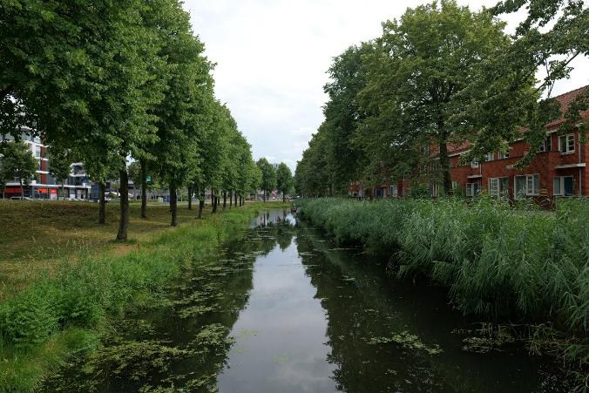

Figure 1.1: Green-blue networks in Almere, photograph by Ellie Pritchard, 2025
Perhaps the most significant limitation of the transferability of Almere to other contexts is its land ownership. As Almere was built on reclaimed land, it benefitted from being a blank canvas with a lack of heritage constraints or issues with fragmentation due to private land ownership. This will not be the case in most places internationally.

2.3 Planning frameworks
Almere’s planning framework is characterised by its polycentric, multi-nucleus model. Almere is made up of multiple semi-autonomous districts, each with their own identity and amenities. Shared infrastructure and designated bicycle and bus lanes connect the districts, which are separated by green and blue landscape components. In its early years, the city exemplified Dutch urban planning traditions of top-down, masterplanned urban developments.
Yet, since the early 2000s, Almere has gained international attention for the popularity of its self-build initiatives in Homeruskwartier, a large-scale new district located in Almere Poort, community-focused housing and place design in the neighbourhood of Nobelhorst, and the experimental, citizen-driven planning model in Oosterwold, located on Almere’s eastern peri-urban edge. Almere has emerged as a notable case in urban food systems, particularly through Oosterwold, where planning regulations require residents to allocate 50 percent of their land to food production. In 2020-2021, Almere became one of the first Dutch cities to establish an urban food strategy (UFS).
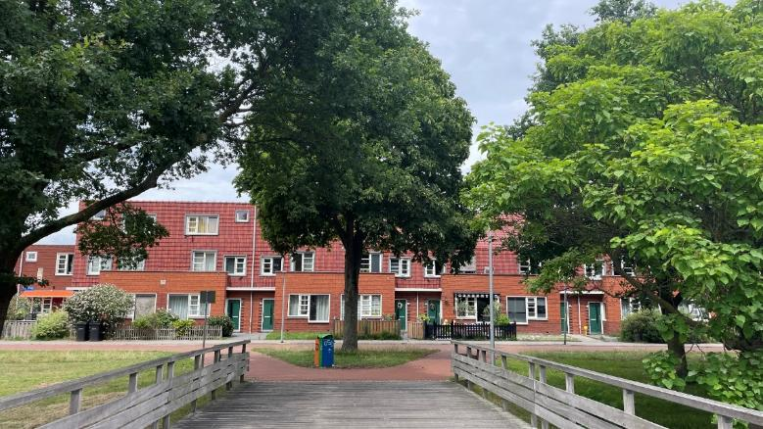

Figure 1.2: Housing in Almere, photograph by Susan Parham, 2025

2.4 Governance structures
The municipality of Almere was founded in 1984. Almere was established as one entity, despite its internal arrangement into separate urban nodes. As the ownership of land was transferred to the municipality, service and infrastructure processes accelerated. After the 2000s, it is thought that the financial crash “spurred urban experimentation” through “social housing models, an emphasis on self-organisation, community involvement and participatory planning”. Almere is a strong case of active municipal agency, which is observable in its phased development and infrastructure provision.

2.5 Adaptability and flexibility: Levers and barriers
Almere is internationally recognised for its approach to food systems and the integration of urban agriculture in peri-urban development. Geographically, food systems have always been significant to Almere due to its positioning within the Flevopolder. This area was initially reclaimed for agriculture and remains one of the most productive food regions in the Netherlands.
Oosterwold is a peri-urban district on the eastern-outskirts of Almere where the municipality has adopted a planning approach that combines residential development with ongoing agricultural activity. Almere also has the aim of producing “10 percent of its future food” from Oosterwold.
Planning approaches in Oosterwold have avoided a detailed blueprint or masterplan. Instead, the development of the area occurs more organically, within minimal land use planning rules and “dependent on the self-organisation of the (future) residents”.
Academics note that due to the population of Almere, as well as the prospected growth in population, the city has not been “spared by urbanisation or the problem of feeding the city”. Almere’s food-orientated planning represents both the continuation of its agricultural heritage and an experimental approach which integrates housing, self-organisation and food.
Other parts of Almere have also focused on food. Architects we interviewed who have completed a number of projects in Almere, including in the peri-urban neighbourhood of Nobelhorst, explain that the area “calls itself the village of Almere” and has a “Buurtschuur” (Neighbourhood Barn). They explained:
“Residents get a piece of land and a budget and can choose how to use it. Some made a garden for vegetables, some made a barn to have birthday parties, or whatever you want and does not fit in your living room.”
The architects reflected, from a recent visit to Nobelhorst, that “when you see the kids’ toys laying all over the playground you realise they are at home in their neighbourhood”.
The examples of Oosterwold and Nobelhorst are significant within the case study of Almere as local planning experiments. They are also important as part of Almere’s broader urban food strategy. This is supported by Dutch national policies that encourage innovation in sustainable development. The self-organising framework here moves away from conventional planning or governance models. The municipality provides only broad parameters and leaves the practicalities of design, organisation and farming up to residents. In Oosterwold, as many residents do not come from backgrounds in agriculture, a handbook which contains background information in urban agriculture is provided to residents. Community groups have also organised knowledge exchanges on urban agriculture. For urban planners internationally, Almere demonstrates how food systems can be creatively included in planning.
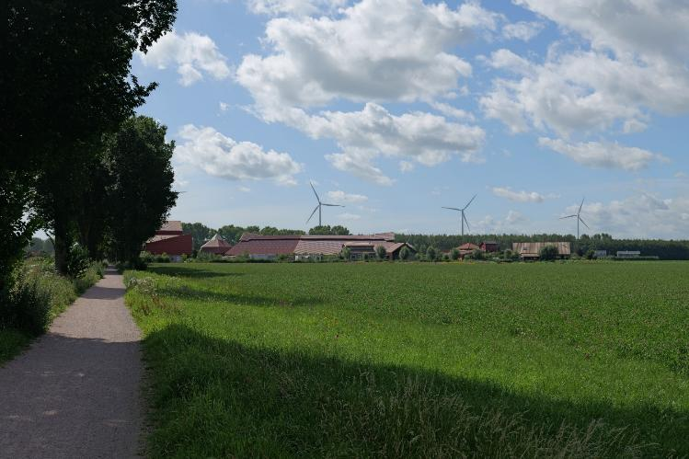

Figure 1.3: Land dedicated to farming, photograph by Ellie Pritchard, 2025

2.6 Thematic discussion

New towns as sites of urban experimentation
Since Almere was first established, the city has trialled novel approaches to housing delivery. When the area opened for development in the 1970s, there was a strong emphasis on people-centered planning. Throughout the 1980s and into the early 2000s, however, neoliberal policies drove rapid urbanisation and real estate development. This evolution continued after the 2000s, when the financial crisis contributed to another evolution of Almere’s planning. This led to experimentation with new housing models which prioritise self-organisation, community participation, and collaborative planning practices.
In its short history of 50 years, Almere’s approach to housing has continuously evolved. Urban planning in Almere has reflected political and economic trends of its time. This evolved from early top-down experiments, such as the 1970s neighbourhood of Almere Haven’s housing tailored for “introverts” and “extroverts”, to more recent initiatives like self-build schemes in Oosterwold. Almere Haven was built with an intricate street layout that has resulted in a convoluted and poorly legible urban form. Subsequent neighbourhoods have shifted toward more accessible and connected road layouts such as in Nobelhorst.
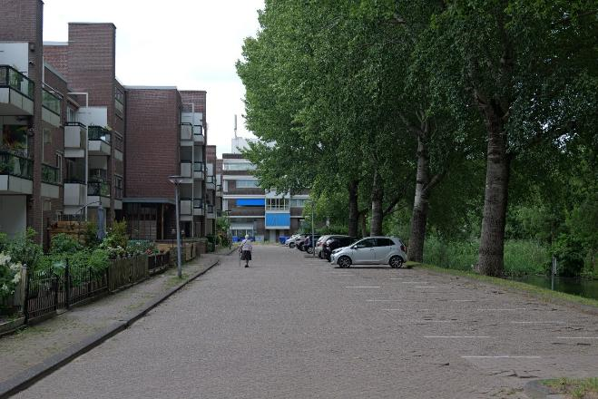

Figure 1.4: Housing in Almere Haven, photograph by Ellie Pritchard, 2025
Homeruskwartier, located in Almere Poort, is the largest self-build neighbourhood in the Netherlands. It is a key example of Almere’s experimental approach to housing. Homeruskwartier accommodates a broad spectrum of lower and middle-income households. This includes those who might otherwise rely on social housing. In contexts such as the Netherlands, the rise of self-builders has challenged the traditional dominance of commercial developers over land and profit.
This form of housing has attracted the attention of planners, policy-makers, and politicians because of its potential for self-builders to reflect their social and cultural values into the making of urban space. As the project began before the 2008 financial crisis, construction was able to continue even as many developers halted their activities, with self-builders carrying forward the process. Self-building is directly linked to individual household incomes, making it less vulnerable to economic fluctuations than large-scale developments.
Self-building is a form of “do-it-yourself" urbanism, making it a symbol of individual freedom. Yet, in practice, self-build typically relies on frameworks such as “master planning, regulatory guidance, and building codes￼. An example of this are “plot passports”, which are offered to residents and outline the parameters for what is possible on their land. These have been understood as a source of “inspiration” for residents as opposed to restricting them. Self-build programmes in Almere foster a sense of connectedness to place that is particularly valuable in a new town context, offering a compelling model for resident-led housing initiatives internationally.
Almere has been called a “laboratory for innovative housing solutions”.

2.7 The significance of social and cultural lived experience
Almere has been praised for its multiculturalism and sense of community. Currently, the city is home to 148 nationalities, and 44 percent of the urban population has a migration background. Residents of Almere have organised a range of community groups and activities. There are “leisure locales” in Almere which include purely recreational areas such as a beach, lakes, and woodlands, as well as mixed-use areas such as shopping and entertainment areas. Many of these “leisure locales” are orientated around nature, which has “strengthened future thinking” and created different types of landscapes, which in turn allow for more “possibilities of rootedness”.
The extensive and well-connected public transport, footpaths, and bicycle lanes are also a significant component of the sociability of the city. Almere has six railway stations which connect the city to Amsterdam and the wider region. Railway stations are integrated with extensive bus and tram services, bicycle lanes and pedestrian paths to reduce car dependency through sustainable mobility and active travel.
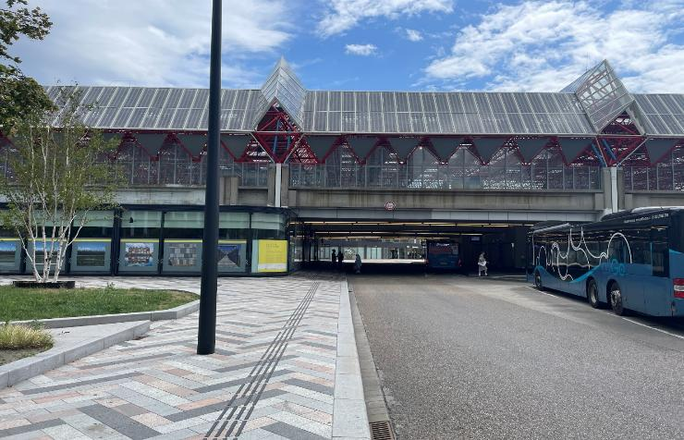
Like many new towns internationally, dominant narratives of Almere are often negative. In a newspaper poll in 2008, Almere was voted the “ugliest city in the Netherlands”, along with Nieuwegein, another new town built in the 1970s. A shared characteristic of the nominated cities is that they are familiar to the Dutch public by name but rarely attract visitors from outside the local population. As a result, perceptions are shaped less by direct experience and more by assumptions and stereotypes.

Figure 1.5: Railway station with bus interchange, photograph Susan Parham, 2025

2.8 Key lessons

Lesson 1: The importance of strong governance and alignment between national and local policy
Almere’s development was supported by national policy direction and was designated as a key growth centre. This political backing has ensured long-term investment, land availability, and delivery of infrastructure. This serves as a reminder for others that new towns and other ambitious growth projects require consistent national-local alignment rather than leaving delivery to market forces. In an interview with Dr Jan Eelco-Jansma, who specialises in urban and peri-urban agriculture in planning, he told us that some failures are inevitable in the development of a new town, and that taking a long-term view is helpful in delivering high quality urban areas. Almere’s development has “been an iterative process” which has involved “experimentation and learning from experimentation”. .

Lesson 2: Participatory planning and self-build can strengthen identity, creativity and food systems
Beyond housing delivery, Almere has also pursued innovative methods of placemaking. This is notably through large-scale self-build programmes that involve residents in the development of their own neighbourhoods, including integrated urban food systems that link community identity and agriculture. In an interview on this topic an academic expert told us that “Almere has always been a city for the people”, and that there has “been an understanding that people make the city and that people need to be part of the process”.
It was noted that participation through self-build and urban agriculture has created a sense of rootedness and has “allowed some creativity to citizens”. The academic also highlighted the significance of narrative in the development of new towns. Participatory methods have helped to form Almere’s urban identity as a people-focused, innovative, and green city. This link between participation and positive place identity is an international learning point.

Lesson 3: Early integration of sustainable transport supports liveable growth
Almere’s planning has also prioritised from the town’s inception accessibility and connectivity in non-car modes of transport. Designated bus lanes, cycle paths, walkways and railway systems are interconnected to allow for active travel throughout the city. The city’s clear networks demonstrate how early integration of sustainable accessibility systems can reduce car dependency.

Lesson 4: Embedding green-blue infrastructure in urban form
Almere has made green-blue infrastructure a central organising element in urban form, weaving water management with parks, public spaces and green corridors. This provides flood resilience, mitigates urban heat, offers benefits to biodiversity, and increases liveability of urban environments.

2.9 References

3. Case study: Freiburg
Consistency of approach brings dividends for urban design and sustainability

3.1 Headlines
Location
Freiburg, Germany, Europe
Key dates
1994-present
Key features
High quality, sustainability-driven development at a range of scales, from 41-hectare brownfield site to 140-hectare greenfield urban extension

Key lessons
- Experience from Freiburg shows the importance of consistency and coherence of policies related to urban development, design and planning. This includes high standards of urban design for social spaces like play streets, green infrastructure aspects like sustainable urban drainage, and measures to manage parking and encourage public transport use.
- In order to build support for the latest urban extension in Freiburg, the City Council have embarked on a proactive and positive public engagement campaign. This included a one-day festival which mixed fun activities with information stands on planning and construction, guided tours, and politicians and officers on hand to explain and discuss proposals with local people.
- Over the more than 30-year period since the beginning of the brownfield development of Vauban in Freiburg, the City Council have maintaining the consistency of their approach and recognised the need for flexibility and pragmatism as economic circumstances have changed.
- Freiburg shows adaptability to demographic changes and an ageing population, with homes designed to be subdivided into smaller properties as residents seek to downsize.

Key recommendations
- Use design competitions, with sustainability a key criterion for success, to raise the quality of planned developments.
- Provide meaningful communication with local people, whether in relation to consultation on new schemes or to explain retrofit activities.
- Make use of community self-build initiatives to bring multiple benefits, including raising the standard of development and building support for approaches such as reducing car use in neighbourhoods.

3.2 Overview
Freiburg (full name Freiburg im Breisgau) is a small city in the state of Baden-Württemberg in the south west of Germany, close to the French and Swiss borders. With a population of around 240,000 Freiburg is only the fourth biggest city in this state, but its name has far wider recognition than other small European cities, particularly amongst planners and those interested in sustainable urban development. Freiburg has a long history of sustainability in its planning policies, developing from opposition to a nuclear power plant in the 1970s, which led to a heightened awareness of environmental issues in the city. The city today has strong policies related to reducing carbon emissions and hence car use, with a strong priority given to other modes of transport. As a result, the proportion of journeys made by car in the city has fallen from 30 percent to 16 percent. This is the context within which the city’s new districts of Vauban, Rieselfeld and Dietenbach have been developed since the 1990s.

3.3 Planning frameworks
The German planning system makes use of a zoning-type approach – the Federal Building Code sets out a two-tier system, with a broad plan at the municipal level accompanied by binding land-use plans for specific areas within each municipality that grant building rights. Coverage of these binding land-use plans is not comprehensive, indeed “a perhaps surprisingly large part of the built-up area of German municipalities remains ‘unplanned’”.
Development in Germany has in recent years become more development-led, with municipalities preferring to only go to the expense of preparing land-use plans where a developer is in place – or using land-use plans prepared by developers themselves. The new towns and other developments in Freiburg show a mixture of approaches. The lessons which can be learned from these approaches can in most cases be applied to places which do not use a zoning approach to planning based on rules, but a discretionary system based on planning judgements.

3.4 Governance structures
Vauban, within Freiburg, is an internationally recognised exemplar of sustainable development that is regularly identified as best practice in planning and other literature. It was described to us as “sort of a bubble”, with a particular demographic matching its green credentials. These points, however, should not blind us to the potential for learning from Vauban, and or seeing how it is influencing the next generation of new communities in Freiburg and beyond.
Vauban is a medium-sized new district, with a population of around 5,500, and was built on a a former barracks around two miles from the city centre. The district was planned in a way which is unusual even in its context, with a working group comprised of planners working for the city, elected councillors and the public. This group made proposals which were subsequently ratified by the City Council through the formal planning process.
Strong planning and design principles emerging from this group included the retention of some of the original military housing which demonstrated the potential for re-using buildings in new ways. It also included the incorporation of lines of green space cutting through the development for cooling and ventilation. The place design was built around the proposed extension of the tram (which was installed in 2006) and had a mix of tenures. This includes a significant proportion of Baugruppen, a distinctive group-build approach which originated in Germany.
Rieselfeld is less well known than Vauban but originated at around the same time. It is an urban extension on the outskirts of Freiburg (c. four miles from the city centre), built on part of a former sewage infiltration area (this is the literal translation of Rieselfeld). Of the 320-hectare site of the infiltration area, around 80 hectares was built on for the urban extension. The remainder is being kept as green infrastructure. The Rieselfeld community has a population today of around 11,000, built over four phases from 1994 to 2010.
The design of Rieselfeld was the subject of a design competition, a common feature of urban development in Freiburg. The winning design led to a masterplan and in turn detailed zoning plans for each phase. Each of those detailed plans has a different overall design approach, but some common features. These include a fairly high proportion of Baugruppen (group build), and a tiered approach to building density with five to seven storeys along the central axis where the tram line is located, and which was installed before the housing was constructed. Rieselfeld was described to us as being more “normal” than Vauban, with a demographic mix closer to the average in Freiburg.
Dietenbach is a new “climate neutral” district, intended to have a population of 15-20,000, which has recently begun construction on greenfield agricultural land next to Rieselfeld. This land was purchased through a compulsory purchase approach (Städtebauliche Entwicklungsmaßname) at a negotiated price of €65 per m². This is between the value of agricultural land (€5 to €10 per m²) and construction land (€500 to €1,000 per m²) so represents a considerable saving over a commercial land price. The legal basis for this ‘expropriation’ approach whereby government can acquire private land is set out in Sections 165-171 of the German Town and Country Planning Code, which requires that it can only be used in pursuit of the public interest.
The city of Freiburg is taking the lead by installing infrastructure ahead of construction and will then lay out the development and sell plots to individual developers – who will be a mix of private developers, the municipal housing company and Baugruppen self builders. The uplift in value between the initial price paid to landowners and the receipts from developed plots is used to fund the costs of infrastructure and green space which has been installed.
A municipal referendum was held to decide whether to go ahead with the Dietenbach development. This passed with a 60 percent majority, but in order to build more public support for the scheme, the city is running an extensive public engagement campaign, including Das Fest Für Alle, a six hour “festival” on the site of a forthcoming music festival. The consultation festival included cycle tours around the site and an introduction to a model of the proposals by Deputy Mayor of Freiburg, Martin Haag.
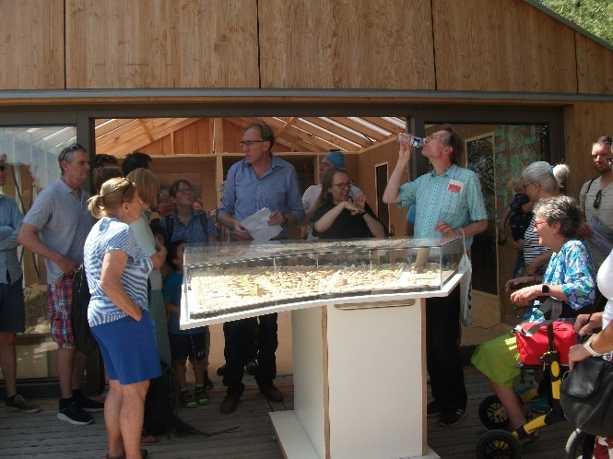

Figure 2.1: The city’s alderman for urban development & construction introducing the proposals to citizens (with live sign language translation), photograph by John Sturzaker, 2025
There are various other developments in Freiburg which provide further illustration of the consistent approach of the City Council. These include Weingarten, a redevelopment of four social housing blocks to retrofit to the Passivhaus standard and to adapt to the need for smaller households; and the Güterbahnhof scheme, on the former goods yard owned by Deutsche Bahn, the state-owned rail company. As Freiburg city council did not own the Güterbahnhof site, it has had less ability to impose its own preferences as seen in other schemes across the city, with a developer-led approach to development. However, design quality remains high.
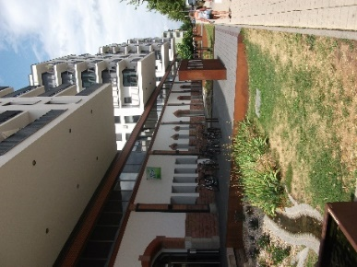

Figure 2.2: Historic rail buildings retained, repurposed and integrated into new buildings in the Güterbahnhof scheme, photograph by John Sturzaker, 2025

3.5 Thematic discussion

New towns as sites of urban experimentation
The story of new towns/settlements in Freiburg is one of experimentation within a supportive institutional and cultural context, and of those experiments informing the next generation of new town development.
A key example is the approach to car parking management in Vauban with centralised garages and car free neighbourhoods. This was highly experimental at the time and the subject of much negotiation with the state government to reduce parking provision below usual standards. The success of the parking model is partly down to residents continuing to support it. This has given confidence to Freiburg City Council that the model may be replicable. In the new (much larger) settlement of Dietenbach, a similar approach to managing cars is being planned.
Other aspects of innovation are now established as part of the mainstream approach to planning in Freiburg. These include the integration of green infrastructure throughout, and strong segregation between roads and non-car travel modes.

The significance of social and cultural lived experience
The approach to car parking management in Vauban involves the reserving of some land at the edge of the district to meet future parking requirements. This land is used as a green space in the interim and remains as such until/unless it is needed. At present, car ownership remains low so there is no immediate prospect of more parking being required. A widespread use of (electric) shared cars is an important contributory factor. These factors illustrate the importance of residents buying into the approach to more sustainable mobility.

New towns as political and ideological projects
Choices made through the planning process in the allocation of building plots to different types of developer have an (implicit or otherwise) ideological component. The system encourages Baugruppen, the community group build model which is common across Freiburg (and to a lesser extent the whole of Germany), as opposed to allowing the dominance of private sector developers. This is a conscious choice that in turn leads to other benefits.
In both Vauban and Rieselfeld there are notably higher standards of environmental design provision in Baugruppen plots, with more solar panels and green roofs. This is partly a function of the lower design and built costs. There is no marketing budget needed in this form of development. There are also economies of scale from development which brings together groups of individuals compared to individual schemes which must manage the more complicated preferences of these communities.

Functionality, adaptability, and the future of new towns
There are several important aspects to highlight regarding adaptability of the new town-style settlements in Freiburg. One is the adaptability to demographic changes and an ageing population. Homes are designed to be subdivided into smaller properties as residents seek to downsize as they become smaller households. This is facilitated by the medium density housing that is common across the new settlements. Three or four storey buildings with both shared and private green space offer choices for households to change their dwelling size.
Adaptability to climate change is also strong, with green infrastructure and sustainable urban drainage being standard features. These green infrastructure and drainage systems are being retrofitted into some open spaces and along public transport routes in the older parts of Freiburg. Rieselfeld illustrates the need to adapt to a changing financial context, as the proportion of affordable housing delivered was lower than planned for, due to changes in central funding.
Whilst Vauban has unique case study features, some of the planning and design principles which underpin it including on energy efficiency, green infrastructure, sustainable urban drainage, walkability, and car use and storage, have influenced other developments in Freiburg and beyond. Dietenbach, which is just beginning construction, has taken inspiration from the approach to car parking management, the use of Verkehrsberuhigter Bereich (play streets) and the integration of green infrastructure to help with urban cooling.
These factors all point to the adaptability of communities and the long-term success of the approaches to new town planning and development in Freiburg.
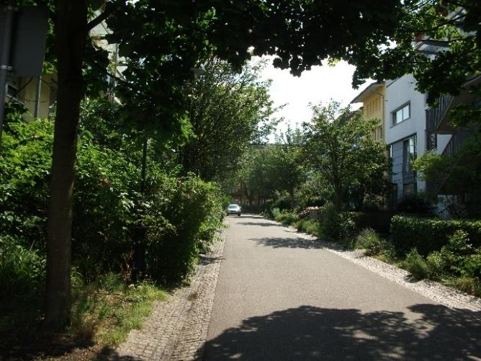

Figure 2.3: Green infrastructure is woven throughout Vauban, photograph by John Sturzaker, 2025

3.6 Adaptability and flexibility: Levers and barriers
Vauban is internationally recognised as an example of best practice in relation to sustainable urban development. Factors leading to this recognition include strong community involvement in planning and design, integration of green infrastructure at various scales, strong public transport connectivity, a high proportion of community self-build (in the form of Baugruppen) and a grouped approach to car parking space management.
There is very little parking adjacent to housing, with most provision being in the form of district garages. Car owners in the parking space-free area which is connected to the district garages have to buy a parking space in one of the garages if they want access to parking. There is a very low car ownership of 20 per 100 residents, compared to 57 per 100 residents in Germany as a whole. While access by vehicle is possible for one-off visits, collections and drop-offs, most people use other ways to move around.
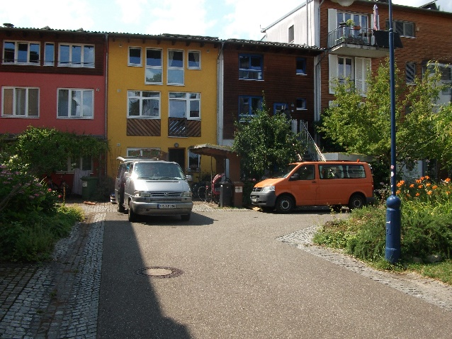
Figure 2.4: Vehicular access for loading/unloading, photograph by John Sturzaker, 2025
In Vauban this has become part of a self-reinforcing approach with the district being particularly popular with those who share preferences for low car ownership and other sustainable neighbourhood elements. In relation to adaptability to changing demographics, some of the buildings in Vauban were designed to make it easy to subdivide homes, facilitating downsizing and other flexible uses over the longer term.
Rieselfeld was built at around the same time as Vauban, but is notably different in scale and approach. In some respects, given Vauban’s unique character, Rieselfeld provides a wider range of experiences which planners can learn from.
One example of successful design is the variable approach to building density, whilst maintaining strong public transport connectivity. There are higher density mixed-use developments closer to the tram line in Rieselfeld as compared to semi-detached homes further out. This makes most effective use of the proximity to transport by housing more people closer to services. At the same time, all homes are within easy walking distance of one of the three tram stops. Residents are also served well by community infrastructure in the form of local parks, schools, a library and multi-faith community spaces.
Rieselfeld also provides an example of the city council being forced to adapt to a changing context. The original proposal for the whole district was for 50 percent of the homes to be social housing, but due to cuts in state spending this fell to c. 20 percent, mostly concentrated into the first and second phases. Each phase has therefore adapted to changing financial circumstances. Planners are also dealing with the increasing challenges from climate change. Green infrastructure and other climate adaptations are being retrofitted in.
Freiburg City Council had particularly strong control over Rieselfeld as the land it was built on was owned by the city, in contrast to the Güterbahnhof former rail freight depot. While one of our interviewees felt the developer-led approach at Güterbahnhof had produced more of a car-dominated streetscene, the high quality of urban design visible throughout the city was also evident. Some historic buildings were retained, repurposed or integrated into new buildings in Güterbahnhof, illustrating the success of a consistent approach to urban design over a long period.

3.7 Key lessons

Lesson 1: The importance of consistency and coherence
Freiburg is home to a range of innovative urban developments, from small infill sites to large-scale greenfield urban extensions of 20,000 inhabitants. A key lesson across these developments is that of consistency and coherence. Whether on land owned by the City Council or otherwise, standards of urban design are extremely high, and the approach has remained consistent for many years. Developers therefore know what is expected, and residents can be confident about the quality of new development, meaning that proposals for additional housebuilding are greeted more positively.

Lesson 2: Proactive and positive consultation and engagement
A positive approach to consultation was reflected in the referendum on whether to build Dietenbach, the newest of the developments in Freiburg, and the early stages of which are under construction now.
A majority supported the development: 60 percent in total. Despite this, Freiburg City Council is in the midst of a long and intensive programme of consultation and engagement on Dietenbach, in part to try and convince some of the 40 percent who voted against it. The activities being undertaken include Das Fest Für Alle, a festival to give people the chance to see what new development in the Dietenbach area would be like, which coincided with our visit to Freiburg. We saw first-hand the high-quality engagement exercises being undertaken by the City Council. This offers another important lesson for planning policy makers internationally.

Lesson 3: Pragmatism and flexibility
While there is a great deal to admire in Vauban, the circumstances of its development are extremely particular to it. Freiburg City Council does not, therefore, seek to replicate every aspect of it when planning for new developments. Instead, aspects which are more easily replicable are used in other schemes, such as the use of design competitions with sustainability a key criterion for success. Through such approaches planners, policy makers and others can take inspiration from Vauban, Rieselfeld, Dietenbach and other developments in Freiburg and apply these lessons to a range of different contexts, flexibly picking the aspects most adaptable to their circumstances.

3.8 References

4. Case study: The Paris region
Planning new towns collectively and at the regional level can create an additional economic centre of gravity to a dominant central city

4.1 Headlines
Location
Paris, France, Europe
Key dates
1965-present
Key features
A strategy of “deconcentrated concentration” in five new towns was intended to fix earlier problems of urban sprawl and isolated housing estates around France’s capital city. These new towns’ modernist design principles have not always stood the test of time and some are being retrofitted.

Key lessons
- Ambitious, top-down governance and a consistent national planning strategy and economic focus helped ensure the Paris region new towns were built quickly on a big scale. Substantial regional public transport – mostly rail – has been important to moving people to and from them and supporting employment and access to affordable housing.
- Grand architectural visions for housing and public spaces can overshadow the reality of community needs. Expensive-to-maintain, low quality, unpopular housing and public spaces are now requiring subsequent interventions, which tend to replicate more traditional placemaking approaches.
- This new approach is focused on mixed land uses; walkable, attractive streets and neighbourhoods; human-scaled town centres with shops, cafes and food markets; excellent public spaces; and good quality medium density-medium rise housing, using robust materials. These examples of new and redeveloped places are proving both popular and economically viable.

Key recommendations
- Provide consistent vision, governance, and planning policy focus on the new town programme over time.
- Make planning policy support affordable housing by keeping land costs low.
- Focus on regional and local transport infrastructure to ensure new towns are connected to each other and the wider economy. This means that residents can more easily reduce their reliance on the private car.
- Employ masterplanning and partnerships to guide placemaking which makes new towns more attractive places to live for current and new residents. 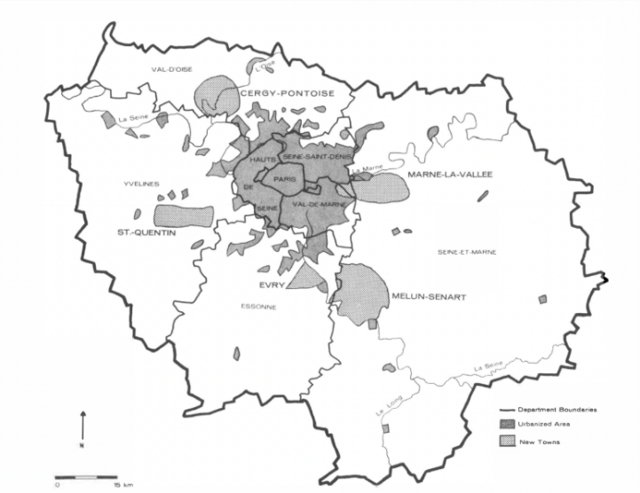
Figure 3.1: Location of Paris region new towns. Source: Rubenstein.

4.2 Overview
A strong national vision in France saw the five new towns of Cergy-Pontoise, Marne-le-Vallée, Quentin-en-Yvelines, Evry and Sénart developed in the region around Paris from 1965. Each had a Master Plan for Development and Urban Planning (SDAU) creating a mechanism for this to occur. All the new towns were based on existing urban area and intended to absorb up to 500,000 residents, with an overall projected population of some four and half million people, later revised downward to 1.7 million .
In a strategy of “deconcentrated concentration” of people and jobs, the new towns were intended to fix earlier suburban expansion problems caused by isolated housing estates and urban sprawl around Paris. The Paris region new towns offer lessons on adaptability of planned settlements including on governance and planning coherence, economic diversification, rapid housing provision at scale, regional transport infrastructure, and more recently, specific town and neighbourhood examples of liveable and popular placemaking.
The new towns were urban “poles” developed as part of a national urban programme to provide housing and jobs away from the overheated, unaffordable central Paris. The new towns offered some important key features, such as affordable housing, good jobs and pleasant green environments, but their 20th century principles for designing housing and places have not always stood the test of time. More recent new and redeveloped neighbourhoods have proved more popular and sustainable by following a traditional town design and masterplanning approach to their placemaking.

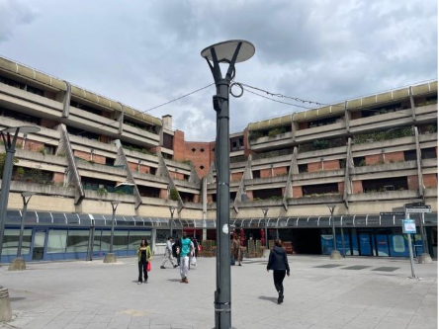
Figure 3.2: Cergy-Pontoise New Town town centre area to the east of Paris. Source: Photograph by Susan Parham, 2025

4.3 Planning frameworks
The Paris new towns were planned to deconcentrate economic growth and solve urban problems including the rapid growth of low-amenity suburban sprawl by developing a polycentric spatial planning model from a highly centralised one. Established at 25-30 kilometres distance from central Paris, the intention was to provide “new centralities with the suburbs”. These would be good places to live and work within a Paris economic agglomeration, initially using taxation and administrative advantages to support them. Young middle class people were the dominant new town pioneers, but social mix was an aim from the outset. Today, the new towns have aged demographically, as have places elsewhere in France.
Although the Paris region new towns have not been as demographically or economically important as planned, they have diversified jobs and economic activity. They provide business districts, administrative centres, major company headquarters and research centres, and development around airports. The new towns have contributed significantly to the socio-spatial organisation of Paris’s suburbs by guiding sprawl into more acceptable spatial forms for their 7.35 million residents (as of 2010) .
The planning of the Paris region new towns is complex but has benefited from a regional focus. This provides some integrating planning structures that help overcome policy fragmentation. Land costs have been kept down using a ‘ZAD’ (deferred development zone) system. According to James Rubenstein:
“Zone d'Amenagement Différe (deferred development zone) [refers to] an area established by government decree within which prices of land are frozen at the level of one year prior to the decree. The ZAD technique is used to discourage speculation as well as to keep prices low for land to be acquired. It has been used quite liberally in the new towns”.
Less positively, transport planning control over Parisian suburbs is fragmented across seven counties which manage and fund most of the transportation network.
However, sixty percent of this region is within the Métropole du Metro (Metropolis of Greater Paris) which provides a strong coordinating framework. The Metropolis of Greater Paris is:
“a dense, urban inter-municipal area that includes the city of Paris, 122 municipalities from the three departments of Hauts-de-Seine, Seine-Saint-Denis and Val-de-Marne, and 7 municipalities from Essonne and Val d'Oise”.
Within the Paris region there are twelve intercommunal cooperative territories which have planning and development functions. Cross-territory management is an emerging trend encouraged by the French government to achieve service-provision efficiencies at scale. French national laws meanwhile require regional and local plans to address environmental and 25 percent local affordable housing requirements. Public bodies have additional capacities to demand affordable housing on publicly owned land parcels. This:
“provided Paris with a tool for regulating its growth, with the aim of limiting the demographic and physical development of the capital as well as its inner suburbs.”

4.4 Governance structures
France’s national government retains a central role in structuring planning in the Paris region, Île-de-France. The key moment in the constitution of the Paris urban region was 1960, when a General Development and Organization Plan for the Paris Region (PADOG) was published. A strong focus on closely studying and understanding urban conditions and providing “a new institutional system to guide their growth” characterized planning for the new towns in the Île-de-France region in the 1960s and 1970s.
This included a Development Corporation (the Etablissement Public d’Aménagement) created to manage the new towns’ development. A delivery vehicle called the syndicate for community development (Syndicat Communautaire d'Amenagement), was instituted which amalgamated governance of local governments operating within the territory of each of the new towns.
After some devolution locally in the 1980s, the more recent establishment of the Greater Paris Metropolis in 2016 as a spatial, governance and planning entity has seen some recentralisation of power over planning from local authorities to the regional level. This makes different scales of planning join up: “Policies in the Île-de-France regional plan must be incorporated into municipal plans and plans developed by inter-communal institutions.”
It is also noted “local plans incorporate zoning and thus directly link the policy goals of the national and regional governments to on-the-ground development requirements”. Part of the structure of Metropole du Grand Paris is also a mandate to meet regional level policy goals for town planning including for the new towns.

4.5 Thematic discussion

Consistent vision, governance and planning policy focus
Positive elements include consistent national strategic and policy focus that emphasises cooperation at the regional scale. Along with financing instruments this has helped support the economic viability of new towns. The Metropolis of Greater Paris is critical as a regional scale governance, strategic planning, policy and structure and financing vehicle in the area around Paris. Treating new towns collectively as a kind of linked regional settlement form can offer an additional economic centre of gravity to a dominant central city. This can help offset the problems caused by a central city’s overheated economy and housing market. It can also help speed up the delivery of affordable housing and jobs and make liveable places.

4.6 Land use and transport planning policy to support affordability and accessibility
Despite a complex governance and planning context a range of planning instruments have supported the Paris new towns. These include the ‘ZAD’ (deferred development zone) system and 25 percent local affordable housing requirements which have helped lower new town housing costs by keeping land costs low and a percentage of housing affordable. Meanwhile, transport infrastructure that spatially links the new towns has helped underpin the around 1.5 million new jobs that were created in the Paris region between 1968 and 2018. The RER and Transilien rail/tram network have been instrumental in creating good links to and between some new towns, and created subcentre economic locations within them.
In the Paris region new towns, targeted regional transport development has been pursued in combination with the programme of decentralising, polycentric urban growth. Proximity to RER stations has increased economic activity – primarily of urban jobs. Transport oriented development nodes have also been developed through area development contracts (‘Contrats de développement territorial’). These “set targets for housing construction, economic development and public facilities in areas around the future automatic metro stations” .

4.7 Learning from earlier garden towns, garden suburbs and 20th century place models
This was not the first time new towns were developed around Paris. A 1920s round of French garden towns and suburbs in the Paris region, such as Suresnes on the western edge of Paris (designed by Henri Sellier), are still highly attractive living environments. These garden cities are an important context for the post war French new towns because the planners for the 1960s new towns drew a number of elements from them. These included success in attracting people and jobs, a context for public art and incorporating the natural landscape. Yet in placemaking terms, while planners originally ‘tried to take into account their nature resources in the urban plan’ they included few other garden city model ‘place’ elements.
Today the Paris region new towns are looking in more detail at the garden city model’s relevance to making liveable places. The 1960s new towns were explicitly organised to be very different to the ‘grands ensembles’ (large scale) high rise housing estates that came before them. Instead, they focused on “high modernist” experiments with housing design, often with very large scale town centre architecture, such as monumental residential architecture by Ricardo Bofill, and Les Arènes de Picasso residential buildings, designed by Manuel Núñez Yanowsky in the Noisy-le-Grand residential area in Evry (known as ‘Les Camemberts’ and ‘Les Pyramides’ because of their unusual shapes). They also incorporated pieces of ‘land art’, use of modern materials and experimental system building techniques, such as by Dani Karavan at Cergy-Pontoise .
Such experimentation has proved expensive in terms of social and environmental costs, spatial impacts and physical maintenance problems. It is increasingly being retrofitted at more human scale following traditional placemaking approaches. The places now being made or remade in the new towns are closer in design terms to the 1920s garden suburbs that came before. This suggests successful placemaking models should not be ignored even when they don’t fit the dominant architectural ideas of the time.

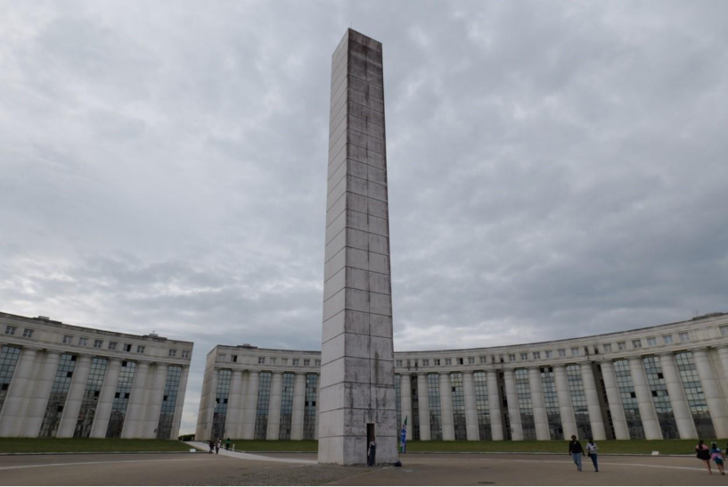
Figure 3.3: Housing and public art designed by Ricardo Bofill, Cergy-Pontoise centre: Source: Photograph by Susan Parham, 2025

4.8 Learning from the new towns’ placemaking experience over time
Residents moving to new towns identified them positively as being “a city in the countryside” with easy access to nature, abundant green space in neighbourhoods with a village character, and walkability on a town-wide pedestrian network away from traffic, sometimes on raised walkways. Access to private gardens, services, facilities and public transport in town and neighbourhood centres were attracting elements. Yet the new towns began with a suburban approach which made it harder to maintain sufficient density to underpin urban services and facilities.
More positively, there has been an increasing focus on achieving density around transport nodes, high density centres, and the evolution of neighbourhood design in some of the new towns to emphasise liveable place qualities. There is also proving to be space for hybrid approaches to placemaking. such as the Sycomore eco quartier in Bussy-Saint-Georges on the edge of Marne-le-Vallée. This mixes modernist architectural housing styles with green construction and place features in an explicitly ‘eco’ approach.
Facilitating social and income mix was a deliberate aim from the outset of the new towns. All the same, tenures are dominated by social housing and housing for sale, with little private rental housing available. Social mix has latterly increased in some of the new towns by bringing in more affluent residents, a change not all welcome. Today the engagement of residents is reinforced by the requirements of planning law to consult local communities on proposed developments but there is little town-wide engagement from below.
At large geographical scale, Paris region’s new towns have strong landscape qualities, with neighbourhoods interspersed with parks and protected natural areas. The urban context intertwined with the new towns is complex – including suburban housing estates, middle class and working-class neighbourhoods, social housing estates, and “legacies of old urban fabric” of existing villages and towns.
This was reflected in various associations that developed around the new towns to defend existing places’ traditional qualities of rural character, local green space, access to countryside landscapes, existing land ownership, and traditional village. This succeeded at Champs and Croissy-Beaubourg near Marne-le-Vallée and Cergy village against what was seen as the problematic design of the Cergy-Pontoise new town development.

4.9 Different kinds of placemaking partnerships for new towns
The more recent placemaking examples of Val d’Europe and Le Plessis-Robinson areas within Marne-le-Vallée new town demonstrate walkable, mixed use, medium density places with traditional residential architecture. These have managed to avoid the problems created previously of overly large, hard-to-maintain housing structures and public spaces. Val d’Europe emerged from partnership working between the French state and the Disney Corporation to help design the place qualities of the final part of the 40-kilometre linear city of Marne-le-Vallée. It was intended as “an opportunity to stimulate a new development of the eastern section of the new town and produce a major tourist attraction” .
In placemaking terms, Val d’Europe employed a traditional block and street form, making human-scaled, walkable neighbourhoods and limiting and carefully locating car access and parking” . As of 2019, 12,000 housing units had been built in five districts centred on local centres, with Disney developing 6,000 of them. Such examples reflect a strong preference in the housing market, among consumers, by developers, and among the region’s political leaders, for placemaking that produces places with these attractive design qualities.
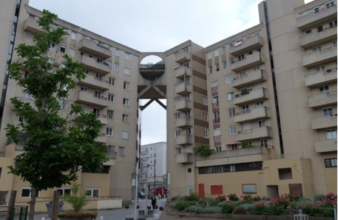
Figure 3.4: Large scale housing scheme at St Quentin-en-Yvelines new town south east of Paris. Source: Photograph by Susan Parham, 2025

4.10 Adaptability and flexibility: Levers and barriers
The range of new towns developed around Paris since the 1960s offer lessons on adaptability and flexibility in a number of themes. These themes include regional strategic and land use planning, regional transport planning, managing complex governance arrangements over time, development financing, affordable land and housing provision, landscape and green infrastructure features, and liveable placemaking through ‘concentrated deconcentration’.
Planners internationally can learn from the Paris region new towns’ largely failed experiments in monumental residential architecture and grandiose placemaking in a suburban context. These are their least successful elements. Policy makers since have started to develop places at a more human and urban scale, showing a willingness to flexibly adapt the approach. This has meant avoiding a strictly ‘modernist’ architectural vision or car-dependent suburban practice, despite these approaches being dominant in many urban contexts internationally.
The Paris region new towns are now showing in places like Val d’Europe that traditional placemaking produces commercial viability, resident popularity and sustainable design qualities. These approaches already align with key urban design principles for making high quality new places. They would therefore be relevant wherever new towns may be located internationally.
Additionally, some existing new towns globally face problems with their housing and place quality. Paris region new towns also provide some worked examples, such as Le Plessis-Robinson, of how to retrofit existing new towns. These forms of new town development and renewal show how new towns can be adapted once built, or new parts of them built, to a human-scaled masterplanning model.

4.11 Key lessons

Lesson 1: Strategic governance and planning
The Paris region constellation of new towns shows strategic, policy and masterplanning coherence, as well as some capacity to update their placemaking approach. This is demonstrated in how they are governed, planned and managed. It is in part the result of the nature and scale of the original new towns masterplan. It also reflects more recent initiatives such as the Metropolis of Greater Paris, which in turn supports governance clarity, economic vibrancy, and good transport connectivity in the Paris region new towns.
Policy makers internationally can learn from this regional level focus by bringing together central government, regional and local government and new town consortia in a combined approach. This should be especially viable where new towns are similarly located around existing major cities and conurbations which already have metropolitan-region governance structures in place. These structures can be used to ensure a regional focus on new towns.

Lesson 2: Benefits of connected regional transport infrastructure
A key lesson from the Paris Region is the importance of connectivity between new towns and the central city. This can be understood in terms of transport infrastructure but also social and economic connectivity. According to Jean-François Ruault:
“each week inhabitants of the Paris Region generate 266 million trips for various purposes, including 52 million commuting trips between department areas and 38 million supporting out-of-home place activities such as working, shopping or having lunch”.
While diverse in their individual placemaking, these new towns centres and subcentres are not self-contained. They are interconnected places both intraregionally and towards the primary capital to which they are geographically connected. The development of transport connections, including the regional express train network (RER) (Réseau Express Régional), Transilien rail and light rail systems, local bus networks, and cycle paths, both activates and is supported by the constellation of settlements.
The learning point here is how this experience reinforces the importance and worth of building on existing transport infrastructures in locating new towns. This infrastructure can also act as a platform for creating new active travel opportunities (cycle and walking routes focused on stations) that link to public transport services. Together the combination of regional transport services and network coverage are key placemaking elements that new towns internationally should consider.

Lesson 3: Learning from ‘traditional’ place design and masterplanning of towns and neighbourhoods
Social mix and liveability have benefitted from strongly defined land use planning policy and masterplanning frameworks in the Paris region. It has been positive that planning policy treated the new towns in the Paris agglomeration in a largely coherent, connected way, but some placemaking qualities proved problematic. On the urban edge of Paris, the new towns’ original low densities and modernist architectural preferences produced a liveability problem.
Today, increasing densification of neighbourhoods includes medium rise, medium density housing and other services being designed into masterplanning frameworks. These are helping build in more liveable qualities to new and retrofitted places. The popularity of neotraditional architecture and masterplans produced in some of the Paris region new towns has broken the stereotype of the peripheral dormitory new town. Instead, places like the garden city inspired Le Plessis-Robinson and Val d’Europe are constructing an urban identity based on more traditional placemaking that is highly popular among consumers.

Lesson 4: Learning lessons from specific places to guide new town development
Some of the newer developments in the Paris region new towns – with Val d’Europe being the most prominent – demonstrate that it is possible to develop places that are commercially viable, politically supported, popular with residents, successful in the housing market, and liveable, sustainable and attractive. Some wider scale regional green landscape qualities are another strength of the Paris region new towns. Access to these landscapes is valued by new town residents as space for recreation, wellbeing and culture. Regional parks provide substantial green infrastructure which helps with urban heat island effects and water management at a broad scale.

Lesson 5: Learning lessons from specific places to guide new town retrofit
The Paris region shows substantial evidence of successful new town retrofitting. This is managing problems caused by their original car-dominated placemaking and lack of robust housing and public spaces. Retrofitting and extending places can be used to raise development quality. It also helps respond to climate change issues including mitigating heat islands and improving walkability and cycling opportunities.
New town retrofit can rapidly provide more affordable housing and greater social and land use mixing. It is quicker, less expensive and less wasteful of energy and other resources to make use of existing frameworks of infrastructure, transport and services rather than building entirely anew. Policy makers globally need to make use of places that are already developed wherever possible. Some Paris region new town examples are showing how this retrofitting can be done.

4.12 References

5. Case study: Chandigarh
The limitations of modernist planning

5.1 Headlines
Location
Chandigarh, India, Asia
Key dates
Planned 1947–1951, inaugurated 1953, major construction completed by the 1960s
Key features
Chandigarh exemplifies modernist masterplanning through its sector-based layout, integration of green spaces, and monumental architectural forms.

Key lessons
- Chandigarh demonstrates the value of embedding design quality, green infrastructure, and liveability at the core of urban form.
- Overly deterministic masterplanning can neglect local cultural and climate considerations and restrict possibilities for mixed-land use.
- Chandigarh exemplifies the risks of top-down leadership and the need to balance this with participatory and adaptive structures.

Key recommendations
- National and local governments should ensure strong policy alignment and stable long-term frameworks to support the delivery of new towns and strategic growth areas.
- Masterplanning should incorporate cultural and climate considerations to promote flexibility and resilience in placemaking.
- Governance models for new towns globally should encourage both strategic coordination and opportunities for community participation in shaping long-term development.

5.2 Overview
The Indian city of Chandigarh holds a unique place in the history of urban planning as one of India’s first post-independence planned cities. Replacing the Punjabi capital of Lahore after Partition, Chandigarh became the shared capital of both Punjab and Haryana. When the state was recognised on 1 November 1966, Chandigarh became a Union Territory, an administrative arrangement that further amplified its symbolic status. Jawaharlal Nehru, independent India’s first Prime Minister referred to Chandigarh as a “new town, symbolic of the freedom of India unfettered by the traditions of the past, an expression of the nation’s faith in the future”.
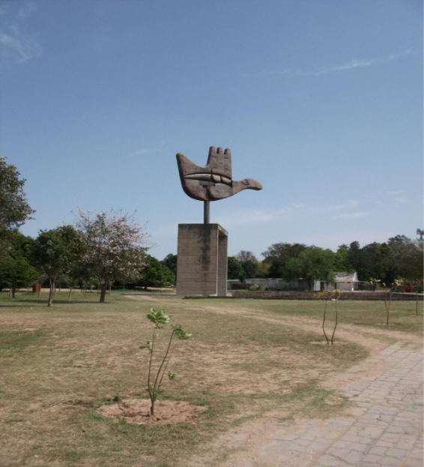
Figure 4.1: Open hand monument, Chandigarh, photograph by John Sturzaker

Chandigarh thus emerged as a statement of postcolonial modernity as opposed to a continuation of more traditional urban forms. Academics have discussed the significance of Chandigarh outside of the Indian planning context and have referred to it as “one of the twentieth century’s globally significant city building experiments”.
Two plans were prepared for Chandigarh. The first was prepared by Albert Mayer, an American architect-planner and Polish architect Maciej Nowitzki (more famously known as Nowicki). The second was designed by controversial Swiss-French architect Le Corbusier and his team of Swiss architect Pierre Jeanneret, English architect Maxwell Fry and English architect and town planner Jane Drew. It is thought that the Mayer team were replaced by Le Corbusier due to Nowicki’s death in 1950, along with the increasing value of the American dollar.
Despite complexity in the historical and political context of the city and in its planning, Chandigarh was built quickly. It was inaugurated in 1953, with main infrastructure complete by the 1960s.
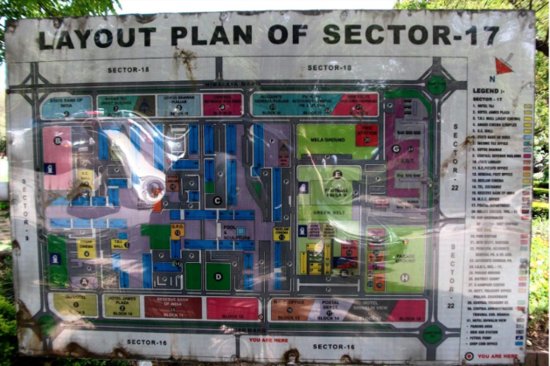
Figure 4.2: Layout plan of sector 17 (the central sector), photograph by John Sturzaker

5.3 Planning frameworks
Rooted in Modernist planning ideals, Chandigarh was divided into sectors which contained amenities and promoted walkability while accommodating the automobile. Le Corbusier used the metaphor of the body to describe the layout of the city. The ‘“head’” houses the Capitol Complex with key governmental and administrative buildings; the ‘“heart’” encompasses the commercial Sector 17; and the “lungs” are green spaces integrated throughout the city.
Chandigarh is a highly significant case study of a new town, as it demonstrates both the ambitions and limitations of modernist urban planning. While the city is often praised for the clarity of its urban form, green spaces, and iconic architecture, it has been criticised for being culturally dissonant and alienating, and lacking the vibrancy of traditional Indian cities. There are considerable factors that limit the transferability of lessons from Chandigarh to many other contexts, namely, its political and historical context, climate, and elements of its planning that are unlikely to be replicated in the present day. However, Chandigarh offers a range of lessons crucial to the development of new towns, such as the risks of overly deterministic masterplanning.
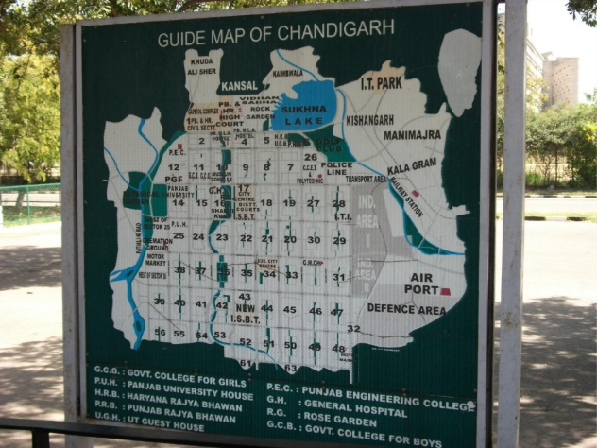
Figure 4.3: Guide map of sectors in Chandigarh, photograph by John Sturzaker

5.4 Governance structures
The governance and implementation of Chandigarh’s plan were closely tied to India’s early post-independence political context. The project was backed by central government and Prime Minister Nehru’s vision of modernisation through planning and architecture. This strong state-led approach enabled fast delivery of infrastructure in Chandigarh. However, it also limited opportunities for local participation and adaptation over time.
Chandigarh exemplifies the modernist planning approaches of its era, where centralised governance and visionary design were seen as vehicles for progress. Its development illustrates both the strengths and constraints of this model. It highlights the need to balance strong, directive leadership with flexibility, inclusivity and sensitivity to local socio-cultural conditions.
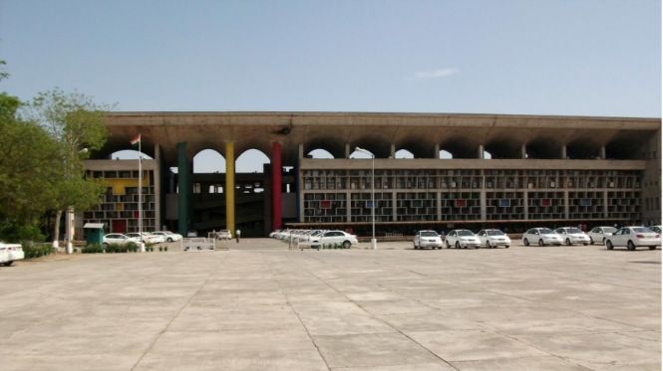
Figure 4.4: Punjab and Haryana High Court, Chandigarh, designed by Le Corbusier, photograph by John Sturzaker

5.5 Adaptability and flexibility: Levers and barriers
Chandigarh’s urban planning demonstrates both remarkable achievements and notable limitations. Chandigarh has a sector system of self-contained neighbourhoods which are intended to provide residential, civic, and commercial facilities. Sectors are 800m by 1200m in size, and were designed to be self-sufficient, containing “housing, schools, health centres, places of recreations and worship and a marketplace” . However, the self-sufficiency of sectors has been questioned, as academics have noted that residents are “forced to go elsewhere for their shopping” . The urban environment of Chandigarh is highly organised and contains an “integrated network of seven types of roads” .
Despite efforts to keep road networks away from pedestrian routes, the walkability of Chandigarh is problematic. A 2025 study of the central business area, Sector 17, and adjacent sectors 8, 9, 10, 16, 18, 21, 22, and 23 found that there were significant obstacles to walkability. Some of these obstacles are directly related to the planning and the maintenance of the city. This includes:
“obstructed and poorly marked zebra crossings, poorly maintained, discontinuous and obstructed sidewalks (footpaths), single-use zoning with scattered services, and limited crossing time intervals”.
Given these issues Chandigarh does not fit a 15-minute city structure, although plans are proposed to improve its walkability.
Despite original visions of creating an “equitable, walkable environment in the city”, Chandigarh has transformed into a car-centric environment that discourages walking. Chandigarh’s functional zoning and dispersed sectoral layout has contributed to a high degree of car dependency. Chandigarh now has the highest density of car ownership in India, which has put a strain on the city’s road infrastructure.
In this sense, the case study of Chandigarh highlights that purpose-built planned cities can fail in meeting their original goals. Although its modernist place design was shaped around car use, Chandigarh’s situation cannot be solely attributed to design. It reflects a range of factors, including car ownership as a status symbol - which makes sense considering the relatively high incomes of the city’s residents.
Chandigarh’s planners placed great emphasis on the city’s “lungs”. This is a network of parks including the 8-kilometre Leisure Valley, a linear green corridor running through the city. Despite population growth which has increased pressure on parks, most neighbourhoods in the city are “within a reasonable proximity to a well-maintained green space”. Academics have praised Chandigarh for “excelling in integrating green spaces into its urban fabric” and have discussed how its “green corridor enhances large-scale connectivity and serves as a vital recreational and ecological spine”. Over time, these lungs have expanded, with recent data showing that nearly 50 percent of Chandigarh’s territory is now under green cover. This plays a crucial role in regulating air quality, mitigating heat, and improving liveability.
It appears that both the apparent successes and challenges in Chandigarh are deeply entwined with modernist planning and spatial logic. While Chandigarh has achieved its goal of creating a legible urban form with integrated green spaces, the highly structured environment has produced a range of problems.
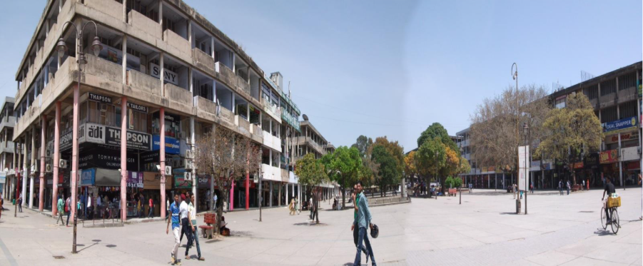
Figure 4.5: Shopfronts in Chandigarh, with signage visible behind facades, photograph by John Sturzaker

5.6 Thematic discussion

New towns as political and ideological projects
Chandigarh has been understood as an ideological project in a myriad of ways. Firstly, Chandigarh’s symbolic weight as one of the first postcolonial Indian cities is significant. Chandigarh was to be a “tangible metaphor for Nehru’s modern India”. Academics have also explored how Chandigarh “introduced to India a new urbanity”, a “breathtaking handling of urban form and space”. Chandigarh stands as a typical example of modernist planning, expressing rationality and order through its gridded sectors, functional zoning, and hierarchical road system.
Le Corbusier’s Capitol Complex (Legislative Assembly, High Court, Secretariat) uses monumental, geometric, reinforced-concrete forms to convey civic authority. The identity of Chandigarh is often associated with these sculptural buildings, and of housing designed by Drew, Fry and Jennerret.
British and American approaches to planning and neighbourhood design, along with the Garden City Movement, can be understood as key influences for Chandigarh. Jane Drew’s work in Chandigarh often took a more "anthropological approach” than the city is known for, and it is thought that her work is often “overshadowed by machismo and more flamboyant” designs in Chandigarh. Drew also undertook “extensive consultation” with local people during the design. Drew is credited for her work on Sector 22 which is comprised of mostly “homely” and “practical” architecture.

Functionality, adaptability, and the future of new towns
There are several areas to highlight on the adaptability and functionality of Chandigarh. The modernist design of the city has been seen as restrictive to local businesses in recent years. Academics have described how Chandigarh’s “austere modernist facades, set designs and prescribed building use” have been “met with resistance by shopkeepers” . These buildings often limit opportunities for “individual expression” , and have been described as “functionally obsolete” . Due to elements of Chandigarh’s planning that have not allowed for adaptability through the years, while the city is “iconic”, its masterplan is “static” .
Yet, Chandigarh has a vibrant street life which has emerged through the everyday appropriation of space. This takes many forms in Chandigarh: “vendors attach cloths and rope to built structures to form their own makeshift enclosures, sidewalks and passageways are appropriated as commercial spaces for selling food or produce”, and “pavement curbs are taken from the street and stacked to form work surfaces and vending stalls” . Through these practices, residents actively adapt the environment to meet social, economic and cultural needs. In this sense, Chandigarh demonstrates both the limits of modernist rationalism and the creativity of urban life in “modifying the built environment” .
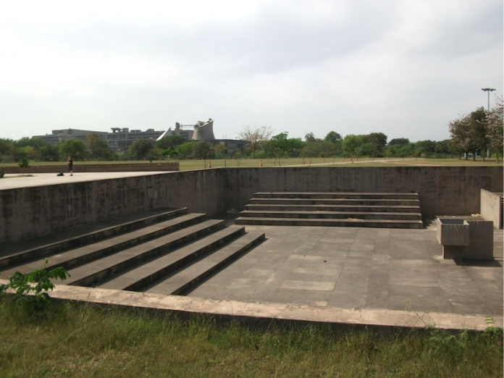

Figure 4.6: Park in Chandigarh, photograph by John Sturzaker

5.7 Key lessons for policy-makers

Lesson 1: The importance of adaptability and ongoing review
Chandigarh demonstrates the risks of an overly fixed masterplan that doesn’t account for cultural, economic and climate changes. A key lesson for policy-makers is the importance of implementing periodic reviews of plans, which consider infrastructure needs, demographic data, and climate targets.

Lesson 2: The limitations of rigid functional zoning
The sector-based design of Chandigarh created a legible and ordered urban form but also imposed a strict separation of land uses. The sector system has limited opportunities for mixed-land use and has left adaptations into the hands of residents. A key lesson for policy-makers is that planning frameworks should avoid rigid functional segregation and instead encourage mixed-use, adaptable neighbourhoods. This allows areas to evolve with changing social, environmental and economic conditions.

Lesson 3: Designing to reduce car dependency
With car ownership in Chandigarh now exceeding the local population, Chandigarh also highlights the potential risks of designing cities too heavily around private car ownership. By actively embedding strong public transport networks and possibilities for active travel, including walkability, excessive car dependency can be avoided in new towns.

Lesson 4: Integrating green infrastructure
Chandigarh’s green infrastructure was designed as a central component of the city’s plan. Chandigarh’s meticulously planned layout has created a “well-distributed hierarchy of greenspaces, from local parks to city-level parks”, which “promote accessibility at multiple scales” . Over time, the “lungs” of the city have expanded. There is increasing recognition of the importance of planning with green space, and this should continue in the development of new towns.

5.8 References

6. Case study: Daybreak
A pioneering approach to avoiding car-based sprawl

6.1 Headlines
Location
Daybreak, Utah, USA, North America
Key dates
2005-present
Key features
Large scale ‘traditional neighbourhood development’ comprising a range of dwelling types alongside commercial and mixed land use, built in accord with ‘New Urbanist’ principles of compact, mixed use, green space and transport oriented placemaking.

Key lessons
- Experience from Daybreak illustrate the importance of long-term commitment and a vision that is then implemented in stages over a sustained period.
- In order to achieve the scale of development that Daybreak now comprises, a programme of land remediation was initially needed. This ‘brownfield first’ approach required significant investment. This underscores the value of a delivery agency with adequate resources and a long-term vision.
- New Urbanist placemaking principles have produced a new town development that is popular and resilient in sustainability terms by challenging regional development norms that produce car dependent sprawl. Daybreak demonstrates the potential for high quality placemaking.

Key recommendations:
- Maintaining affordability is a challenge for successful new town developments especially in a solely market based housing context. Full consideration of the blend of dwelling types and tenures is needed if mixed communities are the goal. New Urbanist new town development works best when making use of typologies that have been identified to provide a range of smaller, more affordable housing types.
- Recognise that engaging a significant landowner/corporate organisation is essential in some circumstances to achieve wholesale redevelopment. This may be particularly the case where a former industrial site has high remediation costs which cannot otherwise be met.

A development such as Daybreak raises important questions about how uplift in value can be shared including to provide affordable housing and infrastructure. Explore ways to return to the community the uplift in land values resulting from the consent to develop, in the form of public goods.

6.2 Overview
Daybreak is located in South Jordan, Utah, approximately 30 minutes’ drive time from downtown Salt Lake City and is the largest master-planned community in Utah’s history. Based on a masterplan by leading New Urbanist Peter Calthorpe, Daybreak is developed on part of a former mining site. Its transport and nature oriented development approach follows New Urbanist placemaking principles of sustainable, human scaled, compact, walkable, mixed use design.

6.3 Planning frameworks
As with the rest of the federal United States, Utah’s land use planning system is zonal in character. There is extensive use of local plebiscites to guarantee an important moment of democratic control in the planning process. Although not unique to the US, this is an unusual approach to planning decision-making.
Another contextual feature that distinguishes Utah even from the other states of the US is the strong association between the state and the Church of Jesus Christ of Latter Day Saints (henceforth LDS church). As of 2020, over 60 percent of Utahns identify as members of the LDS church. Accurate estimates are not available at small area geographies but it is widely reported that around half the population of Daybreak identifies as members of the LDS church.
This cultural feature of Utah is important in understanding some aspects of the development, but it also makes it very specific. For example, it would be unlikely that a new town in some other settings would exist in a context where such a significant proportion of the population identify with one particular religious or cultural grouping.
A hugely important feature of Daybreak’s development has been the principle of urban sustainability. This includes walkable neighbourhoods, a 50-mile nature trail system (“the loop”), and the 67-acre constructed Oquirrh lake (Figure 5.1) which acts as a central focal point for the development as a whole. Daybreak includes “an extensive parks and open space system that integrates stormwater management, water conservation, habitat creation and local food production” .
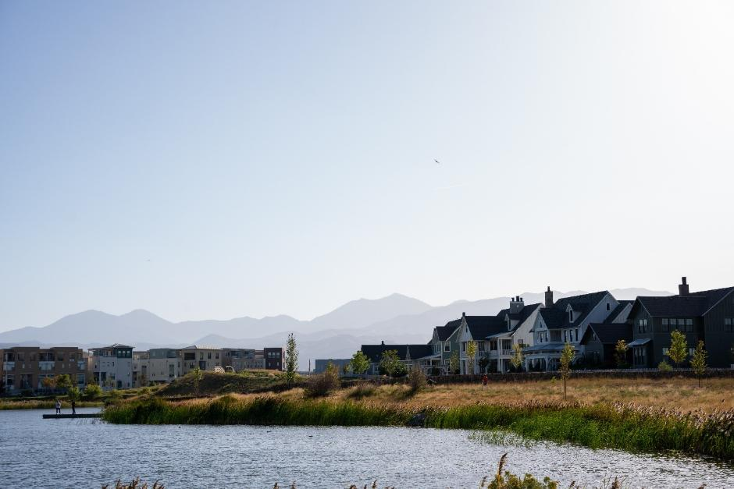
Figure 5.1: 5.1 Oquirrh Lake in Daybreak, Utah. Joey Ingelhart via Getty Images.
Daybreak has also taken a sustainable approach to transport, walkability and its urban centre. A light rail line of the Utah Transit Authority’s TRAX network (Figure 5.2) connects Daybreak to the University of Utah and downtown Salt Lake City. Daygreak’s downtown area is being developed as a compact, mixed use centre developed through extensive community consultation, Envision Utah, that looked at scenarios for growth:
“Participants preferred the future of mixed-use, compact development connected by light rail over the business-as-usual scenario of unmitigated sprawl and more highways (126 square miles versus 409 square miles of new development)”.
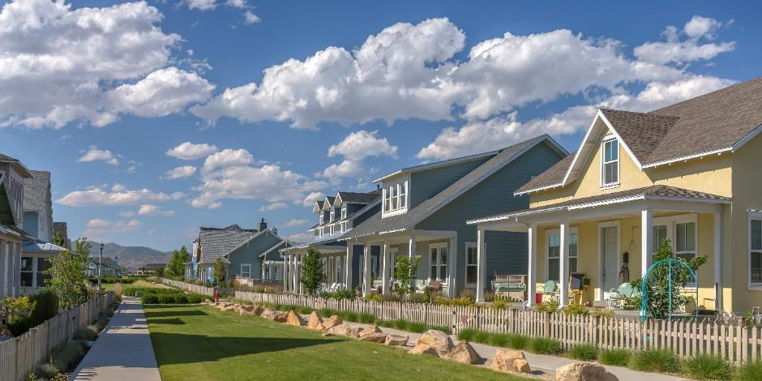
Figure 5.2: Houses in Daybreak, Utah, arranged at relative density and around a landscaped path. Jason Finn via Getty Images.
Daybreak’s walkability is a very significant feature of the development’s masterplanning. A corresponding increase in outdoor physical activity, particularly amongst children, has been recorded in Daybreak relative to other more ‘typical’ forms of development.
These features of Daybreak mark it out as different to many new developments in the western United States. More usually low-density housing and car-dependence provide the overarching context which explains suburban sprawl and neighbourhoods of indeterminate character. By contrast, the population of South Jordan has increased from just over 50,000 in 2010 to just over 80,000 in 2022, principally as a result of the expansion of Daybreak.
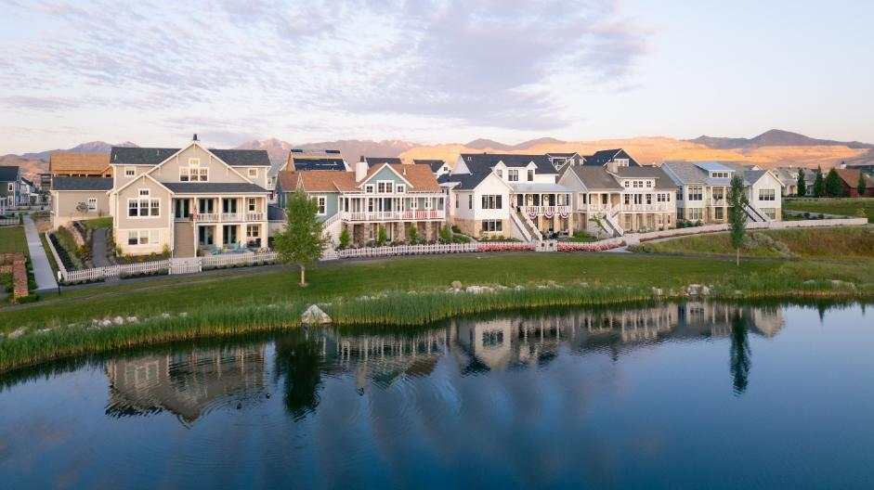
Figure 5.3: Houses adjacent to Oquirrh Lake in Daybreak, Utah. O2O Creative via Getty Images.

6.4 Governance structures
Originally developed by Kennecott Land, a subsidiary of multinational mining company Rio Tinto, the development is based in the buffer zone for the Bingham Canyon mine, an area that has historically been a centre for minerals and metals extraction, principally copper. The development was taken over by Larry H Miller developments in 2021. Originally envisioned as comprising 13,500 dwellings, a second phase for Daybreak was subsequently negotiated with the city of South Jordan (the relevant local planning authority). This will result in Daybreak growing to 20,000 residential units alongside a downtown area comprising around 9 million square feet of retail and commercial space, including a baseball park to accommodate the relocation of the Salt Lake Bees.
The development as a whole is repeatedly described as of ‘high quality’ in the secondary literature. This is indicated by its walkable, transport oriented, New Urbanist ethos and masterplan by Peter Calthorpe, one of the founders of the Congress for the New Urbanism, who also led the Envision Utah process. High quality is also reflected in homes built to Leadership in Energy and Environmental Design (LEED) standards - the first elementary school and community centre were built to LEED Silver standard.

6.5 Thematic discussion

New towns as sites of experimentation
Daybreak is an experimental project in at least two important ways.
Firstly, it is a redevelopment project: the land that Daybreak occupies is the original buffer zone that separated the Bingham Canyon mine from all other land uses. In this sense the new town represents a very clear example of the aspiration for ‘brownfield first’ development.
Secondly, Daybreak’s character marks it out as experimental in the context of the western United States. Some of the original masterplanning features of the development – walkable neighbourhoods, light rail transit, a compact, mixed use downtown, higher than average development densities, and a strong connection to nature and outdoors pursuits – marks Daybreak out as different to other significant developments in the rest of Utah and comparable states in the western US. Looking at several of these features in turn serves to illustrate important lessons that could be very meaningful for policy makers.
At 4,126 acres (1,670 hectares) Daybreak covers a significant area of land. However, it is important to note that this is part of a broader area comprising over 40,000 acres that separated the activities of Kennecott Utah Copper, a subsidiary of the multinational mining conglomerate Rio Tinto, at Bingham Canyon mine. The status of this buffer zone is in large effect related to the scale of the extractive industry to which it relates: Bingham Canyon is reputed to be the largest human constructed excavation on the planet covering an area of approximately 2.75 miles wide and one mile deep.
In the early 2000s as the environmental impacts of primary extractive industries became more well known and politically relevant, a new subsidiary of Kennecott Utah Copper was created, Kennecott Land. This had the specific mission of remediating part of the buffer zone and delivering a high-quality real estate project. To understand the broader context for this it is important to understand the position of the parent company, Rio Tinto, when work on Daybreak began in 2003. This point was clearly made by one of our interviewees:
“Daybreak was a postcard for Rio Tinto when they went to other places around the world seeking mining licences. Daybreak was their postcard to say, ‘this is what we did with the land after we went away’”.
From this perspective some of the specific characteristics of Daybreak and the quality of the development itself can be understood as a form of experimentation driven by a desire to showcase corporate social and environmental responsibility. This observation may have been important in understanding the freedom that was given to the original masterplanning agency, Calthorpe and Associates, to deviate from some of the policy and design principles that would have been considered the norm in other contexts both in Utah and neighbouring states.
This second point, the character of Daybreak’s development as a form of experimentation, can be seen in some of the features of the masterplanning. For example, the location of educational premises was determined on the principle that all households should be within walking distance of suitable schooling. This is a mainstream New Urbanist principle but should be understood as highly experimental in the western US where school commutes can be lengthy and are often undertaken by bus or, most commonly, by car.
Delivering a development that includes this principle of walkable neighbourhoods in turn required greater densities than would typically be the case in comparable situations. Daybreak’s masterplan uses a tripartite typology of ‘neighbourhood’, ‘village’ and ‘town’ to provide a mix of dwelling types. These contrast markedly with other semi-rural contexts in Utah and comparable development situations in other states. The densities range from around five units per acre in ‘neighbourhoods’ (which would be typical in Utah) to 18-25 dwellings per acre in the ‘village’ settings and over 25 dwellings per acre in the ‘town’ contexts (Figure 5.3).
These densities have resulted in urban design features which further mark Daybreak out as atypical and ‘experimental’ in the context of the western USA. For example, in the most densely developed parts of Daybreak residents parking is housed in parking garages that are sensitively hidden, typically at the rear of dwellings to remove cars from property’s frontages.
For one interviewee these aspects of the development clearly mark Daybreak out as quite different to what might typically be the case in other comparable contexts:
“The scale and density of development is remarkable for Utah – particularly in the town houses where parking has been handled so sensitively”.

New Towns as political and ideological projects
The strong association between the state of Utah and the LDS church is well-known and has inevitably had an impact on Daybreak’s development. A report by the Urban Land Institute clearly makes this point:
“Market studies conducted through the 1990s established that 65 percent of Salt Lake Valley residents were Mormons, a market that, on the whole, places a high value on homeownership and education”.
Whilst there is no explicit association between the LDS church and Daybreak there are some connections that point to the relevance of this feature of Utah’s specific culture. For example, the Oquirrh Mountain Temple (Figure 5.4) was built on land at the edge of Daybreak which was donated by Kennecott Land to the LDS church.

Figure 5.4: The Draper Temple of the Latter Day Saints within Daybreak, Utah. (c) Salil Bhatt via Getty Images.
The general connection between some of the features that have been important in the development of Daybreak and some of the characteristics that have sometimes been attributed to the LDS church were well made by one interviewee:
“A big thing for Utahns is that we love our access to the outdoors. Family-orientated community is also important to many people. People want their kids to be outside and safe and know where they are. It draws a lot of families to the Daybreak area. Lots for the kids to do in the neighbourhood – different to an urban setting where there is an opportunity for kids to get into trouble.”
Features of Daybreak’s character - dwelling types and tenure, the connection to the natural environment, walkable, safe neighbourhoods and good quality schooling – all speak directly to priorities that are consistent with Utah’s specific demographic features. These are elements that are core to a New Urbanist placemaking approach.

6.6 Adaptability and flexibility: Levers and barriers
Two overarching contextual features help to judge the success of the development.

Remediation of brownfield land
The extent of the contamination present at the core of the site is well-described by the Urban Land Institute case study published early in Daybreak’s development. This noted much of the land had originally been used for farming. It was then a site for evaporation ponds associated with mining in Bingham Canyon. The soil where the ponds were located also had elevated levels of heavy metals that needed to be remediated. The site developer, Kennecott Land, decided to go beyond standard industry practice and spent tens of millions of dollars to remove the remaining pond sediment from the site in order to develop an 85-acre (34-hectare) lake and housing on the east side of Daybreak.
In many societies the political goal of encouraging new housing to be delivered on brownfield sites finds a telling obstacle in the economics of the private development industry. The extra costs of cleanup in brownfield settings make them far less attractive than greenfield contexts, which are generally more straightforward and, usually, more profitable. It is a significant success of Daybreak that an area which for decades was the buffer zone for such an enormous copper mining operation has been transformed over a twenty-year period into a large community, sensitively incorporated into the spectacular local environment and supported by relevant infrastructure, including schools, public transport, and recreation facilities.

Affordability
Perhaps the most significant downside to Daybreak is the common issue that frequently accompanies the creation of desirable new places: unaffordability. According to Redfin.com as of June 2025 the median price of a dwelling in Daybreak was $594,088, up 3.6 percent year on year, compared to a state-wide median average of $523,000. As one interviewee noted, there is a clear market premium to Daybreak’s real estate because of its housing and landscape design quality:
“You can get the same square footage of home just outside Daybreak for around 10 percent less. But the architecture of the homes and the landscape architecture creates that emotional response that you are getting something special. That is what makes Daybreak different”.
Unlike many contexts where housing affordability is an issue, in many states of the US there is not always a mandatory policy of requiring developers to provide a proportion of dwellings on an affordable tenure. The result is that Daybreak comprises only market housing. The ‘developer’s contribution’ that would often materialise as a fraction of affordable dwellings in other contexts has been realised in other forms of infrastructure such as new school premises and three stations on the red line of the Utah Transit Authority’s TRAX public transport network. The result is a large-scale new community that is well served by services and infrastructure but characterised by a mono-tenure market housing offering.
It is unlikely that many new towns in other contexts would proceed purely via a market-based approach. The delivery of homes on an affordable tenure is politically and culturally a priority in many settings. Indeed, there is evidence that the issue of affordability has risen up the political agenda in Utah with it potentially becoming more likely that developments may be required to include a proportion of affordable homes in the future. For example, of the 2817 new dwellings consented at Terraine in the Utah’s ‘West Bench’ area 350 dwellings will be reserved for rental.
Despite this overarching issue, there are also examples of more affordable housing schemes and house types in Daybreak. This fits into the ‘missing middle’ approach to housing. This focuses on affordable housing types that meet a variety of housing needs that are discouraged by conventional development. Missing middle types includes a range of smaller, more affordable options such as ‘accessory dwelling units’ often above garages, cottages and tiny homes, mews houses and town centre apartments above commercial and retail spaces. In Daybreak, the development Daybreak Mews is an example of more affordable town homes below the median price in the new town because of their smaller size.
However, it is important to note that there are trade-offs and those features of Daybreak that can be considered a success are to some extent built upon the profitability of the development supporting investment in community benefits other than affordable housing. Compromising the market-orientated nature of the development would inevitably have an impact on the scale of investment available for public goods. This raises an important question for any future generation of new towns: how the uplift in land values resulting from consent to develop at such as scale is materialised in public goods.

6.7 Key lessons for policy makers and others
In some respects, there are features of Daybreak that make it almost unique. It is located on very large area of land which is solely in the ownership of a hugely significant multi-national corporation. The goal of creating a community of a substantial scale and high quality is part of a broader goal of illustrating Rio Tinto’s commitment to social and environmental corporate social responsibility. The quality of the built environment and the supporting infrastructure stems from this foundational goal of creating what one interviewee referred to as a ‘postcard’ for these exemplary actions. Nevertheless, there are three ways in which Daybreak serves to provide lessons for policy makers in other settings.

Lesson 1: Land value uplift and trade-offs
As a new town of a considerable size – initially over 13,500 dwellings, latterly 20,000 dwellings – the uplift in land values resulting from consent to develop has been returned to the site of development in the form of a range of public goods.
In the initial plan for Daybreak these ‘developer contributions’ took the form of public goods such as school buildings and the TRAX public transport infrastructure. As consent for Daybreak extended to 20,000 dwellings, it has worked on the development of the downtown area. This is comprising light rail stations, commercial space, office space, a health campus, a library, retail and entertainment uses including an amphitheatre and performing arts centre, and a baseball stadium.
Daybreak also features employment in light industry like warehouses and data centres. Its “first phase includes 100,000 square feet of office space and 75,000 square feet of retail, food, and beverage businesses, [and] 900 residential units” . This is an important feature of development in the US where sales taxes are a key source of revenue for local government.
However, it is important to reiterate that there is no affordable housing requirement in Daybreak; the entirety of the development is open market housing that, on average, trades for approximately a 10 percent premium to dwellings outside Daybreak.
The implications are clear: the return on investment from development on the scale of Daybreak can be materialised in multiple ways that interact with each other. Requiring a proportion of a development to be made available on an affordable tenure may have crowded out the provision of other public goods. This may have constrained public transport infrastructure and ‘downtown’ type amenities.
Furthermore, in the case of Daybreak 100 percent market housing may well relate to strong local, cultural preferences for home ownership and a broader development context that privileges investment in the natural environment, schooling and sustainable transport. In different contexts where affordable housing is a greater political priority it is possible that it may be more difficult to secure community benefits of the kind that typify the Daybreak experience.

Lesson 2: Who pays for ‘brownfield first’?
Daybreak’s proximity to the Bingham Canyon mine makes it a very strong exemplar of the ‘brownfield first’ principle. Whilst no specific figure is available for the costs of land remediation, the Urban Land Institute case study of Daybreak puts the estimate in the “tens of millions of dollars”. In this sense Daybreak is a great example of an environment that is proximate to a hugely significant industrial land use but which, as a result of significant investment, has been transformed into a desirable residential development.
Many economies have similar situations where industrial activities have bequeathed ‘brownfield’ settings. These are areas which may not be readily available for residential development until a programme of environmental remediation has first taken place. In the case of Daybreak, Rio Tinto provided the initial investment necessary for Daybreak’s delivery.
Policy makers will need to consider the issue that achieving a similar outcome in different contexts globally would require either similar circumstances such as those that motivated Rio Tinto or to find an alternative investor such as the state. This would be needed to make the considerable initial investment necessary for brownfield land to become an attractive option for the development industry to build out a new town.

Lesson 3: Using high quality masterplanning to deliver exemplary development that avoids sprawl
Daybreak is unusual in the western American urban development context because it has avoided car dependent urban sprawl. Instead, it has produced a sustainable, highly attractive and well-connected place to live and work. This is largely based on its use of New Urbanist placemaking principles through Peter Calthorpe’s masterplan and its high level of engagement with local community through Envision Utah.
Policy makers internationally should consider if these placemaking approaches could be used in their development setting to help produce a resilient new town that is well adapted to climate and biodiversity issues.

6.8 References

7. Case study: Curitiba
Urban planning as continuous adaptation

7.1 Headlines
Location
Curitiba, Brazil, South America
Key dates
1965-present
Key features
Long-term flexible planning framework for urban expansion with an approach to governance and urban form that is adaptable to changing context.

Key lessons
- Curitiba shows that urban planning is about both the implementation of a plan and ongoing strategic and problem-solving functions. Successful planning structures allow for both elements, as in Curitiba where there is a strong relationship between mayor and urban planning and transport authorities. Curitiba demonstrates flexibility and adaptation to the inevitable contextual changes in which towns and cities grow. This includes its adaptability on aspects such as water management, waste management and urban agriculture, public transport accessibility, pedestrian zones, energy use, and the development of parks and other green infrastructure.
- Urban planning managers need to contribute to urban governance beyond making decisions solely about land-use change. Curitiba shows that the benefits of planning are best realised where its coordination and problem-solving aspects are closely tied to how it governs broader place aspects such as those above.
- Problems and issues that appear to be about one issue only are often related to a broader urban context that also needs attention. Issues such as flooding or lack of open space may respond to solutions that tie them together. In Curitiba examples are the creation of new parks in Curitiba that also integrated ponds to contain floodwater, and where waste management and urban agriculture are connected as discussed below.

Key recommendations
- Orientate new towns around public transport nodes and corridors. Map urban densities around these corridors to make sure that there is a sufficient number of people to use transport services. This will help ensure traffic congestion that would follow from disconnected car-dependent settlements is avoided.
- Planners should pay attention to the aspects of planning that go beyond the implementation of the plan. This can be done by establishing an urban planning agency to take an overview of a new town’s development. Unforeseen issues inevitably arise as a new settlement develops. These unforeseen issues need the capacity to solve problems and formulate new ideas from a strong urban planning and management agency.
- Ensure that future development continues to fit within a shared vision of the new town. This should be established at the outset, acknowledging that this vision and its practical planning proposals for development must be adaptable to changing conditions. This can militate against the tendency for planning of new towns to be reactive, responding rather than adapting to challenges. Curitiba has used a combination of strong mayoral leadership and urban planning and transport agencies with substantial powers to do this job.
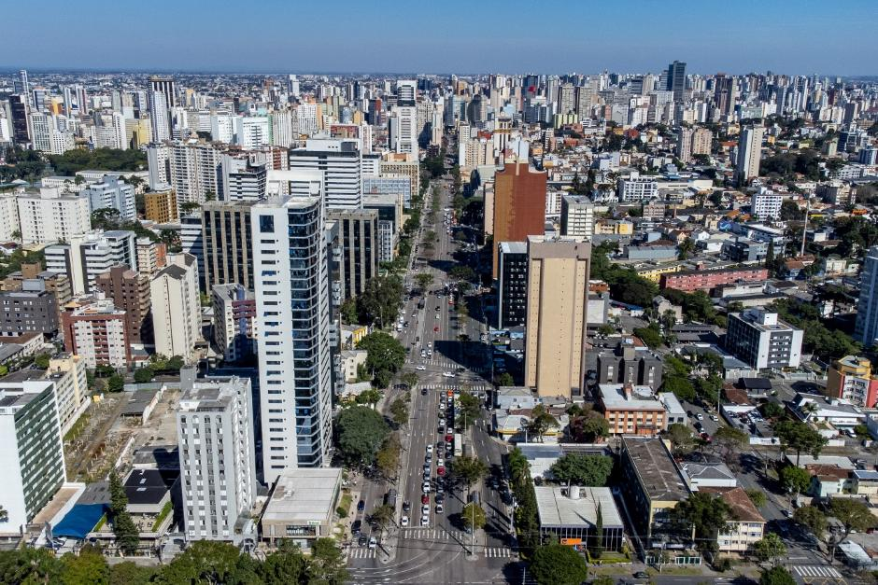
Figure 6.1: Central region of Curitiba. Roberto Dziura Jr via Getty Images.

7.2 Overview
A rapidly expanding city, whose metropolitan region population has now reached 3,700,000 from fewer than 200,000 in the 1950s, Curitiba is known to planners worldwide for its Bus Rapid Transit (BRT) network and sustainability credentials. The city also deserves particular renown, however, for its growth management in the face of intense urbanisation pressures. While Curitiba is not a new town per se, it shares a range of new town management issues and characteristics worth exploring.
Lessons from Curitiba’s experience are keenly sought as cities wrestle with the challenges of managing urban growth. Moreover, the strategies taken in Curitiba are relevant not only to cities in a similar phase of growth, as are found elsewhere in the Global South, but also to Global North cities facing different challenges relating to urban complexity and change.
Curitiba is the largest city and capital of the Southern Brazilian state of Paraná, around 120km from the coast to its east and 400km from São Paolo to its north. The city’s origins are in the 19th century cattle ranching and agriculture that dominate southern Brazil. But present day Curitiba’s story began in the 1960s, when population growth and the expansion of car ownership led to a search for a new plan to guide the city’s development. What emerged was not as straightforward as the city-wide growth plan sought. Instead, Curitiba undertook a wholesale reimagining of urban management. This allied a physical plan to contain and direct urbanisation with multiple cross-sectoral interventions in green space provision, active transport, water and waste.

7.3 Planning frameworks
The Brazilian planning system uses masterplans prepared at the municipal level to determine the pattern and characteristics of future growth, as well as to respond to economic and social challenges. Over time, the nature of masterplans has changed, with those of the 1960s and 1970s now seen as technocratic and rigid. Masterplans written in more recent decades are more openly political and representative of social and environmental interests.
Curitiba’s ‘year zero’, at which point its present planning trajectory was established, is 1965. This was when a new masterplan for the city, commissioned to respond to the rapid population growth that had come with industrialisation, was put in place. The so-called ‘Wilheim Plan’, named for its lead author Jorge Wilheim, established the BRT corridors that Curitiba is now most famous for, alongside other initiatives to reshape and grow the city. Since that point, successive masterplans have continued to guide the city’s continued growth. These have done so by incorporating, most prominently, an increasing focus on ecological restoration of the city alongside urban development.
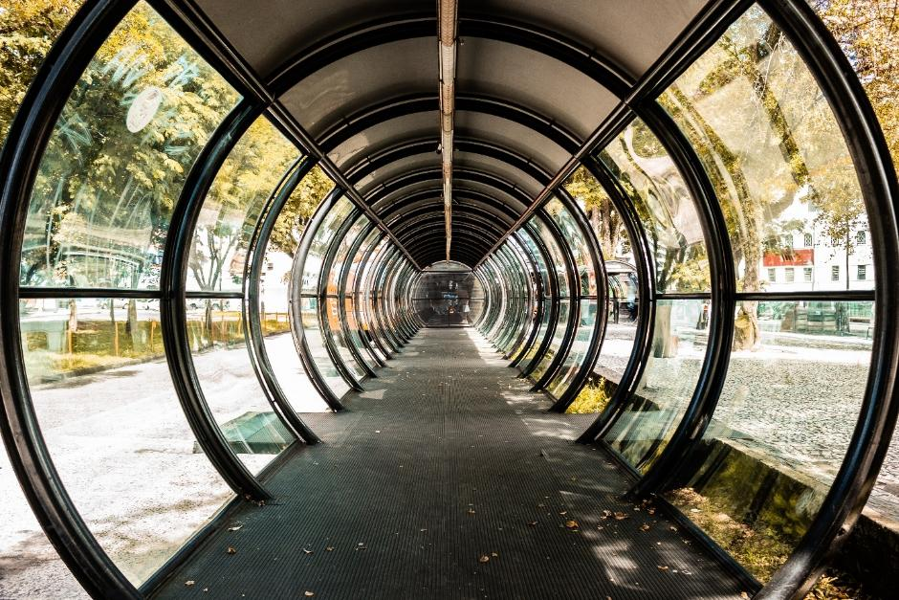
Figure 6.2: Tube bus station in Curitiba. Capuski via Getty Images.
Certain aspects of planning in Brazil and Curitiba are particularly reflective of its context. Most obviously, informal development is a widespread issue. Informal settlement has, since the 1980s, been the locus of reformist policies supporting services provision and allocating property rights. Brazil’s national focus on developing the potential of peripheral regions is also relevant. This is most obviously evident in its development of a new capital city – Brasília – in the under-developed interior of the country. The challenges of accommodating growth at the city-regional scale and of implementing the infrastructure necessary for urban growth are common to many contexts.

7.4 Governance structures
The governance of urban planning in Brazil is closely tied to the country’s development trajectory through the latter half of the 20th century as a rapidly growing resource economy. Land-use planning has by its nature a growth-mindset and focuses on the need to address social problems that come about through rapid urban expansion. National and regional plans have embodied attempts to foster growth in slower-growing regions, to varying levels of effectiveness. The Curitiba case is a successful example of this.
The accomplishments of the Wilheim Plan are not only in the plan itself but in the governance structures established for its implementation. At the 1965 plan’s outset two municipal agencies were set up. These are the URBS (the Curitiba Urbanisation Corporation) as the transport authority; and the IPPUC (Institute of Research and Urban Planning of Curitiba) as the urban planning authority responsible for the implementation of the city’s master plan. The strength and influence of the IPPUC in particular is closely associated with the planning trajectory taken by Curitiba, which has benefited from the centrality and long-term presence of the IPPUC in the overall governance of the city.

7.5 Thematic discussion

Liveable neighbourhoods between infrastructure corridors
The major innovation of the 1965 Wilheim Plan was to adapt Curitiba’s existing radial road structure into five linear transit-oriented axes that cut through the city centre and along which development would be concentrated. This provided a worked proposal for a public transport system and for mixed-use development that would reorientate the city away from a low-density car-dependent future. As a result, the city is mainly known in planning circles for its transport system, which uses the world’s first BRT to achieve efficiencies in the absence of funds for subway construction.
This innovation is only one, albeit major, component of a more wholesale approach to urban planning. Combined with land use planning powers to determine densities and use mix, Curitiba’s development fed off the then-current reorientation of planning away from modernism. Instead, Curitiba oriented its planning towards a more human scale approach to favour pedestrianisation, mixed-use neighbourhoods, public transport use, green space and heritage protections.

Planning as the gradual building up of small-scale interventions
The implementation of this overall strategy has become almost as well known as the strategy itself. The approach in Curitiba follows the principle that complex urban problems need not demand complex solutions. This focus on simplicity has been combined with a pragmatism that has led to a practical approach to ‘getting things done’. This is the tactical counterpart to the strategy. Its component parts are shown through a series of masterplans that have followed the 1965 plan. This is most obviously found in the so-called ‘urban acupunctures’ - small-scale interventions made at key points within the city, such as public squares, parks and transport interchanges, in order to catalyse change and whose impact goes beyond their scale.
These interventions can be as small in scale as tree planning on empty plots. They can be as comparatively large scale as the ‘Citizenship Streets’ initiative, which situated civic centres at transport stations in suburbs throughout the city. This improved accessibility to public services including housing and health support, as well as leisure and sports facilities.
Many built environment interventions, including the Citizenship Streets and the tube-shaped bus terminal design, promote a highly recognisable public architecture that enhances urban legibility. More cynically, it is suggested that a number of public structures in the city seem to exist “with the purpose of simply imprinting the signature of each administration on the urban environment”.
Curitiba has also worked on linking aspects of urban resilience such as waste management and urban agriculture. The municipality runs an Urban Agricultura Programme that supports vegetable gardens, urban farms, ‘honey gardens’ and composting facilities. Food access is linked to recycling. “For every 4kg recyclable waste collected the city reimburses its residents with 1kg of fresh fruits, eggs and vegetables or bus transit passes”. Residents can drop off recyclables at local green exchanges including those located at bus interchanges to receive fresh food in return.

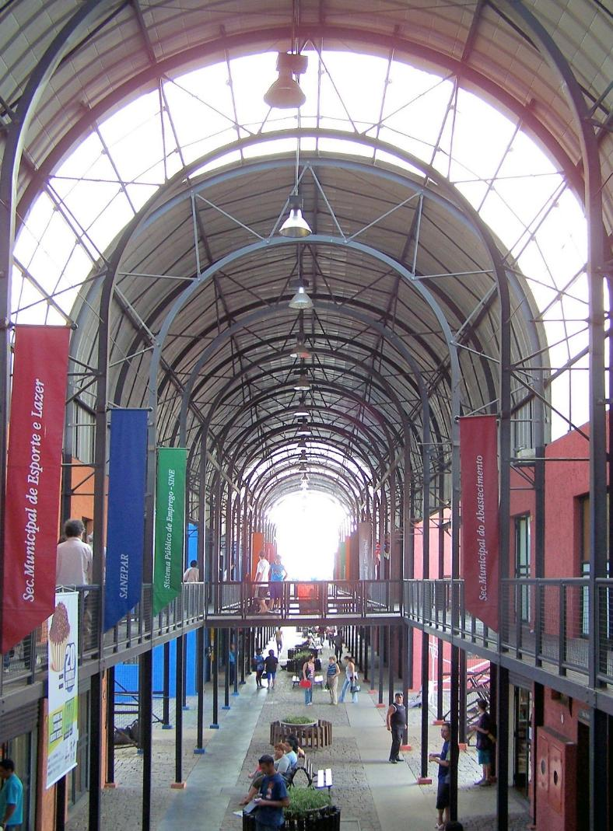
Figure 6.3: Pinheirinho Citizenship Street. Maria F. Ramirez. Photographed March 2006. Copyright University of Cincinnati Libraries, Design, Architecture, Art, and Planning Library, JSTOR, https://jstor.org/stable/community.35182708 Reproduced with permission.

7.6 Adaptability and flexibility: Levers and barriers
The measurement of Curitiba’s success in terms of adaptability and flexibility must be assessed against how it has addressed long-term urban challenges. Curitiba has been very effective in the management of its urban change over the past almost-half century. It has been able to address the challenges common to many cities of rapid population growth and a looming tendency towards urban sprawl.
Curitiba’s present trajectory dates back to the 1965 Wilheim Plan and the establishment of the IPPUC planning authority to oversee its implementation. The Wilheim Plan was written by a group of architects influenced by the ideas of Jane Jacobs and a human-centred urban form. This marked an urban transformation worth evaluating for what it can add to our understanding of how urban planning can function as a continuous adaptation to change.
Against the aim of creating a more human-centred, less car-dependent city, Curitiba has fought against the tide of rising car ownership and consumption that follows wage growth. Indeed, in 2010 Curitiba had the highest car ownership rate of any city in Brazil, reflecting its relative economic strength. Even within this context, however, Curitiba is viewed positively, scoring high on the Index of Sustainable Urban Mobility, with especially notable performance on indicators for accessibility of services and environmental quality.
The city’s remarkable continuity of planning practice and political leadership in the first two decades that followed the Wilheim Plan is partly due to the close association between the city’s governance and the military dictatorship then leading Brazil. Curitiba could be used as a success story in Brazil’s economic miracle of the 1960s and 1970s. This predisposed the repressive military regime towards the city’s urban planning and management apparatus. It ensured that plans could be implemented without political opposition.
While Curitiba’s planning is rightly regarded as successful in its ability to adapt to change, it is questionable whether it was able to – or indeed needed to – incorporate and interpret the public interest into this flexibility. This is highlighted by the dependence of the Curitiba model upon the ‘locking-in’ of power of the IPPUC which was situated as a technical rather than political organisation. The IPPUC could promulgate technocratic urban management that was insulated from electoral politics without including sufficient citizen participation.
In defence of the alliance of planning and politics that implemented Curitiba’s plans, the military junta could be viewed as an external condition that local planners and politicians had no choice but to operate within. The city’s planning approach was later validated by popular mandate with the coming of democracy in the mid-1980s.

7.7 Key lessons for policy makers

Lesson 1: Planning is dealing with change
The 1966 Plan was a persuasive vision for the future of the city of Curitiba. The effectiveness of the city’s development is due in part to its ability to put its faith in the Wilheim Plan and those that succeeded it. The plan’s inheritors did not build out the Plan over the subsequent decades solely because it was required to. Curitiba’s long-term governance maintained the principles established in the Plan because these offered a sound urban development framework that was also capable of adaption to changing circumstances. Its masterplans resemble strategic plans orientated around public projects rather than blueprint plans to be realised as detailed developments.
To fulfil the strategic intentions of the plan is, somewhat paradoxically, to acknowledge that planning involves not only the forethought to formulate the plan in the first place but also the responsiveness to adapt to changing conditions. It is important to acknowledge that the plan for a new town, or for a drastically altered one in the case of Curitiba, is more than anything the establishment of a trajectory. In the language of institutional change, the plan is path-shaping, but the future development of the city need not be path-dependent.
The original vision for Curitiba has been characterised as having established a “developmental trajectory that is more important than any individual period in itself”. This is reinforced by Jaime Lerner’s reflection on Curitiba’s development: “to innovate is to start: planning is a trajectory that can always be adjusted if you listen to the people” . Curitiba’s approach has been to formulate a strategic long-term vision and to integrate incremental decision-making into the ongoing realisation of that vision.

Lesson 2: Adaptive urban management as well as urban planning
Much of the attention to new towns internationally will rightly focus on urban planning’s land-use planning function, encompassing site selection, land assembly, layout and servicing of land. Yet Curitiba demonstrates the critical role of coordinating and managerial qualities of strategic spatial planning. It shows the importance of the associated tying together of manifold urban functions into a coherent notion of urban management. This builds on the previous lesson that planning must be understood as dealing with change. It further demonstrates that solutions to urban problems need urban management that goes well beyond the realisation of a plan or strategy. Curitiba emphasises the importance of understanding and managing the city as an ongoing – in fact never-ending – project of adaption.
To support the implementation of the 1965 Plan, the state of Paraná created the IPPUC. Originally tasked with supporting the implementation of the plan, the IPPUC became a ‘brain-pool’ of architects, engineers, and social scientists that combine long-term strategic thinking with day-to-day problem-solving. Quasi-autonomous from the city government, the IPPUC nevertheless has a close connection to the mayor’s office, pointing to the centrality of planning to the city’s ongoing development.
Planning by local government and IPPUC, as effectively an urban planning and management agency, has a high value in Curitiba. This is demonstrated by the continuity between the head of IPPUC role and the mayor’s office. Both Jaime Lerner, and later Cassio Taniguchi, have made the journey from leading the IPPUC to leading the city. The intermediate space occupied by the IPPUC gave it a quasi-autonomous status, and insulated it from politics. Yet it has a direct channel of communication to the mayor. This has granted the IPPUC coherence and continuity but equally means it does not completely represent Curitiba’s citizens. Similar questions have been grappled with in other new town management contexts, where the balance between local authorities and early New Town Corporations was crucial.

Lesson 3: Urban complexity demands the integration of solutions
In the course of devising solutions to urban problems, the IPPUC has taken a holistic approach. This ties together issues that span the extent of the city’s working parts. Curitiba does not insulate matters like transport, housing, water, and waste within discrete functional areas. Instead, Curitiba’s planning develops a strategic overview that casts these as different parts of the same machine. This enables decision-makers to consider their interrelationships.
In this approach to managing urban complexity, Curitiba’s problems with flooding were addressed in a way that also addressed its lack of access to water for leisure and recreation. This meant that the standard solution of engineered flood run-off channels was replaced by a sustainable urban drainage solution. A series of lakes was created to serve as both retention ponds for flood water and recreational spaces.
As put by Cassio Taniguchi, former head of the IPPUC and later mayor of Curitiba:
“That is one of the fundamental concepts of Curitiba: never to think about transport in an isolated manner; never to isolate the shantytown issue; never to use land in an isolated manner. Planning uses this as a lever within an urban structuring process that makes possible an organicism of several urban functions – all of them mixed.”.

Lesson 4: Human scaled planning approaches work
Curitiba demonstrates that land-use planning powers can be used to reorientate planning away from over-scaled modernism. This has proved possible, even while maintaining a city-wide focus on placemaking through development of its urban axes. Curitiba has been able to adapt densities, land use mix and movement structure towards a more human scaled approach. This favours pedestrianisation, mixed-use neighbourhoods, public transport use, easier access to green and food growing space, and more heritage protections.
Like other new town cases applying these placemaking principles has had a positive impact on the city’s resilience and liveability. Policy makers in other new towns can learn from this application of the human scale to planning.

7.8 References

8. Synthesis of cross-cutting findings from case studies

Lessons from across the case studies
In this section we synthesise important learning points (‘lessons’) which either occur in more than one case study, or emerge through comparison between two or more cases.
These cross-cutting lessons, and those highlighted separately in relation to each case study, lead to the eight over-arching and high-level recommendations, set out in chapter 9.

8.1 Lesson 1: Consistency of approach over time
A consistent approach to planning policy over time has led to benefits in the most successful new towns. This might be at the national scale (Almere), national-regional in combination (Paris region), or city-level (Freiburg and Curitiba). In all instances there has been coherence in policy principles. This consistency has been maintained through changes in government and ideological approach, with important planning philosophies being maintained.
This has not necessarily led to a rigidity in, for example, urban design choices, but has in instead lent itself to a successful atmosphere of experimentation - whether in design for food, nature, green space, water, public transport, walkability, parking and or other aspects of placemaking. This is a feature of the development in Almere, Freiburg, Daybreak, Curitiba and, more recently, in the Paris region as it has sought to redesign some its new towns according to more traditional placemaking principles.

8.2 Lesson 2: Importance of partnerships
Effective partnerships are central to the successful delivery of new towns and the new towns studied show a diversity of these. Examples include partnerships between national government and regional strategic planning agencies as in the Paris region, between strategic planning agencies and local authorities as in Curitiba, and between developers, masterplanners and citizens as in Daybreak through its Envision Utah process. In Almere partnership between local communities and the city government have led to innovative forms of urban development as in Nobelhorst and Oosterwold neighbourhoods.
In Curitiba partnership working has allowed for continuous adaption to make a more sustainable, equitable and resilient city. The city-regional governance and masterplanning model in Paris has succeeded in integrating local plans into a regional approach, developing economic vibrancy and transport connectivity at large scale.
In Daybreak, the community, working with the city’s masterplanners, has shown it prefers development that rejects an unsustainable sprawl model. As Almere shows, successful partnership also underpins effective stewardship on themes such as food. Converseley, the top-down approach to planning in Chandigarh led to local people needing to find their own way to adapt the place to meet their needs.

8.3 Lesson 3: Use masterplanning to offer a clear but flexible vision for placemaking
Masterplanning can provide a clear vision with capacity for flexibility in delivery of new town placemaking. Almere, Freiburg, Daybreak and Curitiba all show the benefits of high-quality masterplans to making liveable places, as do more recently parts of the Paris region such as Le Plessis-Robinson and Val d’Europe.
Chandigarh and Almere offer two contrasting trajectories of planned urbanism that reveal important lessons for other places. Chandigarh exemplifies a highly prescriptive masterplan with monumental architecture, rigid land-use segregation and high levels of car dependency as well as more positive elements, such as easily accessible green infrastructure. Almere, by contrast, is an adaptive and iterative project, where planning frameworks were deliberately flexible and allowed for incremental growth over time. These divergent approaches highlight the limits of rigid masterplanning. Almere demonstrates the value of a more open-ended framework that can accommodate social, economic, and technological change.

8.4 Lesson 4: Strong community involvement
The local planning process in Almere and Freiburg is characterised by self-organisation and strong community involvement, while Daybreak’s broad consultative processes to inform its placemaking are one of its key strengths. In Curitiba, meanwhile, community involvement was historically limited. But today the city runs a ‘Speak Curitiba’ programme through which residents can state their views.
In Almere and Freiburg, planning processes are oriented around a bottom-up approach. There is a strong legal and cultural emphases on communities having not just a right to speak, but a right to be heard. These communities in turn feel a strong affinity with their place, and in Freiburg at least, support measures such as reducing car ownership.
This is in contrast to in Chandigarh, where a top-down approach with little community involvement was typical of the time of its inception. This has meant that local people have felt the need to adapt to the environment by travelling further afield, beyond formally ‘self-contained’ areas, to meet their social, economic and cultural needs.

8.5 Lesson 5: Importance of land assembly
Assembly (or reclamation) of land by a public or private sector actor is an important feature of successful large-scale development. Local authorities have made use of compulsory purchase powers to keep land values low in a number of the case study examples. Planning gain has been retained for the benefit of the public, as opposed to landowners, through these approaches in Paris and Freiburg. In Daybreak the developer paid the very high cost of brownfield land reclamation. In Chandigarh the site was identified and developed by the state. In Curitiba, where the focus is on adapting existing space, the state’s powers through the IPPUC (including transferring development rights) are crucial to redeveloping urban spaces.
In most of these cases this means that high quality infrastructure and community facilities are installed before developments are occupied. Using and value capture in this way directly links these new towns back to a key feature of the Garden City model.

8.6 Lesson 6: Effective transport and active travel planning is key to more sustainable living
The case studies showed a range of approaches, with some areas being particularly successful in incorporating active travel and public transport. In some (notably Almere, Freiburg and Daybreak), cycling and walking has been given priority with extensive, safe cycle and walking paths. Curitiba’s innovative, affordable city-wide bus corridors have been a great success.
The Daybreak case may be particularly surprising in this context, with walkability being an organising principle for neighbourhood, village and town centre design. This includes schools being built within walking distance of homes. In fact, this fits well with a New Urbanist placemaking model of transit orientation. By contrast, in Chandigarh walking is challenging because of the priority given to car-based movement.
Strong regional transport connectivity characterises the Paris new towns, which has helped the ‘concentrated deconcentration’ approach to work. This decentralisation of population and jobs, supported by transport links, is cooling the overheated economy and housing market in central Paris. Town-wide public transport is very well used in Almere, Freiburg, Daybreak, Paris and Curitiba, and encouraged by a range of planning (and non-planning) approaches. This includes designing settlements around public transport routes in Freiburg – even if the tram, in the Vauban instance, was not installed until some years after construction of homes began.
Car ownership is higher than average in some of the case study locations, notably Chandigarh and Curitiba, but in Curitiba at least car usage is relatively low. In Chandigarh and the Paris region, conversely, roads are dominant, compromising walkability and everyday social interaction. These new towns were built during the high point of modernism in the 1960s. This sort of path dependency, leading toward the dominance of car use, has been hard to break in Chandigarh.
In contrast, since the 1990s some Paris region new towns have worked on walkable, compact, mixed use place design. As a consequence, some examples have much more accessible, less car dependent forms – demonstrating flexibility and adaptability through active urban design and planning.

8.7 Lesson 7: Proactive planning for housing leads to diversity of tenure
In some case studies there is an emphasis on affordable housing provision, notably Almere, the Paris region and Freiburg. These are communities built over very different periods, and in different global and local fiscal contexts, showing an enduring commitment to the importance of this principle. Conversely, the popularity of Vauban (in Freiburg) and Daybreak has led to property prices being higher than in similar places. This reflects the popularity of well designed and built new communities, a point we return to below.
The role of self-build, prominent in Almere and Freiburg, is another recurring aspect of housebuilding. This is reflective of housing markets and cultures that are supportive of this model of delivery. Self-build opportunities are also actively planned for in both contexts. Possible residents of self-build zones are involved in the planning process from an early point.
In Freiburg, Almere and Daybreak, there is also an intentional mix of dwelling types, sizes and density including the ‘missing middle’ housing noted in Daybreak. This housing mix has avoided some of the mono-tenure problems afflicting post-war housing estates and new towns in many countries. In Chandigarh, the architect Jane Drew’s work was notable in allowing for a range of housing types within the limitations of mono-functional separation of land uses across the city.

8.8 Lesson 8 – Diversity in land use is essential to build resilience
In Almere, Freiburg and the Paris region planners have aimed for a conscious mixing of land use. This in turn assists with the viability of non-car transport, unlike in Chandigarh, where rigid zoning and a car-focused modernist masterplan means that it is hard to easily access daily needs.
Space for food growing has been an important land use included in the mix in some cases, prominent again in Almere, Paris and Freiburg. Similarly, green and blue infrastructure has been planned into these new towns. The Paris region new towns have abundant regional green and recreation space as does Chandigarh, although some of the photographs of the latter also show the problems resulting from monumental provision of open space.
There are multiple benefits from green and blue infrastructure, with urban cooling increasingly important. To that effect, green infrastructure has been retrofitted into some open spaces in Freiburg. This is also a strength of the designs of the Paris region new towns, where there has been a strong and consistent focus on blue-green space both in design at a regional scale and internally, within communities, where parks are threaded through neighbourhoods.
Renewable energy is often provided via solar panels in Freiburg (more obviously on self-build homes than conventional market-build homes), in Daybreak, and Curitiba. District heating schemes and heat pumps play a significant role in Almere and Paris new towns,. Freiburg has both heat and power (CHP) combined with district heating systems (DHS). Low energy building design is also being pursued in a number of the cases. This is a key part of both adapting to and mitigating climate change.
The scale of some of this land use diversity is not necessarily large – this includes small urban gardens in Freiburg and Almere, ‘urban acupunctures’ in Curitiba, and car parking courts and garages in Vauban and Daybreak. But it does show that while large-scale coordination of development might be important, small interventions broadly applied across a city can be very powerful for improving quality of life.

8.9 Lesson 9: The limits of modernist approaches
Across all the cases modernist planning has been an issue. In some cases, like Chandigarh, the Paris region and Almere, modernist planning was the original basis for place design. This was shaped around car use, based on mono-functional zoned areas, often developed at very low densities, and using materials that have been hard to maintain. In other cases, like Daybreak and Curitiba, there was a conscious decision to reject or reconfigure the city’s design towards more traditional placemaking principles for sustainability and resilience reasons.
In originally modernist places like Almere and the Paris region there has been significant retrofitting to redevelop neighbourhoods along more human scaled, compact, mixed use, walkable, green-focused, and public transport-oriented lines. In Freiburg this approach has also focused on ecological aspects to develop carbon neutral places.
Traditional placemaking principles today are often associated with concepts like the 15 minute city. The majority of the cases have recognised that this kind of approach makes for well-functioning and liveable space. This is space that adapts to and mitigates the effects of climate change and biodiversity loss.

8.10 References

9. Conclusions and recommendations for policy makers
It is possible to develop new towns that are commercially viable, politically supported, popular with residents, successful in the housing market, and highly liveable, sustainable and attractive.
In order for such places to be the norm, some high-level recommendations emerge from the case studies and above lessons for policy-makers and planners. International contexts vary in their planning systems, land ownership models, climate and culture - these recommendations focus upon what planners and others are trying to achieve, as much as the details of how they did it.

9.1 Recommendation 1: Ensure that planning policy is consistent over time
The first and most important recommendation is to ensure that policy on planning is consistent. The places which are most successful, or where new towns have proven most effective or popular, are those where policies at the national (Almere and Freiburg), regional (Paris) and local (Freiburg and Curitiba) level have remained consistent over a sustained period of time. This absolutely does not mean that policy must remain rigidly dogmatic. Rather, common principles that are broadly agreed guide decision-making over the longer term.

9.2 Recommendation 2: Harness the path shaping powers of planning, and avoid path dependency
There is a strong contrast between Curitiba, where principles of plan-making were maintained over the long-term, and many new towns which have been built according to design blueprints that specified an end-state.
As we note in the Curitiba case study, what planning for new towns should be seeking to do is to establish a trajectory for the development of the place. The plan should be shaping the way ahead, that is, ‘path-shaping’. At the same time the new towns to come must not be ‘path-dependent’ - that is, their future completely defined by a rigid plan.
New towns need to have the space to flexibly adapt to changing circumstances. This can be achieved through a masterplanning approach which clearly and firmly establishes principles for the design and development of the new town, within which change can be accommodated as yet unforeseen challenges responded to.

9.3 Recommendation 3: Go beyond the plan – the importance of ‘urban management’ and setting up partnerships for delivery
Depending on the new town’s unique circumstances, partnership may be between tiers of government, or with the private, institutional, and third sectors. It may be between developer and residents. Policy makers delivering new towns need to proactively set up such partnerships which engage relevant stakeholders to work together on developing their town. As an example, the city-regional governance and masterplanning model in the Paris region new towns has succeeded in integrating local plans into a regional approach. This has helped develop economic vibrancy and transport connectivity at the regional scale.
Stakeholders beyond the public sector must also be included, in pursuit of what we have referred to as ‘urban management’. Successful planning must go beyond the plan itself and consider other aspects of implementation and stewardship. The success of experimental approaches to planning for housing and transport in Freiburg and Almere show how important it is to bring residents of new towns along on the planning journey.

9.4 Recommendation 4: Transport and land use planning must be integrated
The most successful of the new towns studied have been planned around public transport and active travel, at scales from the very local to the regional. There are strong and well-established justifications for supporting a transport-oriented approach that provides alternatives to the private car, and planning has an important role to play in this.
At the regional and sub-regional scales, new towns must be in locations which can easily be connected to strategic transport routes. At the local scale, ensuring that homes are within easy walking distance of buses, trams or trains is essential. A local active travel focus reflects that most trips are short and can be done on foot, or by other active means such as cycling or wheeling, if infrastructure allows it.

9.5 Recommendation 5: Mixed land uses and tenures lead to better outcomes, and planning for community-led models of development can build support
A common criticism of some twentieth century new towns is that they were monofunctional and dominated by social housing. Integrating a mix of land uses and supporting a range of housing tenures both build stronger, healthier, and more sustainable communities.
Evidence from places such as Freiburg and Almere is that community self-build results in higher quality and more energy efficient development. It also brings greater community buy-in to new town developments - something which will be essential to overcome local opposition. New town delivery bodies should include a proportion of this tenure in masterplans, and mixed use should also be a foundational starting point.

9.6 Recommendation 6: Growth management must accommodate different urbanisation pressures and provide space for adaptation
Curitiba demonstrates that it is possible to take a sustainable approach to urban growth management even under rapid urbanisation pressure. It has shown substantial scope for innovative urban planning approaches that are affordable, adaptable and inclusive, and which relate to transport, housing, green space, waste, energy, food and more.
Almere provides an interesting example of the potential for peri-urban development to be partially self-sufficient. This is relevant for locations where urbanisation is rapid and not well planned.
In Almere, Curitiba and Freiburg, the integration of food production, energy systems, and water management demonstrates how multifunctional land use can be embedded into expanding cities, offering an alternative to the typical greenfield sprawl. Self-build initiatives, urban agriculture and low-density residential growth in Oosterwold in Almere provide a flexible, participatory model for peri-urban development that focuses on food production. This may offer a more widely transferable framework to international policy makers.
Chandigarh provides important lessons about the limits to a top down, modernist growth management model when community needs and preferences change. In Val d’Europe, in the Paris region, the use of traditional placemaking principles to plan the newest part of Marne-le-Vallée new town demonstrates how it was possible to shift the growth management approach. New town policy makers have learned from past mistakes to better accommodate contemporary placemaking requirements for human scaled, compact, walkable, mixed-use neighbourhoods.

9.7 Recommendation 7: Put placemaking at the heart of planning approaches - and learn from time-tested traditional place design principles
Recent developments in the Paris region new towns, as well as self-build areas in Almere, eco-quarters in Freiburg, Daybreak in Utah and Curitiba in Brazil all demonstrate a focus on placemaking as a foundational component of urban planning. Rather than prioritising architectural form or functional efficiency alone, these approaches focus on creating adaptable, human-scale, walkable environments.
In contrast, many twentieth century new towns were designed according to modernist principles that sought to revolutionise how people lived and moved through space. The living environments of modernist new towns like Chandigarh have proven to be difficult to adapt and maintain, although have strengths including their iconic buildings and abundant green landscapes.
For international policy makers, these examples highlight the need to embed well-tested placemaking principles within planning frameworks. Placemaking needs to be at the heart of planning and should be a measurable objective alongside housing delivery and sustainability targets.
9.8 Recommendation 8: Implement nature-based solutions to work with nature
In places including Almere, Curitiba and Freiburg there is a strong focus on providing town-wide ‘green infrastructure’. This helps these new towns adapt – and be more resilient to – climate change, especially for liveability in the face of increasing heat, more extreme flooding and the need for better access to affordable, fresh, and local food. The infrastructure examples include tree planting for shaded streets, gardens and transport routes to cut urban heat island effects.
There are sustainable urban drainage systems that deal with both heat and flooding, including rain gardens and revegetation programmes to manage water and cut heat. Meanwhile, greater access to water space such as green parks with integrated ponds, permeable streets with softer surfaces, all allow for local drainage and ponding. More food growing spaces such as gardens, parklets, allotments, orchards and ‘forageable’ streets enable an ‘edible urbanism’ approach. These solutions have also positive health and well-being impacts, fostering more resilient communities. Nature-based solutions make these places more liveable.

9.9 References

The RTPI, through its international work, promotes the worldwide value of planning and its role in shaping a sustainable future and addressing those global challenges. This research delivers on the RTPI International Strategy. The Strategy is clear that one of the RTPI’s priorities is to support the production and dissemination of critical, original and sound planning knowledge to inform practice and policy internationally. Planning is Global is part of our commitment to developing planning skills and evidence and make them available globally, particularly where planning capacity is limited.
United Nations Development Programme, ‘UNDP Strategic Plan 2026-2029’, Executive Board of the United Nations Development Programme, the United Nations Population Fund and the United Nations Office for Project Services, 27 June 2025 [accessed 08/11/2025]
UN-Habitat, ‘The first session of the open-ended Intergovernmental Expert Working Group on Adequate Housing for All’, United Nations, 2024 [accessed 16/07/2025]
UN-Habitat, ‘State efforts to progressively realize adequate housing for all’, United Nations, 2024 [accessed 30/07/2025]
New Towns Taskforce, ‘Report to government’, Ministry of Housing, Communities & Local Government, 28 September 2025 [accessed 06/10/2025]
Ebenezer Howard, Peter Hall, Dennis Hardy and Colin Ward, To-Morrow: A Peaceful Path to Real Reform. Original Edition with Commentary (Routledge, 2003)
Richard Peiser and Ann Forsyth, New towns for the twenty-first century: A guide to planned communities worldwide (University of Pennsylvania Press, 2021)
Sarah, Moser, Laurence Côté-Roy, ‘Reflections on researching new cities underway in the Global South’. Journal of Urban Affairs, 46.9 (2024), pp.1793-1809.
Garth Myers, ‘Urbanisation in the global south’, in Urban ecology in the global south, ed. by Charlie M. Shackleton, Sarel S. Cilliers, Elandrie Davoren and Marié J. du Toit (Springer International Publishing, 2021), pp. 27-49.
Debolina Kundu and Arvind Kumar Pandey, ‘World urbanisation: trends and patterns’, in Developing national urban policies: Ways forward to green and smart cities, ed. by Debolina Kundu, Remy Sietchiping and Michael Kinyanjui (Springer Nature Singapore, 2020), pp.13-49.
Lauren Andres, Hakeem Bakare, John R. Bryson, Winnie Khaemba, Lorena Melgaço and George R. Mwaniki. ‘Planning, temporary urbanism and citizen-led alternative-substitute place-making in the Global South’, Regional Studies, 55.1 (2021), pp. 29-39.
New Towns Taskforce, ‘Report to government’, Ministry of Housing, Communities & Local Government, 28 September 2025 [accessed 06/10/2025]
For example: Richard B. Peiser and Ann Forsyth (eds.), New Towns for the Twenty-First Century - A Guide to Planned Communities Worldwide, Philadelphia, University of Pennsylvania Press (2021).
Ayşe Burcu Kısacık, ‘Level of participation in land development: The case of Almere, Netherlands’, Journal of Design for Resilience in Architecture and Planning, 5. Special Issue (2024): 101-117
Almere Municipality, 'About Almere' [accessed 08/11/2025]
Nobelhorst, ‘The Village of Almere’ [accessed 08/11/2025]
Jan Eelco Jansma and Sigrid C.O. Wertheim-Heck, ‘Thoughts for urban food: A social practice perspective on urban planning for agriculture in Almere, the Netherlands’, Landscape and Urban Planning, 206 (2021), pp. 2-13.
Anke Brons, Peter Oosterveer and Sigrid Wertheim-Heck, ‘In- and exclusion in urban food governance: exploring networks and power in the city of Almere’, Journal of Environmental Policy and Planning, 24-6 (2022), pp. 777–793.
Jing Zhou, ‘Urban Vitality in Dutch and Chinese New Towns: A comparative study between Almere and Tongzhou’, TU Delft, Faculty of Architecture, Urbanism department, (2012), pp. 15-385.
Ayşe Burcu Kısacık, ‘Level of participation in land development: The case of Almere, Netherlands’, Journal of Design for Resilience in Architecture and Planning, 5. Special Issue (2024): 101-117
Ayşe Burcu Kısacık, ‘Level of participation in land development: The case of Almere, Netherlands’, Journal of Design for Resilience in Architecture and Planning, 5. Special Issue (2024): 101-117
Jan Eelco Jansma and Sigrid C.O. Wertheim-Heck, ‘Thoughts for urban food: A social practice perspective on urban planning for agriculture in Almere, the Netherlands’, Landscape and Urban Planning, 206 (2021), pp. 2-13.
Samuel Agyekum and Harrison Esam Awuh, ‘Striving for just sustainabilities in urban foodscape planning: the case of Almere city in the Netherlands’, Local Environment, 29.8 (2024), pp.1063-1084.
Jan Eelco Jansma and Sigrid C.O. Wertheim-Heck, ‘Thoughts for urban food: A social practice perspective on urban planning for agriculture in Almere, the Netherlands’, Landscape and Urban Planning, 206 (2021), pp. 2-13.
Jan Eelco Jansma and Sigrid C.O. Wertheim-Heck, ‘Thoughts for urban food: A social practice perspective on urban planning for agriculture in Almere, the Netherlands’, Landscape and Urban Planning, 206 (2021), pp. 2-13.
Jan Eelco Jansma and Sigrid C.O. Wertheim-Heck, ‘Thoughts for urban food: A social practice perspective on urban planning for agriculture in Almere, the Netherlands’, Landscape and Urban Planning, 206 (2021), pp. 2-13.
Samuel Agyekum and Harrison Esam Awuh, ‘Striving for just sustainabilities in urban foodscape planning: the case of Almere city in the Netherlands’, Local Environment, 29.8 (2024), pp.1063-1084.
Netherlands, National Urban Policy Database, Urban Policy Platform, Facilitated by UN-Habitat [accessed 08/11/2025]
Jan Eelco Jansma and Sigrid C.O. Wertheim-Heck, ‘Thoughts for urban food: A social practice perspective on urban planning for agriculture in Almere, the Netherlands’, Landscape and Urban Planning, 206 (2021), pp. 2-13.
Jan Eelco Jansma and Sigrid C.O. Wertheim-Heck, ‘Thoughts for urban food: A social practice perspective on urban planning for agriculture in Almere, the Netherlands’, Landscape and Urban Planning, 206 (2021), pp. 2-13.
Ayşe Burcu Kısacık, ‘Level of participation in land development: The case of Almere, Netherlands’, Journal of Design for Resilience in Architecture and Planning, 5. Special Issue (2024): 101-117
Ayşe Burcu Kısacık, ‘Level of participation in land development: The case of Almere, Netherlands’, Journal of Design for Resilience in Architecture and Planning, 5. Special Issue (2024): 101-117
Ayşe Burcu Kısacık, ‘Level of participation in land development: The case of Almere, Netherlands’, Journal of Design for Resilience in Architecture and Planning, 5. Special Issue (2024): 101-117
Christian Jantzen and Mikael Vetner, ‘Re-inventing Città Ideale: Designing Urban Experiences in Almere’, paper delivered at conference, Aalborg University, (2008), pp. 1-24.
Ayşe Burcu Kısacık, ‘Level of participation in land development: The case of Almere, Netherlands’, Journal of Design for Resilience in Architecture and Planning, 5. Special Issue (2024): 101-117
Daniël M. Bossuyt, ‘The value of self-build: understanding the aspirations and strategies of owner-builders in the Homeruskwartier, Almere’, Housing Studies, 36.5, (2020), pp. 696-713.
Daniël M. Bossuyt, ‘The value of self-build: understanding the aspirations and strategies of owner-builders in the Homeruskwartier, Almere’, Housing Studies, 36.5, (2020), pp. 696-713.
Ayşe Burcu Kısacık, ‘Level of participation in land development: The case of Almere, Netherlands’, Journal of Design for Resilience in Architecture and Planning, 5. Special Issue (2024): 101-117
Daniël M. Bossuyt, ‘The value of self-build: understanding the aspirations and strategies of owner-builders in the Homeruskwartier, Almere’, Housing Studies, 36.5, (2020), pp. 696-713.
Daniël M. Bossuyt, ‘The value of self-build: understanding the aspirations and strategies of owner-builders in the Homeruskwartier, Almere’, Housing Studies, 36.5, (2020), pp. 696-713.
Daniël M. Bossuyt, ‘The value of self-build: understanding the aspirations and strategies of owner-builders in the Homeruskwartier, Almere’, Housing Studies, 36.5, (2020), pp. 696-713.
Ayşe Burcu Kısacık, ‘Level of participation in land development: The case of Almere, Netherlands’, Journal of Design for Resilience in Architecture and Planning, 5. Special Issue (2024): 101-117
Brons, Oosterveer and Wertheim-Heck, ‘In- and exclusion in urban food governance: exploring networks and power in the city of Almere’.
Han J. A. Wezenaar, ‘Leisure land-use planning and sustainability in the new town of Almere, The Netherlands’, Tourism Geographies, (Routledge, 1999), pp. 460-476.
Han J. A. Wezenaar, ‘Leisure land-use planning and sustainability in the new town of Almere, The Netherlands’, Tourism Geographies, (Routledge, 1999), pp. 460-476.
Christian Jantzen and Mikael Vetner, ‘Re-inventing Città Ideale: Designing Urban Experiences in Almere’, paper delivered at conference, Aalborg University, (2008), pp. 1-24.
Christian Jantzen and Mikael Vetner, ‘Re-inventing Città Ideale: Designing Urban Experiences in Almere’, paper delivered at conference, Aalborg University, (2008), pp. 1-24.
Anna Growe and Tim Freytag, ‘Image and implementation of sustainable urban development: Showcase projects and other projects in Freiburg, Heidelberg and Tübingen, Germany’, Raumforschung und Raumordnung Spatial Research and Planning, 77.5 (2019), pp. 457–474.
Sebastian Dembski and Phil O’Brien, ‘Zoning in or zoning out? Lessons from Europe’, in Planning in a Failing State – Reforming Spatial Governance in England, ed. by Olivier Sykes and John Sturzaker (Policy Press, 2024), pp. 103-119.
See for example Gary J. Coates, ‘The Sustainable Urban District of Vauban In Freiburg, Germany’, International Journal of Design & Nature and Ecodynamics, 8.4 (2013), pp. 265-286 [accessed 07/08/2025]
David Thorpe, ‘The Baugruppen model of development’, theoneplanetlife.com, 2020 [accessed 07/08/2025]
Stadtplanungsamt Frankfurt am Main, ‘Urban Development Measures’, Stadtplanungsamt Frankfurt am Main, 2025 accessed 27/08/2025]
For more on land value capture in Germany, see Tony Crook, ‘Local authority land acquisition in Germany and the Netherlands: are there lessons for Scotland?’, Scottish Land Commission (2018).
Freiburg City Council, ‘Das Fest Für Alle’, 2025 [accessed 07/08/2025]
Ralph Buehler and John Pucher, ‘Sustainable Transport in Freiburg: Lessons from Germany's Environmental Capital’, International Journal of Sustainable Transportation, 5:1 (2011), pp. 43-70.
Urban Design Lab, ‘Vauban Eco District Freiburg as a Model for Sustainable Urban Regeneration’, 24 April 2025 accessed 08/11/2025]
Anoush Darabi, ‘What one of the world's greenest neighbourhoods looks like’, Apolitical, 2018 [accessed 07/08/2025]
Freiburg, ‘The feast for everyone on 13. July’, [accessed 08/11/2025]
James M. Rubenstein, ‘The French new towns’, (Johns Hopkins University Press, 2019).
Yonah Freemark, Justin Steil and Kathleen Thelen, ‘Varieties of urbanism: A comparative view of inequality and the dual dimensions of metropolitan fragmentation’. Politics & Society, 48:2 (2020), pp. 235-274.
John N. Tuppen, ‘The development of French new towns: an assessment of progress’. Urban studies, 20:1 (1983), p.11-30.
Didier Desponds and Elizabeth Auclair, ‘The new towns around Paris 40 years later: New dynamic centralities or suburbs facing risk of marginalisation?’, Urban Studies, 54.4 (2017), pp. 862-877.
Desponds and Auclair, ‘The new towns around Paris 40 years later: New dynamic centralities or suburbs facing risk of marginalisation?’
Antoine Haumont and Isabelle Chesneau, ‘La mixité sociale programmée dans les villes nouvelles. Les exemples de Cergy-Pontoise et de Marne-la-Vallée’. Les Annales de la recherche urbaine, 98 (2005), pp. 83-87.
Didier Desponds and Elizabeth Auclair, ‘The new towns around Paris 40 years later: New dynamic centralities or suburbs facing risk of marginalisation?’, Urban Studies, 54.4 (2017), pp. 862-877.
Didier Desponds and Elizabeth Auclair, ‘The new towns around Paris 40 years later: New dynamic centralities or suburbs facing risk of marginalisation?’, Urban Studies, 54.4 (2017), pp. 862-877.
James M. Rubenstein, ‘The French new towns’, (Johns Hopkins University Press, 2019).
Yonah Freemark, Justin Steil and Kathleen Thelen, ‘Varieties of urbanism: A comparative view of inequality and the dual dimensions of metropolitan fragmentation’. Politics & Society, 48:2 (2020), pp. 235-274.
Métropole du Grand Paris [accessed on 08/11/2025]
Yonah Freemark, Justin Steil and Kathleen Thelen, ‘Varieties of urbanism: A comparative view of inequality and the dual dimensions of metropolitan fragmentation’. Politics & Society, 48:2 (2020), pp. 235-274.
Yonah Freemark, Justin Steil and Kathleen Thelen, ‘Varieties of urbanism: A comparative view of inequality and the dual dimensions of metropolitan fragmentation’. Politics & Society, 48:2 (2020), pp. 235-274.
Emeric Lambert, ‘Faire la ville suburbaine. Le projet Sénart’. Articulo-Journal of Urban Research, 5 (2009). [accessed 09/11/2025]
John N. Tuppen, ‘The development of French new towns: an assessment of progress’. Urban studies, 20:1 (1983), p.11-30.
James M. Rubenstein, ‘The French new towns’, (Johns Hopkins University Press, 2019).
James M. Rubenstein, ‘The French new towns’, (Johns Hopkins University Press, 2019).
Frédéric Pousin and Nathalie Roseau, ‘Behind the metropolis: understanding Grand Paris through the history of its regional plans’. Planning Perspectives, 39.2 (2023), pp. 371-403.
Yonah Freemark, Justin Steil and Kathleen Thelen, ‘Varieties of urbanism: A comparative view of inequality and the dual dimensions of metropolitan fragmentation’. Politics & Society, 48:2 (2020), pp. 235-274.
Yonah Freemark, Justin Steil and Kathleen Thelen, ‘Varieties of urbanism: A comparative view of inequality and the dual dimensions of metropolitan fragmentation’. Politics & Society, 48:2 (2020), pp. 235-274.
Anton Salov and Elena Semerikova, ‘Transportation and urban spatial structure: Evidence from Paris’, Environment and Planning B: Urban Analytics and City Science, 51.6 (2024), pp. 1248-1273.
Anton Salov and Elena Semerikova, ‘Transportation and urban spatial structure: Evidence from Paris’, Environment and Planning B: Urban Analytics and City Science, 51.6 (2024), pp. 1248-1273.
Anton Salov and Elena Semerikova, ‘Transportation and urban spatial structure: Evidence from Paris’, Environment and Planning B: Urban Analytics and City Science, 51.6 (2024), pp. 1248-1273.
Caroline Gallez, ‘Territorial Development Contracts in the ‘Grand Paris’ project: towards a negotiated networked development’. Town Planning Review, 85:2 (2014), pp. 273-286.
Paraphrased from David Fée, Bob Colenutt and Sabine Coady Schäbitz, ‘Lessons from British and French New Towns: Paradise Lost?.’ in Lessons from British and French New Towns: Paradise Lost?, ed. by David Fée, Bob Colenutt and Sabine Coady Schäbitz (Emerald Publishing Limited, 2020), pp. 1-15.
Didier Desponds and Elizabeth Auclair, ‘The new towns around Paris 40 years later: New dynamic centralities or suburbs facing risk of marginalisation?’, Urban Studies, 54.4 (2017), pp. 862-877.
David Fée, Bob Colenutt and Sabine Coady Schäbitz, ‘Lessons from British and French New Towns: Paradise Lost?.’ in Lessons from British and French New Towns: Paradise Lost?, ed. by David Fée, Bob Colenutt and Sabine Coady Schäbitz (Emerald Publishing Limited, 2020), pp. 1-15.
Catherine Blain, ‘A Tangible Utopia: The Genesis of Built Experiments in French New Towns’, in Lessons from British and French New Towns: Paradise Lost?, ed. by David Fée, Bob Colenutt and Sabine Coady Schäbitz (Emerald Publishing Limited, 2020), pp. 216-232.
Sabine Coady Schäbitz, ‘A Controversial Heritage: New Towns and the Problematic Legacy of Modernism’, in Lessons from British and French New Towns: Paradise Lost?, ed. by David Fée, Bob Colenutt and Sabine Coady Schäbitz (Emerald Publishing Limited, 2020), pp. 233-254
Stéphanie Vermeersch, Amélie Flamand, Isabelle Chesneau and Véronique Biau, ‘The socio-urban project of new cities: experimentation and obsolescence’, Research report, VN-2003-VER, Ministère de la culture et de la communication / Bureau de la recherche architecturale et urbaine (BRAU); Ecole nationale supérieure d’architecture Paris Val-de-Seine; Laboratoire des organisations urbaines: Espaces, Sociétés, Temporalités (LOUEST). (2005). hal-01824933
Camille Le Bivic and Romain Melot, ‘Scheduling urbanization in rural municipalities: Local practices in land-use planning on the fringes of the Paris region’. Land Use Policy, 99 (2020), p.105040.
Antoine Haumont and Isabelle Chesneau, ‘La mixité sociale programmée dans les villes nouvelles. Les exemples de Cergy-Pontoise et de Marne-la-Vallée’. Les Annales de la recherche urbaine, 98 (2005), pp. 83-87.
Quentin Ramond, ‘The politics of social mix in the Paris metropolitan area’. Housing studies, 39.2 (2022), pp. 419-437.
Stéphanie Vermeersch, Amélie Flamand, Isabelle Chesneau and Véronique Biau, ‘The socio-urban project of new cities: experimentation and obsolescence’, Research report, VN-2003-VER, Ministère de la culture et de la communication / Bureau de la recherche architecturale et urbaine (BRAU); Ecole nationale supérieure d’architecture Paris Val-de-Seine; Laboratoire des organisations urbaines: Espaces, Sociétés, Temporalités (LOUEST). (2005). hal-01824933
Antoine Haumont and Isabelle Chesneau, ‘La mixité sociale programmée dans les villes nouvelles. Les exemples de Cergy-Pontoise et de Marne-la-Vallée’. Les Annales de la recherche urbaine, 98 (2005), pp. 83-87.
Stéphanie Vermeersch, Amélie Flamand, Isabelle Chesneau and Véronique Biau, ‘The socio-urban project of new cities: experimentation and obsolescence’, Research report, VN-2003-VER, Ministère de la culture et de la communication / Bureau de la recherche architecturale et urbaine (BRAU); Ecole nationale supérieure d’architecture Paris Val-de-Seine; Laboratoire des organisations urbaines: Espaces, Sociétés, Temporalités (LOUEST). (2005). hal-01824933
Elżbieta Muszyńska and Elżbieta Tomaszewska-Taton, ‘Val d’Europe–ville du XXI siècle’. MAZOWSZE Studia Regionalne, 30 (2019), pp. 11-32.
Anne-Marie d’Hauteserre, ‘Val d’Europe: A pioneering turn to ‘experience’ planning?’. European Urban and Regional Studies, 20:4 (2012), pp. 435-446.
Elżbieta Muszyńska and Elżbieta Tomaszewska-Taton, ‘Val d’Europe–ville du XXI siècle’. MAZOWSZE Studia Regionalne, 30 (2019), pp. 11-32.
Elżbieta Muszyńska and Elżbieta Tomaszewska-Taton, ‘Val d’Europe–ville du XXI siècle’. MAZOWSZE Studia Regionalne, 30 (2019), pp. 11-32., citing Borezée, 2010.
Jean-François Ruault, ‘Beyond tourism-based economic development: city-regions and transient custom’, Regional Studies, 52:8 (2018), p.1124.
Valérie Foucher-Dufoix and Vanessa Fernandez, ‘Quelle discordance des temps fabriquons-nous? Le succès des styles «néo» architecturaux, décors et projet de société dans le Grand Paris’. Textes et contextes, 17 :1 (2022).
Valérie Foucher-Dufoix and Vanessa Fernandez, ‘Quelle discordance des temps fabriquons-nous? Le succès des styles «néo» architecturaux, décors et projet de société dans le Grand Paris’. Textes et contextes, 17 :1 (2022).
Ganeshwari Singh, Simrit Kahlon and Vishwa Bandhu Singh Chandel, ‘Political Discourse and the Planned City: Nehru’s Projection and Appropriation of Chandigarh, the Capital of Punjab’, Annals of the American Association of Geographers (2019), p1226.
Peter Fitting, ‘Urban Planning/Utopian Dreaming: Le Corbusier's Chandigarh Today’, Utopian Studies, 13.1 (2022), pp. 69-93
HISTORICAL BACKGROUND, Chandigarh, The official website of the Chandigarh Administration (no date) [accessed 09/11/2025]
Nihal Perera, ‘Contesting visions: hybridity, liminality and authorship of the Chandigarh plan’, Planning Perspectives, Routledge, 19.2 (2004), pp. 175-199.
Nihal Perera, ‘Contesting visions: hybridity, liminality and authorship of the Chandigarh plan’, Planning Perspectives, Routledge, 19.2 (2004), pp. 175-199.
Nihal Perera, ‘Contesting visions: hybridity, liminality and authorship of the Chandigarh plan’, Planning Perspectives, Routledge, 19.2 (2004), pp. 175-199.
Architectuul, 'City of Chandigarh', Architectuul [accessed 09/11/2025]
Bhoomika Ghale, Kshama Gupta and Arijit Roy, ‘Exploring the impact of urban planning on access to hierarchical green spaces: A comparative study between planned and unplanned cities’, Urban Forestry & Urban Greening, 112 (2025), pp. 1-15.
Manish Chalana, ‘Chandigarh: City and Periphery’, Journal of Planning History, 14 (2014), pp. 62-84.
Andreea Cutieru, ‘Modernist Chandigarh Through the Lens of Roberto Conte’, ArchDaily, 14 March 2020 [accessed 09/11/2025]
Jason Sayer, ‘City of Chandigarh, India by Le Corbusier’, Architecture Today, 2025 [accessed 22/10/2025]
Jason Sayer, ‘City of Chandigarh, India by Le Corbusier’, Architecture Today, 2025 [accessed 22/10/2025]
Manish Chalana, ‘Chandigarh: City and Periphery,’ Journal of Planning History, 14, (2014), pp. 62-84.
Niyati Jigyasu, ‘Re-Planning ‘Planned’ Public Spaces: The Neigbourhood Market of Sector 15 in Chandigarh’, Creative Space, 2.1 (2014) p. 106
Niyati Jigyasu, ‘Re-Planning ‘Planned’ Public Spaces: The Neigbourhood Market of Sector 15 in Chandigarh’, Creative Space, 2.1 (2014) p. 106
Niyati Jigyasu, ‘Re-Planning ‘Planned’ Public Spaces: The Neigbourhood Market of Sector 15 in Chandigarh’, Creative Space, 2.1 (2014) p. 106
Tara Singla and Tej Karki, ‘Walkability in planned urban environments: Evaluating policy and planning gaps – A case study of Chandigarh’, Journal of Transport & Health, 44, (2025), p. 5.
Tara Singla and Tej Karki, ‘Walkability in planned urban environments: Evaluating policy and planning gaps – A case study of Chandigarh’, Journal of Transport & Health, 44, (2025), p. 5.
Tara Singla and Tej Karki, ‘Walkability in planned urban environments: Evaluating policy and planning gaps – A case study of Chandigarh’, Journal of Transport & Health, 44, (2025), p. 5.
Thejaswini Jagannath, ‘Public Space in Smart Cities: A Case Study of Chandigarh, India.’ Smart City Concept: 22. IGLUS Quarterly, 4.1 (2018), pp. 22-25
Tara Singla and Tej Karki, ‘Walkability in planned urban environments: Evaluating policy and planning gaps – A case study of Chandigarh’, Journal of Transport & Health, 44, (2025), p. 5.
Nitin Jain, 'More Vehicles Than People in Chandigarh, Highest Density in Country', The Tribune, 30 June 2025 [accessed 09/11/2025]
Juan Andres Rodríguez-Lora, Ana Rosado and Daniel Navas-Carrillo, ‘Le Corbusier’s urban planning as a cultural legacy: An approach to the case of Chandigarh’, Designs, (2021) pp. 1-23.
Bhoomika Ghale, Kshama Gupta and Arijit Roy, ‘Exploring the impact of urban planning on access to hierarchical green spaces: A comparative study between planned and unplanned cities’, Urban Forestry & Urban Greening, 112 (2025), pp. 1-15.
Bhoomika Ghale, Kshama Gupta and Arijit Roy, ‘Exploring the impact of urban planning on access to hierarchical green spaces: A comparative study between planned and unplanned cities’, Urban Forestry & Urban Greening, 112 (2025), pp. 1-15.
Hillary Victor, 'With 9 percent Growth Since 2017, Half of Chandigarh Area Now Under Green Cover', Hindustan Times, 12 March 2024 [accessed 09/11/2025].
Iain Jackson, ‘Maxwell Fry and Jane Drew's early housing and neighbourhood planning in Sector-22, Chandigarh’, Planning Perspectives, (2012), p. 3.
Rosemary Wakeman, ‘Practicing Utopia: The Intellectual History of the New Town Movement’, University of Chicago Press (2016), p. 129.
Tara Singla and Tej Karki, ‘Walkability in planned urban environments: Evaluating policy and planning gaps – A case study of Chandigarh’, Journal of Transport & Health, 44, (2025), p. 5.
Tara Singla and Tej Karki, ‘Walkability in planned urban environments: Evaluating policy and planning gaps – A case study of Chandigarh’, Journal of Transport & Health, 44, (2025), p. 5.
Vinayk Bharne, ‘Le Corbusier’s Ruin: The Changing Face of Chandigarh’s Capitol’, Journal of Architectural Education (2011) p. 99.
Iain Jackson, ‘Maxwell Fry and Jane Drew's early housing and neighbourhood planning in Sector-22, Chandigarh’, Planning Perspectives, (2012), p. 3.
Iain Jackson, ‘Maxwell Fry and Jane Drew's early housing and neighbourhood planning in Sector-22, Chandigarh’, Planning Perspectives, (2012), p. 3.
Iain Jackson, ‘Maxwell Fry and Jane Drew's early housing and neighbourhood planning in Sector-22, Chandigarh’, Planning Perspectives, (2012), p. 3.
Iain Jackson, ‘Maxwell Fry and Jane Drew's early housing and neighbourhood planning in Sector-22, Chandigarh’, Planning Perspectives, (2012), p. 3.
Iain Jackson, ‘Maxwell Fry and Jane Drew's early housing and neighbourhood planning in Sector-22, Chandigarh’, Planning Perspectives, (2012), p. 3.
Niyati Jigyasu, ‘Re-Planning ‘Planned’ Public Spaces: The Neigbourhood Market of Sector 15 in Chandigarh’, Creative Space, 2.1 (2014) p. 106
Niyati Jigyasu, ‘Re-Planning ‘Planned’ Public Spaces: The Neigbourhood Market of Sector 15 in Chandigarh’, Creative Space, 2.1 (2014) p. 106
Niyati Jigyasu, ‘Re-Planning ‘Planned’ Public Spaces: The Neigbourhood Market of Sector 15 in Chandigarh’, Creative Space, 2.1 (2014) p. 106
Niyati Jigyasu, ‘Re-Planning ‘Planned’ Public Spaces: The Neigbourhood Market of Sector 15 in Chandigarh’, Creative Space, 2.1 (2014) p. 106
Niyati Jigyasu, ‘Re-Planning ‘Planned’ Public Spaces: The Neigbourhood Market of Sector 15 in Chandigarh’, Creative Space, 2.1 (2014) p. 106
Manish Chalana and Tyler S. Sprague, ‘Beyond Le Corbusier and the modernist city: reframing Chandigarh's ‘World Heritage’ legacy’, Planning Perspectives, (2012) p. 215.
Chalana and Sprague, ‘Beyond Le Corbusier and the modernist city: reframing Chandigarh's ‘World Heritage’ legacy’.
Manish Chalana and Tyler S. Sprague, ‘Beyond Le Corbusier and the modernist city: reframing Chandigarh's ‘World Heritage’ legacy’, Planning Perspectives, (2012) p. 215.
Niyati Jigyasu, ‘Re-Planning ‘Planned’ Public Spaces: The Neigbourhood Market of Sector 15 in Chandigarh’, Creative Space, 2.1 (2014) p. 106
Nitin Jain, 'More Vehicles Than People in Chandigarh, Highest Density in Country', The Tribune, 30 June 2025 [accessed 09/11/2025]
Bhoomika Ghale, Kshama Gupta and Arijit Roy, ‘Exploring the impact of urban planning on access to hierarchical green spaces: A comparative study between planned and unplanned cities’, Urban Forestry & Urban Greening, 112 (2025), pp. 1-15.
Hillary Victor, 'With 9 percent Growth Since 2017, Half of Chandigarh Area Now Under Green Cover', Hindustan Times, 12 March 2024 [accessed 09/11/2025].
Robert Steuteville, ‘New towns are important part of New Urbanism’, Public Square A CNU Journal, 17 March 2025 < > [accessed 08/11/2025]
Robert Steuteville, Ten ways to build small-scale urbanism. Public Square A CNU Journal, 1 August 2022 < > [accessed 08/11/2025]
Daybreak, South Jordan, Utah, Smart growth for Utah, Design Workshop, 2025 [accessed 08/11/2025]
Robert Steuteville, ‘New towns are important part of New Urbanism’, Public Square A CNU Journal, 17 March 2025 < > [accessed 08/11/2025]
Robert B. Stevens and Barbara B. Brown, ‘Walkable new urban LEED_Neighborhood-Development (LEED-ND) community design and children's physical activity: selection, environmental, or catalyst effects?’ International Journal of Behavioral Nutrition and Physical Activity, 8.139 (2011), pp. 1-10.
Robert Steuteville, ‘New towns are important part of New Urbanism’, Public Square A CNU Journal, 17 March 2025 [accessed 08/11/2025]
Roger Hodges, ‘Daybreak Community Masterplan, South Jordan, Utah’ [accessed 09/11/2025]
Urban Land Institute, ‘ULI Case Studies, Daybreak: UT.’, Urban Land Institute. 37.24. Case Number: C037024, 2015 [accessed 29/08/2025]
Urban Land Institute, ‘ULI Case Studies, Daybreak: UT.’, Urban Land Institute. 37.24. Case Number: C037024, 2015 [accessed 29/08/2025]
Utah Senate, ‘Affordable Housing’, 2024 [accessed 29/08/2025]
TerraineLife, ‘Elevating from the ground up’, 2025 [accessed 29/08/2025]
Daniel Parolek, Missing Middle Housing: Thinking Big and Building Small to Respond to Today’s Housing Crisis (Island Press, 2020)
Robert Steuteville, ‘An innovative missing middle design’, Public Square A CNU Journal, 25 April 2018 [accessed 08/11/2025]
Robert Steuteville, ‘New towns are important part of New Urbanism’, Public Square A CNU Journal, 17 March 2025 [accessed 08/11/2025]
Clovis Ultramari, Roberto C.E. de Oliveira da Silva and Gisela Meister, ‘Idealizing Brazilian cities: their master plans from 1960 through 2015’, Cities, 83 (2018), pp. 186-192.
Roberto Rocco, Luciana Royer and Fábio Mariz Gonçalves, ‘Characterisation of spatial planning in Brazil: the right to the city in theory and practice’, Planning Practice and Research, 34.4 (2019), pp. 419-437.
Prefeitura de Curitiba, ‘IPPUC, THE INSTITUTE THAT PLANS AND MAKES HAPPEN’, [accessed 08/11/2025]
Joseli Macedo, ‘Planning a sustainable city: the making of Curitiba, Brazil’, Journal of Planning History 12.4 (2013), pp. 334-353.
Jean Mercier, Mario Carrier, Fábio Duarte and Fanny Tremblay-Racicot, ‘Policy tools for sustainable transport in three cities of the Americas: Seattle, Montreal and Curitiba’, Transport Policy, 50 (2016), pp. 95-105.
Maria Elena Zingoni De Baro, ‘A new agenda for cities’, in Regenerating Cities: Reviving Places and Planet. (Springer, 2022), pp. 221-227.
Maria Elena Zingoni De Baro, ‘A new agenda for cities’, in Regenerating Cities: Reviving Places and Planet. (Springer, 2022), pp. 221-227.
Joseli Macedo, ‘City profile: Curitiba’, Cities, 21.6 (2004), pp. 537-549,
International Association of Horticultural Producers, ‘Curitiba, Brazil: Curitiba’s Urban Agriculture’, 2025 [accessed 09/11/2025]
Viable Alternative, Curitiba City, ‘A Model In Sustainable Urban Planning’ [accessed 09/11/2025]
Hellem de Freitas Miranda and Antônio Nélson Rodrigues da Silva, ‘Benchmarking sustainable urban mobility: the case of Curitiba, Brazil’, Transport Policy, 21 (2012), pp. 141-151.
Clara Irazábal, City making and urban governance in the Americas: Curitiba and Portland (Ashgate, 2017).
Jacob Torfing, ‘Rethinking path-dependence in public policy research’, Critical Policy Studies, 3.1 (2009), pp.70-83.
Maria Elena Zingoni De Baro, ‘A new agenda for cities’, in Regenerating Cities: Reviving Places and Planet. (Springer, 2022), pp. 221-227.
Jaime Lerner, Acupuntura urbana (Editora Record, 2003).
Joseli Macedo, ‘City profile: Curitiba’, Cities, 21.6 (2004), pp. 537-549,
Maria Elena Zingoni De Baro, ‘A new agenda for cities’, in Regenerating Cities: Reviving Places and Planet. (Springer, 2022), pp. 221-227.
Katy Lock and Hugh Ellis, New Towns: The Rise, Fall and Rebirth (RIBA Publishing, 2020).
Joseli Macedo, ‘Planning a sustainable city: the making of Curitiba, Brazil’, Journal of Planning History 12.4 (2013), pp. 334-353.
Cassio Taniguchi, ‘Transport and urban planning in Curitiba’, disP: The Planning Review, 37.147 (2001), pp. 14-19.
Luke Antoniou, “Speak Curitiba includes in-person meetings at the Streets of Citizenship and an online platform where everyone can submit their priorities”, ‘Curitiba: how digital transformation and revitalisation go hand in hand’, Special Reports 17 May 2025 [accessed 08/11/2025]
Singla and Karki, ‘Walkability in planned urban environments: Evaluating policy and planning gaps – A case study of Chandigarh’.
Simin Davoudi and John Sturzaker, 'Urban form, policy packaging and sustainable urban metabolism', Resources, Conservation and Recycling, 120 (2017), pp. 55-64.
DLE, ‘Smart Sustainable Solutions Together in Almere’ [accessed 08/11/2025]
Cergy-Pontoise agglo, Rénovation de l’ensemble du réseau de chauffage urbain de Cergy-Pontoise, [accessed 08/11/2025]
Carlos Moreno, The 15-Minute city: a solution to saving our time and our planet (John Wiley & Sons, 2024).
Susan Parham, Food and Urbanism. The Convivial City and a Sustainable Future. (Bloomsbury, 2015)

