Introduction 2
Background and Northern Irish planning context 2
This report 2
Planning funding and performance 2
Planning authorities in 2025 5
Resourcing and skills gaps 6
Demographics 7
Ways of working 7
Planners in 2025 7
Career stage and plans 8
Area of planning 8
Career stage 8
Resourcing and skills gaps 11
Skills, knowledge and training 11
Capacity and challenges 12
Greatest challenge 13
Wellbeing 14
Working and volunteering practices 17
Who responded 18
Demographics 18
Conclusion: what does this mean for the planning profession in Northern Ireland? 18
Appendices 20
Appendix A – Methodology 20
Appendix B – Data sources 21
Appendix C – References 22

Introduction

Background and Northern Irish planning context
It has been 10 years since the two-tier planning system was introduced in Northern Ireland, where local planning responsibilities were devolved to councils from the Department of the Environment, and the Department for infrastructure (DfI) was formed to handle remaining responsibilities. DfI retained regional planning policy, regionally significant planning applications, planning legislation and guidance, and performance management, while councils were given responsibility for local planning, development management and planning enforcement. This happened alongside significant local government reform, where 26 former council districts were condensed to 11. A decade on, and the Northern Irish planning profession are taking stock of the successes and challenges of the reforms.

This report
After a decade of devolution of planning in Northern Ireland, the sector is reflecting on the changes made. This report will provide a summary of issues currently faced by planning authorities such as skills and resourcing challenges. It will also look at planning services’ working practices. In addition, it will give an insight into what it’s like to work as a planner in Northern Ireland in 2025. Using this, and respondents’ own thoughts about future challenges, it will assess the issues faced by Northern Ireland’s planning profession going forward.

Planning funding and performance
Publicly accessible spending data broken down by service in Northern Ireland was not available in a consistent format across councils. Figure 1, below, shows net total outturn for the Department for Infrastructure’s spending on ‘planning and policy’ taken from Annual Report and Accounts publications, adjusted for inflation. These cover DfI policy and planning only. This shows that in real terms, departmental expenditure on planning and policy in financial year ending 2024 was 29.6% lower than in 2017 (the start of available data from DfI).

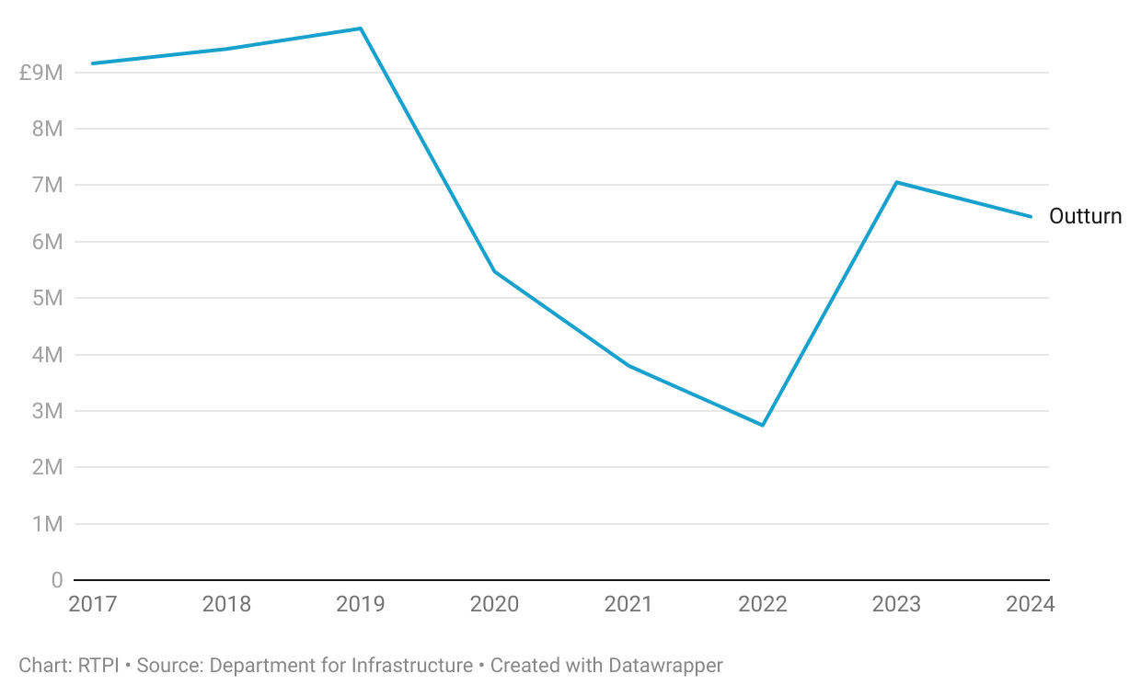
Figure 1. Department for Infrastructure planning and policy spending has decreased compared to 2017.

A 2022 Northern Ireland Audit Office (NIAO) report on planning in Northern Ireland since the 2015 reforms concluded that the planning system was “not working efficiently and was… failing to deliver effectively for the economy, communities or the environment” [1]. The report identified problems with the new model where DfI and councils were expected to work effectively together but were not always able to do so. In addition, funding and staffing issues at the Planning Appeals Commission, whose work includes independently examining draft Local Development Plans, has meant that the LDP process has tended to take longer than the 40 months recommended by DfI [2].
As this shows, and as the NIAO noted, planning performance is often affected by factors beyond the control of planning authorities. For example, planning fees have not risen in line with inflation in recent years, linked to disruption in the Executive. This meant funding had to be diverted from other council areas, which in many cases may not have been enough to cover planning services’ full costs. In a positive development for public sector funding, at the 2025 RTPI NI conference, the Infrastructure Minister announced a consultation on changes to planning fees, meaning this may be set to improve in the coming year.

Figure 2. There has been limited divergence between planning applications received and decided in recent years.
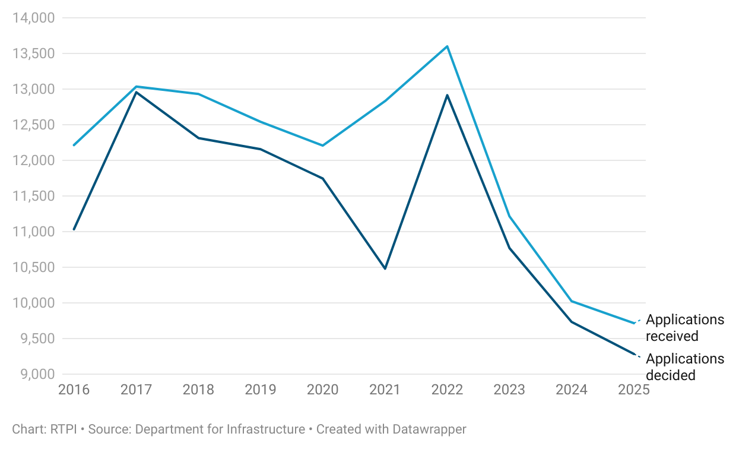

Despite the above, the number of applications decided has not significantly diverged – aside from during the Covid-19 pandemic – from the number of applications received. This suggests that planning teams are managing demand on this front, though this could be partly due to the steadily declining number of applications received since 2023.
Moreover, some of the indicators assessed by DfI against statutory targets to track planning performance across Northern Ireland have improved. The average decision time for major developments has dropped since 2016, however, is still higher than the 30-week target, which has not been hit at a national level since planning was devolved.
Figure 3. Average time taken for decisions in weeks is showing improvement.
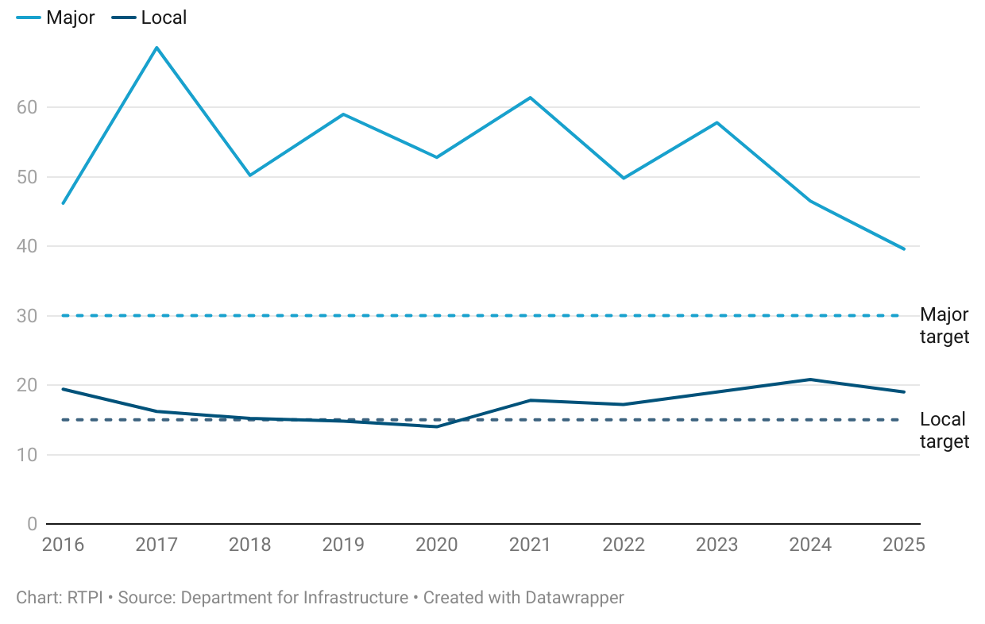

Decision times for local development, though showing an improvement since 2024, have risen in recent years. The target decision time of 15 weeks has not been hit nationally since 2020. That said, in the case of both major and local developments, multiple individual councils have shown sustained average decision times at, or below target.
On the other hand, the percentage of enforcement cases concluded within 39 weeks has shown a decrease. This is despite the number of planning enforcement cases opened in FYE 2025 being 30% lower than in 2016. While resourcing of enforcement teams is likely a factor in this, so too is the complexity of enforcement cases.
Figure 4. Enforcement timelines have increased, despite lower caseload.
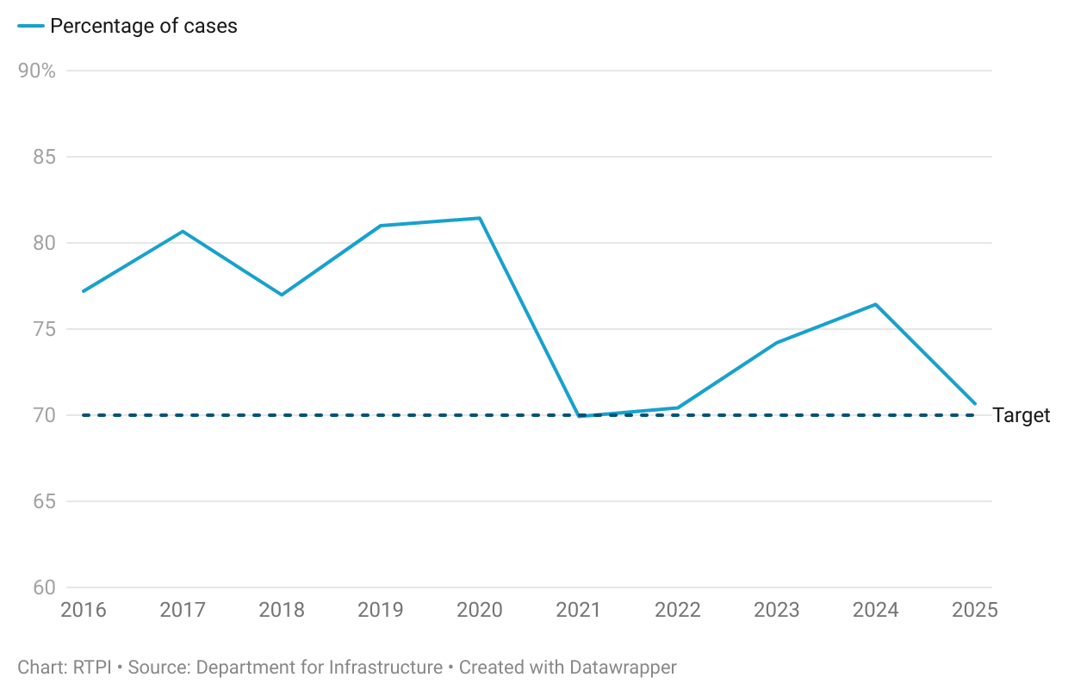

While the Northern Ireland average is above the statutory target of 70% (just about; at 70.7% in FYE 2025), there is still a way to go to consistently reach pre-covid levels of enforcement performance.

Planning authorities in 2025
This section will outline findings from Northern Irish planning authorities concerning resourcing and skills gaps, and ways of working. There were three responses to the survey from planning authorities in Northern Ireland, therefore due to low response, caution is advised when drawing conclusions from these results.

Resourcing and skills gaps
The three planning authorities that responded to the LPA survey all reported their planning teams consisting of between 35 to 40 staff and having fewer than three vacancies. These vacancies tended to be in the mid or senior levels, between planning officer and principal planning officer positions.
As with planning authorities in other UK nations, Northern Ireland’s planning authority respondents found that senior positions were more difficult to recruit for. This was something reflected in members’ responses when asked what they thought would be the greatest challenge for Northern Ireland’s planning system in the coming year. Nearly a third (32.8%) mentioned staffing and recruitment, in particular, “retaining experienced staff in the public sector” with constrained resources. This is explored in the member survey section, below.
Figure 5. Senior roles were more difficult to recruit for.
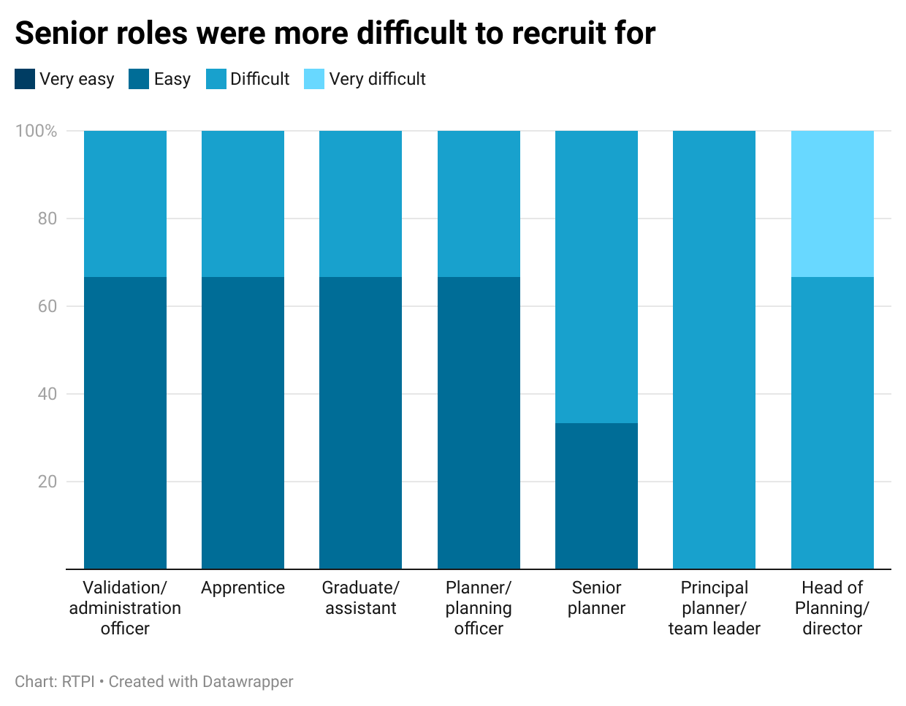

For recruitment within specific areas of planning, enforcement, strategic planning, and environment, ecology or biodiversity were all areas reported by a single planning authority as difficult to recruit in. Planning policy was the only area chosen by two of the three planning authority respondents. All authorities reported using agency or consultant staff, while one reported sharing staff.
The reputation of working in the public sector was the most reported barrier to filling vacancies, chosen by two authorities. This differs from planning authorities in Scotland and England, who generally did not identify reputation as a barrier to recruitment. The third authority identified a lack of qualified or experienced applicants as their primary barrier to recruitment, which was a reason commonly chosen by authorities in other nations.

Demographics
Due to low levels of response, the reported age, gender and ethnicity profiles of Northern Irish planning authorities cannot be published. Information on overall respondent demographics are provided in the member survey data section, below.

Ways of working
Two respondent authorities had a Chief Planning Officer (CPO), while the third did not. CPOs are not a statutory requirement in Northern Ireland’s councils, as they are in Scotland, and as the RTPI is advocating for in England. CPOs are an important interface between planning teams and elected representatives and are well placed to provide impartial advice to those representatives, building the relationships necessary for smooth local decision-making.
All respondent authorities reported that their development management function sat within the same directorate as both their enforcement and planning policy functions. This is positive, as a close working relationship between policy teams and those acting on policies allows more streamlined and informed decision making. Proximity to planning colleagues on the front line of development management and enforcement can result in more practical planning policy at a local level. Moreover, once LDPs are adopted this can make it easier for planners in development management to access help with policy interpretation and application.
Other services that sat in the same directorate as respondents’ planning services included economic development (in 100%), building standards (67%), and environment/ecology, tourism, and capital development (each 33%). Respondents were all unsure about, or did not have plans to use emerging digital planning technology or AI in the coming years.

Planners in 2025
This section will outline findings from the survey of members of the RTPI working in Northern Ireland. Topics addressed included career stage and plans, resourcing and skills gaps, wellbeing, working and volunteering practices, and the geography and demographics of respondents. The member survey had 61 respondents who reported working primarily in Northern Ireland.

Career stage and plans

Area of planning
Most respondents working in Northern Ireland were in the public sector, namely local government (37.7%), arm’s length independent bodies, or the devolved government (both 13.1%). After local government, the private sector was the second largest at 26.2%.
Figure 6. Most respondents worked in local government or the private sector.
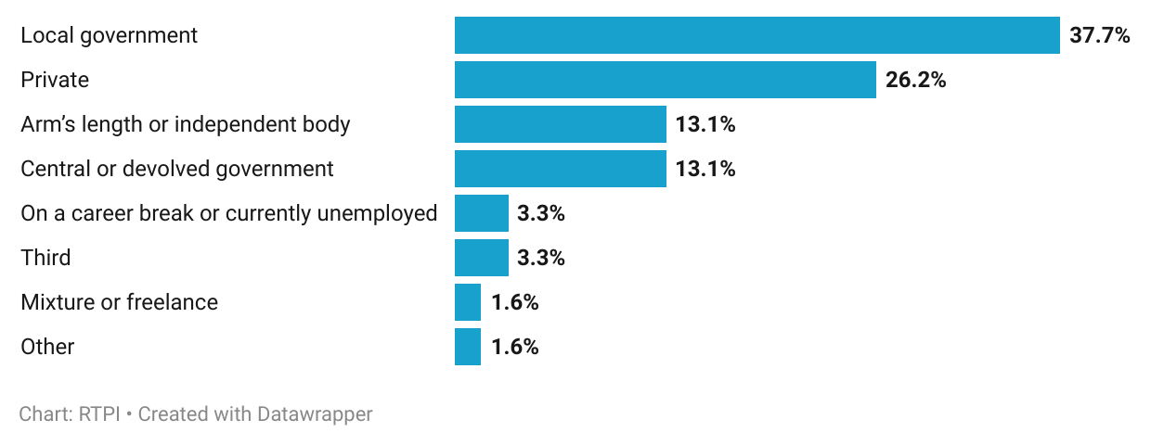

Development management and planning policy were the most selected individual areas, when respondents were asked which area of planning they worked in, at 21.3% and 13.1%, respectively. A notable proportion (14.8%) worked across all areas of planning, for example, as a head of service, or statutory consultee. Energy or renewables, enforcement, and planning inspections accounted for 8.2% of responses each. Other areas including housing, strategic planning, community engagement, commercial, ecology, marine, minerals and regeneration each accounted for less than 5%.

Career stage
Overall, respondents were experienced, with 63.9% having worked in planning for at least 21 years. That said, the level of planning with the most respondents was senior planning officer (31.2%), which could be considered a mid-career role. The next most common positions among respondents were head of planning (19.7%), followed by planning officer (16.4%).

Figure 7. A high proportion of respondents were experienced planners.
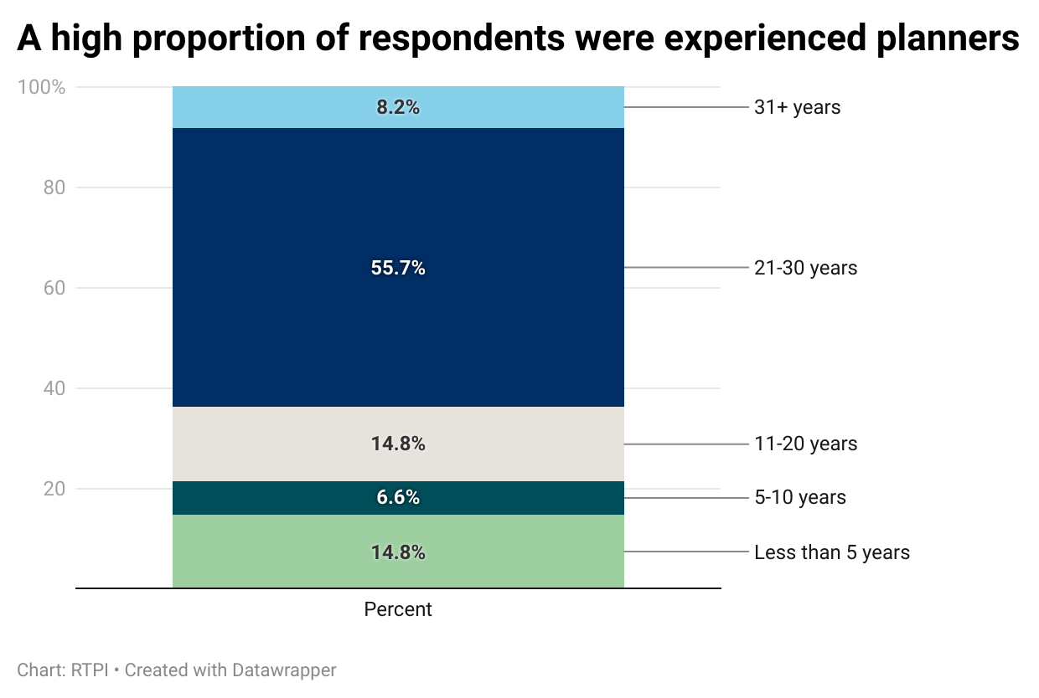

As with other UK nations, the most reported salary band was £40,001 to £50,000, and nearly half of respondents earned between £40,001 to £60,000 (47.5%). There were too few responses to confidently say if salary distributions differed significantly between public and private sectors.
Figure 8. The modal salary band among respondents was £40,001 to £50,000.
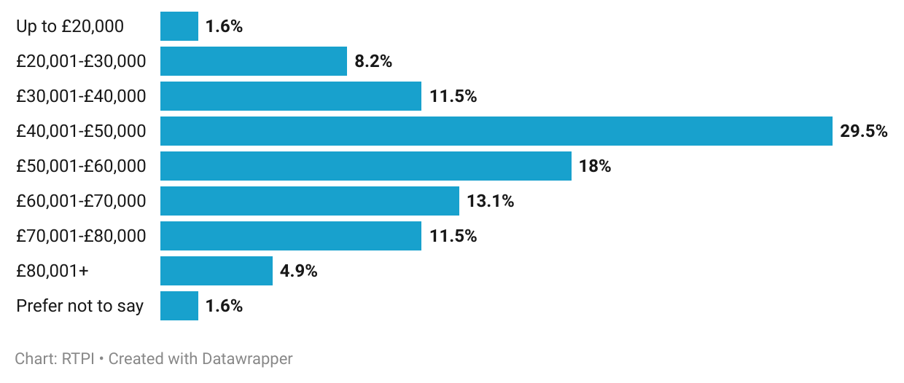

Also in line with other UK nations, respondents working in Northern Ireland were generally satisfied with both their salary and career progression, though more so with progression (figure 9). Just over half were somewhat (42.6%) or very (9.8%) satisfied with their pay, while 36.1% reported being somewhat and 24.6% very satisfied with their progression. There were not enough responses to confidently say if satisfaction differed between levels of seniority.

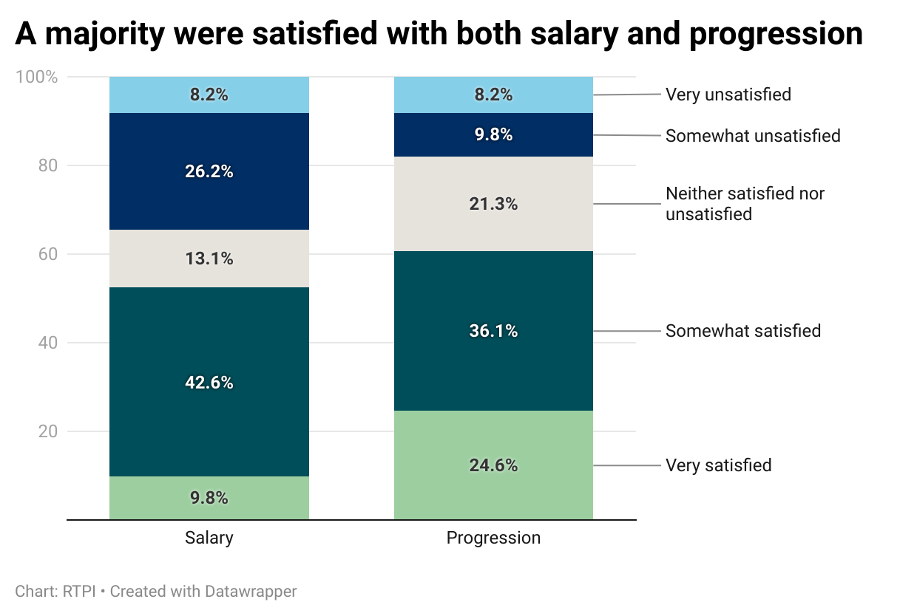
Figure 9. A majority were satisfied with both salary and progression.

Respondents’ future career plans reflected this, with 57.3% intending to stay with their current employer (47.5% in their current role, 9.8% seeking another; figure 10). A further 16.4% wanted to seek opportunities elsewhere in their sector, and 9.8% move to a different profession. To remain in their current role was the top choice among both public and private sector planners (53.9% and 43.8%, respectively), however, the next most chosen differed. Among private sector planners, this was to move to another employer within the private sector (25%), while for public sector planners, it was to move to a different profession (12.8%). Overall, 13.1% planned to leave planning altogether, either through retirement, or to a different profession.
Figure 10. Most respondents intend to stay with their current employer.
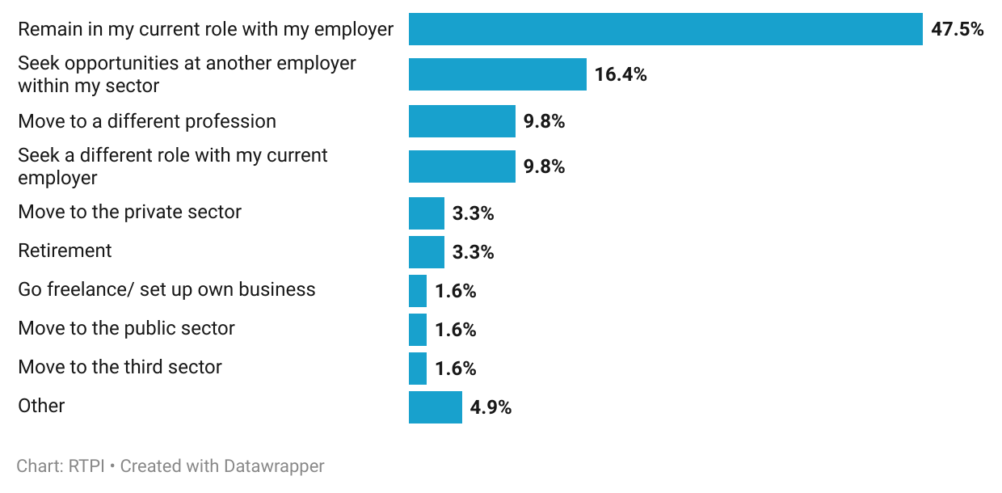

Resourcing and skills gaps

Skills, knowledge and training
Just 4.9% of respondents felt they had no gaps in skills or knowledge relating to various specialist areas of planning (figure 11). The areas in which most reported gaps were similar to those in other UK nations. These included marine planning (59%), digital, data and GIS (55.7%), energy and renewables (50.8%), ecology and biodiversity (45.9%), and infrastructure and utilities (37.7%).
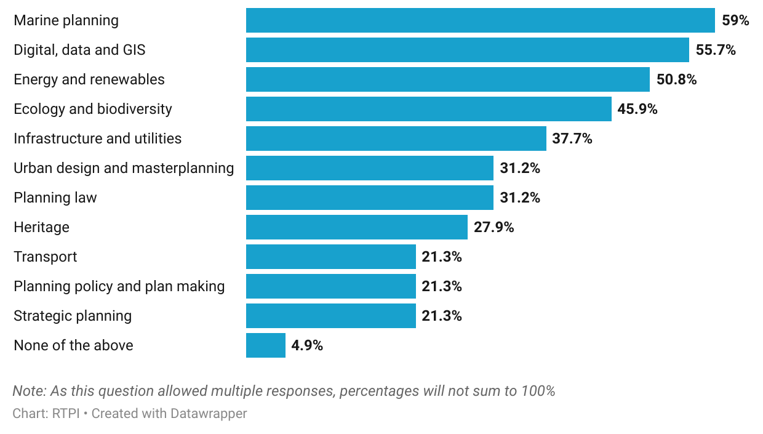
Figure 11. More than half had a skill or knowledge gap in marine, digital and energy planning.

Around a quarter of respondents working in Northern Ireland felt they had a good grasp on generalist skills they may need in their daily work (24.6%; figure 12). However, a fair proportion felt they had gaps around business development (39.3%), project management (31.2%) and negotiation and mediation (27.9%). Just over a fifth (21.3%) felt they had a gap in research skills.
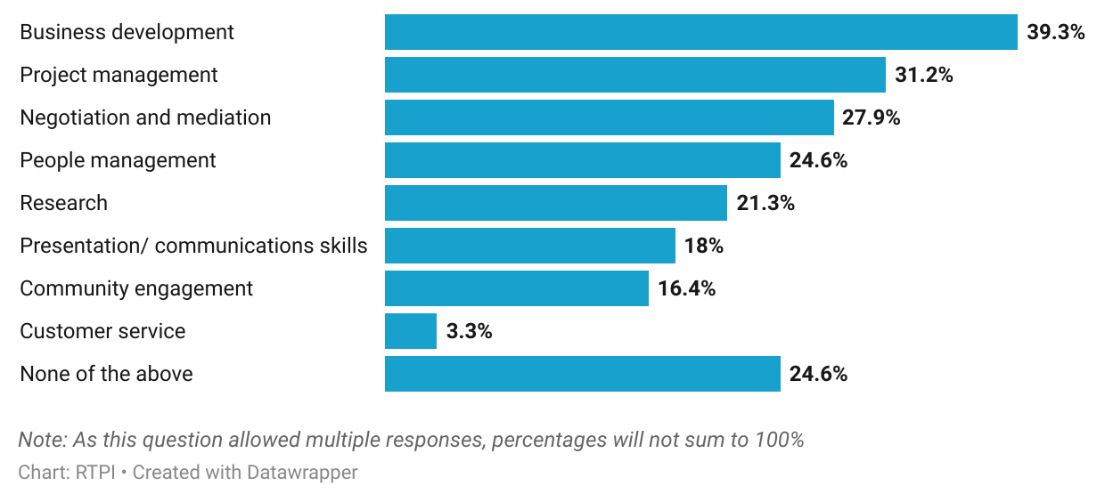
Figure 12. Business development and project management were top reported generalist skill or knowledge gaps.

In contrast to other UK nations, however, and perhaps reflecting the high proportion of respondents reporting knowledge gaps in specialist areas, more planners working in Northern Ireland were unsatisfied than satisfied with the training opportunities they had. Here, 39.3% reported being very or somewhat unsatisfied with training opportunities, while 34.4% were very or somewhat satisfied.

Capacity and challenges
Almost half of respondents said that their teams lacked capacity to meet demand frequently, or all the time (47.5%). As shown in figure 13 below, this was more than twice as likely to be the case for public sector planners than private sector planners (59% and 25%, respectively).
Figure 13. Public sector planning teams were more likely to lack capacity to meet demand.
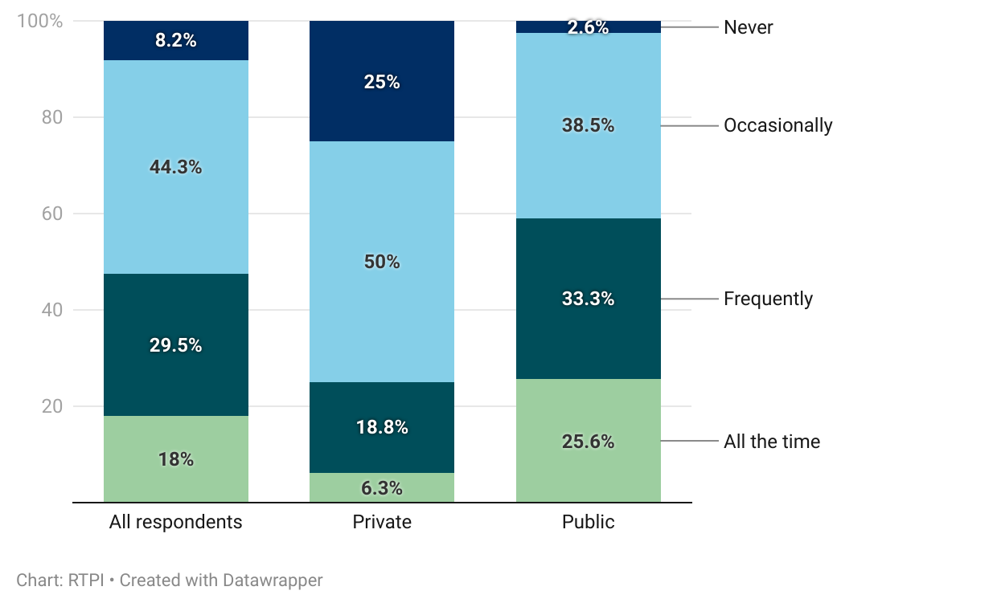

High workloads were the most identified reason for a lack of capacity in planning teams (36.1%; figure 14). The increased complexity of work (23%), external factors (21.3%), and recruitment difficulties (18%) were also highly cited.
Planners working in Northern Ireland were more pessimistic than optimistic about the future direction of their planning system. Just 18% said they were optimistic, while 64% were pessimistic (41% somewhat, 23% very; none were very optimistic). This was the lowest level of reported optimism across the four UK nations.

Figure 14. High workload and increased complexity contributed to capacity issues.
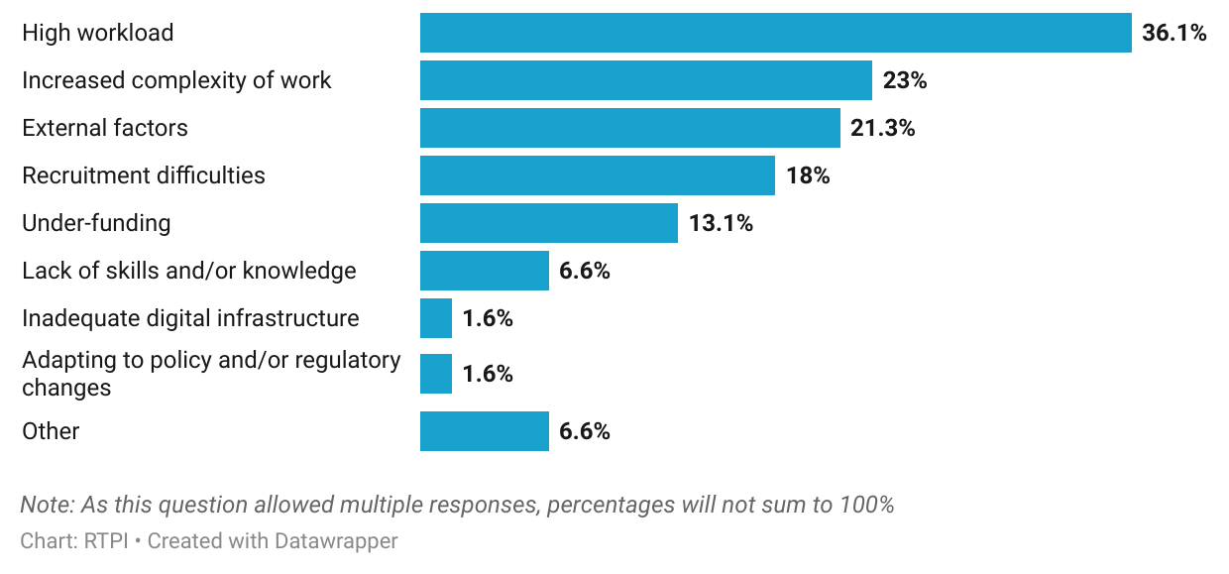

Greatest challenge
When asked what they thought was the greatest challenge faced by the Northern Irish planning sector in the coming year, staffing and recruitment, followed by funding and resourcing were two key themes raised by respondents. Though not all specified, this was often linked particularly to local government. One respondent working in central government cited the difficulty “retaining expertise and skills”, noting that “many are leaving due to poor conditions, lack of career progression opportunities and salaries which are well below those of other related professions”. Wage stagnation was raised by several respondents, linked to difficulty attracting and retaining skilled staff. In their experience, this contributed to issues like low levels of local plan coverage, further uncertainty around, and delays in planning decisions. As seen in the proportion of respondents reporting a lack of capacity in their teams, these issues build up, leading to staff “feeling under-valued”, yet over-worked. Consequent churn and difficulty retaining staff then compound the issue.
Alongside the consequences of challenging public sector budgets, another concern was the increasing complexity of planning work, and how this was not well understood by the public, and stakeholders in the planning process. The “range of considerations planning officers now must assess”, and the difficulty sometimes experienced engaging with consultees in a timely manner leads to increasing delays and uncertainty. As a result, and exacerbated by resourcing issues in the public sector, there was an identified mismatch between applicant expectations and delivery timelines, “leading to an undervaluing of the profession”. It was felt that though planning had a valuable role to play in resolving issues facing Northern Ireland, the UK and the island of Ireland, the profession had been made a “scapegoat for wider problems”. Respondents across sectors thought there had not been enough acknowledgement of these issues, or steps taken to address them by councils and central government.
Further complicating matters are the constraints posed by water infrastructure in Northern Ireland, which numerous respondents mentioned. Significant restrictions on development have been imposed across wide areas due to lack of water and sewerage capacity. In the words of one private sector respondent, these restrictions risk “stalling growth entirely, with projects already being paused or abandoned, and clients diverting their investment to other regions”. Solving this issue and averting loss of confidence due to the resulting development bottleneck will require strong collaboration between councils, consultees, infrastructure providers, the relevant Departments, and the Executive.
With 2025 marking a decade since planning powers were transferred from central to local government in Northern Ireland, responses also highlighted some weaknesses with the system as it developed. One local government planner cited “fragmentation of the planning system with no consistency across the 11 councils”. Others in the public sector highlighted central government’s role in major projects, with one echoing the Audit Office’s report, remarking that “the disjointed two-tier planning system and statutory consultee process does not… work effectively”.
The Infrastructure Minister acknowledged challenges at the 2025 RTPI NI conference, also commenting that the second decade of devolved planning in Northern Ireland offered “a real opportunity to reshape planning to better serve people and places” [3]. These opportunities are real and exciting, however, as outlined by respondents, they need to be backed by proper resourcing to deal with the volume and complexity of planning applications and may not be fully realised until larger infrastructural issues are resolved.

Wellbeing
Despite these challenges, more than half of respondents working in Northern Ireland were happy working in planning. Just 6.6% reported being very, and 23% somewhat unhappy, compared to the 14.8% who said they were very, and 39.3% somewhat happy (with 16.4% neither; figure 15, below).

Figure 15. More than half were happy working in planning.
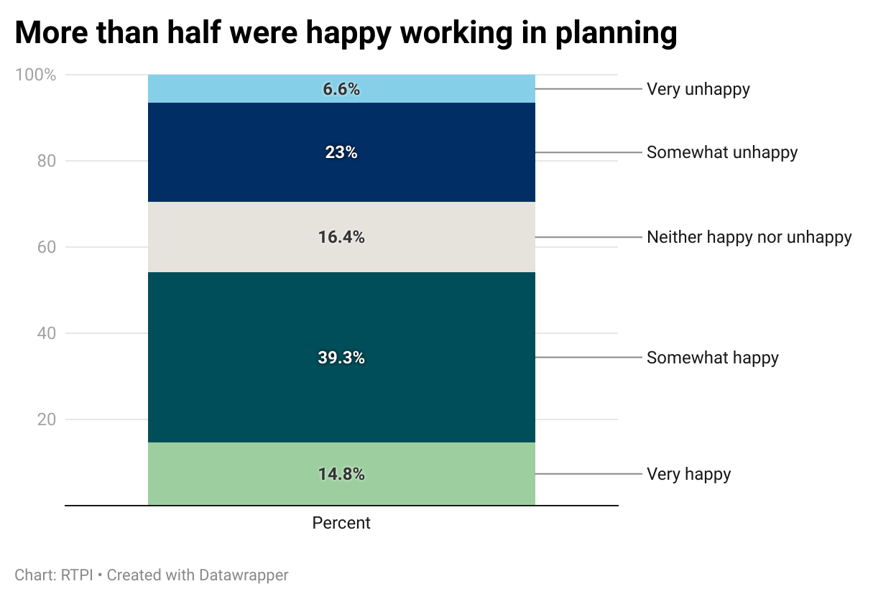

Reported levels of personal overstretch were high, however, as all respondents reported being overstretched at least occasionally. A majority (62.3%) felt overstretched frequently or all the time. This was similar for public and private sector planners and echoes findings from the 2023 Northern Irish Big Conversation research, where 63% were overstretched frequently [4].
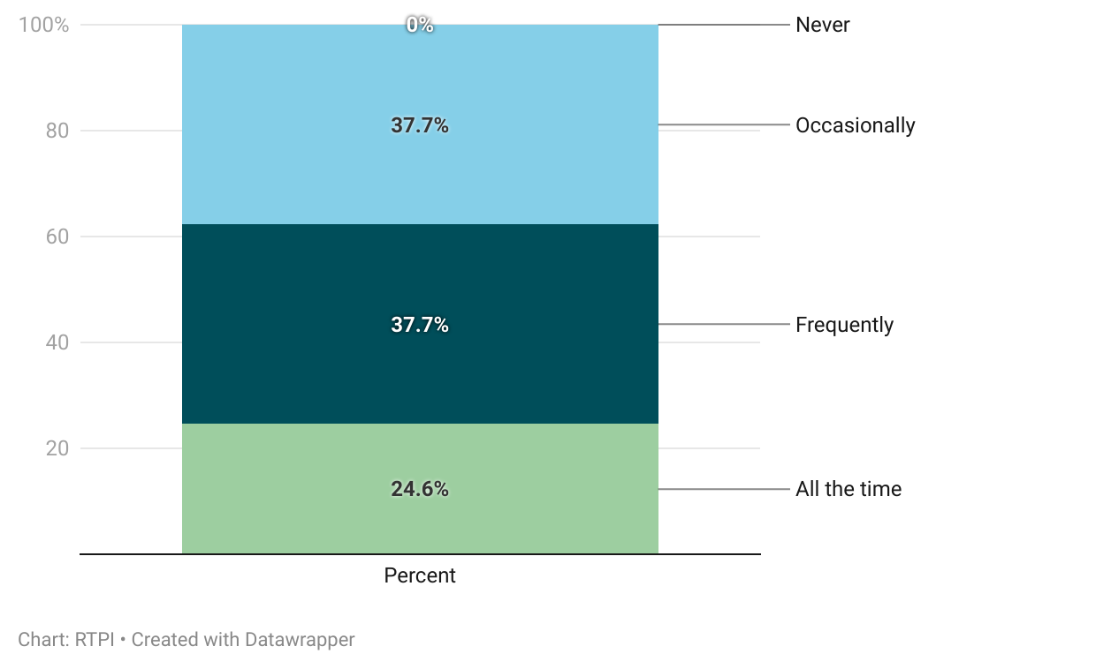
Figure 16. Most respondents felt personally overstretched at least frequently.

Almost all respondents thought that the public had an unfavourable perception of the planning profession (62.3% somewhat, 29.5% very). Northern Ireland is the only UK nation surveyed in which no planners thought the public had a positive perception of the profession. Consequently, a high proportion (59%) also reported that the public perception of the profession impacted them somewhat or very negatively. Compounding this is the proportion who had experienced abuse in their capacity as a planner, with 65.6% having experienced abuse either in person or online. A much higher proportion of public sector planners reported having received abuse than private sector planners (79.5%, compared to 43.8%).
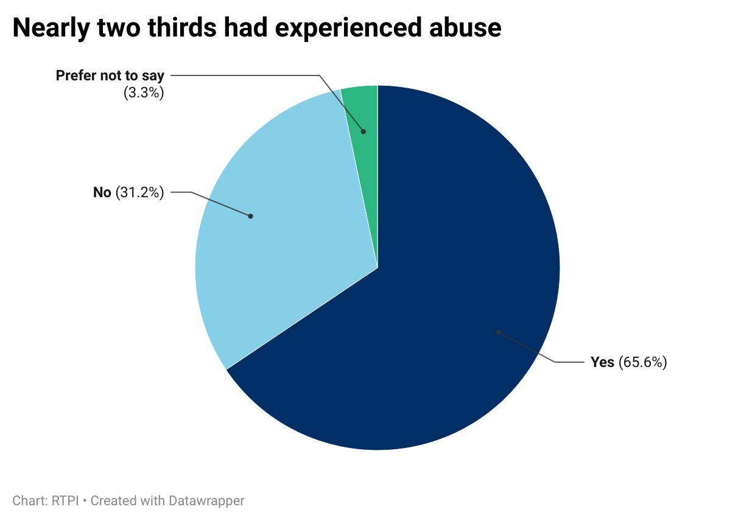
Figure 17. Nearly two thirds had experienced abuse.

Respondents were invited to expand on the issues raised in the wellbeing section. Public consultation events for potentially contentious development were raised by multiple, with one private sector planner commenting that these often felt “like a forum whereby the public can say whatever they like to you”. Accusations of corruption had been experienced by 16.1% of those who chose to expand on their experience, with a local government planner commenting that these were “left unchallenged” by their employer, meaning “the credibility of staff is undermined”. A planner working in central government commented that in addition, “elected representatives are not as supportive as they should be”, with others reporting that they had even contributed to poor treatment of planners, or pressure to override professional judgement.
Some highlighted that unpleasantness had worsened in recent years, potentially related to the COVID-19 pandemic. One remarked that there “has been a noticeable rise in the level of hostility directed towards planning professionals, both in person and online” and that objections were not always rooted “in planning policy or material considerations but instead reflect personal preference or opposition to change”. Verbal abuse or intimidation was mentioned by 22.6%, while physical abuse was fortunately much less common, though still present.
Also apparent throughout responses was that the “complex and demanding” nature of planning work was “frequently misunderstood or underestimated by the public”. It was felt that as a result, there was a mismatch in expectations, contributing to the perceived negative perception of the planning profession by the public. As mentioned above, this was exacerbated by “constraints like resource limitation and lack of experienced officers”, as well as external constraints like water infrastructure.

Working and volunteering practices
Three quarters of respondents working in Northern Ireland worked in a hybrid arrangement, split between the office and home (75.2%). Compared to other UK nations, a higher proportion reported working solely onsite or in office (21.3%), and a lower proportion solely from home (3.3%). Flexi time was the most used flexible working practice among respondents in Northern Ireland, with 49.2% using it. Other practices like compressed hours and a 4-day week were less commonly used (at 6.6% and 4.6% respectively), while 42.6% did not use any flexible working practices.
Figure 18. Use of flexible working practices among respondents working in Northern Ireland.
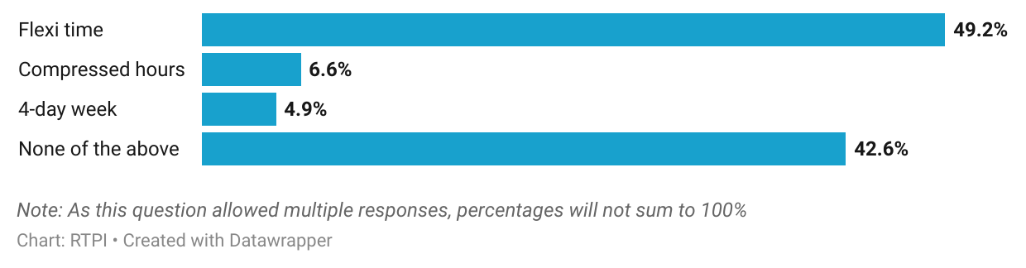

Of the 26.2% of respondents who reported volunteering in their capacity as a planner, 75% were a member of a committee or board, 43.8% undertook educational outreach, and 25% did pro-bono planning work. A further 18.8% had mentored someone, while 12.5% had done work for planning advice service or planning aid.
Given that 29.5% of respondents learned about planning at university, and 8.2% at school, educational outreach is a particularly valuable avenue to help promote planning as a future career choice. After university outreach, word of mouth, through family or friends was the next most reported way that respondents learned about planning as a career (23%), followed by their own research (19.7%).

Who responded

Demographics
The age profile of Northern Irish respondents below shows that middle age groups were the most well represented, with older and younger groups making up much lower proportions. A higher proportion were aged over 45 (57.6%) than under (42.4%).
Figure 19. Age profile of respondents working in Northern Ireland.
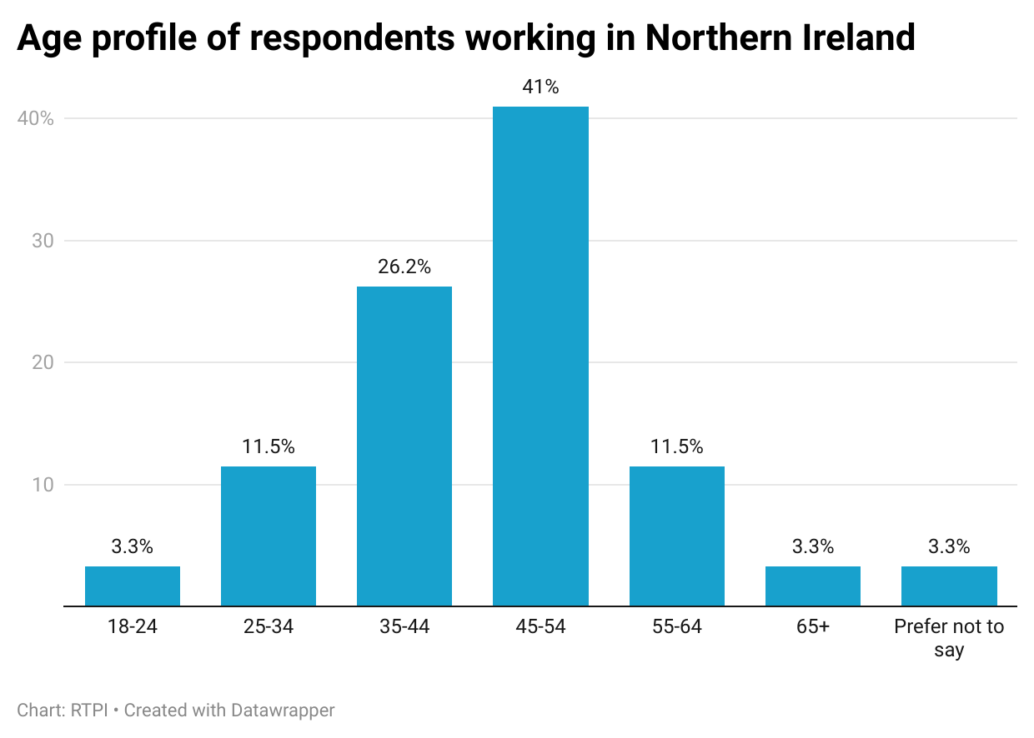

The gender profile of respondents was somewhat skewed, with 60.7% identifying as female, and 36.1% male. Those who preferred not to say accounted for 3.3%.
As the number of respondents from ethnic minority groups was low, detailed breakdowns are not presented here to avoid disclosure. Aggregated, 3.2% of respondents were Black and Minority Ethnic, and 95.1% were White, in line with the 2021 Census [5]. Remaining respondents (1.6%) preferred not to disclose.

Conclusion: what does this mean for the planning profession in Northern Ireland?
A decade on from the devolution of planning, and the Northern Irish planning profession faces its fair share of challenges, but as the minister commented, also significant opportunities to shape a more sustainable and prosperous future.
Perhaps the most acute issue is resourcing, and the compounding effect that years of poor resourcing of public sector planning has had on the whole system. Public sector planners reported capacity issues in their teams due to high workloads and increased complexity of work. Coupled with uncompetitive salaries, it is unsurprising that recruitment of knowledgeable, experienced planners was also an issue. This was not exclusive to the public sector, though; at least a quarter of both private and third sector planners also reported capacity issues. Those respondents’ open responses indicated a few reasons for this, namely increasing complexity, the speed of decision making, and lack of skilled or experienced planning officers.
The low level of optimism among planners working primarily in Northern Ireland compared to other UK nations perhaps reflects this confluence of factors, partly outlined also in critical reports published by the NIAO and Public Accounts Committee in recent years. In addition, water infrastructure constraints are a problem planners must work around and account for, but have little control over, and yet may still be held responsible for impacts on development decisions. Understandably, this breeds frustration, not just for planners, but among the public, applicants, and occasionally, elected members. Contributing to this, respondents thought, was a broader lack of understanding about the purpose of planning; its remit, and increasingly, the level of complexity involved in decisions. Strengthening communication between planners, elected members and the public could go a long way toward addressing this. In particular, there is a role to play for elected representatives in this, and in toning down the rhetoric on planning – something that the RTPI’s Politicians in Planning work programme aims to facilitate.
Looking ahead, planners will be central to meeting Northern Ireland’s policy ambitions around housing, net-zero, and sustainable economic growth. Ensuring they are equipped to do so means investing in planning departments, clarifying policy guidance, and supporting skills development. The upcoming consultation on planning fee changes is one opportunity to help better fund planning services, while the growing emphasis on areas such as digital planning, renewables, and marine planning presents a valuable opportunity to upskill the workforce and attract new talent to the profession. The RTPI will continue to ensure that its CPD offering reflects the reported skills needs.
Despite the pressures addressed in this report, most respondents remain proud to work in planning. This reflects that planning is an engaging and rewarding profession to work in; one that shapes where people live, work, and connect. The challenges are real, but so too are the opportunities. It is crucial that Northern Ireland’s planners are empowered to seize these and to secure positive place-based outcomes for generations to come.

Appendices

Appendix A – Methodology
The data in this report were collected using a survey of working RTPI members, and senior Local Planning Authority officials in Northern Ireland. The RTPI commissioned Research by Design, a market research firm to conduct the two surveys in parallel. Research by Design provided final survey data to the RTPI anonymised, to maintain respondents’ confidentiality.
Survey questions were designed in part to give similar or related outputs to the key outputs from the 2023 State of the Profession report, as well as to provide a baseline for future State of the Profession survey reports. The 2023 State of the Profession report used Office for National Statistics (ONS) Labour Force Survey (LFS) data, but due to a combination of occupation recoding by ONS, and low survey response rates for the LFS, the RTPI decided to design its own surveys to investigate the State of the Profession.
Members
The member’s survey ran for a month over summer 2025. The survey was sent to 22,382 members, and received 2,808 responses, which equates to a 12.5% response rate.
There were 61 responses from members working primarily in Northern Ireland, 2.2% of the overall response. As we wanted to survey working planners with current experience of the planning system, retired members and full-time students were screened out.
For country reports, survey responses were filtered on a question asking “Which RTPI nation is the majority of your planning work for?” and only responses related to the relevant country analysed. Where relevant, responses were broken down by the broad sector that respondents reported working in (public, private, third, other), their level of seniority, or their gender.
Members were asked questions about their career stage and career plans, personal skills gaps, resourcing in their workplace, working and volunteering practices, about their personal wellbeing, and demographics. Survey results represent a snapshot in time, and the survey was self-selecting, meaning responses may not be representative of the wider population.
Local Planning Authorities
The LPA survey ran parallel to the members’ survey in Summer 2025. We decided to keep this survey open slightly longer than initially planned to improve the response. Despite this, we received a low response from Northern Irish planning authorities. Due to this, and the low number of LPAs in Northern Ireland, we advise caution when generalising findings.
The Northern Irish planning authority survey received 3 responses out of 11 authorities, amounting to an 27.3% response rate.
LPA respondents were asked about the current size and number of vacancies in their authority, as well as the number of vacancies and how much difficulty they have recruiting at each level of seniority. Respondents were also asked to report the specialist areas they had most difficulty recruiting for, barriers to recruitment, and the structure, working practices and demographic makeup of their planning authority.

Appendix B – Data sources
Figure 1: Department for Infrastructure Annual Report and Accounts
https://www.infrastructure-ni.gov.uk/search?query=DfI+Annual+Report+and+Accounts
Spending numbers were taken from the ‘Planning and policy’ expenditure line, usually in table SOAS 1. These were adjusted for inflation using the UK GDP deflator, below.
UK GDP deflator
https://www.gov.uk/government/collections/gdp-deflators-at-market-prices-and-money-gdp
Revenue Outturn figures in figures 1, 2 and 3 were adjusted for inflation as measured with the GDP deflator, rather than the headline Consumer Price Index or CPI. The GDP deflator measures base inflation in the economy, while CPI focuses on prices of consumer goods.

Figures 2 to 4: Department for Infrastructure planning activity statistics
https://www.infrastructure-ni.gov.uk/articles/planning-activity-statistics
Applications received and decided – Table 1_1
Time taken to issue decisions – Tables 3_2 and 4_2
Enforcement cases concluded within 39 weeks – Table 6_2

Appendix C – References
[1] https://www.niauditoffice.gov.uk/files/niauditoffice/documents/2023-12/NI Audit Office report - Local Government Auditor 2023.pdf
[2] https://www.turley.co.uk/comment/ten-years-local-development-plans-northern-ireland
[3] https://www.infrastructure-ni.gov.uk/news/minister-kimmins-marks-decade-local-planning-transformation
[4] https://www.rtpi.org.uk/find-my-rtpi/rtpi-nations/rtpi-northern-ireland/latest-updates/the-big-conversation-ni/
[5] Table MS-B01: https://build.nisra.gov.uk/en/custom/data?d=PEOPLE&v=DZ21&v=ETHNIC_GROUP_INTERMEDIATE

Contact information
For feedback or queries, contact analysis@rtpi.org.uk

