State of the Profession: International factsheet

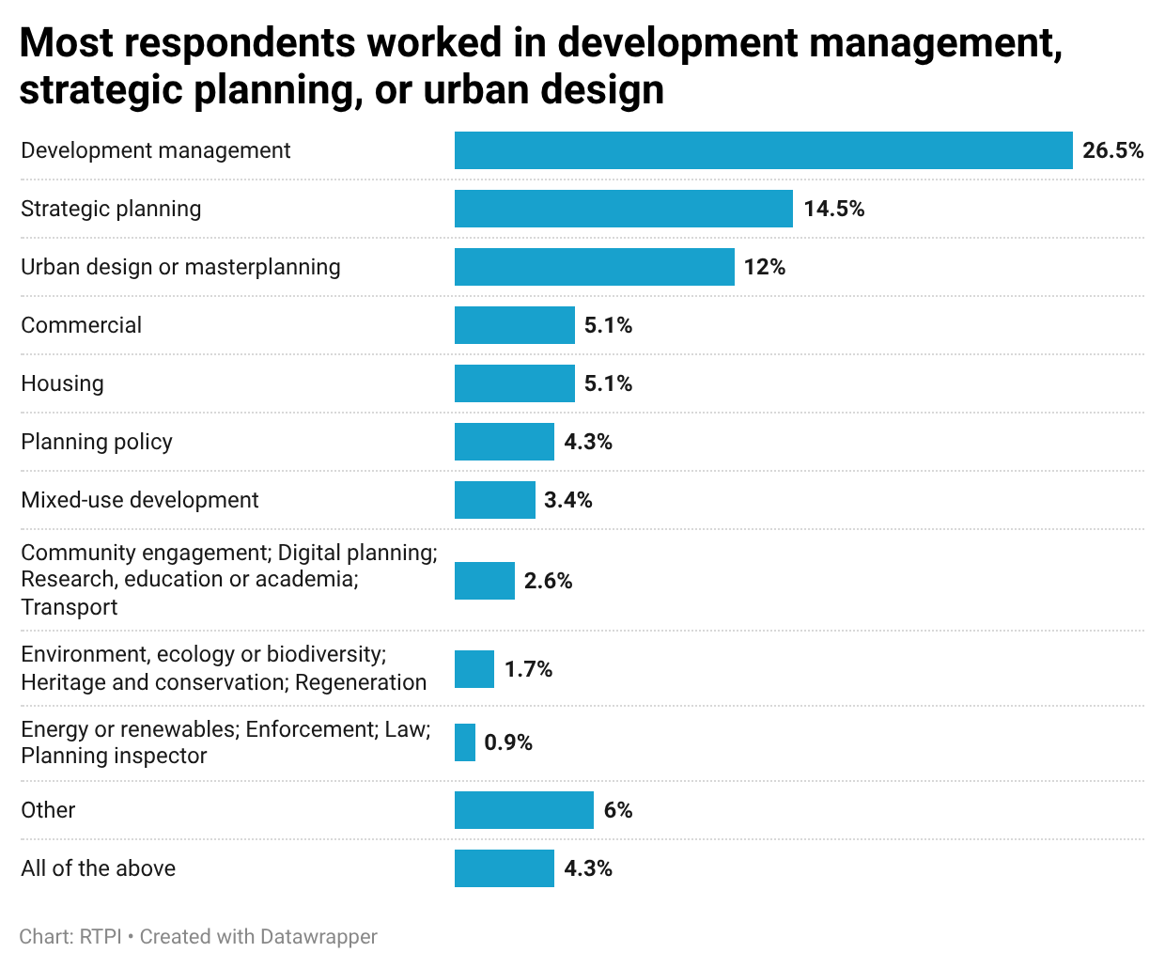
Career
As in the four UK nations, the highest proportion of international respondents to our State of the Profession members’ survey reported working in development management, at 26.5%. This was followed by strategic planning (14.5%), urban design or master planning (12%), commercial, and housing (both 5.1%). The remaining individual areas of planning were selected by less than 5% of respondents, while 6% specified ‘other’. ‘Other’ areas
specified included infrastructure, education, digital technology, and a mixture of multiple areas.
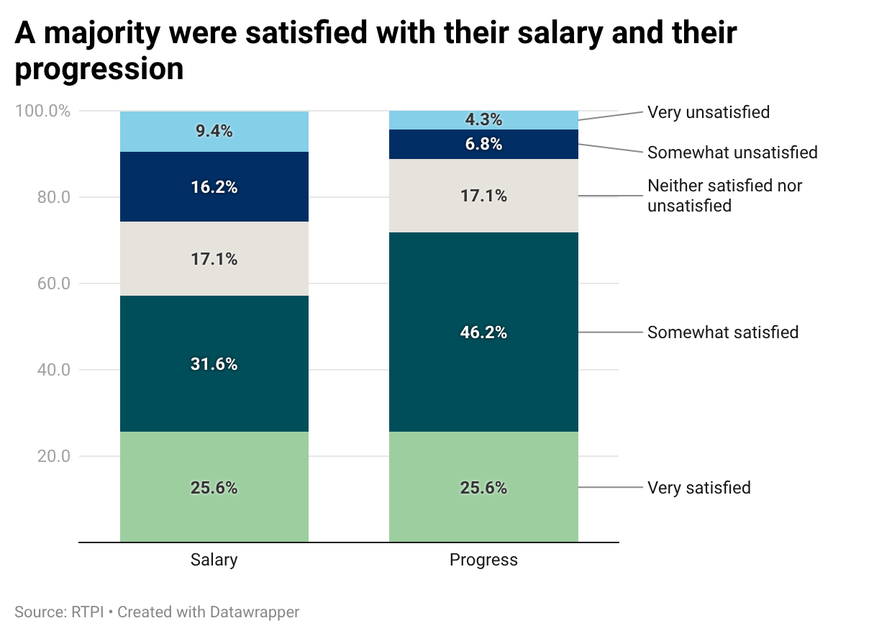
The highest proportion of respondents held 31 or more years of experience in planning (29.1%), followed by 5-10 years (21.5%). Just under half of respondents (49.6%) had 21 or more years of experience. A majority were somewhat or very satisfied with their salary (57.2%) and progression (71.8%).

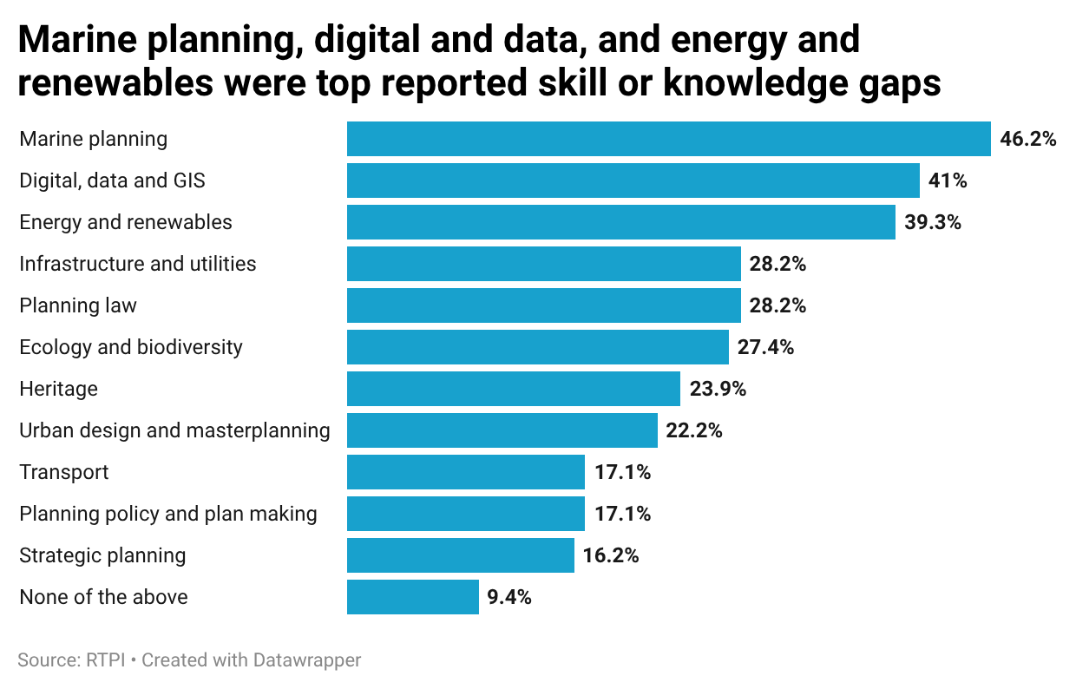
Skills & training
When asked if they felt they had a skill or knowledge gap in any generic, or planning specific areas, the highest reported generic skills gap was business development (39.3%), followed by negotiation and mediation, and people management (30.8%; 23.1%). Around a fifth of respondents (20.5%) said they had a skill gap in project management, community engagement, or research.
In planning specific areas, the most reported gaps were in marine planning (46.2%), digital, data and GIS (41%), and energy and renewables (39.3%). Both infrastructure and utilities and planning law were reported as skill or knowledge gaps by 28.2%. Just under half of respondents (47.9%) were somewhat or very satisfied with their training opportunities (compared to 31.6% somewhat or very unsatisfied).

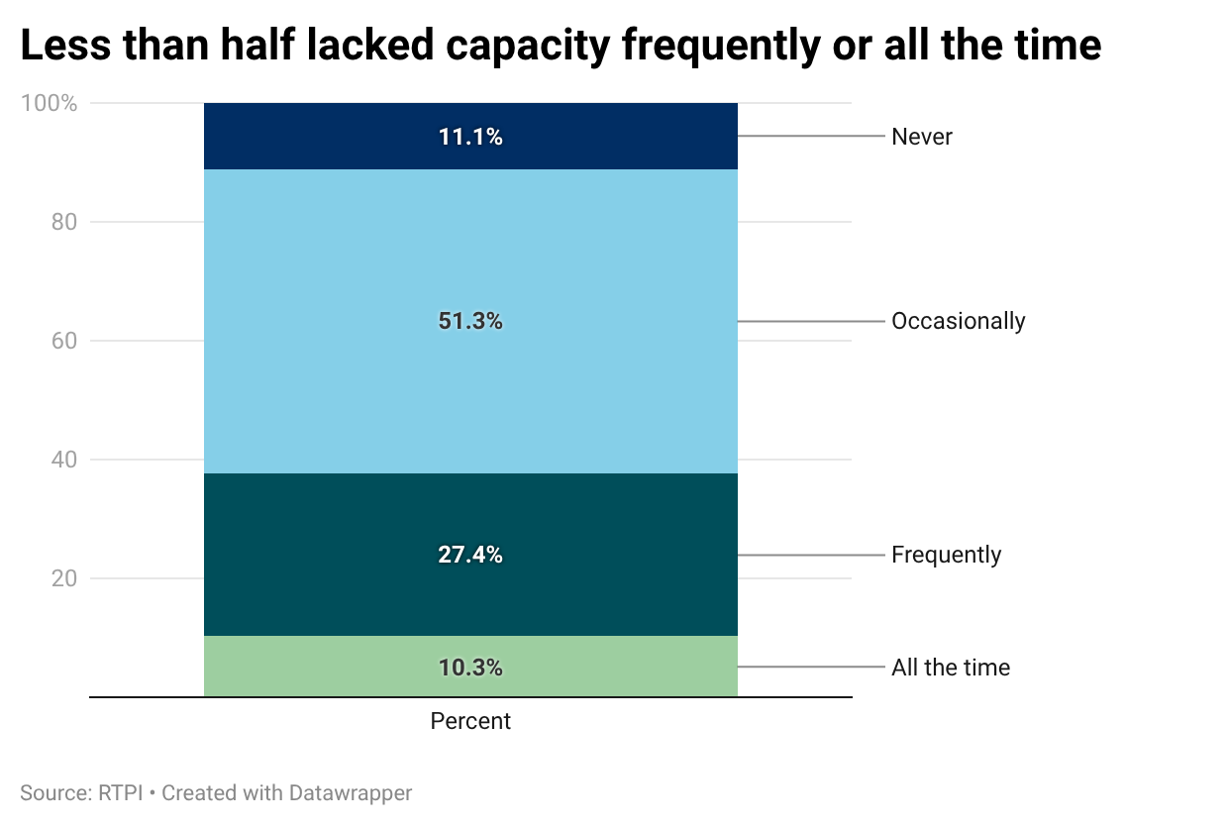
Wellbeing
A marginally higher proportion of respondents were somewhat or very pessimistic (39.3%) about the future direction of their planning system than were optimistic (36.8%). When asked how often their team lacked capacity to meet demand, just over half said they lacked capacity occasionally (51.3%), while 37.7% reported lacking capacity frequently, or all the time. A slightly higher proportion (42.8%) reported feeling personally overstretched frequently or all the time.
The most reported reason for lacking capacity was high workloads (19.7%), followed by increased complexity (17.1%), and recruitment difficulties (11.1%).
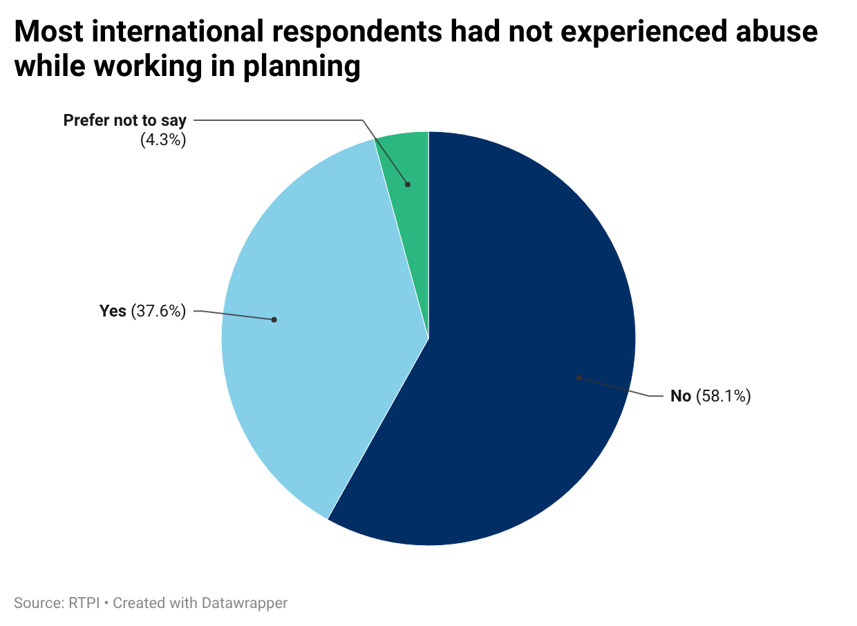
Among international member respondents, 37.6% reported having experienced abuse while working as a planner. This is notably lower than the 65% to 71% of members in UK nations who had experienced abuse. Around half (48.8%) of international respondents thought that the public had an unfavourable view of the planning profession. This was almost double the percentage who thought the public’s perception of the planning profession was positive (24.8%). The reported effect of public perception on the wellbeing of respondents was relatively evenly split between a negative effect (32.5%), positive effect (34.2%), and no effect (33.3%).
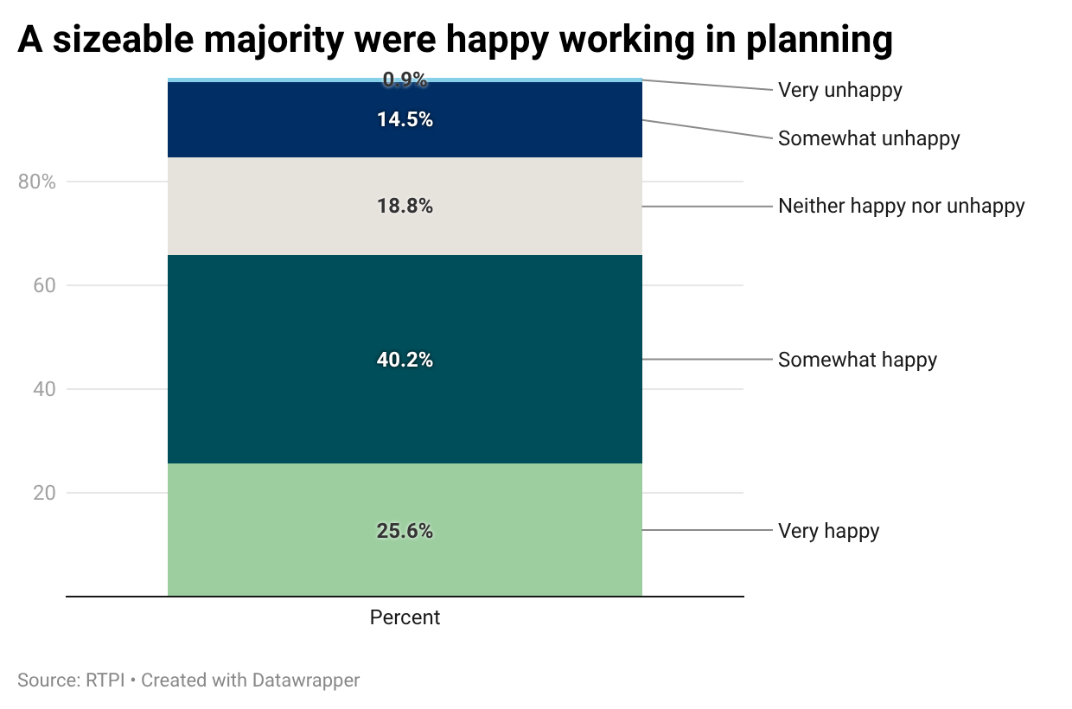
Despite a significant minority reporting a lack of capacity, personal overstretch and a more negative than positive public perception of the profession, a sizeable majority of 65.8% of international respondents were happy working in planning.

Greatest challenges
While there is a limit to how much can be generalised across international respondents, when asked what they thought was the greatest challenge facing the planning profession, there were some overarching themes. One of the primary concerns was climate change. In the words of a planner working in East Asia and the Pacific, the greatest challenge will be “delivering more inclusive, climate-resilient and affordable development in the face of rapid urban change” while “balancing growth pressures with social equity, sustainability, and the need for stronger public trust in planning processes.” The level of public trust in the planning profession was thought important to help address the climate crisis, housing, and other issues. A local government planner in the Americas contended that “the profession is important in building communities (and housing)” and could be part of the solution, but “we're not doing that right now… leading us to become punching bags.”
International respondents were also grappling with the changing role of a planner. One strategic planner noted the increasing proportion of time taken for responsibilities such as “facilitating stakeholders and users to be engaged more in the planning process”. The place of innovation in planning was another area of challenge highlighted, balancing the use of new planning tech innovations like AI to improve placemaking with maintaining skills and engagement. A respondent in the Americas was concerned that the use of AI in planning needed “to be carefully monitored” so “critical thinking around land use and policy planning is not undermined”. In addition, privacy and data governance concerns meant they thought that “clear guidelines need to be established and use cases properly evaluated” for the use of AI in planning. Another respondent in the Americas was concerned about the potentially detrimental impact AI could have on how well graduate planners were able to apply research and analysis skills after graduating.
Economic downturns and market health were raised by several respondents, who feared that more difficult economic conditions could hinder progress in addressing housing and climate needs. The potential impact of such economic conditions on staffing was a concern across sectors, with private sector respondents concerned about lay-offs, and public sector respondents about the general level of staffing and impacts on services if funding were to be squeezed (further). Legislative uncertainty also featured, with the challenge of understanding legislative change and “assimilating planning reform” into daily practice noted.
Among other challenges cited by international members were local politics affecting planning, an underfunded public sector, the capacity of planners, the uncertainty of reform and its effects on building, planners and investors, and public perception of the profession.

Who responded

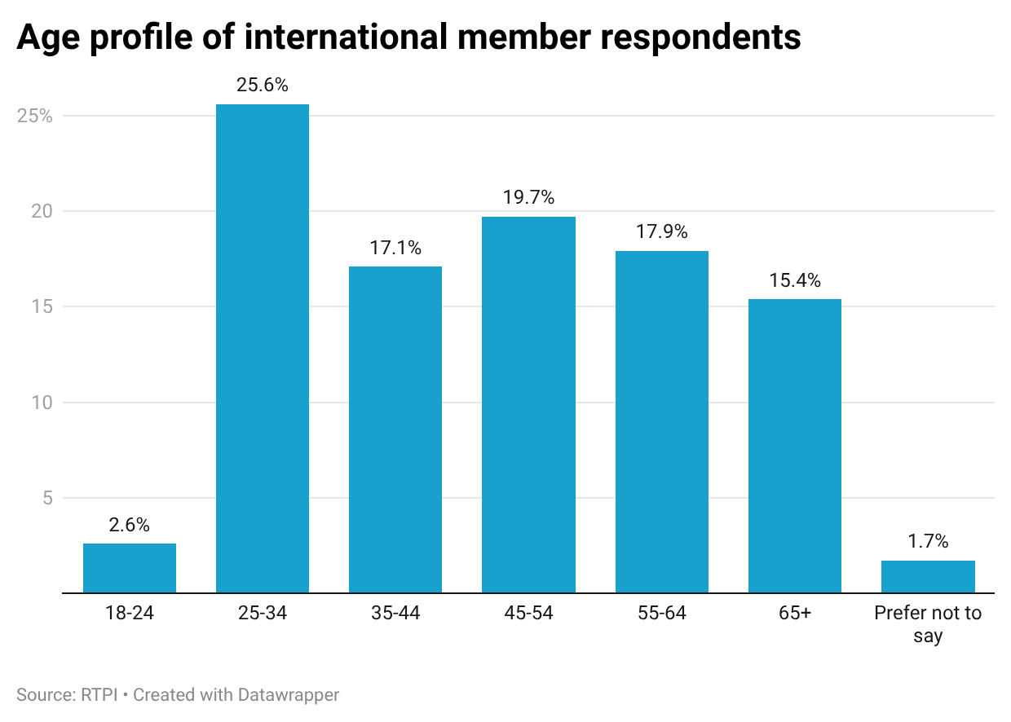
Demographics
The gender profile of international respondents was skewed noticeably male (64.1%), while 32.5% identified as female, and 3.4% preferred not to disclose. Over a quarter of international respondents reported their age as between 25 and 34 (25.6%) and approaching a fifth were aged between 35 to 44, 45 to 54 and 55 to 64.

Geography
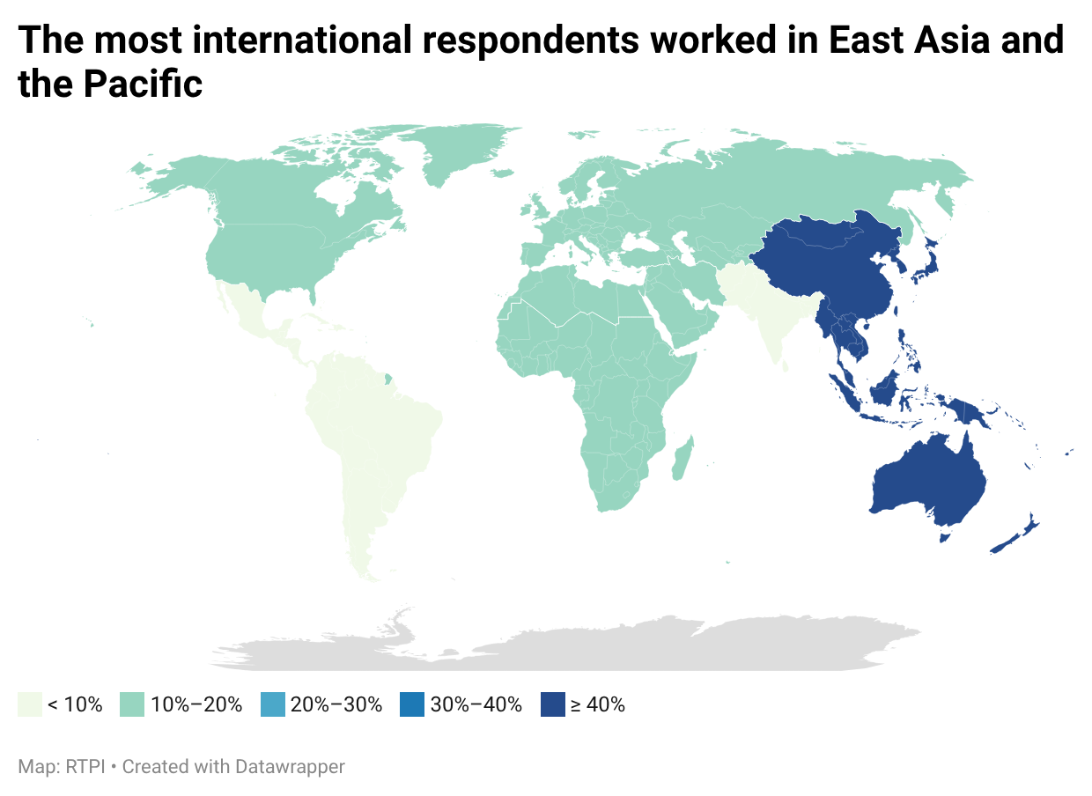
Of international respondents to the State of the Profession member survey, the highest proportion (42.7%) worked in the East Asia and Pacific region. Most of these respondents reported Hong Kong, Australia or New Zealand as their home country. The next best represented global regions among international respondents were the Middle east and North Africa (13.7%), Sub-Saharan Africa (12.8%), Europe and Central Asia (11.1%), and North America (10.3%). South Asia (5.1%) and Latin America and the Caribbean (4.3%) accounted for the smallest proportions of respondents.
Of international respondents, 47% worked in the private sector, while 38.5% worked in the public sector. Those who selected ‘other’ sectors (a mixture, freelance, on a career break, currently unemployed, or other) accounted for 13.7% of respondents, while the remainder worked in the third sector.
