Introduction 2
Background and Welsh planning context 2
This report 2
Planning funding 3
Planning performance 4
Planning authorities in 2025 5
Resourcing and skills gaps 5
Skills gaps 5
Additional duties 7
Resourcing 8
Demographics 9
Ways of working 10
Planners in 2025 10
Career stage and plans 10
Area of planning 10
Career stage 11
Resourcing and skills gaps 13
Skills, knowledge and training 13
Capacity and challenges 15
Greatest challenges 16
Wellbeing 18
Working and volunteering practices 20
Who responded 21
Demographics 21
Conclusion: what does this mean for the Welsh planning profession? 23
Appendices 26
Appendix A – Methodology 26
Appendix B – Data sources 27
Appendix C – References 28

Introduction

Background and Welsh planning context
Multiple significant pieces of legislation have been introduced in Wales in recent years that will have a direct or indirect impact on planning practice, including the Infrastructure Act 2024, the Environment (Principles Governance and Biodiversity Targets) Bill, and most recently, the Planning (Wales) bill. As a result, the Welsh planning system is preparing for a period of transition.
Though the Planning (Wales) Bill does not add to or amend current laws, it does consolidate and modernise them, removing obsolete provisions and references, and providing them bilingually in Welsh and English. Meanwhile, the infrastructure act is intended to streamline infrastructure consenting processes, reducing duplication between the local and national level, while the Environment Bill embeds stronger ecological and biodiversity principles, in line with Wales’s net-zero commitments. In combination, these policies are designed to improve quality and support delivery while safeguarding the environment and communities.
However, the period ahead will not be without challenge. The consolidation bill should simplify access to planning law in the long term but in the short term, may require users to familiarise themselves with a new legislative structure and terminology. This coincides with existing pressure on resources, recruitment and workloads across Welsh planning teams. Effective implementation will depend on sufficient investment in training, systems, and specialist expertise.
Despite existing challenges, recent and upcoming changes in legislation are an opportunity to create a more coherent, forward-looking planning framework that supports efficient delivery, strengthens environmental stewardship, and provides greater clarity for practitioners, developers, and communities alike. If matched with the necessary resourcing and professional support, the coming years could mark a decisive step toward a more integrated and resilient Welsh planning system.

This report
With the Welsh planning system navigating this legislative change, this report will assess the ‘State of the Profession’ in 2025. Using a survey of Welsh Planning Authorities carried out by RTPI Cymru, and of working members of the RTPI, it will give an insight into the resourcing, recruitment and skills needs of LPAs, and the career experiences, career plans, wellbeing and demographics of member respondents.

Planning funding
Spending on planning (taken as development management and planning policy) within Local Authorities in Wales has decreased significantly over the course of the last 15 years. Adjusted for inflation, gross expenditure on planning in financial year ending (FYE) 2025 was 34.3% less than it was in FYE 2010.
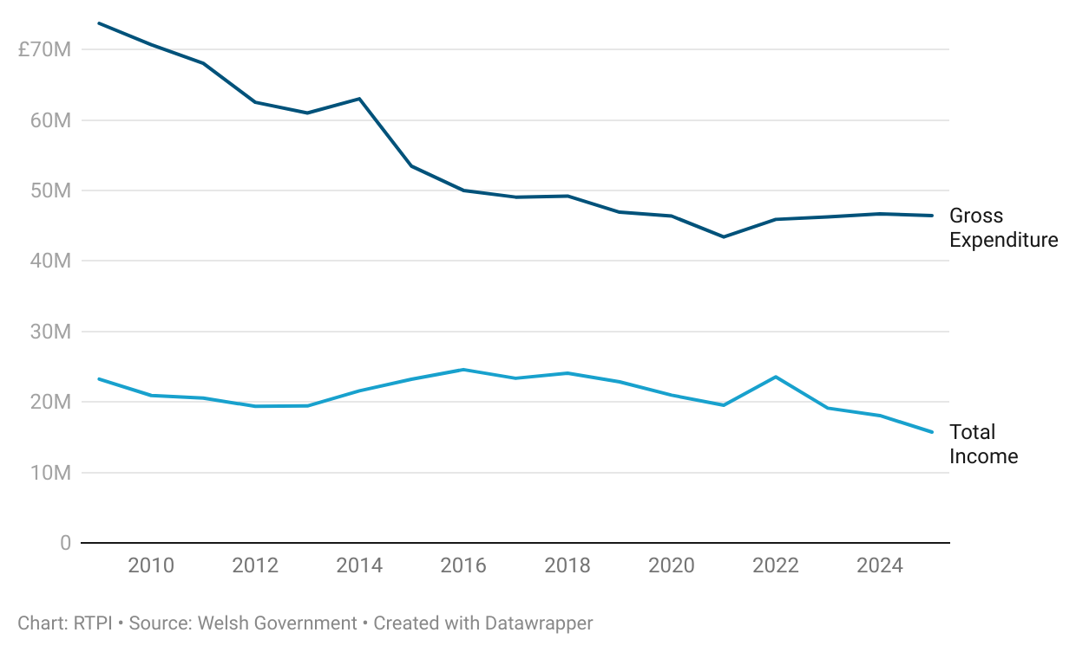
Figure 1. Planning spending in Wales has decreased significantly over time.

Cuts did not affect planning functions equally. While both development management and planning policy saw cuts in gross expenditure, planning policy fared slightly worse between 2010 and 2025. Gross expenditure in FYE 2025 35.3% less than in 2010, while spending on development management in 2025 was 33.8% less than 2010.
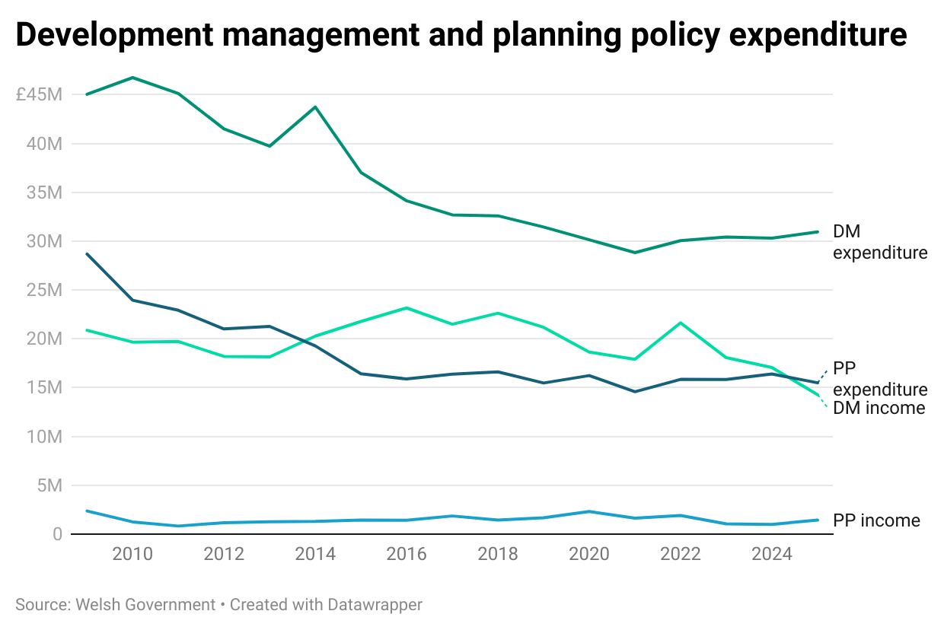
Figure 2. Development management and planning policy expenditure.

Planning performance
Statistics from the Welsh Government’s Development Management Quarterly Survey reflect these spending figures. Major applications took on average 275 days to determine in the financial year ending (FYE) 2025, noticeably higher than the 235 it took in 2017, which was the first full financial year of data.
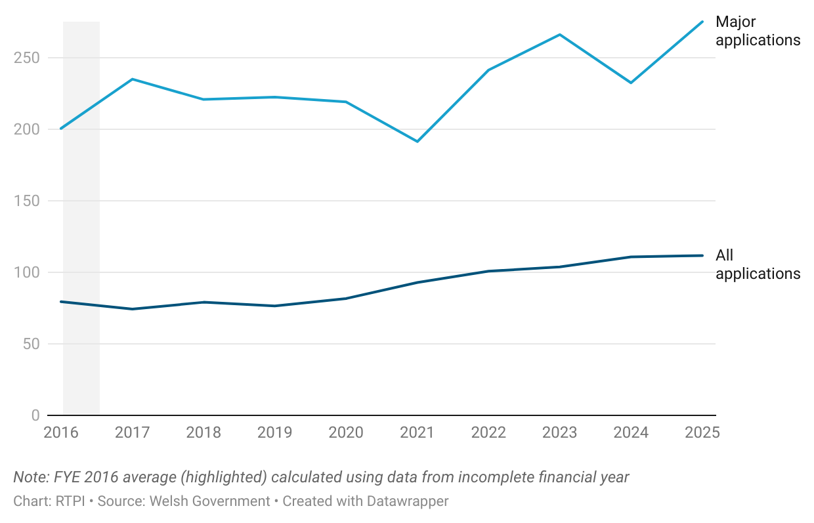
Figure 3. Average number of days taken to determine an application has risen since 2016.

The time taken to determine all applications has risen steadily from an average of 74 days in FYE 2017, to 111 in 2025. That said, the proportion of application decisions made on time (within statutory or agreed timescales) has returned to pre-pandemic levels, at 83.6% in FYE 2025.
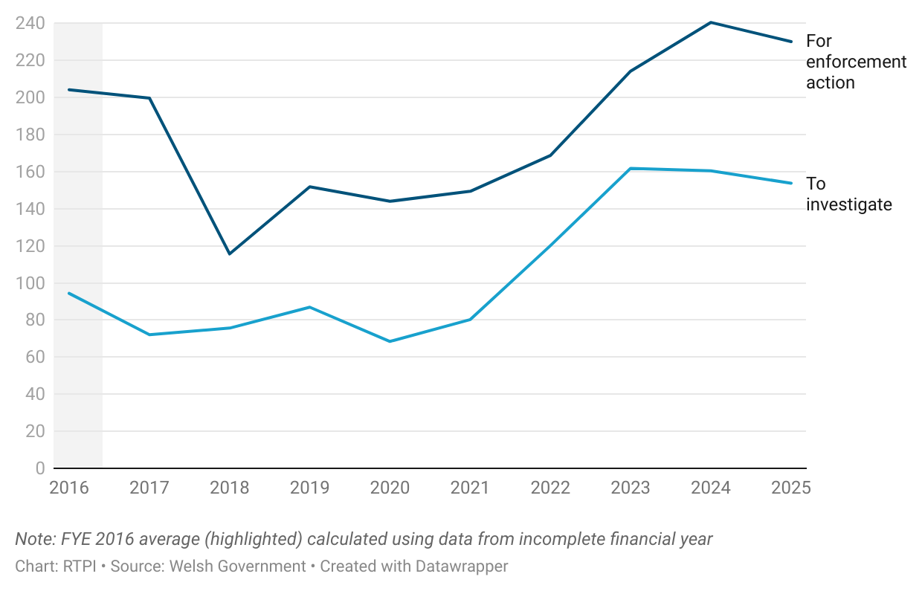
Figure 4. Average number of days taken to investigate and take enforcement action has increased in recent years.

Average time taken to investigate and take enforcement action has shown a more noticeable increase. The average time taken to investigate in 2025 was 153 days, up significantly from 72 in 2017. Average time taken to take enforcement action similarly rose, from 199 days in 2017 to 230 days in 2025.
The rise in the average time taken to determine all application types, and to investigate and take action on enforcement matters could be affected by factors other than planning authority resourcing. That said, taken together, the planning expenditure and planning performance data above suggest that not enough is being done to adequately resource (and train) local authority planning teams to help deal with decision and enforcement workloads.

Planning authorities in 2025
This section will outline findings from the survey of Welsh Planning Authorities carried out by RTPI Cymru in spring 2025, around resourcing, workforce, skills and capacity. There were 24 responses to the survey from planning authorities in Wales. Some results below were derived using a quantitative content analysis of the survey outputs, so may not fully reflect RTPI Cymru’s published findings. These topics and more were explored in more detail in RTPI Cymru’s report on resourcing in Welsh public sector planning [1].

Resourcing and skills gaps

Skills gaps
While most Welsh planning authority respondents believed their authority had a good balance of experience, there were several specialist skills that a majority also reported needing more of. As shown below, top of this list was viability, which 91.7% of authorities reported needing more of. Viability is closely followed by agricultural, landscape and retail planning skills (all 79.2%), minerals planning and urban design skills (both 75%), and conservation and heritage, and master planning skills (both 70.8%).

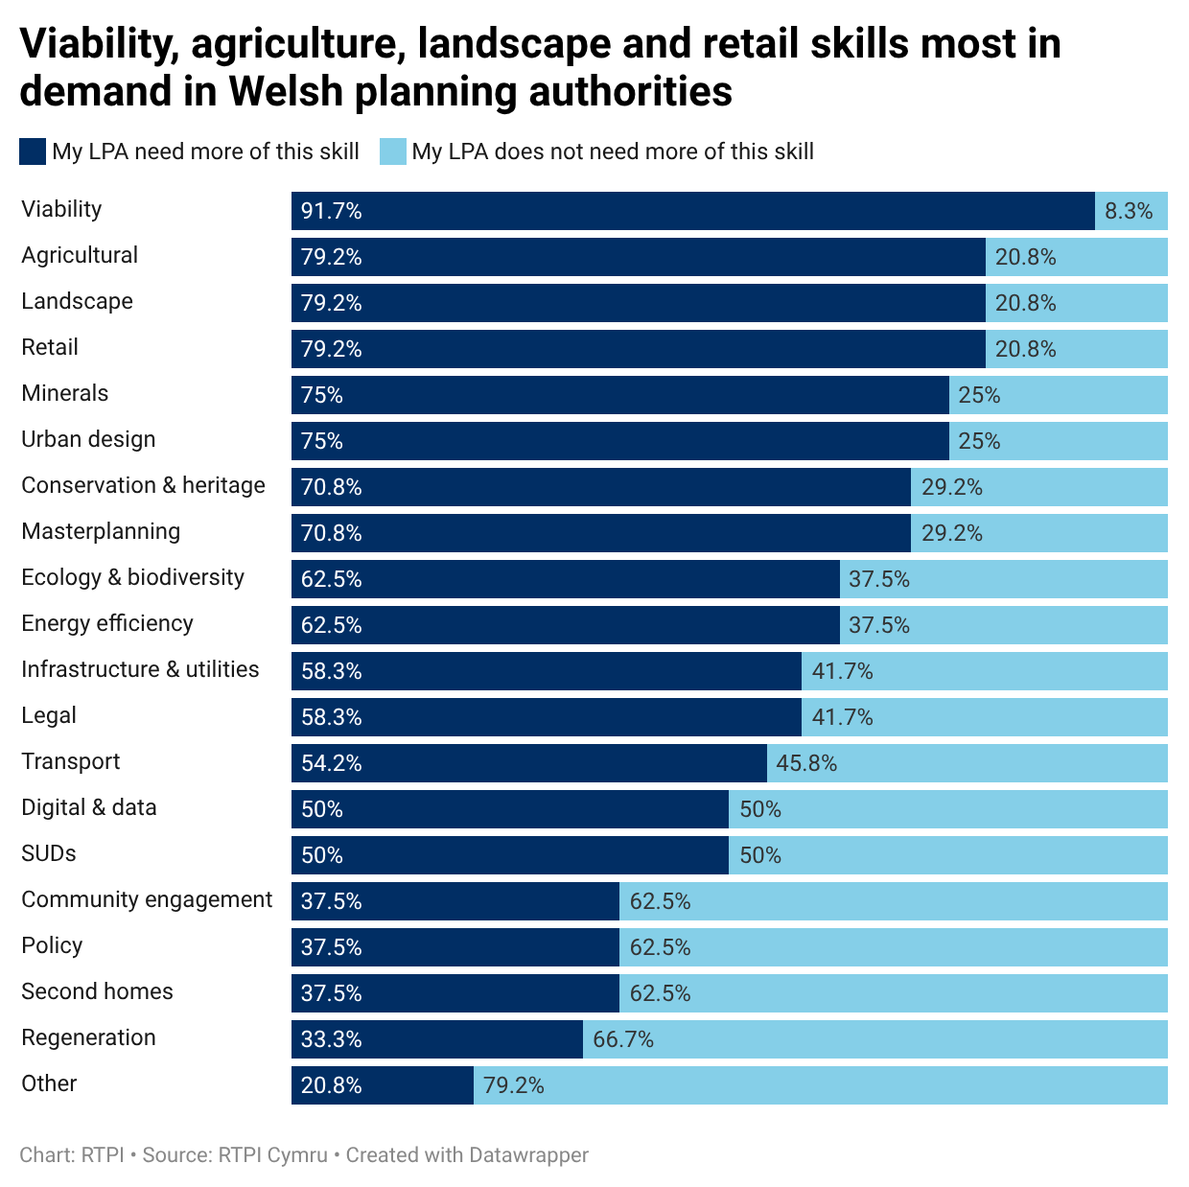
Figure 5. Viability, agriculture, landscape and retail skills most in demand in Welsh planning authorities.

When asked about anticipated future skills gaps, the most mentioned areas were digital, AI and emerging technology, and major projects or Significant Infrastructure Projects (both by 29.2% of authorities). RTPI Cymru’s recently published digital planning research found that while technical capacity across Wales was uneven, there was a strong appetite for incorporating technology into planning [2]. Other areas where skills gaps were expected included energy and net-zero, and ecology (both by 16.7%), and highways officers.
Difficulty hiring specialists was mentioned by almost half of respondents as one of the key recruitment challenges they had faced (45.8%; see below). The pool of applicants being unqualified or inexperienced (41.7%), and too few applicants (29.2%) were the next most reported, with these linked back to specialist recruitment difficulties by multiple. Though more of a concern in some areas than others, the lack of Welsh speaking planners also proved a difficulty in authorities where proficiency in Welsh is particularly important. We surveyed member respondents about their proficiency in Welsh, with results outlined in the respondent demographics section towards the end of this report.
Several authorities reported not having the budget or not being able to use available budget to advertise for roles, meaning job adverts did not reach as widely as they could. Along with the lack of a qualified pool of applicants, multiple planning authorities had to advertise more than once for a role, and some used consultants to fill short (and occasionally long) term vacancies at a greater cost than usual. Of those surveyed, 65% said they had already, or would consider outsourcing some of their work to agency or consultant staff.
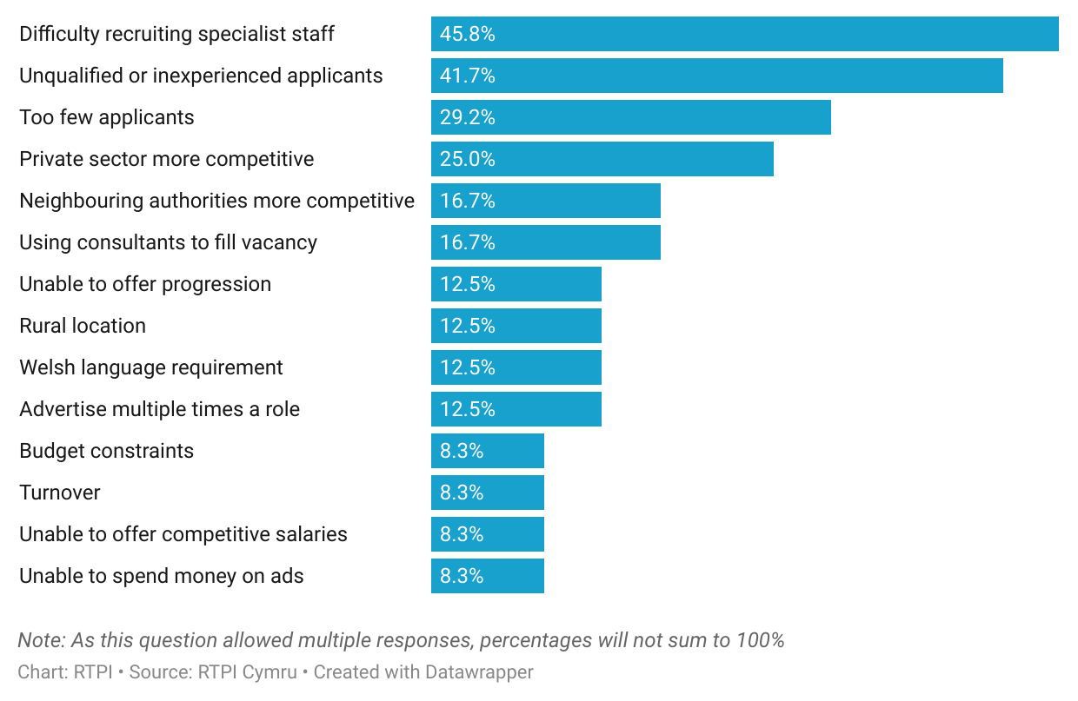
Figure 6. Key recruitment challenges included recruiting specialists, and the pool of applicants.

Budget constraints also affect the training available to local authority planners. Just 4% of planning authorities expected their training budget to increase in the next financial year; most expected theirs to remain the same (67%) or decrease (13%), while remaining respondents were unsure. The capacity of planning staff is another barrier to training, made more difficult by the volume and increasing complexity of applications. One planning authority respondent noted that a robust structure allowing experienced planners to train younger planners would be useful but was not currently possible due to their LPA’s capacity and increasing demand. As discussed below, planners have gained several additional duties in recent years, requiring more specialist expertise. Without adequate recruitment or training, this expertise will be hard to come by, and services may suffer.

Additional duties
When asked about additional duties that had an impact on their capacity, a majority of LPA respondents (62.5%) reported an overall burden increase. Specific areas mentioned included ecology and biodiversity (by 41.7% of authorities), water management and drainage (37.5%), nutrients (33.3%) and energy and net-zero (29.2%).
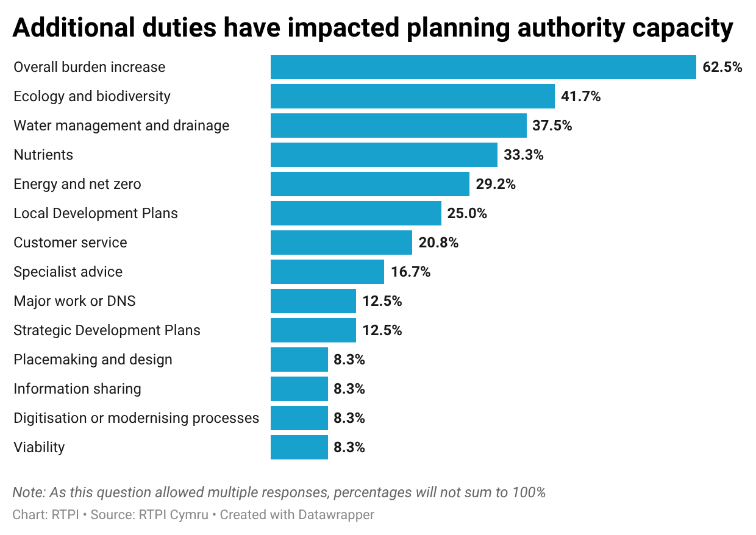
Figure 7. Additional duties have impacted planning authority capacity.

The intention behind the legislation that created these duties is positive and has the potential to positively impact placemaking in Wales. However, without sufficient funding and staffing, planning authorities are less able to deliver them as envisioned. One local government planner in the member’s survey thought that “the increasing complexity of work, a lack of skilled planners and lack of recognition of the local authority to provide funding to recruit additional skilled Planners…represents a huge pressure on delivering an effective planning service”.

Resourcing
While most planning authority respondents supported reinvestment of additional income in their own service, a minority thought that there would be support within their local authority for this. When asked to expand on the budget changes their authority had undergone in recent years, close to 60% mentioned that they had been asked to meet savings targets or generally make efficiencies. Almost 30% reported having a recruitment freeze to stay within budget or deliver savings and 20.8% reported cutting posts outright. Multiple planning authorities sought to increase their income to make up for shortfalls, however in a few authorities, income was not high enough in some areas of planning to cover their costs, meaning it needed to be subsidised from elsewhere in the planning or local authority.

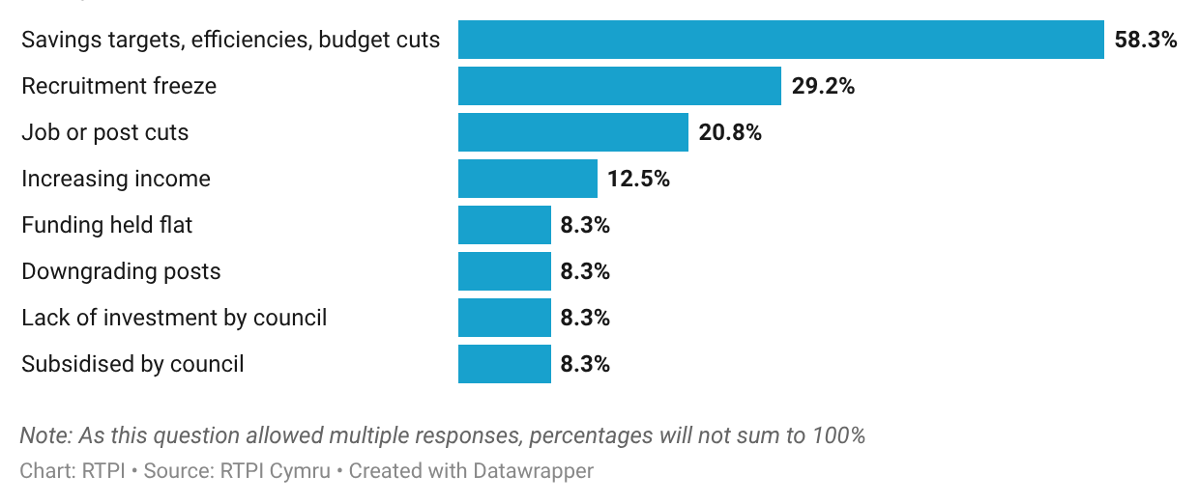
Figure 8. Planning authority budget changes have involved savings targets and recruitment freezes.

This may be set to change, with Welsh Government recently introducing new planning application fee regulations intended to enable full cost recovery, indexed to inflation. Though the Welsh Government has stopped short of ringfencing additional fee income, it has made clear its expectation that additional income is reinvested in planning service improvements.

Demographics
Of local government respondents to the RTPI members’ survey, 60% identified as male, with 38.7% female and 1.3% preferring not to disclose. The ethnicity profile of local government planners was consistent with that of Welsh planners as a whole, detailed in the member section of the report, below.
The broad age profile of respondents to the members’ survey working in local government in Wales is similar to that of other UK nations. Around 77% are between the ages of 30 to 59, while around 11% are under 30 or over 60. Broken down further, 64.9% of local government respondents to the members’ survey who shared their age were over 45, with 35.1% under 45.
A number of planning authority respondents reported difficulty attracting and retaining young planners. This has the potential to make succession planning more difficult in the coming years and means valuable expertise and experience will be lost as older planners retire. As mentioned above, with many teams at or over capacity already, this expertise is less able to be passed on through peer training. To address this, RTPI Cymru have recommended a comprehensive recruitment and retention strategy be developed for planning in Wales, including schools outreach to raise awareness of planning careers, the creation of a level 7 apprenticeship in Wales, and support for services enabling mid-career transitions into planning [1].
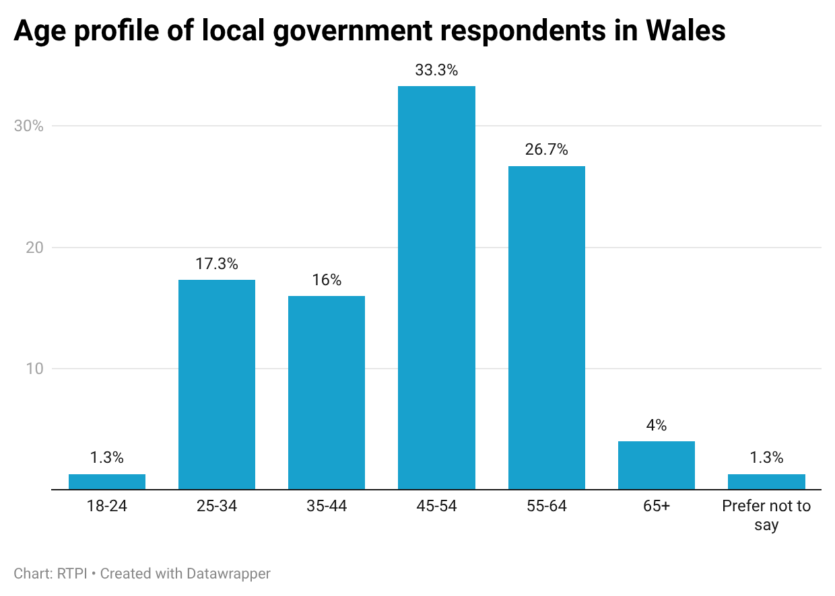
Figure 9. Age profile of local government respondents in Wales

Ways of working
Hybrid working was by far the most common arrangement among member respondents working in local government, with 89.3% reporting working between their home and the office. Most respondents (89.3%) also made use of at least one form of flexible working arrangement. The majority of these (84%) had a flexi time arrangement, with other arrangements like compressed hours (5.3%), a 4-day week (without loss of pay; 2.7%), annualised hours (2.7%) or job sharing (1.3%) much less common.

Planners in 2025
This section will outline findings from the survey of RTPI members working in Wales. Topics addressed included career stage and plans, resourcing and skills gaps, wellbeing, working and volunteering practices, and respondent demographics. The member survey had 138 respondents who reported working primarily in Wales.

Career stage and plans

Area of planning
Just over half of respondents (54.4%) were local government planners, followed by private sector (23.2%) and central/devolved government planners (12.3%). Remaining sectors accounted for less than 5% of response each.

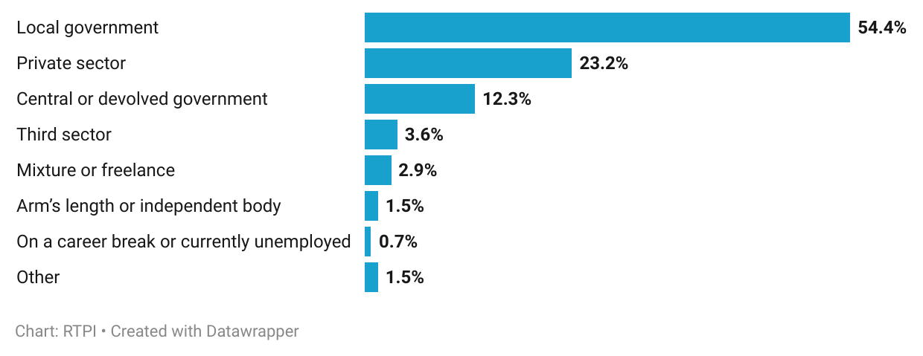
Figure 10. Most respondents working in Wales were in local government or the private sector.

This means that the majority of respondents work within the public sector (68.1%), with the remainder being from the private (23.2%) or third sector (3.6%), or ‘other’ (5.1%; such as freelance, career break, specified ‘other’).
When asked which area of planning they primarily worked in, development management accounted for 31.9% of responses, followed by planning policy (15.2%) then energy or renewables and enforcement (both 7.2%). ‘All of the above’ (for example as head of service or statutory consultee) was selected by 6.5% of respondents, and ‘other’ by 3.6%. Other areas of planning respondents worked in included infrastructure consenting, climate change and research.

Career stage
More than half of respondents were experienced planners, having more than 21 years in planning (55.8%).
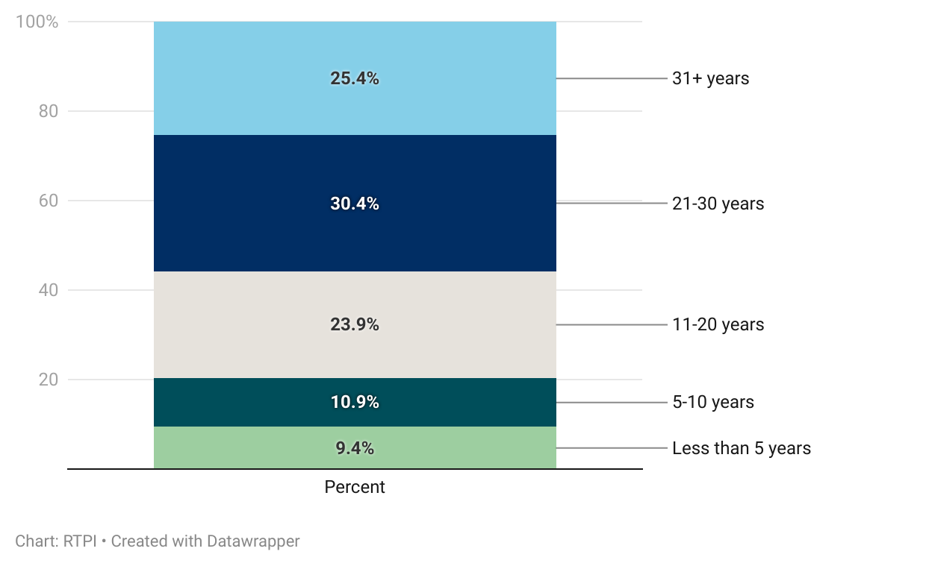
Figure 11. Experienced planners accounted for a high proportion of respondents in Wales.

This corresponded with the level of seniority reported; a higher proportion were mid-to-senior planners than early-career planners, with 54.4% in a senior, associate, or principal planner position.
Earnings tracked similarly to the reported career stages, with almost half (47.8%) earning in the middle of the range, between £40,000 to £60,000. Overall, the salary distribution in Wales was comparable to that of other UK nations.
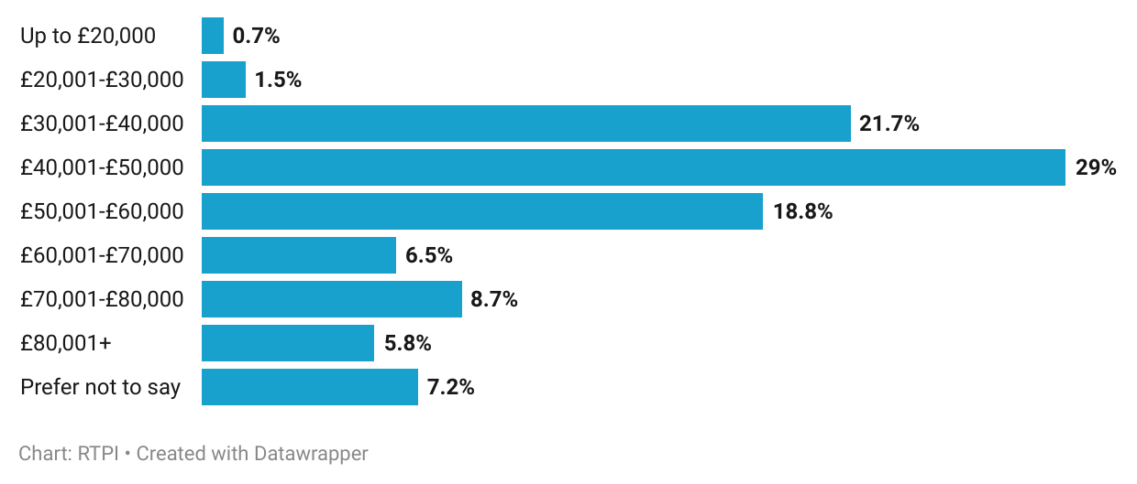
Figure 12. The modal salary band among respondents was £40,001 to £50,000.

Nearly 70% of Welsh planners were satisfied with their career progression, with 23.9% feeling very satisfied and 44.9% somewhat satisfied. Overall, 20.3% were very or somewhat unsatisfied with their progression.
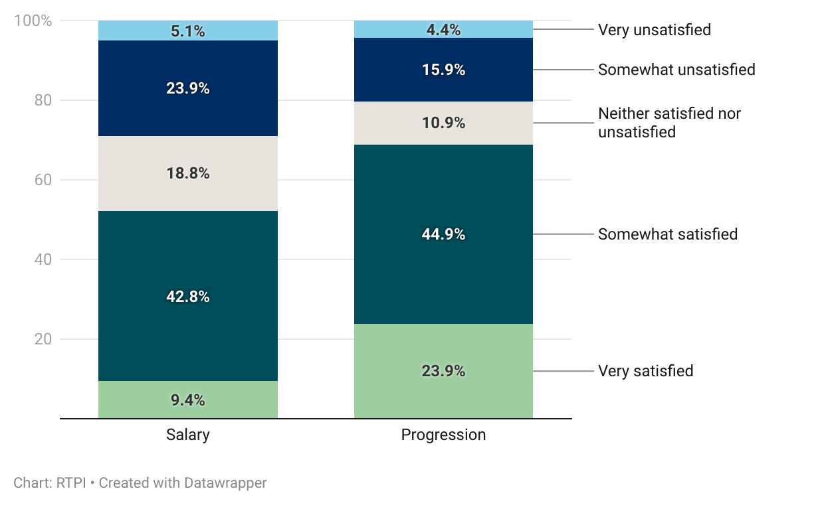
Figure 13. Salary satisfaction was lower than satisfaction with career progression

Salary satisfaction was lower, with a little over half satisfied with their salary (9.4% very, 42.8% somewhat satisfied, and 29% very/somewhat unsatisfied). This was a consistent pattern across the UK, with planners generally feeling more satisfied with their career progression than their salary. There were too few responses to confidently say if satisfaction differed significantly between levels of seniority.
When asked what their most likely career plan was in the next three years, 57.3% said they intended to remain with their current employer (40.4% in their current role, 16.9% seeking another).
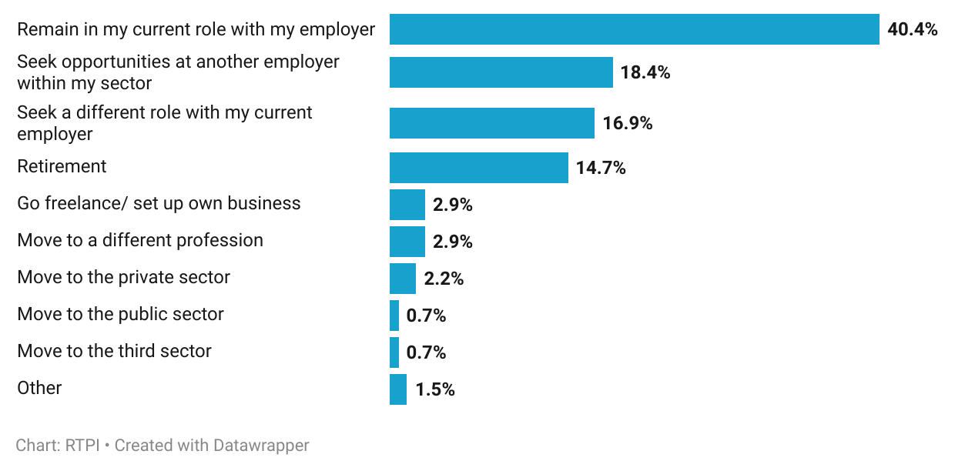
Figure 14. Most respondents intended to stay with their current employer.

This proportion differs slightly between the public and private sector, with 38% of respondents within the former and 47% within the latter anticipating staying where they were. A higher proportion of private sector planners (28%) planned to seek opportunities elsewhere in the private sector, while only 16% of public sector planners planned to move elsewhere in the public sector. Public sector planners were more likely to seek a promotion or role elsewhere in their current workplace, with 21% expecting to seek a different role with their current employer (3% private). However, a higher proportion of public sector planners were looking to retire, at 16%, compared to the private sector’s 9%. Overall, the sum of respondents wanting to leave the profession, and those intending to retire suggests that 17.6% will likely be leaving planning in the coming three years.

Resourcing and skills gaps

Skills, knowledge and training
Of respondents working in Wales, 14% felt they had no gaps in any of the specialist areas listed. Significant proportions reported gaps in the areas of marine planning (56%), digital, data and GIS (38%), and infrastructure and utilities (36%).

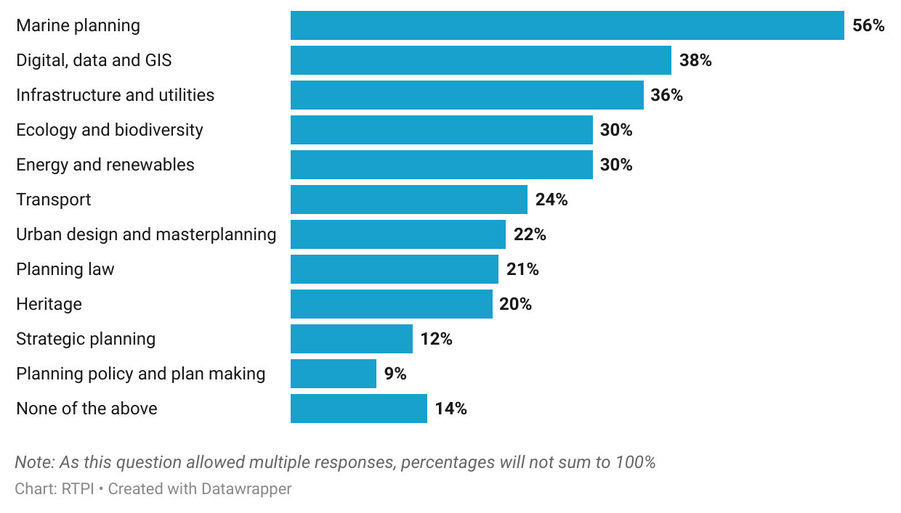
Figure 15. Marine, digital and infrastructure were top reported specialist skill or knowledge gaps.

Ecology and biodiversity, and energy and renewables were also reported as gaps by 30% of respondents, followed by transport (24%), urban design and masterplanning (22%), planning law (21%) and heritage (20%).
The high proportion of respondents recognising a skill gap in the top four areas suggests a link to recent legislation and policy. For example, the scaling up of renewable energy production, such as offshore windfarms around the Welsh coastline necessitate marine, infrastructure and energy and renewables expertise. Multiple Welsh planning authorities also reported an increased need for planners with knowledge around Significant Infrastructure Projects and processes.
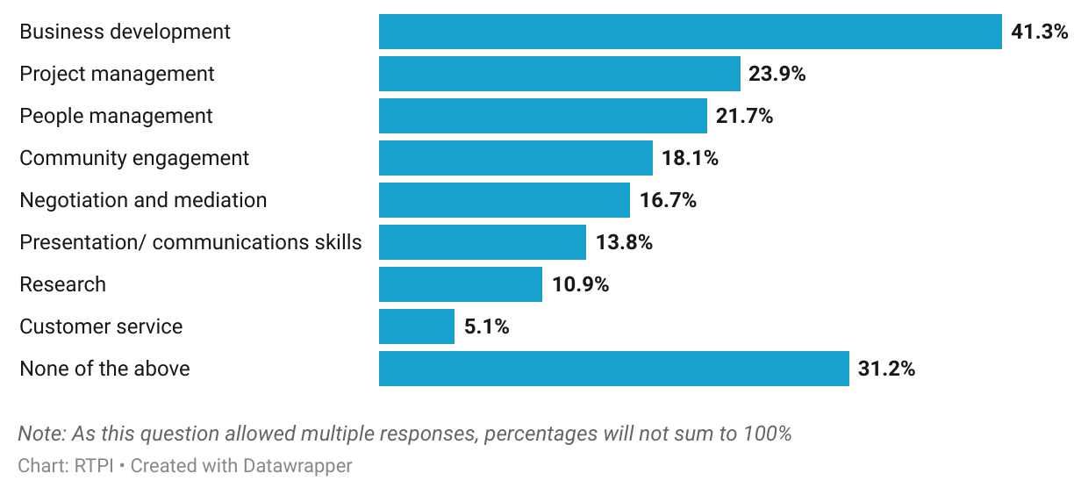
Figure 16. Close to a third reported no generalist skill or knowledge gaps.

Around a third of Welsh planners felt they had good generalist skills and knowledge. When asked if they felt they had a gap in any of the areas displayed above, 31.2% reported none. However, 41.3% felt they had a gap concerning business development, and 23.9% concerning project management. Over a fifth (21.7%) reported a gap in people management.
While gaps in knowledge were reported by both planning authorities and planners themselves, satisfaction with training was still high, with 55.1% somewhat or very satisfied with their training opportunities (compared to 17.4% unsatisfied).

Capacity and challenges
When asked about the frequency that their team lacked capacity to meet demand, 60.1% of respondents reported that this occurred frequently or all the time. Planners in the public sector were markedly more likely to report this (72.4%) than those in the private sector (40.7%). This is consistent with responses from planning authorities, discussed above, where concerns raised included difficulty recruiting, and budget cuts meaning vacancies being held open and increasing pressure on existing staff.
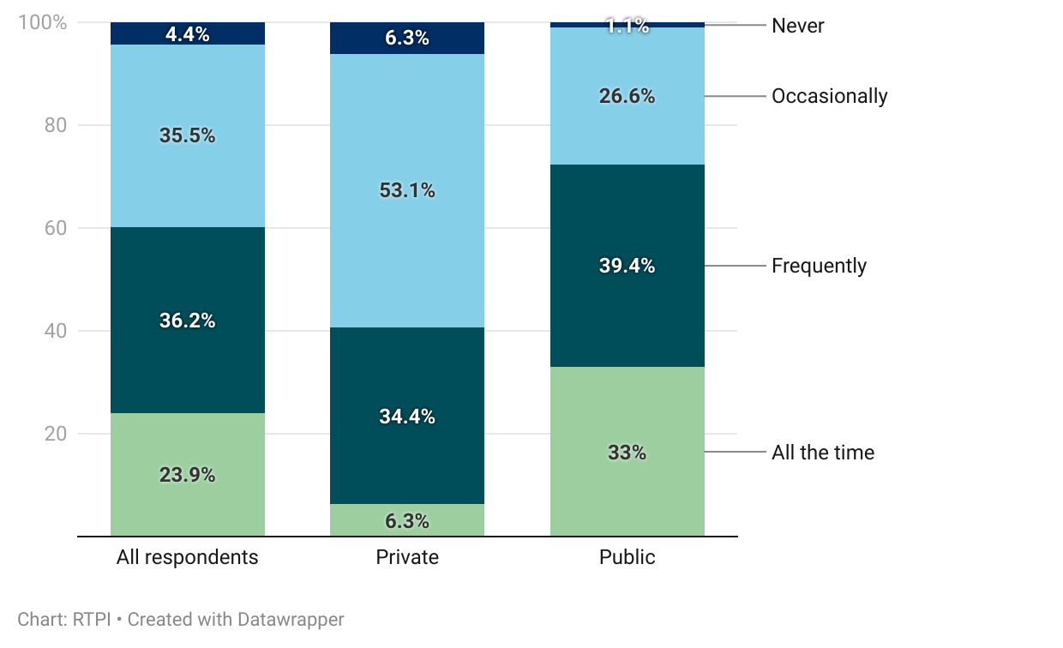
Figure 17. Public sector planning teams were more likely to lack capacity to meet demand.

Of those whose teams lacked capacity to meet demand frequently or all the time, 42% cited ongoing high workloads. The volume of additional duties introduced in recent years were felt across planning sectors, as increased complexity of work was selected by almost a third of respondents (31.9%). Under-funding, and recruitment difficulties were also selected by a high proportion.

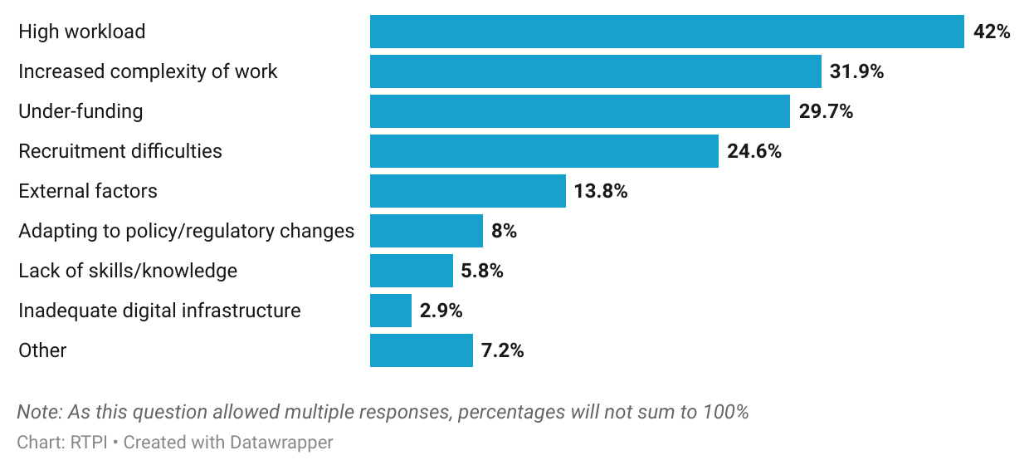
Figure 18. Workload, complexity and funding contributed to capacity issues.

The combination of additional duties and resourcing issues was mentioned by one of the 7.2% of respondents who selected ‘other’, commenting that this resulted in “planners having to be experts in all fields without additional resources”. A number of ‘other’ responses stated that all of the above reasons applied. The risk of judicial review, greater demands from the public, and poor-quality submissions were also cited.
Just under half (47.9%) of planners working in Wales felt some level of pessimism about the future direction of the Welsh planning system. Public sector planners were more likely to report pessimism (50%) compared to the private sector (37.5%; who were also noticeably more likely to feel optimistic, at 46.9%).

Greatest challenges
When asked what they thought would be the greatest challenge facing the Welsh planning system in the coming year, the most common response was funding and resourcing, mentioned by 36.2% of respondents, closely followed by staffing and recruitment, mentioned by 31.9%. One local government planner cited continuing financial pressures, adding that “the increasing complexities of planning matters and the increase in applicant expectations, whilst resources and recruitment struggle are huge barriers to making being a planner an enjoyable experience”. Similarly, recruiting and retaining experienced planning staff was a concern, with multiple public sector respondents reporting colleagues “moving to the private sector due to pay differences”. As noted above, these concerns will contribute to LPA succession planning issues in coming years, as more experienced planners retire.
Another local government planner pointed out that funding, and by extension the salaries offered in local planning authorities can make it difficult for people from less well-off backgrounds to enter the profession through the public sector. This means that the public are not benefiting from the breadth of life experiences that could meaningfully shape planning policy and placemaking.
One of the specific areas mentioned multiple times by respondents was enforcement, which a local government planner reported was suffering due to lack of resourcing and support. They said this had been noticed by some, who were prepared “to risk breaching planning control, with the nature of breaches becoming complex and vast”. Another respondent called current enforcement guidance “toothless”. This offers an insight into the factors contributing to the increased time taken to investigate and take enforcement action, discussed in the introduction to this report. Resourcing in highways planning was also raised by member respondents, as it was by planning authorities.
Public sector resource constraints and their knock-on effects were also a concern of other sectors. One private sector planner questioned the ability of the planning system “to meet the growing demands needed to resolve key planning issues”, given “the lack of resources within Local Authorities”. Respondents across sectors recognised this, as several raised, in the words of one, the “tension between the political drive to speed up the pace of development alongside the increasing complexity and requirements placed on the planning process”. This further spoke to respondents’ thoughts about the purpose of planning, and how it increasingly felt like a box-ticking exercise. Demands are exacerbated by the urgency of issues like the housing crisis, where some struggled with balancing “pressure to bring forward development more quickly” with “quality decision making”.
However, it was felt that there was “a lack of understanding of the purpose or parameters of planning” by the public, policymakers, and occasionally others in the built environment sector that contributed to challenges. Multiple respondents raised legislation, the unintended consequences of which had impacted on their job. Policy guidance in some areas was thought to be fragmented and hard to find, leaving planners unsure how to proceed, or spending a long time searching for it. Legislators, in the words of one planner, did not always have good “practical knowledge of the system and understanding the strain local planning authorities are under”, yet showed “a willingness to reorganise it” without this. Relatedly, the potential for a change in Welsh Government in the 2026 Senedd elections was another concern, and the impact that any resulting pivot in national planning policy could have on the functioning of the Welsh planning system.
It was also widely suggested that (in addition to issues explored above) a lack of understanding of the purpose of planning by the public contributed to the poor perception of the profession, and by extension, some instances of abuse. The lack of understanding of, and consequent perceptions of the profession therefore “affects trust, relationships, decision-making, recruitment and retention”. This will be explored further in the next section.

Wellbeing
Most felt somewhat or very happy working in planning (54.4%). This was reflected in comments from respondents remarking that as a “profession centred around making places better”, the opportunity to have a “meaningful individual input and impact” means planning can be a fulfilling and enjoyable career, despite challenges currently faced.
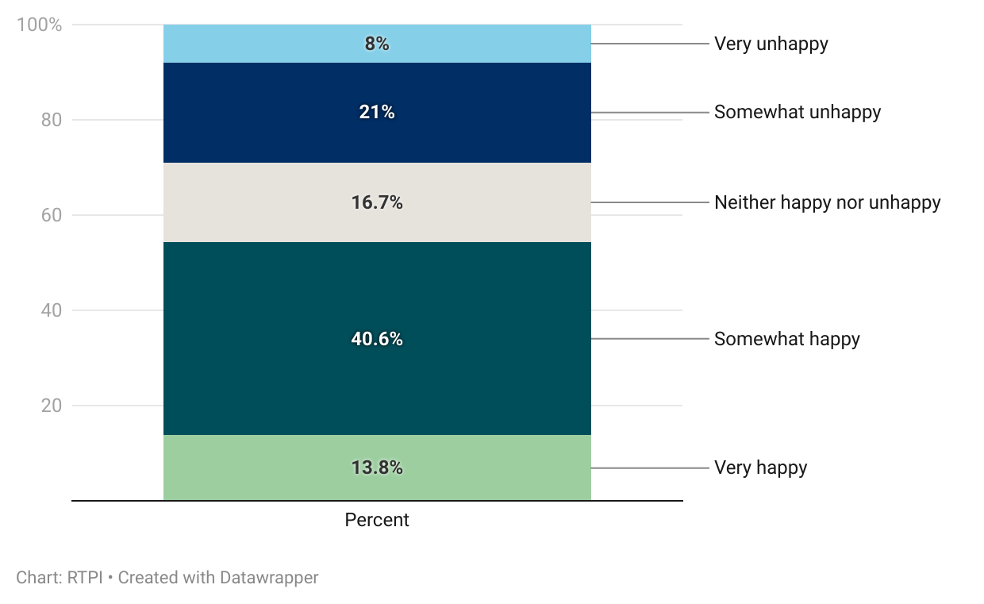
Figure 19. More than half of respondents were happy working in planning.

One of those challenges, as discussed above, is a lack of capacity in the profession and the resultant impact on individual planners. When asked how often they personally felt overstretched working in planning, 63.8% of respondents answered that this occurred frequently or all the time. The 26.1% who said they felt overstretched all the time is an increase on the 21% found in RTPI Cymru’s 2023 research into the wellbeing of planners in Wales [3].
Where such capacity issues meet increasing demands due to complexity and volume of applications, this can contribute to perceptions of the profession as a whole. Welsh respondents largely felt that this was somewhat, or very unfavourable (55.8%, 33.3%, respectively). Consequently, 60.9% reported public perception impacting their wellbeing negatively.

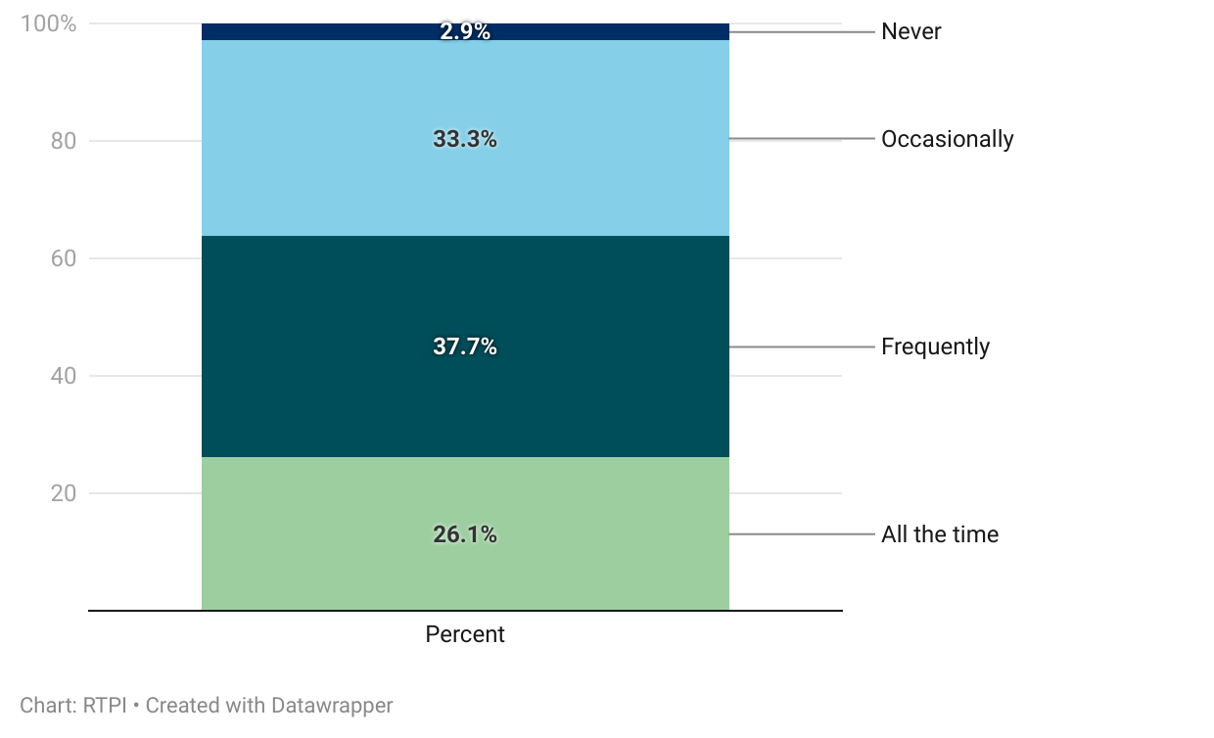
Figure 20. A high proportion of respondents felt overstretched at least frequently.

Also impacting wellbeing among planners is instances of abuse, which 70.3% of respondents reported having experienced. This was an increase on the 64.8% found to have experienced abuse at least occasionally in the 2023 Big Conversation research. The increased visibility of planning decisions in the UK, and the accessibility provided by social media and email means that this is unfortunately all too common. As those responsible for granting and refusing applications, and developing and consulting on planning policy, public sector planners were markedly more likely to experience abuse than private sector planners (78.7%, compared to 50%).
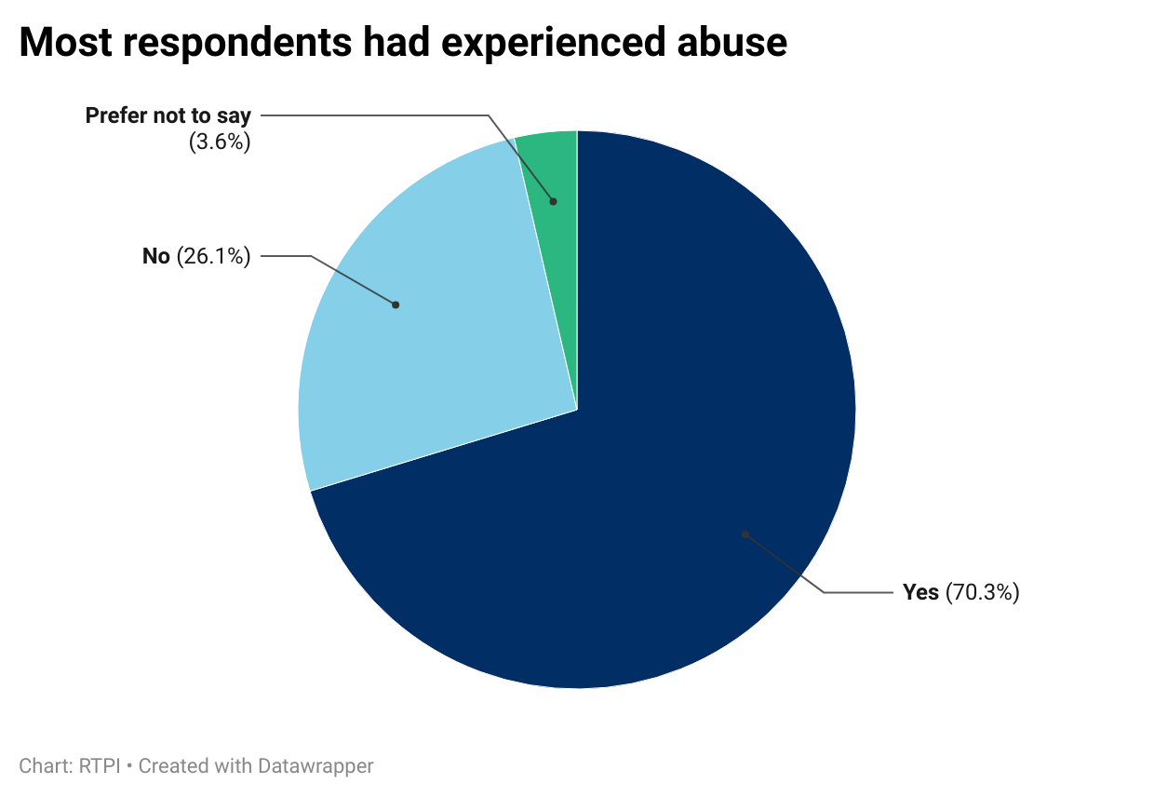
Figure 21. Most respondents had experienced abuse.

When invited to elaborate on the above, 34.4% mentioned verbal abuse or intimidation. One respondent who had worked across sectors reported that “members of the public have been openly verbally hostile” and that unfortunately, “this is becoming increasingly common… including at consultation events, planning committee, LP examinations, planning inquiries and other public events“. Respondents also mentioned general unpleasantness, like being pressured or undermined by other stakeholders, such as consultants working on behalf of applicants and even elected representatives.
This is made easier by the accessibility and anonymity afforded by social media and, to an extent, email. In addition to “general social media bashing of planners and planning“, multiple respondents reported being singled out in Facebook groups, through direct messages and over email. Exacerbating factors included unhelpful discourse from local politicians on occasion, and misinformation, particularly accusations of corruption, with “the inevitable brown envelope comment” mentioned by multiple.
Inevitably, resourcing has an impact on what public sector planners can achieve, as one local government planner expanded, a “lack of resources and inexperienced staff put pressure on senior staff… mistakes inevitably happen”, which leads to “more time taken in dealing with complaints, dissatisfied customers, FOIs etc”. Planning is a profession “centred around making places better”, a principle that suffers when planners are not adequately resourced to deal with everyday demand, let alone to proactively place make. The same respondent made the case for full cost recovery that would “enable staff to be hired, trained and to allow experienced staff the time to breathe and make good decisions”. The recently introduced fee regulations are a positive development in this area.
Several respondents felt that a lack of understanding of the purpose and remit of planning contributed to instances of abuse. A respondent in the third sector contended that “community frustration emerges from a systematic lack of awareness and education about the purpose, scope and value of the planning system”. In particular, the public were felt not to understand “that the planning system is there to protect the wider public interest” through balancing “all aspects of development” to “come to a compromising, sustainable decision”. As this was an issue brought up by respondents across all four UK nations, it is apparent that further work needs to be done to increase public understanding of the purpose of planning, as well as to tone down negative and unhelpful rhetoric. This could build on the RTPI’s ‘It takes planners & you’ campaign that invites the public to see planners as allies, rather than obstacles in shaping great places to live [4].

Working and volunteering practices
The majority of respondents working in Wales followed a hybrid working model, with 72.5% splitting their time between home and the office. Remaining respondents were split relatively evenly between being solely office- or home-based (12.3% and 15.2%, respectively).
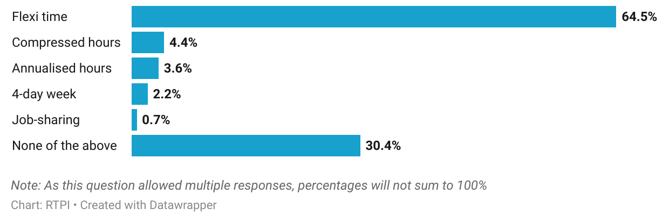
Figure 22. Use of flexible working practices among respondents working in Wales.

Flexi time was the most reported flexible working practice among respondents, used by 64.5%, while other practices like compressed hours, annualised hours and a 4-day week were reported by fewer than 5%. This level of flexible working use is positive, as it makes planning more accessible to a broader range of people, allowing the profession to benefit from diverse perspectives and experiences. Nearly a third reported using no flexible working practices (30.4%).
Of the 18.1% of respondents who had volunteered in their capacity as a planner, most (60%) were a member of a committee or board. Given that 21% of all respondents learned about planning as a career through university or school, that 32% also reported engaging in both educational outreach and mentoring is encouraging.
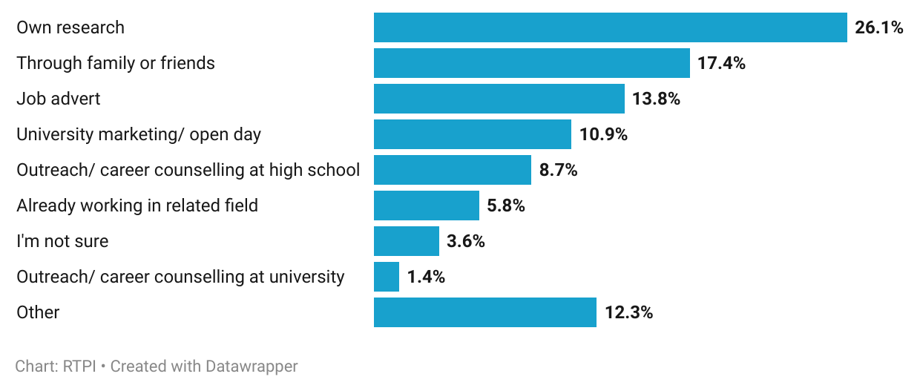
Figure 23. Most respondents learned about planning as a career through their own research or word of mouth.

Who responded

Demographics
The figure below shows that the age profile of Welsh respondents was weighted more towards older age groups, with 40.9% under 45, while 59.1% were over 45.
The gender profile of respondents was somewhat skewed, with 65.2% identifying as male, and 33.3% female. Those who preferred not to say, or used another term accounted for 1.4%.
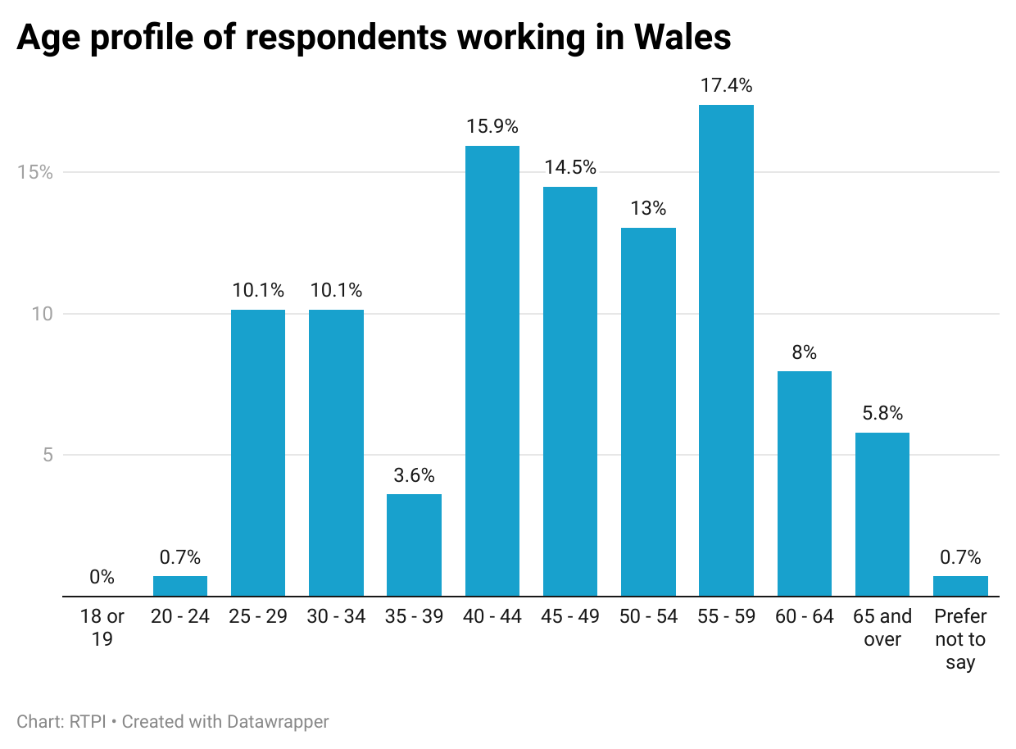
Figure 24. Age profile of respondents working in Wales

A large majority (94.9%) of respondents reported their broad ethnic group as White, with the next largest group being Asian or Asian British, and Black or Black British (both 1.5%). Those belonging to Mixed or multiple ethnic groups were 0.7% of respondents, and none reported belonging to an Other ethnic group. This compared to the 2021 Census, where 93.8% identified as White, 2.9% Asian or Asian British, 1.6% of Mixed or Multiple ethnic groups, 0.9% Black or Black British, and 0.9% of an Other ethnic group.
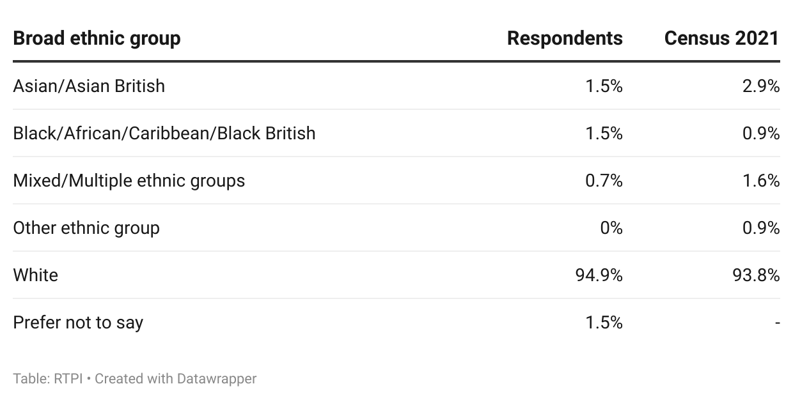
Figure 25. Broad ethnic group of respondents working in Wales.

In addition, 10.1% of respondents reported having a disability, condition or access need.
As reported by multiple planning authorities, recruiting planners in Wales who can speak Welsh has proven difficult. The accessibility of planning to Welsh speaking communities and planners will be improved by the Welsh Government’s provision of the Planning Consolidation (Wales) Bill. This would be enhanced further by a higher proportion of planners in Wales being proficient in Welsh. When asked to rate their level of proficiency in Welsh, 35.5% rated themselves as intermediate, fluent/advanced, or having Welsh as their first language. While the proportion of people living in Wales who can speak Welsh has increased over the past decade according to the Welsh Government [5], this suggests there is still some progress to be made in the planning profession.
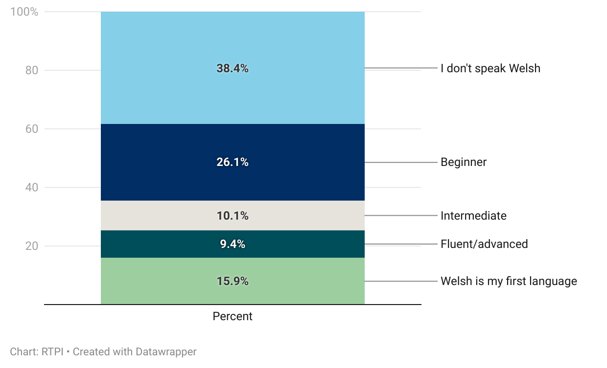
Figure 26. A third of respondents had intermediate or higher level of proficiency in Welsh

Conclusion: what does this mean for the Welsh planning profession?
Wales has been a trailblazer when it comes to legislating to ensure a healthy society for future generations. The Welsh planning system will be instrumental in delivering the constituent parts that enable this, including renewable energy infrastructure for the transition to net-zero, building affordable housing in thriving neighbourhoods, and the community and transport infrastructure to support this. However, as with other UK nations, the Welsh planning system is facing challenges.

Respondents to both the planning authority and member survey cited the volume of additional duties created in recent years in areas such as biodiversity, water management and nutrients. While these are intended to minimise any detrimental impact development might have on its surrounding environment, and ensure places are well designed and functional, these intentions are undermined by insufficient resourcing of planning teams to deal with them. Respondents also reported that policy guidance in some of these areas was fragmented, or minimal, leaving them unsure how to proceed, or spending too much time searching for it. The Planning (Wales) Bill will seek to address some of that fragmentation within existing legislation, but Welsh Government must also ensure that current and future policy guidance is clear, comprehensive, and easy to find.

Recruitment and retention, especially within specialist posts was another key issue that could further undermine such duties. Numerous authorities reported that the relatively low wages in the public sector meant biodiversity, highways and water management posts were difficult to fill (among others). Counterintuitively, this then meant that some were spending more on contractors and consultants than if there was in-house capacity. The dearth of specialist resource could be addressed by ensuring that existing planners have both the capacity and the means to pursue further training.

Recruitment of new planners into the profession is an additional concern, with 31.2% of respondents at or approaching retirement age, and almost 15% intending to retire in the next three years. Many were concerned that there were not enough entrants into the profession both to take over from the existing leadership cohort, and to address Wales’s future planning needs. Attracting young planners into the profession and ensuring that the valuable knowledge of older planners is passed on will be a key challenge for the profession in the coming years. Establishing a dedicated planning apprenticeship is one measure the Welsh Government can take to help secure the next generation of planners.

At the root of many of the above issues is funding, which, as the planning expenditure statistics at the beginning of this report showed, is significantly lower than it was in 2010. A level of resourcing is required that enables planning teams to deal with additional responsibilities, without which teams will continue to be overstretched, undermining the government’s ambitious policy programme. Newly introduced planning fee regulations will help with this, but they must be set at a level to meaningfully fill the gaps planning teams have reported that they face. To match the level of ambition shown by Welsh Government, and enable proactive place making, planners must be adequately resourced to do so.

Despite the issues highlighted in this report, most respondents reported that they enjoy working in planning. They identified that planning has a meaningful, visible, positive impact on peoples’ lives, and that planners get to tackle a variety of interesting issues to shape places for the better. The coming years therefore represent a pivotal moment for the Welsh planning system. If challenges around funding, recruitment and skills can be addressed, the sector is well placed to drive forward the transition to net-zero, delivering affordable homes, and embedding wellbeing at the heart of decision making. Realising this potential will depend on empowering planners to do what they are trained to do, and what they do best: creating thriving, sustainable, and well-designed places for future generations.

Appendices

Appendix A – Methodology
The data in this report were collected using surveys of working RTPI members, and senior Local Planning Authority officials in Wales. The RTPI commissioned Research by Design, a market research firm to conduct the member survey. Research by Design provided final survey data to RTPI anonymised, to maintain respondents’ confidentiality.
Survey questions were designed in part to give similar or related outputs to the key outputs from the 2023 State of the Profession report, as well as to provide a baseline for future State of the Profession survey reports. The 2023 State of the Profession report used Office for National Statistics (ONS) Labour Force Survey (LFS) data, but due to a combination of occupation recoding by ONS, and low survey response rates for the LFS, the RTPI decided to design its own surveys to investigate the State of the Profession.
Members
The member’s survey ran for a month over summer 2025. The survey was sent to 22,382 members, and received 2,808 responses, which equates to a 12.5% response rate.
There were 138 responses from members based in Wales, 5% of the overall response. As we wanted to survey working planners with current experience of the planning system, retired members and full-time students were screened out.
For country reports, survey responses were filtered on a question asking “Which RTPI nation is the majority of your planning work for?” and only responses related to the relevant country analysed. Where relevant, responses were broken down by the broad sector that respondents reported working in (public, private, third, other), their level of seniority, or their gender.
Members were asked questions about their career stage and career plans, personal skills gaps, resourcing in their workplace, working and volunteering practices, about their personal wellbeing, and demographics. Survey results represent a snapshot in time, and the survey was self-selecting, meaning responses may not be representative of the wider population.
Local Planning Authorities
In the spring of 2025, RTPI Cymru carried out a survey about resourcing in Welsh planning authorities. To avoid survey fatigue, we decided not to re-survey Welsh planning authorities for the State of the Profession. Instead, we have used a combination of RTPI Cymru survey responses and Welsh members’ responses to the members’ survey to inform the planning authority section of the Welsh State of the Profession report.
The RTPI Cymru survey was sent to all LPAs in Wales (25) and received 24 responses.
The proportions in figure 5 were reached by summing the proportion of authorities responding as follows:
- My LPA need more of this skill: sum of "My LPA needs more people with this skill", "We buy this in from consultants" and "We buy this in from another LPA"
- My LPA do not need more of this skill: sum of "My LPA has sufficient people with this skill" and "This skill is not needed in my LPA"

Several questions in the RTPI Cymru survey were open response. In these cases, respondents’ answers were analysed using a quantitative content analysis approach. This involved:
- Reading through responses to familiarise and devise initial categories relating to the question
- Re-reading responses and noting the frequency with which categories were mentioned
- Summing the frequency of each category and calculating the percentage of planning authorities that mentioned them

For the demographics and working practices of LPA planning teams, details from respondents to the members survey who reporting working in Local Government were aggregated, with a summary of age, ethnicity and gender profiles, and working practices derived from these.

Appendix B – Data sources
Figures 1, 2: Revenue outturn expenditure summary, by authority
https://stats.gov.wales/en-GB/b483d2c5-e60e-4dfb-b03a-49df9e1931a0
These were adjusted for inflation using the UK GDP deflator, below.
UK GDP deflator
https://www.gov.uk/government/collections/gdp-deflators-at-market-prices-and-money-gdp
Expenditure on planning was adjusted for inflation as measured with the GDP deflator rather than the headline Consumer Price Index or CPI. The GDP deflator measures base inflation in the economy, while CPI focuses on prices of consumer goods.

Figures 4, 5: Development Management Quarterly Surveys
https://www.gov.wales/development-management-quarterly-surveys

Figure 25: Census 2021 broad ethnic group statistics
https://www.nomisweb.co.uk/datasets/c2021ts021
TS021 - Ethnic group

Appendix C – References
[1] https://www.rtpi.org.uk/find-my-rtpi/rtpi-nations/rtpi-cymru/policy-and-research/policy-publications/public-sector-resources-landing-page/
[2] https://www.rtpi.org.uk/find-my-rtpi/rtpi-nations/rtpi-cymru/policy-and-research/policy-publications/scoping-the-potential-for-digital-planning-to-ease-resource-pressures-and-improve-planning-outcomes/
[3] https://www.rtpi.org.uk/new-from-the-rtpi/the-big-conversation/
[4] https://www.rtpi.org.uk/about-the-rtpi/our-campaigns/it-takes-planners-you/
[5] https://www.gov.wales/welsh-language-data-annual-population-survey-april-2024-march-2025-html

Contact information
For feedback or queries, contact analysis@rtpi.org.uk

