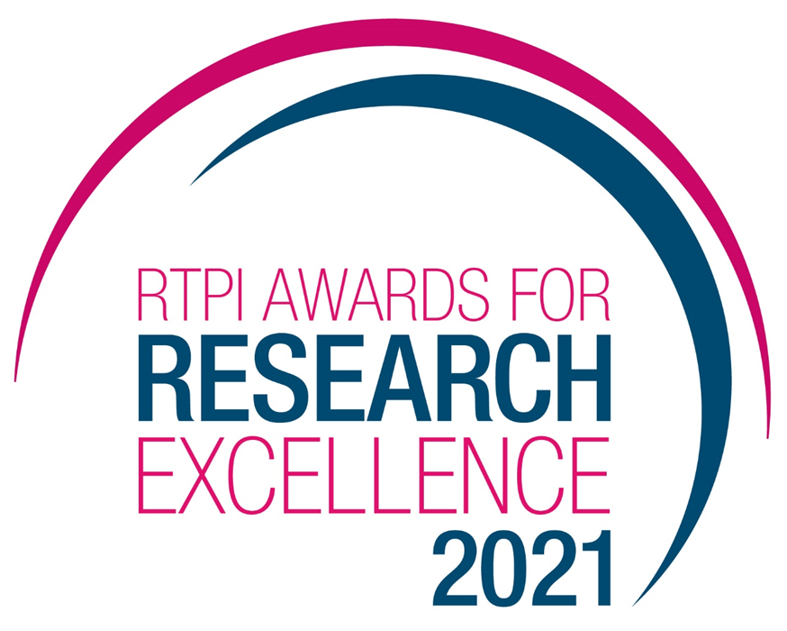

Practitioner Research Fund

Category Information and Entry Form

Submission deadline: Monday 17 May 2021

Category information 1
Practitioner Research Fund 1
Eligibility 1
Geographical coverage 2
The definition of ‘planning research’ 2
Entries 2
Judging criteria 2
How to enter 3
Awards ceremony 3
Contact us 3
Terms and Conditions 3
Entry form 5
A. Contact data 5
B. Affiliations 5
C. Eligibility 5
D. Research - general data 6
E. Research Proposal Summary 7
G. Other 8

Practitioner Research Fund

In addition to our established award categories, this year we are accepting entries for the biennial, award for practitioners called the ‘Practitioner Research Fund’. This award category celebrates the Town and Country Planning Summer School, which ran from 1933 to 2013, and played a huge role in the evolution of the discipline. As well as advancing the science and the art of town planning, it attracted some of the most influential figures in the discipline’s history, and inspired generations of young planners.

Rather than being an award for completed research, this is open to RTPI members who are working in practice, and wish to submit proposals for research they wish to undertake in the future.

A judging panel will assess the quality of proposals, and two winners will each receive £5,000 towards the costs of completing and publishing their research, which they will have circa six months to complete. Winners will also be paired with established researchers from an RTPI-accredited planning school, who will support them in their work.

Eligibility
The Practitioner Research Fund is open to all RTPI members, except those employed by, enrolled at, or affiliated to, an academic institution at the time of submission. Individual members who work in a non-academic research role (for example, in a think tank, charity or research-focused planning consultancy) may apply, but should be aware that proposals will be judged on the likelihood that the funding will enable individuals to carry out research which they would have been otherwise unable to conduct (see point 5 of the judging criteria, below). Collaborative bids, in which multiple eligible individuals come together to bid for one of the two pots of funding, are welcome.

It is important to note that by submitting an entry to this award, entrants confirm that their employers are fully aware of, and also support, their application.

Submitted proposals must be for additional work done in the course of normal practice, and the proposed work should take less than six months to complete. The grant could be used for study leave (e.g. allowing an employer to cover an employee’s absence), travel/expenses, materials, etc.

If you are unsure about eligibility, or suitable uses of the grant money, please contact the RTPI research team at Research@RTPI.org.uk

Geographical coverage
The submitted research and its potential implications for planning policy and practice can relate to anywhere in the world (focus on UK or Ireland is not required).

The definition of ‘planning research’
We interpret ‘planning research’ broadly. For example, research could primarily focus on implications for planning education or professional development, rather than practice or policy. Though the awards focus on spatial planning research, we encourage interdisciplinary and multidisciplinary research. We welcome non-traditional pieces of research such as applied research, action research or research by design.

Entries
Due to the significant amount of funding allocated as part of the Planning Research Fund, entrants to this award category are required to submit three pieces of information through the submission portal, on which proposals will be judged:

1. A 1500-word, plain English, research proposal document that briefly explains:
- Why the proposed research will make a valuable contribution to planning knowledge
- Important context, and existing research on the topic
- The project’s aims, objectives, research questions
- Methods
- How the funding would be spent if the proposal is successful
- Planned outputs, engagement or dissemination activities
2. A 250 word ‘short summary’ of the proposed project (see entry form below): This can be a condensed version of the full research proposal.

3. A Curriculum Vitae: Judges will use this to assess the ability of entrants to carry out their proposed research to a high standard.

Judging criteria
Proposals submitted to the Practitioner Research Fund will be judged across each of the above materials on the following criteria:

- Relevance of topic: The research proposal puts forward an original approach to issues and themes of current concern and relevance to spatial planning
- Understanding of topic: The research proposal demonstrates a strong understanding of the research topic and related fields of enquiry
- Ability to conduct the research to a high standard: The methodology, proposed methods and plan for spending the funding are clearly articulated and rigorous, and the entrant’s CV demonstrates the ability to conduct the research to a high standard
- Likelihood of impact: There is a clear strategy for ensuring that the findings will be impactful, and that they are disseminated effectively to relevant audiences
- The spirit of the Practitioner Research Fund: This fund exists to enable creative, novel, practitioner research which would not happen otherwise. Proposals should make clear how the awarded funding will enable the entrant to carry out research which they would not otherwise have been able to do.
The final award of funds to the winners of the Practitioner Research Fund will be dependent on the RTPI, the winner, and the paired RTPI planning school agreeing a final project plan.

How to enter
Entries must be submitted by 5pm on Monday 17 May 2021. Incomplete submissions will not be considered. Please make sure you have the document for the correct category.

- Download and save this document;
- Complete the Entry Form below and save the file
- Open your browser and go to www.rtpi.org.uk/awards-form/;
- On the drop-down menu, select “RTPI Awards for Research Excellence”;
- Complete the form on the website;
- Convert the Research Proposal to .pdf; and
- Convert your CV to .pdf
- Upload your completed Entry Form, CV and Research Proposal and click on “submit”

Naming convention
Please follow the following naming protocol for submissions:
● SUBMISSION FORM:
[First name]_[Last name]_SF_PRF_[Short title].pdf
E.g. John_Doe_SF_PRF _An article about planning.pdf
● RESEARH PROPOSAL:
[First name]_[Last name]_MS_PRF_[Short title].pdf
E.g. John_Doe_MS_PRF_An article about planning.pdf
● CV:
[First name]_[Last name]_CV_PRF.pdf
E.g. John_Doe_CV_PRF

If for any reason you are unable upload the research proposal (or it is above the size limit of
10Mb), please provide a link where the submitted entry can be freely downloaded or
consulted in section G1 below. Failure to do so will disqualify your submission

Please ensure you enter your name on the entry form the way it should appear on the RTPI website and on any award certificates issued.

Awards ceremony
The winners of the RTPI Awards for Research Excellence 2021 will be announced at an awards ceremony, to be held virtually by Newcastle University on the afternoon of Wednesday 8 September 2021. All entrants are welcome to take part in the ceremony or send a delegate.

Contact us
If you have any questions about entering the RTPI Awards for Research Excellence, or to report any issues with the application process, please contact research@rtpi.org.uk.

Terms and Conditions
- Full submissions must be received by the RTPI by Monday 17 May 2021.
- Word counts will be checked. A variation of up to 10% will be allowed, but anything beyond that will not be considered by the judges.
- The RTPI reserves the right to share submissions with our member magazine The Planner.
- The RTPI reserves the right to share submissions and entry forms with our judging panel.
- Submitted material will be retained electronically by the RTPI.
- The Royal Town Planning Institute is not liable for any costs you incur submitting this entry.
- The decisions of the judging panel are final and no correspondence will be entered into before or after the event.

Entry form
Practitioner Research Fund

A. Contact data
A1. Title: ____________________
A2. First name(s): ___________________________
A3. Middle name(s): _________________________
A4. Last name: _____________________________

(Optional: phonetic pronunciation of full name: _____________________________)

A5. Postnominals: ____________

A6. Gender: ______

A7. Contact email: __________________________
A8. Contact telephone: ______________________
A9. Contact address:

A10. OPTIONAL - Social media accounts:
(we will engage with shortlisted and winning authors on social media):
A10a. Twitter: ______________________________
A10b. Instagram: ___________________________
A10c. Facebook: ___________________________
A10d. Linkedin: ____________________________

B. Affiliations
B1. Main organisation: ______________________________________
B2. Department: ___________________________________________________________

B3. Other current institutional affiliations:
(separated by comma or semicolon)

C. Eligibility
C1. Are you a Member of the RTPI? ___

D. Research - general data

D1. Proposed research title: ____________________________________________________

D2. Affiliation of the co-authors:
(separated by comma or semicolon.)

D3. OPTIONAL Co-authors’ contacts and social media:
(separate authors by semicolon. Include the contact/social media in brackets, separated by commas)

E. Research Proposal Summary
E1. Short summary of research proposal
.
Please provide a short summary of the research (250 words) of the proposed project. This can be a condensed version of the full research proposal.

G. Other
G1. Submission link:
If for any reason you are unable to upload the submission on the RTPI portal, please provide a link where the submitted entry can be freely downloaded:

G2. OPTIONAL - Observations
Please add any additional information that you might want to provide in the space below. While not part of the judging process, your observations can provide contextual information about the entry:
G3. OPTIONAL - Feedback
Please insert any feedback on the submission process:

The submitter must be the first author of the paper and must possess the relevant criteria for submitting the entry.
This is the institution where the entrant was at the time the research proposal was submitted.
Please list all the current institutions (academic or otherwise) you are engaged in, member of (besides professional bodies), employed by or sponsored by.
This title will be used for all communications concerning the research. Please do not include the subtitles.

