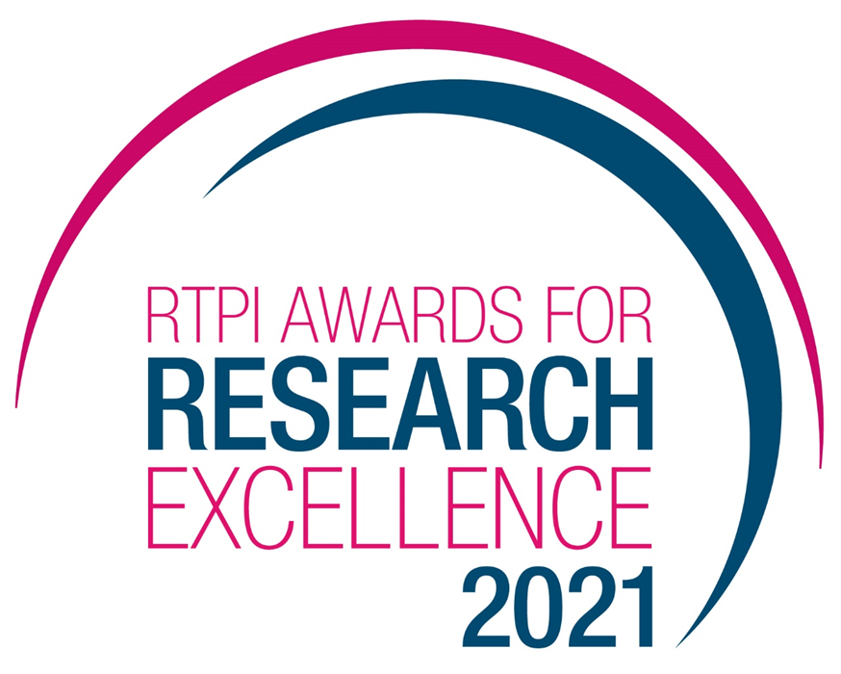

Planning Practitioner Award

Category Information and Submission Form
Submission deadline: Monday 17 May 2021

Category information 3
The Planning Practitioner Award 3
Eligibility 3
Geographical coverage 3
The definition of ‘planning practitioner’ 3
The definition of ‘planning research’ 3
The definition of ‘published’ 4
Judging criteria 4
How to enter 4
Awards ceremony 5
Contact us 5
Terms and Conditions 5
Entry form 6
A. Contact data 6
B. Affiliations 6
C. Eligibility 6
D. Research - general data 7
E. Research - Research summary 8
F. Research - Critical evaluation 9
G. Other 14

Category information
The RTPI Awards for Research Excellence recognise and promote high quality and impactful spatial planning research from RTPI accredited planning schools and planning practitioners in the UK, the Republic of Ireland and internationally. The Awards are intended to:

- Recognise the best spatial planning research from RTPI accredited planning schools and Members;
- Highlight the implications of academic research for policy and practice;
- Recognise the valuable contribution of planning practitioners (in the public and private sectors) to planning research; and
- Promote planning research generally.

Being shortlisted or winning these prestigious awards is a clear demonstration of the quality of your work. All shortlisted and winning entrants will be provided with an RTPI Awards for Research Excellence logo, which can be used on your website, email, social media and promotional materials. We wish you the best of luck!

The Planning Practitioner Award

Eligibility
The Planning Practitioner Award is open to non-academic planning practitioners and organisations conducting valuable research with the potential to inform planning policy and/ or practice. The entrant must be an RTPI member1.

Only planning research first published between April 2020 and April 2021 (inclusive) is eligible for entry.

Geographical coverage
The submitted research and its potential implications for planning policy and practice can relate to anywhere in the world (focus on UK or Ireland is not required).

The definition of ‘planning practitioner’
We adopt a broad definition of ‘planning practitioner’ as someone working in a range of organisations including (but not restricted to) local authorities, government agencies, planning consultancies, charities and social enterprises based anywhere in the world.

The definition of ‘planning research’
We interpret ‘planning research’ broadly. For example, research could primarily have implications for planning education or professional development, rather than practice or policy. Though the awards focus on spatial planning research, we encourage interdisciplinary and multidisciplinary research. We welcome non-traditional pieces of research such as applied research, action research or research by design, as long as they are published (see below). However, non-text-based research might incur further requirements (such as the provision of a longer summary, see entry form below).

For the purposes of the award, ‘research’ is a single published piece of research and the actions directly related to its communication and dissemination. For example, a single article, a single chapter in an edited book, a single report, a book, a toolbox, a project or a plan can all be considered as ‘research’. Wider research programmes, edited thematic numbers and books comprised of different contributions, and series or collections are not considered as ‘research’ for the purposes of the award.

The definition of ‘published’
We accept entries published in any form. However, publications submitted for this award category must be publicly available online at the moment of the submission (whether for free or behind a paywall). In the case of published books, they must be available for free download or for purchase and the full text must be made available to the judges in digital form (to this end, preprint versions are accepted). Online repositories, including Academia.edu, Researchgate, institutional repositories and project websites are all considered as forms of publishing for the purposes of the award. When entries have been published multiple times, the publication date refers to the date it was first published and must be within the date range specified for each category.

Judging criteria
Entries to this category will be judged on the strength of the research submitted and its academic rigour. A particular stress will be put on ‘impactful’ research (i.e. that furthers planning practice, theory, or research) and on innovative research putting forward cutting-edge methods, approaches and theories.
A successful submission must satisfy the following five criteria:
- Relevance: addresses issues and themes of current concern and relevance to spatial planning.
- Robustness: evidence of an appropriate review of relevant literature and understanding of the current state of knowledge.
- Methodology and analysis: sound methodological reflection leading to the choice of an appropriate methodology and methods, depth of analysis and critical abilities in handling the qualitative/quantitative results.
- Outcomes: clearly presented results that achieve a better understanding of the subject and/or the development of new fields of enquiry.
- Dissemination and impact: implications of the research and analysis for planning policy and/or practice.

How to enter

Entries must be submitted by 5pm on Monday 17 May 2021. Incomplete submissions will not be considered. Please make sure you have the document for the correct category.

- Download and save this document;
- Complete the Entry Form below and save the file;
- Open your browser and go to www.rtpi.org.uk/awards-form/;
- On the drop-down menu, select “RTPI Awards for Research Excellence”;
- Complete the form on the website;

- Convert the submitted research output (paper, book, thesis etc) to .pdf; and
- Find a .jpeg image of yourself which best illustrates the submitted research
- Upload your completed Entry Form, Research Output and Photograph and click on “submit”

Naming convention
Please follow the following naming protocol for submissions:
● SUBMISSION FORM:
[First name]_[Last name]_SF_Practitioner _[Short title].pdf
E.g. John_Doe_SF_Practitioner _An article about planning.pdf
● SUBMITTED PAPER:
[First name]_[Last name]_MS_Practitioner_ [Short title].pdf
E.g. John_Doe_MS_Practitioner_An article about planning.pdf

If for any reason you are unable upload the research (or it is above the size limit of
10Mb), please provide a link where the submitted entry can be freely downloaded or
consulted in section G1 below. Failure to do so will disqualify your submission.

Please ensure you enter your name on the entry form the way it should appear on the RTPI website and on any award certificates issued.

The entry form will be used to judge your submission.

Awards ceremony

The winners of the RTPI Awards for Research Excellence 2021 will be announced at an awards ceremony, to be held virtually by Newcastle University on the afternoon of Wednesday 8 September 2021. All entrants are welcome to take part in the ceremony or send a delegate.

Contact us

If you have any questions about entering the RTPI Awards for Research Excellence, or to report any issues with the application process, please contact research@rtpi.org.uk.

Terms and Conditions
- Full submissions must be received by the RTPI by Monday 17 May 2021.
- Word counts will be checked. A variation of up to 10% will be allowed, but anything beyond that will not be considered by the judges.
- The RTPI reserves the right to share submissions with our member magazine The Planner.
- The RTPI reserves the right to share submissions and entry forms with our judging panel.
- Submitted material will be retained electronically by the RTPI.
- The Royal Town Planning Institute is not liable for any costs you incur submitting this entry.
- The decisions of the judging panel are final and no correspondence will be entered into before or after the event.

Entry form
Planning Practitioner Award

Contact data
A1. Title:
A2. First name(s): A3. Middle name(s): A4. Last name:

(optional: phonetic pronunciation of full name: _____________________________)

A5. Postnominals:
A6. Gender: Other
______

A7. Contact email: A8. Contact telephone: A9. Contact address:

A10. OPTIONAL - Social media accounts:
(we will engage with shortlisted and winning authors on social media):
A10a. Twitter: A10b. Instagram: A10c. Facebook: A10d. Linkedin:

Affiliations

B1. Main organisation:
B2. Department:

B3. Other current institutional affiliations:
(separated by comma or semicolon)

Eligibility

C1. Are you a member of the RTPI?
___

Research - general data

D1. Research short title:

D2. Research full bibliographic reference:
(Harvard or Chicago style)

D3. Affiliation of the co-authors:
(separated by comma or semicolon. Please include the academic affiliation in brackets)

D4. OPTIONAL Co-authors’ contacts and social media:
(separate authors by semicolon. Include the contact/social media in brackets, separated by commas)

Research - Research summary

E1. Research summary
Please provide a summary of the research (between 250 and 1000 words).
Text-based research should aim for a summary that is 10% of the word count of the submitted entry. Non text-based and diagrammatic entries (i.e. entries of which diagrams comprise 50% or more) should aim for a 1000 word research summary.

E2. OPTIONAL - Research description
If you wish, you can provide a 100-word description that will be featured in our communications regarding shortlisted and winning entries.

Research - Critical evaluation
You will need to critically evaluate the work carried out and must demonstrate the strengths of your research.

F1. Relevance
Please outline (max 250 words):

  - the research question(s) that are addressed by the research;
  - how the research understands and deals with themes of current concern;
  - why the research is relevant to spatial planning; and
  - the research’s intended contribution to the better understanding of the subject and/or to the development of new fields of enquiry.

F2. Robustness
Please outline (max 250 words):

  - the principal scientific literature and/or corpus of knowledge that the research has engaged with;
  - the gaps in knowledge that existed prior to the research and how the research has engaged with them;
  - the scope of the research, including a critical consideration on its limits; and
  - the research’s intended contribution in relation to the wider literature on the matter.

F3. Methodology and analysis
Please outline (max 250 words):

  - the chosen methodology and the methods that were employed;
  - the reflection that led to the choice of the methodology;
  - what theories were mobilised in analysing the data and accounting for the findings;
  - how the empirical data was analysed.

F4. Outcomes
Please outline (max 250 words):

  - the main outcomes of the research;
  - how the outcomes are presented (conclusive section, infographics, posters, abstracts, web resources...);
  - in what way the outcomes respond to the research question(s); and
  - how the outcomes contribute to the better understanding of the subject and/or to the development of new fields of enquiry.

F5. Dissemination and impact
Please outline (max 250 words):

  - what efforts have been made to make the research accessible to non-specialists (simple language, open access, use of images…);
  - how the research is disseminated (open data, publications, presentations, conferences, interviews, workshops, non-specialist articles, trainings, web resources...); and
  - how the outcomes contribute to planning policy and/or practice.

Other

G1. Submission link:
If for any reason you are unable to upload the submission on the RTPI portal, please provide a link where the submitted entry can be freely downloaded:

G2. OPTIONAL - Observations
Please add any additional information that you might want to provide in the space below. While not part of the judging process, your observations can provide contextual information about the entry:

G3. OPTIONAL - Feedback
Please insert any feedback on the submission process:

For the purposes of the Practitioner award, all types of membership (excluding Affiliate membership) are considered.
The submitter should be the first author of the research and must possess the relevant criteria for submitting the entry.
This is the institution where the entrant was at the time the research was submitted (for dissertations and theses) or published (for any other piece of research).
Please list all the current institutions (academic or otherwise) you are engaged in, member of (besides professional bodies), employed by or sponsored by.
This title will be used for all communications concerning the research. Please do not include the subtitles.
This and the following lists must be considered as an indicative, non-exhaustive and non-mandatory guideline for applicants’ evaluation.

