Introduction 2
Background and Scottish planning context 2
This report 2
Planning funding 3
Planning performance 4
Planning authorities in 2025 5
Resourcing and skills gaps 5
Demographics 8
Ways of working 10
Planners in 2025 11
Career stage and plans 11
Area of planning 11
Career stage 11
Resourcing and skills gaps 13
Skills and training 13
Capacity and challenges 15
Greatest challenge 16
Wellbeing 17
Working and volunteering practices 19
Who responded 21
Geography 21
Demographics 21
Conclusion: what does this mean for the Scottish planning profession? 23
Appendices 25
Appendix A – Methodology 25
Appendix B – Data sources 26
Appendix C – References 27

Introduction

Background and Scottish planning context
The Scottish planning system has seen significant change over the past decade. A raft of planning reforms kicked off with the 2015 white paper, leading to the modernising Planning (Scotland) Act 2019, and more recently, the National Planning Framework 4 (NPF4) in 2023.
With the Planning Act, the Scottish government aimed to create a more efficient and effective planning system which accounted for modern priorities, including climate change. This was reflected in the NPF4, which was ambitious in implementing national planning policies, and elevating the importance of climate and biodiversity. While this focus has been welcomed, additional unfunded duties on planning authorities have not necessarily been supported with additional resources.
Moreover, the Planning Act introduced a requirement for gate check reviews in the local development plan process, where a reporter examines the local development plan evidence base. The intention of the change was to reduce the amount of debate around the plan and smooth its passage upon formal examination. These reviews have potentially, however, contributed to delays in plan preparation. At the time of writing, 17 of 34 Scottish planning authorities have completed a gate check, while 5 are currently under review, according to Scottish Government’s list of plan examinations [1]. Of those completed, nine were found insufficient, six were passed and two were withdrawn. It is debatable, therefore, whether Scottish Government’s aim to have all local development plans updated by May 2028 will be realised.

This report
At a time of significant adaptation in the Scottish planning system, this report will provide an overview of issues faced by planning authorities such as skills and resourcing challenges. It will also look at the demographics of planning services, and their working practices. In addition, using a survey of members of the RTPI, it will give an insight into what it’s like to work as a planner in Scotland in 2025, including career plans, training needs, and wellbeing.

Planning funding
Funding for planning in Scotland has decreased considerably since the financial year ending 2010. In real terms, total expenditure on planning (consisting of development management and planning policy) has decreased by 33%, while income has increased by 38%. This means that although income generated by planning services increased, this was not reflected with increased spending on them. This reduction in funding has occurred at the same time as the introduction of new processes like gate check reviews, and numerous unfunded duties [2].
Figure 1. Spending on planning in Scotland has decreased, while income has increased
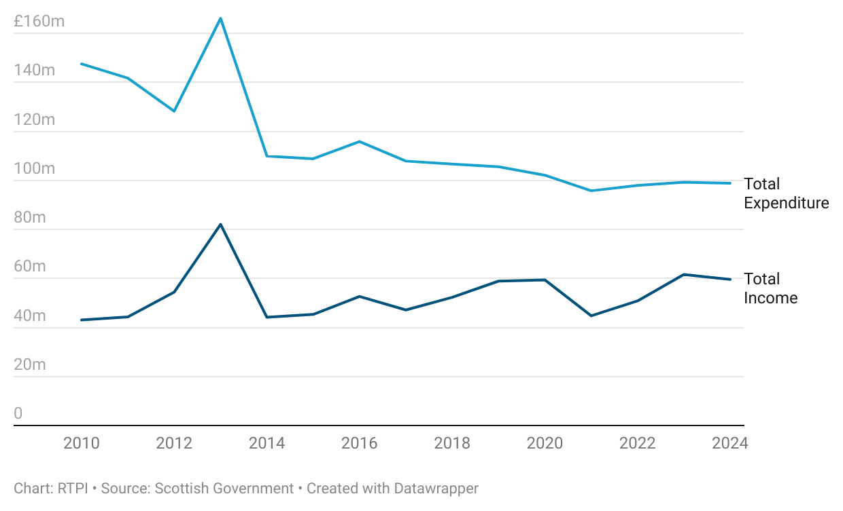

Planning functions were not affected equally, however. Between the financial years ending 2010 and 2024, development management saw a drop in spending of 19%, but a significant increase of 60% in total income, echoing the overall pattern of planning spending in Scotland (figure 2). On the other hand, planning policy saw a drop in both total expenditure and income, with expenditure falling by 48%, and income by 32% in real terms. This drop in funding for planning policy teams has been and will continue to be detrimental to the implementation of the new local development plan process.

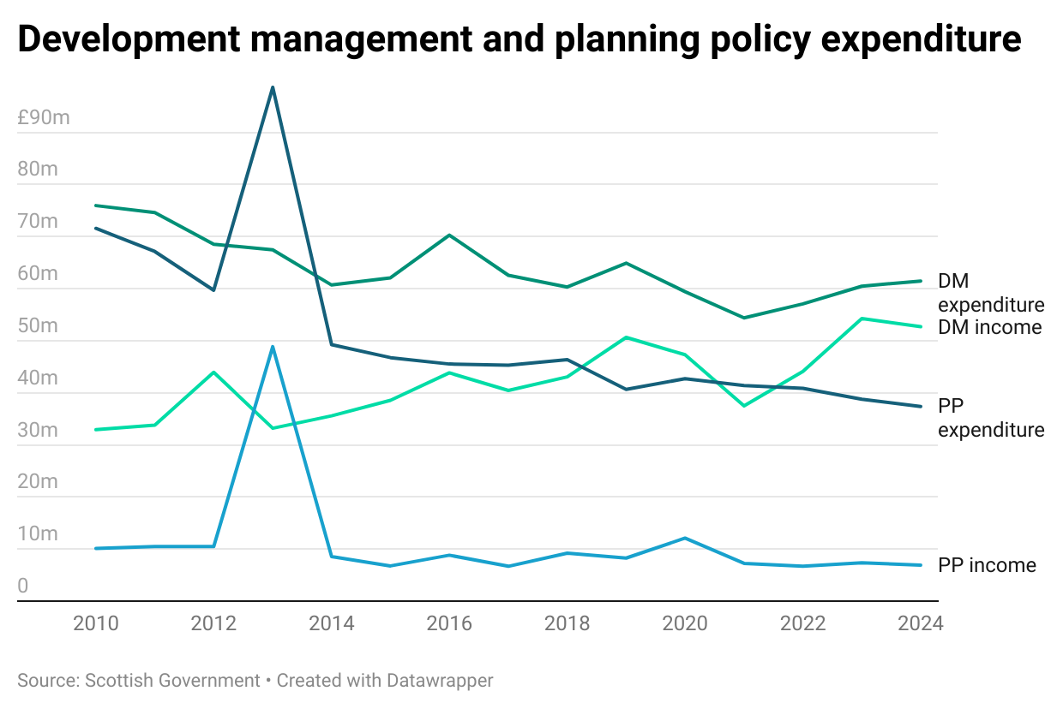
Figure 2. Development management and planning policy expenditure.

Planning performance
This reduced spending on planning has also likely contributed to a rise in the average time taken to issue planning decisions (figure 3). The average decision times for both major and local applications are well above their respective targets of 16 and 8 weeks.
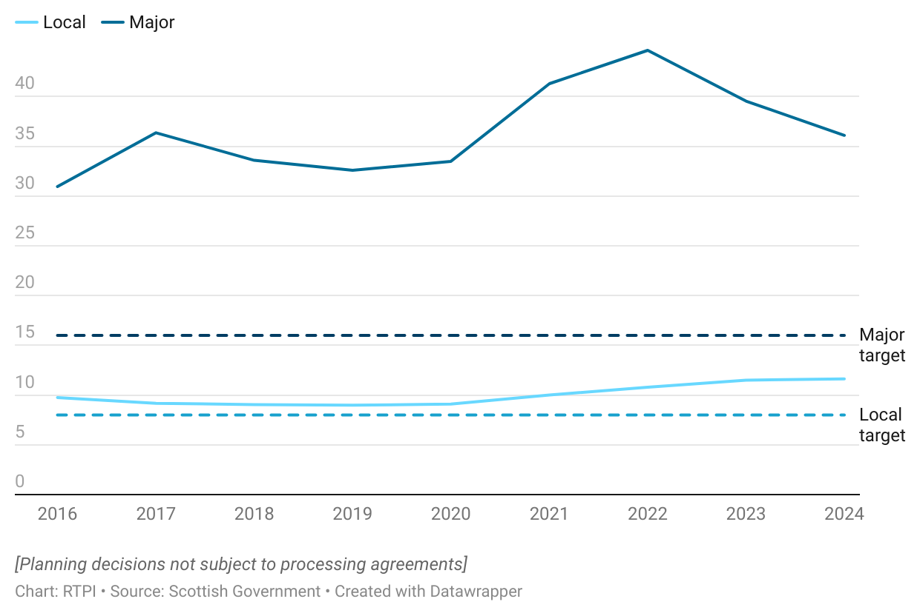
Figure 3. The average number of weeks taken to issue decisions have consistently not met statutory timelines

For local applications, decisions took almost 2 weeks longer to decide in 2024 than at the beginning of the series in 2016. At 11.6 weeks, this is the highest average recorded so far for local decisions and is 3.6 weeks above the target time.
In the case of major developments, applications are taking more than double the target time, at 36.1 weeks on average. Though improved compared to a peak of 44.6 weeks in 2022, major applications still take just over 5 weeks longer on average to decide than in 2016. This suggests planning services may be struggling to get back to their pre-pandemic levels of decision-making.

Planning authorities in 2025
This section will outline findings from a survey of Scottish Local Planning Authorities carried out by National Planning Improvement at the Improvement Service in autumn 2025, around workforce, skills and capacity in the financial year ending 2025. There were 28 responses to the survey from planning authorities in Scotland. The below topics are also explored further in the Improvement Service’s recently published workforce and capacity report [3].
We thank National Planning Improvement at the Improvement Service for their help delivering this survey.

Resourcing and skills gaps
A majority of responding Scottish planning authorities had more than one vacancy, with 44.4% holding 1 to 3 vacancies, 29.6% with 4 to 6 vacancies, and 14.8% with more than 6 (figure 4). Just 11.1% reported zero. The impact of these vacancies will differ between authorities, depending on the seniority of the vacancies, the size of their team, and their workload. Around 11% of authorities had a number of vacancies that equated to a third or more of their reported staff count.
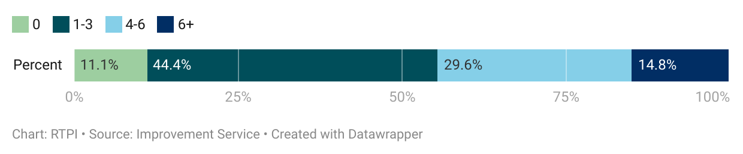
Figure 4. Most Scottish planning authorities had one or more vacancies.

Broken down by roles at different levels of seniority, most vacancies were held in the planning officer, senior planning officer, or ‘other’ categories (figure 5; ‘other’ being roles in planning outside of the standard categories provided).
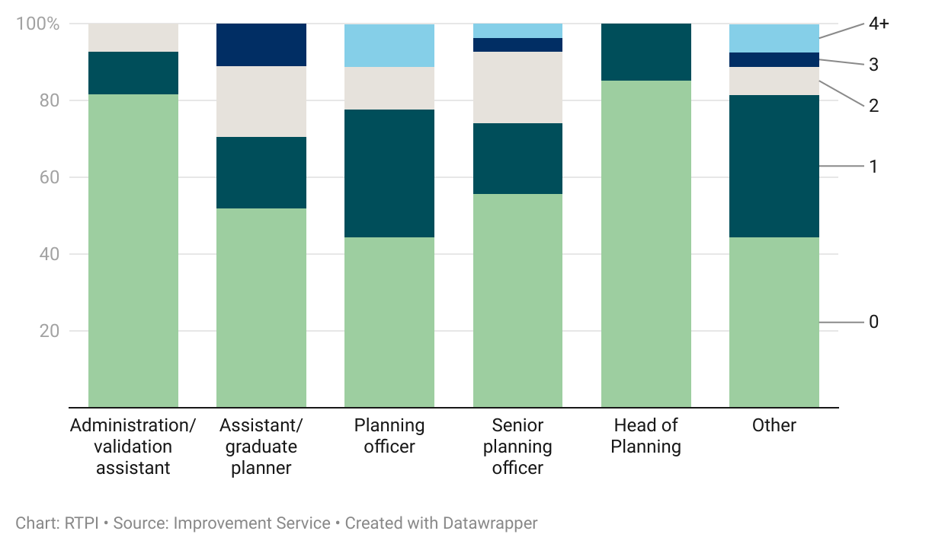
Figure 5. Vacancies were mostly held in planning officer, senior planning officer, and other posts.

This is consistent with the roles that planning authorities said they found the most difficult to recruit for. Senior planning officer roles were reported difficult to fill by 46.4% of authorities (21.4% difficult; 25% very difficult), as were planning officers (39.3% difficult; 7.1% very; figure 6).
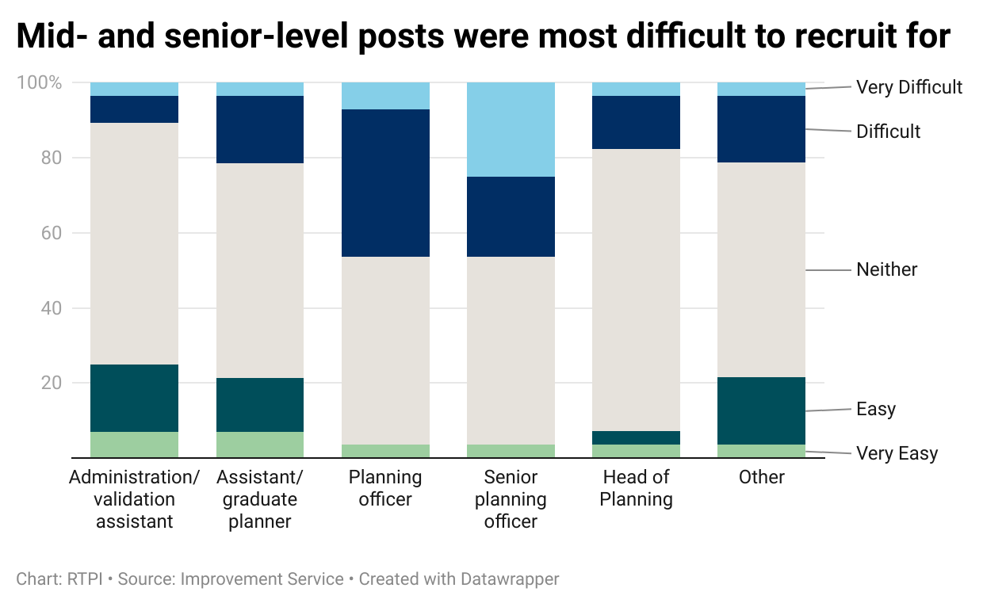
Figure 6. Mid- and senior-level posts were the most difficult to recruit for.
‘Other’ roles, and assistant or graduate planners were both found difficult to recruit by 21.4% (17.9% difficult; 3.6% very). However, overall, 50% or more of authorities reported neither difficulty nor ease when recruiting for each role type.
When asked to select specific areas they had found difficult to recruit in, top reported specialisms included environment, ecology and biodiversity (25%), and energy or renewables (7.1%). However, day-to-day planning functions had the most reported difficulty, with 28.6% of respondents selecting planning policy, and 17.9% enforcement.
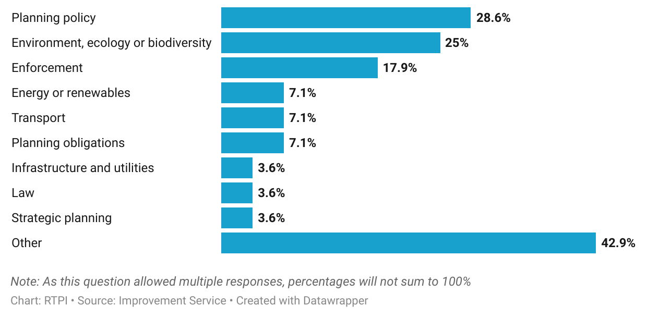
Figure 7. Planning authorities had difficulty recruiting in policy, ecology and biodiversity, and enforcement.

In addition, a high proportion of authorities (42.9%) selected ‘other’. For 58.3% of these, the question was not applicable, as the authority had not needed to recruit in the specific areas listed (e.g. due to small authority size). A quarter (25%) mentioned difficulty recruiting for development management positions, while other areas mentioned included flood technicians, environmental health officers, and quantity surveyors. Other areas included in the question but not chosen by any authorities included digital planning, heritage and conservation, marine planning, commercial, minerals and waste, regeneration and urban design or master planning.
A lack of qualified or experienced applicants was a barrier to recruitment for a significant majority of Scottish planning authorities (67.9%). A smaller (though still notable) proportion cited hiring freezes or lack of funds (35.7%), uncompetitive wages (32.1%) and remote location (28.6%).

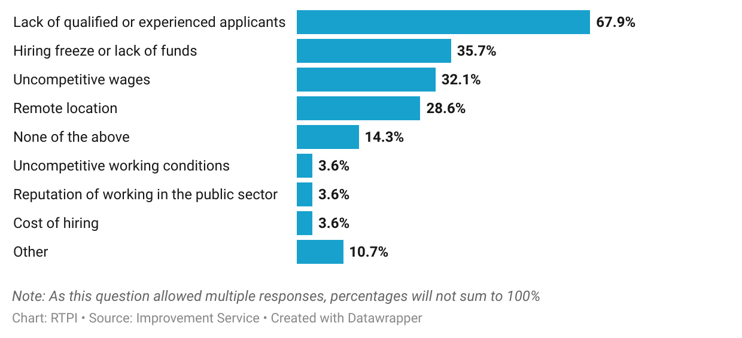
Figure 8. Lack of suitably qualified or experienced candidates was a barrier to recruitment for two thirds of authorities.

While none who selected ‘other’ opted to provide further detail, multiple authorities reported difficulty keeping up with wages offered by other authorities and the private sector, particularly the energy sector. Multiple authorities further recorded increasing pressure on staff, exacerbated when existing staff left.
To help support workforce capacity, 39.2% of authorities had used agency or consultant staff. Other capacity support measures used included use of digital planning tools (21.4%), shared services (17.9%), and artificial intelligence (10.7%). Shared services can be useful for smaller planning authorities that are not able to employ specialists full-time but do need access to one.

Demographics
Of respondents to the members’ survey who worked in local government, 81.7% were between the ages of 30 to 60, consistent with the average age profile reported by Scottish planning authorities. The age profile of member respondents working in local government Is broken down further in figure 9, below, showing that the age group with the highest proportion of respondents was those over 50. This pattern is similar to that found in the 2022 Future Planners research by Heads of Planning Scotland, the Improvement Service, and RTPI Scotland [4].

Figure 9. Age profile of local government respondents in Scotland.
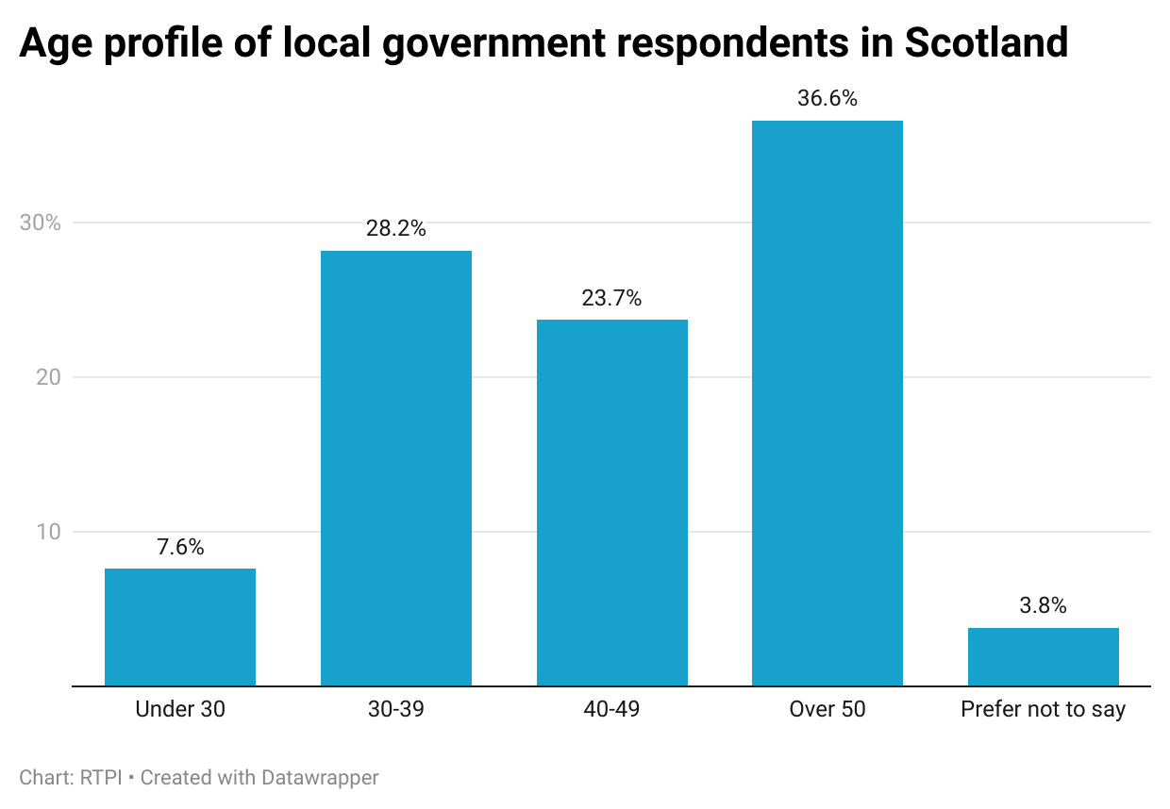

The gender split of local government respondents was even, with 46.6% identifying as female, 49.6% as male, and 3.8% who preferred not to say.
The reported broad ethnic groups of respondents working in local government was slightly more diverse than the Scottish population, as found in the 2022 Census. Of local government respondents to the member survey, 6.1% were Asian or Asian British, 0.8% Black or Black British, 2.3% of Mixed or Multiple ethnic groups, and 84% White. In comparison, the Census found that 92.9% of those usually resident in Scotland identified as White, 3.9% as Asian or Asian British, 1.2% Black or Black British, 1.1% of Mixed or Multiple ethnic groups, and 0.9% another ethnic group. Due to the number of respondents, we advise caution when drawing conclusions from these proportions.
Figure 10. Broad ethnic group of local government respondents in Scotland.
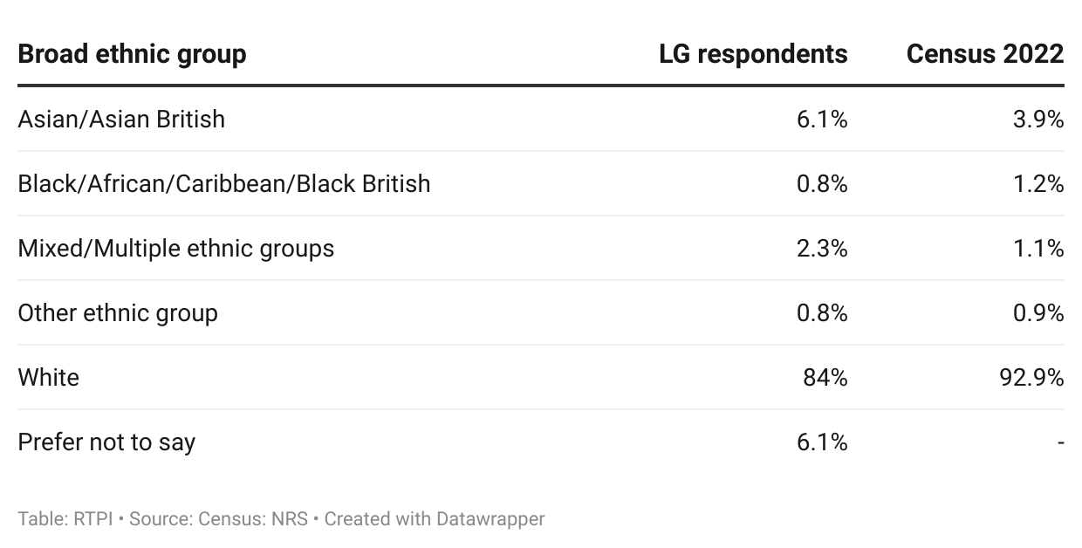

Ways of working
Nearly all planning authorities had a Chief Planning Officer (96.4%) in financial year ending 2025. In the same proportion of authorities, development management and policy making sat together under one directorate. All authorities had development management and enforcement in the same directorate.
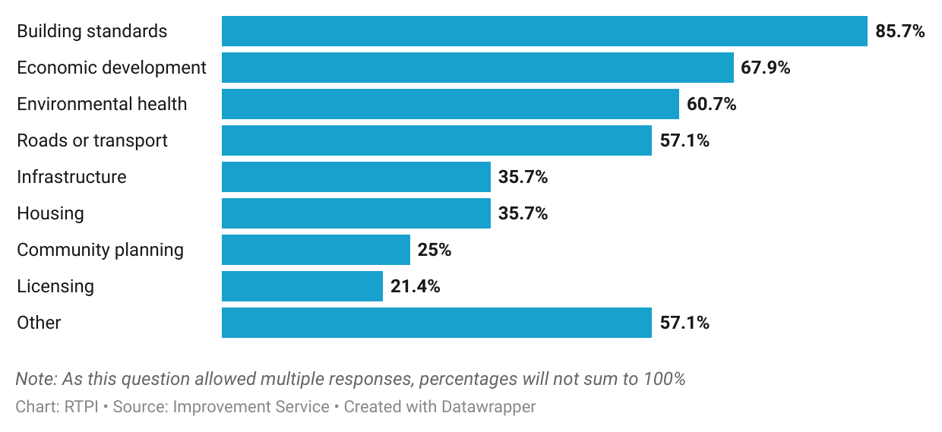
Figure 11. Planning tends to sit in the same directorate as building standards, economic development and environmental health.

Other services commonly reported as being in the same directorate as planning included building standards (in 85.7% of authorities), economic development (67.9%), environmental health (60.7%) and roads or transport (57.1%; figure 11). Some of the areas specified by those who selected ‘other’ were trading standards, climate change and sustainability, regeneration, tourism, culture, sport & leisure, and heritage.
With the capacity issues reported above, digital planning technologies and artificial intelligence (AI) is seen by some as an opportunity to ease workloads and streamline decision making. Most authorities (82.1%) said they had used digital planning technologies or AI in some way, and a majority also intended to use them going forward. A quarter reported that they had no plans for, or were unsure about future use of AI specifically, but had previously used digital technologies, and would presumably continue using them. Relatively few (17.9%) said they had no plans to use digital technologies or AI – one of whom cited resource constraints as a reason for this.
Work-life balance is another key factor that impacts staff capacity; 78.6% of authorities said they offered flexible working to their staff, and all operated a hybrid working model.

Planners in 2025
This section will outline findings from a survey of members of the RTPI working in Scotland, concerning career stage and plans, resourcing and skills gaps, wellbeing, working and volunteering practices, and the geography and demographics of respondents. The member survey had 230 respondents who reported working primarily in Scotland.

Career stage and plans

Area of planning
A majority of respondents worked in local government (57%), with around a third (28.3%) in the private sector. Other sectors were less well represented, with central or devolved government respondents accounting for 6.1%, and remaining sectors for less than 5% each. This means that most respondents were public sector planners (64.8%), with the remainder being private (28.3%) or third sector (2.2%), or ‘other’ (4.8%; such as freelance, career break, specified ‘other’).
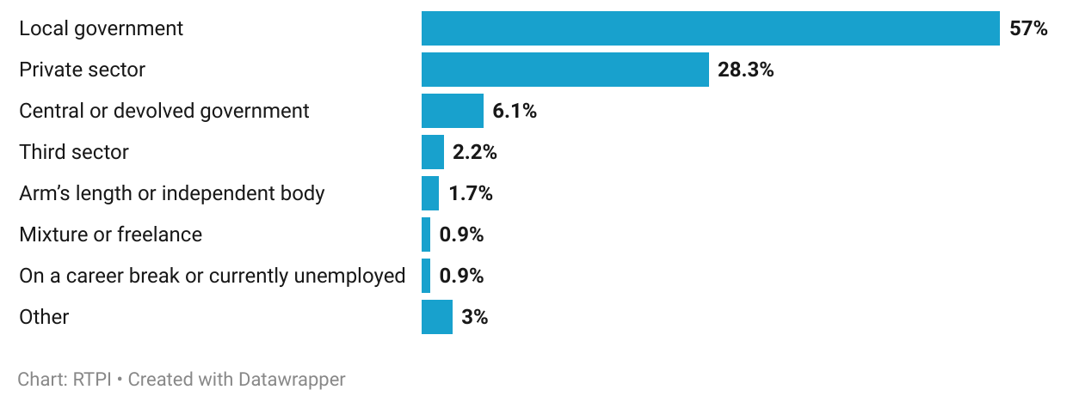
Figure 12. Most respondents working in Scotland were in local government or the private sector.

A wide range of planning areas were represented, but, like other UK nations, the highest proportion worked in development management (30%). This was followed by planning policy (13.5%), and energy and renewables (10.9%). Just under 5% worked in commercial, and environment, ecology and biodiversity (4.8%), and regeneration (4.4%). Of the 6.5% who reported working in another area, 67.7% specified that they worked in multiple, but not all of the listed areas of planning.

Career stage
Almost half of Scottish respondents had 21 or more years of experience in planning, at 46.1%, while around 35.7% had been in the profession for between 5 and 20 years, and 18.3% less than 5. Most respondents were early or mid-career professionals, with 54.3% at the graduate or assistant planner, planning officer, or senior planner level. Of the 11.3% that did not fit into these categories and described their role as ‘other’, 26.9% were consultants. Among other roles specified were planning technicians, research fellows, and architects.
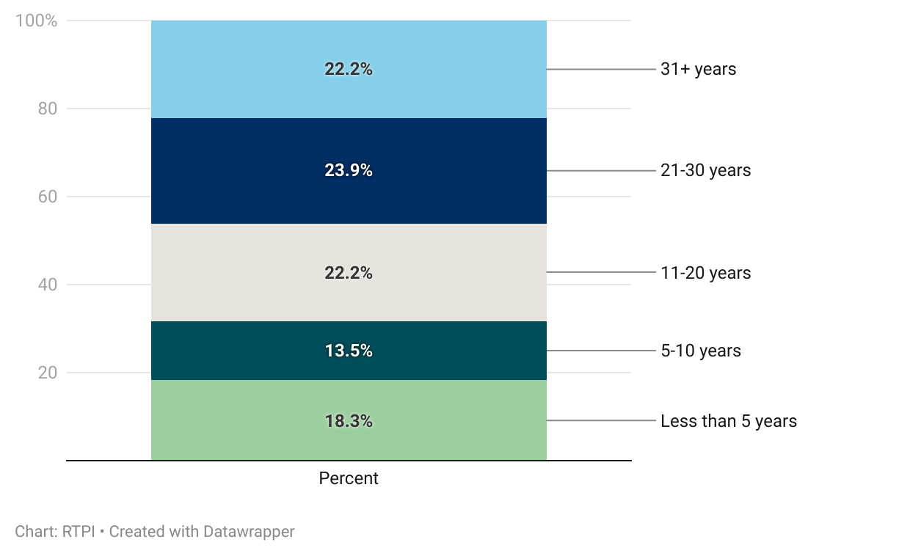
Figure 13. Nearly half of respondents had at least 21 years of experience in planning.

The most reported salary band by planners working in Scotland was £40,001 to £50,000. When split by sector, this remained the case for the public sector, whereas private sector planners were more likely to earn £80,001 or more.
Figure 14. The modal salary band among respondents was £40,001 to £50,000.
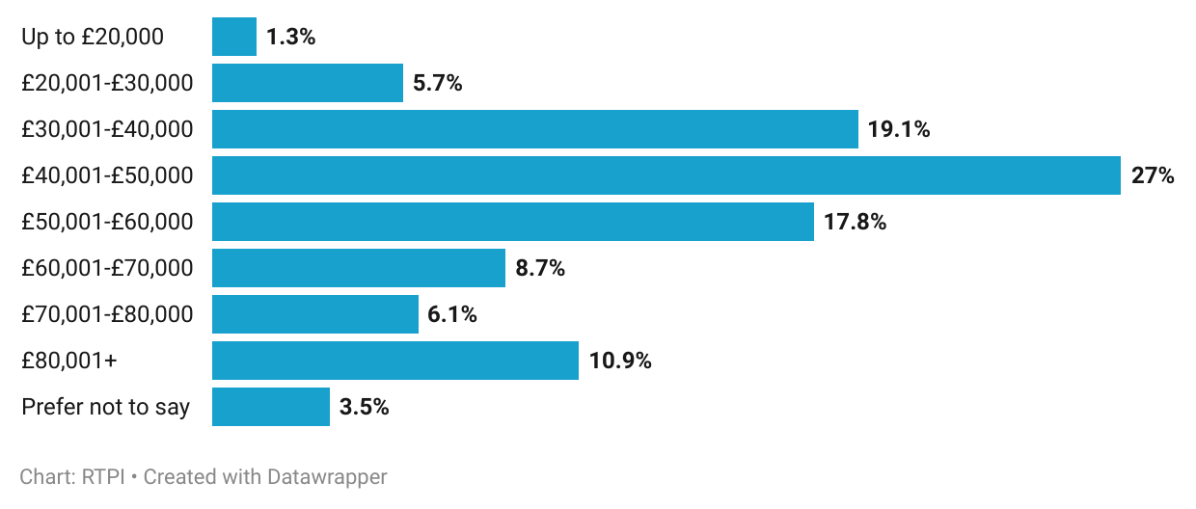

Slightly under half of respondents earned within the middle of the range, between £40,000 to £60,000 (44.8%). Overall, this salary distribution was comparable to other UK nations, and to the UK as a whole.
More than half of respondents were satisfied with their salaries (16.5% very, 47.5% somewhat). Career progression satisfaction, too, was generally high, with 25.7% very and 43% somewhat satisfied. While a slightly higher proportion of public than private sector planners were unsatisfied with both salaries and progression, in both cases, a majority remained satisfied. Satisfaction with salary was also lower among more junior planners. A lower proportion of those in graduate planner and planning officer roles reported being very or somewhat satisfied with their salaries (53.6%, 52.8%, respectively) than senior planners, principal planners and heads of planning (at 61.4%, 63.2% and 81.1%).
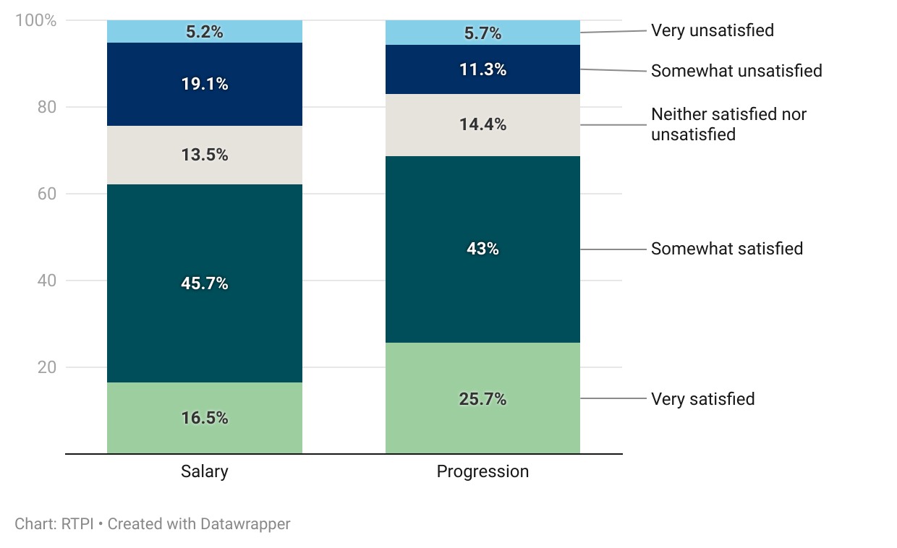
Figure 15. Planners working in Scotland were mostly satisfied with their salaries and career progression.

These levels of satisfaction are reflected in respondents’ future career plans for the next three years, where a sizable majority intended to remain with their current employer, either in their current role (45.2%), or seeking another (16.5%). A further 11.3% looked to move elsewhere within their sector, with 10.3% planning on retiring. In addition to the 3.9% who planned to move to a different profession, this suggests that 14.2% of respondents in Scotland intend to leave the planning profession in the coming years. Of the ‘other’ plans specified, 38.5% were independent consultants intending to continue growing their practice, while others had plans to diversify or specialise.

Resourcing and skills gaps

Skills and training
A small proportion of respondents felt they had no gaps in knowledge or skills in any specialist areas (10%). Areas with a high proportion of knowledge gaps among Scottish planners were consistent with those in other UK nations; 46.5% of respondents felt they had a gap relating to both digital, data and GIS, and marine planning. This was followed by energy and renewables (36.5%), ecology and biodiversity (36.1%) and infrastructure and utilities (33.9%).
These reported specialist knowledge or skills gaps may reflect the current salience of the respective policy areas, with changes in the NPF4 elevating the need for ecological expertise, and with the intended transition towards renewable energy making marine, energy and infrastructure knowledge more important.
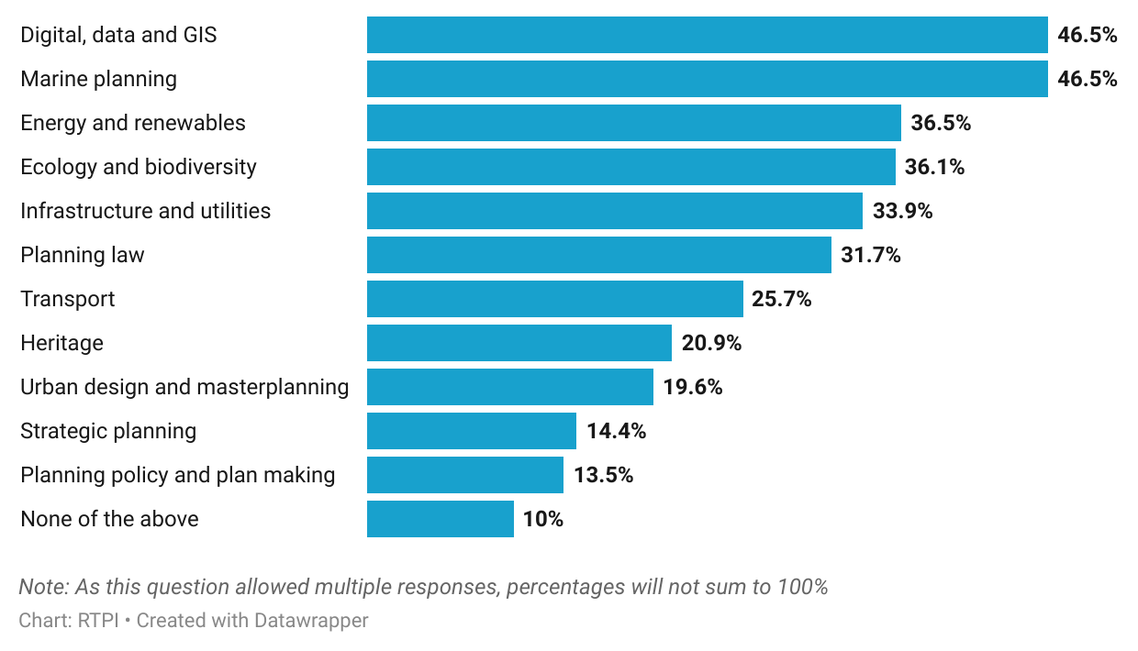
Figure 16. Digital, marine and energy planning were top reported specialist skill or knowledge gaps.

Around a third of respondents felt they had no gaps in knowledge or skills relating to a range of generalist areas that might be used in their day-to-day work (32.6%; figure 17). However, among those areas planners did feel they had a gap in were business development (30%), negotiation and mediation (26.1%), project, and people management (25.2%, 21.3%, respectively).
Figure 17. Business development and negotiation were top reported generalist skill or knowledge gaps.
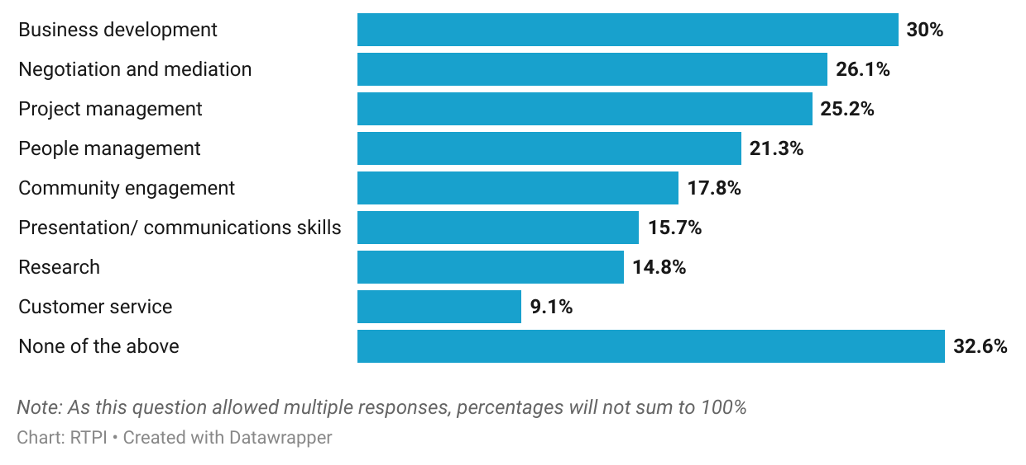

Despite the high proportion with knowledge gaps in some of the areas listed above, 58.7% of respondents were somewhat or very satisfied with the training opportunities they had (compared to 19.2% unsatisfied).

Capacity and challenges
When asked how often their teams lacked capacity to meet demand, a small majority of Scottish planners reported lacking capacity, either frequently (20.4%) or all the time (34.4%). This was almost twice as likely in the public sector (65.8%) than the private sector (33.8%). This is one of the challenges explored in respondents’ own words, below.
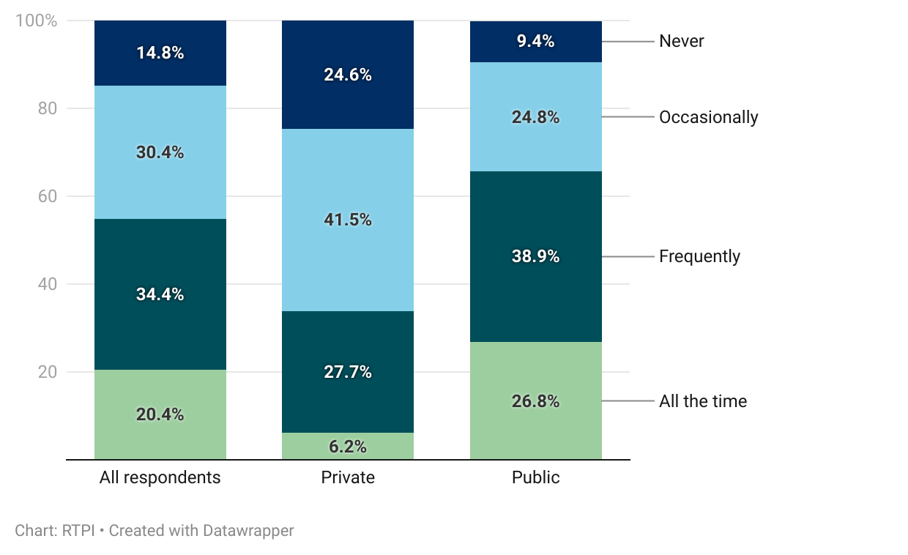
Figure 18. Public sector planning teams were more likely to lack capacity to meet demand.

For those who reported lacking capacity frequently or all the time, the most common reason identified was high workloads (35.2%). Under-funding was cited by almost a quarter (24.8%), and increased complexity of work by 20%. A slightly smaller proportion (18.3%) thought recruitment difficulties and external factors (17.8%; such as delays with statutory consultees, planning committees or other stakeholders) had contributed.
Consequently, a higher proportion of respondents were pessimistic about the future direction of the Scottish planning system than were optimistic (42.2%, compared to 33%). In contrast to other UK nations, pessimism was lower in the public than the private sector (41.6%, 47.7%, respectively).

Greatest challenge
When respondents were asked what they thought are the greatest challenges facing the Scottish planning system in the coming year, the most common themes were staffing and recruitment, and funding and resourcing. This is consistent with other UK nations. One local government planner commented that due to rising demand and complexity in the system, “planners are facing pressure to develop expertise in specialised areas” ordinarily covered by external consultees, adding that this “raises concerns about capacity, effectiveness, and the sustainability of current workloads”. Increasing complexity was linked by multiple respondents to recent legislation and policy, and the consequences of Scottish Government not properly considering “resourcing shortfalls and complexity of the matters…included within NPF 4”. The impacts of increasing workload and complexity extends to personal development, where one planner pointed out that it was increasingly hard to keep up with training and CPD, as workloads were such that this could be done only “at the cost of impacting your ability to stay on top of your work”. As a result, planners “not only risk getting de-skilled”, but are less able to engage with elements of the job they are interested in, or passionate about.
Recruitment, too, was an issue raised by many, with multiple levels of seniority highlighted. At entry level, specific issues included wages, with one young planner remarking that it is “difficult to find positions that are even paid at living wage”. With an ongoing crisis in the cost of living, this is a trade-off young planners are increasingly unwilling to make. Additionally, the lack of undergraduate planning degrees in Scotland could prove an issue for young people interested in the built environment, and “may limit how many people come into the profession”. Multiple respondents across sectors thought a lack of mid-career staff was also a problem, tying this (particularly in the public sector) to issues foreseen with succession planning. Overall, there was a recognition of the need “to meet the demand in terms of number of people entering the profession versus the number of people retiring from the profession”.
At the heart of planning as a profession is the balancing of factors to come to a decision about what constitutes sustainable development. Numerous respondents thought that balancing priorities would be a key challenge in the near future. In particular, balancing “the competing demands of economic growth, population growth, housing demand, transport, and sustainability/environment/ecology”.
Intentions to transition away from fossil fuels, towards renewable energy solutions may be hampered by a lack of energy planning expertise. This is an area that some LPAs reported difficulty recruiting in, and a fair proportion of member respondents reported a knowledge or skill gap in. One private sector respondent commented that “there simply is not enough qualified Town Planners across the public sector to process planning and S36/S37 Electricity Act 1989 applications quick enough”. A local government planner commented further that this legislation was out of date, and that “unrealistic deadlines” were imposed on Local Authorities to consent to electricity infrastructure, denting the confidence of locals in planning. Another local government planner linked this back to net-zero, and that there is a “need to upgrade the energy network to meet the needs of renewable sources of electricity” but that such efforts faced “increasing levels of public objection”.
However, the increasing policy salience of planning could also prove an opportunity. In the words of one respondent, “there is an increasing understanding of… the need to build good places, which provides positive opportunities for planners to make a difference in this important area, if we rise to the challenge”. Highlighted also was the opportunity for technology to free up planners’ time, allowing more focus on proactive placemaking.

Wellbeing
Positively, most respondents were somewhat (43.5%) or very (18.3%) happy working in planning. One respondent commented that “I'm quite proud of being a planner and the planning profession generally”. Others who expressed a similar sentiment related this to the impact they felt they could have in their role, “balancing the need for economic development growth with viability… while ensuring good placemaking outcomes and supporting delivery of community infrastructure”.
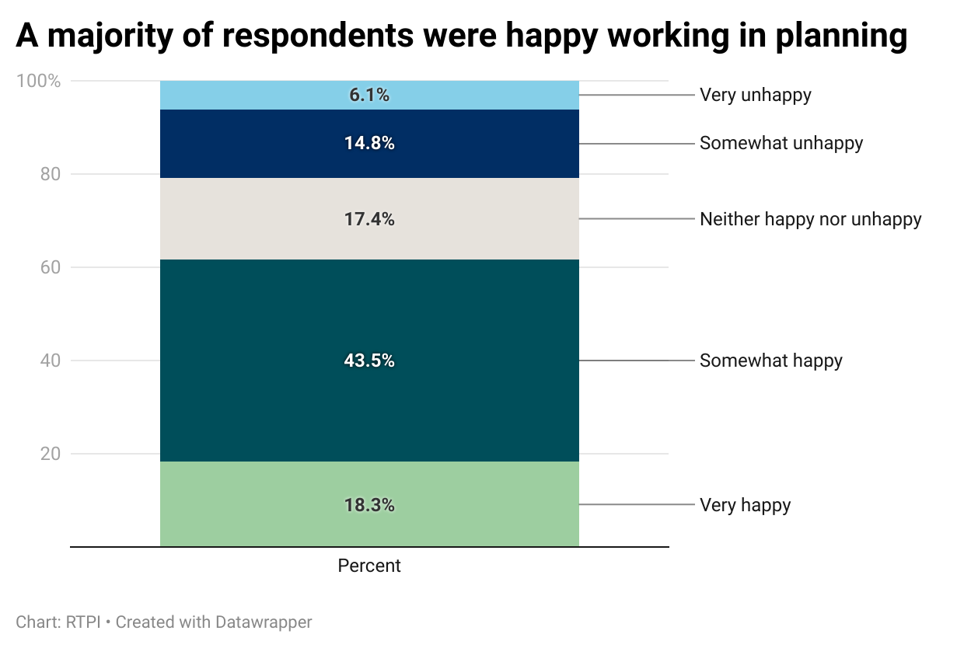
Figure 19. A majority of respondents were happy working in planning.

Despite this, one of the most frequently reported challenges faced by respondents was workload, and dealing with increased demand, on top of increasing complexity, often without adequate resource to do so. It is perhaps unsurprising, then, that 59.6% felt personally overstretched frequently, or all the time.
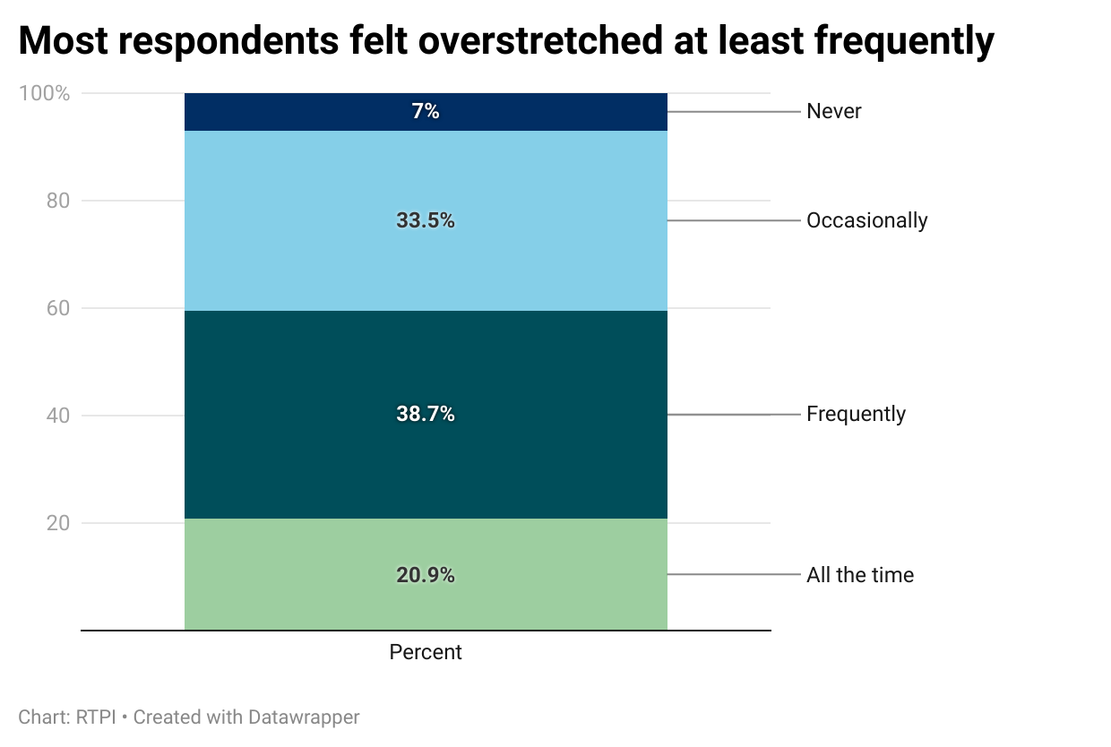
Figure 20. Most respondents felt overstretched at least frequently.

Moreover, this confluence of factors can contribute to decisions taking longer to issue, leading to dissatisfied applicants or stakeholders, and the resultant impact on the public perception of the profession. Reflecting this, nearly three quarters (74%) of respondents thought the public perception of the planning profession was somewhat or very unfavourable. Consequently, 49.1% reported this having a negative impact on their wellbeing. Likely also contributing here is the proportion of respondents working in Scotland who had experienced abuse, at 64.8%.
Figure 21. Almost two thirds had experienced abuse.
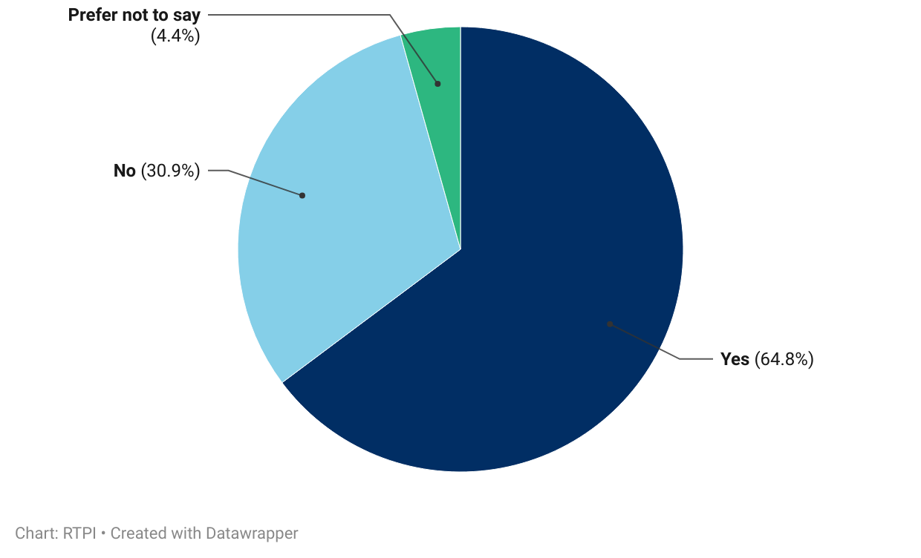

When invited to elaborate on their answers in this section, responses made it apparent that instances of unpleasantness and abuse had unfortunately become more common in recent years, such that “it's becoming normalised and accepted as part of the job”. Public consultation events were mentioned by a fifth (20.6%) of those who chose to expand on their experiences, with one private sector planner commenting that where there are “perceived systemic failures… planners are inevitably the target for outlay of frustrations and public events provide a forum and audience for this”. Multiple respondents reported also experiencing ill treatment from planning agents, developers, and elected representatives.
Social media has played an increasing role post-covid, giving people the “opportunity to vent opinions in a very personal and public way” if a planning decision did not go their way. Several reported that this has contributed to disinformation and conspiracy theories, with associated communications on the relevant topics sometimes tipping over into abuse. Among these were accusations of corruption, which one respondent said was a “constant refrain on social media”, another elaborated that “even the most carefully planned and consulted on development leads to shouts of 'brown envelopes'”.
As this suggests, and as reported by respondents above, there is felt to be a negative public perception of the planning profession, something that is compounded by poor resourcing in the public sector. One local government planner remarked that this perception “becomes harder to deal with when you cannot meet expectations from applicants due to lack of resources”. Another put this down to a “disconnect between… aspirations of the Scottish Government and the resourcing of those tasked at [the] sharp end of delivery”.
Several respondents suggested that the perception of the planning profession could be improved with greater public understanding of its purpose. A planner working in central government contended that “much of the core of the problem is that… the general public still don't understand what land use planning even is”, often conflating it with “the work of private developers, statutory undertakers, local council improvement works etc.”. Political rhetoric and the media were identified as key factors in this and could therefore be key levers for addressing it.

Working and volunteering practices
Most respondents working in Scotland worked between their home and their office, with 76.1% being hybrid, while 14.4% were solely office-based, and 9.6% home-based. Just under half (47%) used flexi time as a flexible working option, with 12.6% doing compressed hours. Other flexible working options like a 4-day week and annualised hours were much less common (3%), and a significant proportion (39.6%) reported using no flexible working practices.
Figure 22. Use of flexible working practices among respondents working in Scotland.
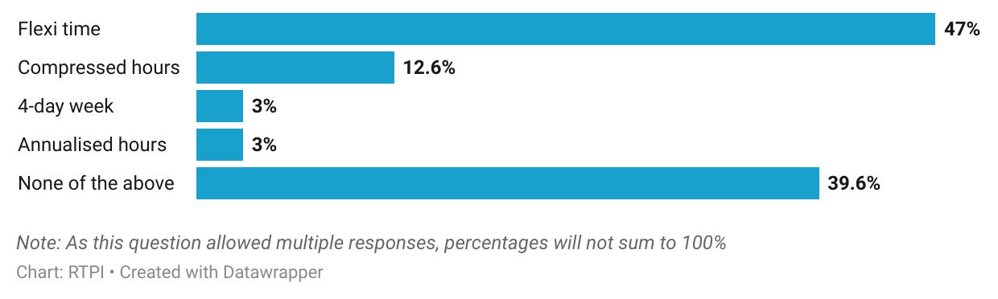

Of the 27.8% who volunteered in their capacity as a planner, the highest proportion of these did so with Planning Aid Scotland, or as a member of a committee or board (both 39.1% of those who volunteered). Over quarter engaged in educational outreach (28.1%) and pro-bono consultation (26.6%). ‘Other’ forms of volunteering specified included advising charities, place-based learning and development, and voluntary work in other built environment professions, like architecture.
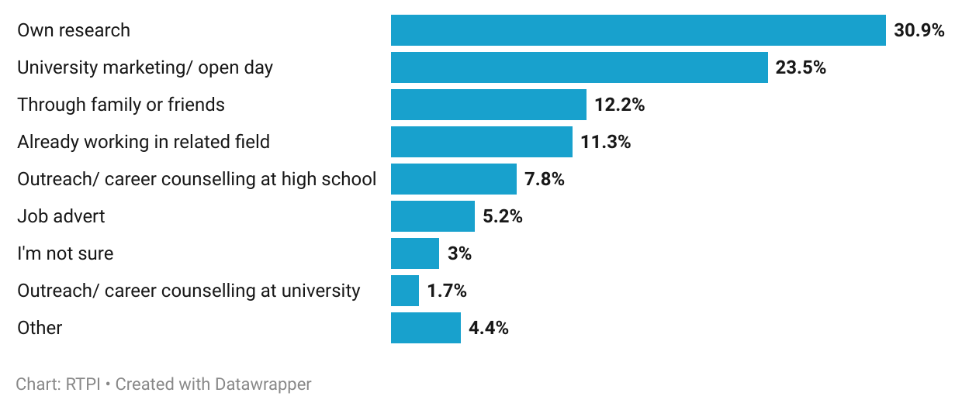
Figure 23. Most respondents learned about planning as a career through their own research or education.

Education was the most common way respondents said they had learned about planning as a career, with 33% hearing about the profession through university marketing, university careers counselling, or school careers counselling. A high proportion also learned about planning through their own research (30.9%), or family or friends (12.2%).

Who responded

Geography
When asked which region of Scotland respondents primarily worked in, the West of Scotland was the most well represented, at 23%. This was followed by Central Scotland (18.7%), the Highlands and Islands (14.8%), and East of Scotland (10%). Fewer respondents worked in Grampian (8.3%), the South East (7.4%), and Dumfries and Galloway (1.7%).
Those working nationally, such as on central policy, or infrastructure projects accounted for 16.1% of responses. Caution is advised here, as ‘national’ was mistakenly omitted as a response option initially, meaning early respondents to the survey were not able to select it where they perhaps would have, if available.
Figure 24. Scottish region respondents primarily worked in.
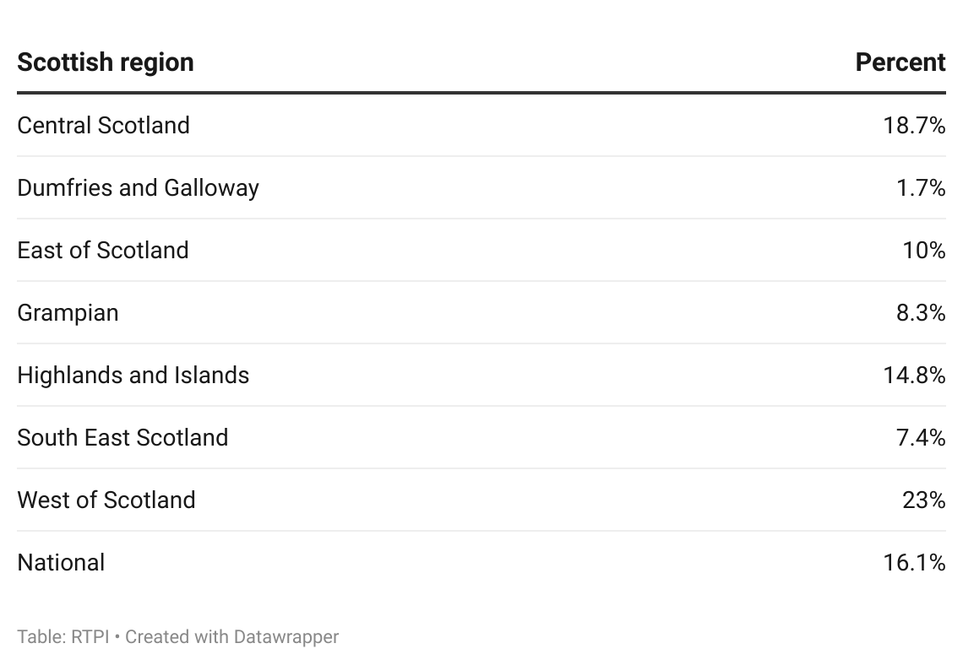

Demographics
The age profile of respondents, below, shows that older age groups were slightly better represented. Of those who provided their age, 44.6% were under 45, while 55.4% were over. Some of the largest age groups were those who may intend to retire in the next 10 to 15 years, while the proportion in younger age groups point to the issue mentioned by both planning authorities and members, of recruiting young planners.
The gender profile of respondents was relatively evenly split between those identifying as male (52.6%) and female (44.8%). Those who preferred not to disclose accounted for 2.2%, with remaining respondents using another term.

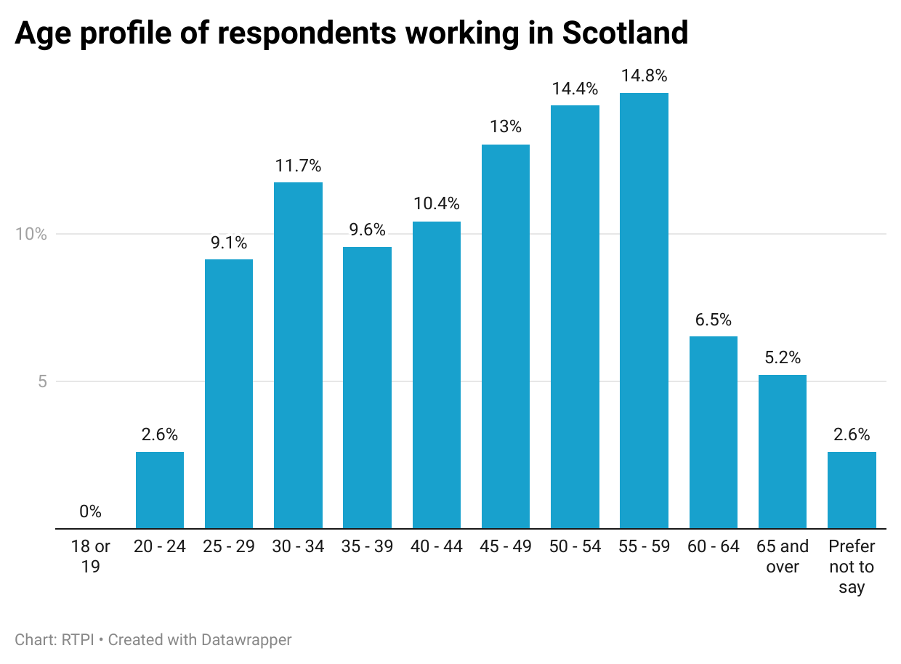
Figure 25. Age profile of respondents working in Scotland.

A large majority of respondents (88.3%) self-reported their broad ethnic group as White, while the next largest group was Asian or Asian British, at 4.8%. Following these were respondents of Mixed or Multiple ethnic groups (1.3%), and Black or Black British or Other ethnic groups (both 0.9%). Of note is that respondents working in Scotland as a whole were slightly more diverse than the Scottish population as enumerated in the 2022 Census.
In similar proportions to other UK nations, 8.3% of respondents working in Scotland reported being disabled, or having an impairment, condition or access need.
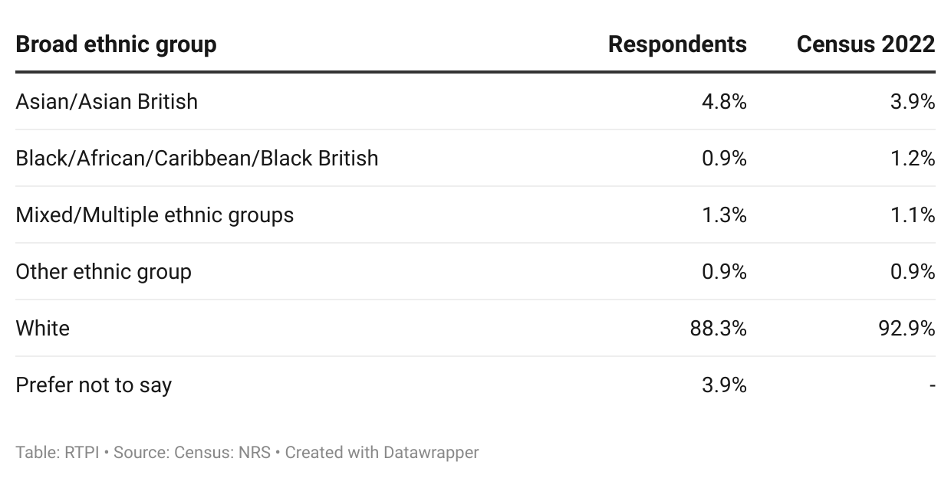
Figure 26. Broad ethnic group of respondents working in Scotland.

Conclusion: what does this mean for the Scottish planning profession?
This report set out to explore the experiences of planners working in Scotland, with particular attention to workforce capacity, skills, training and wellbeing. The above presents a nuanced picture of a sector that though largely happy working in planning, and generally satisfied with salaries and progression, are nevertheless operating under considerable strain from resource shortages, along with increasing policy complexity, and evolving technical demands.
While overall satisfaction with pay and progression is high, persistent challenges relating to workload, funding, and recruitment shape planners’ day-to-day experience, particularly in the public sector. The reduction in funding between 2010 and 2025 has had a significant impact on planning teams’ ability to meet demand, and levels of demand will only increase where planning is critical to addressing several major policy challenges. Capacity pressures are widespread, alongside skill or knowledge gaps, and recruitment difficulties in areas aligned with Scotland’s future priorities. These trends underline the need for sustained investment in staffing and professional development to keep pace with the system’s expanding technical scope. Part of this will be ensuring that there are numerous and diverse routes into the profession, including through university, apprenticeships, and mid-career change pathways.
As national priorities like implementing the NPF4, climate transition and biodiversity increase expectations of the planning system, there is a growing risk that ambition may outstrip capacity. Without targeted measures to address workforce pressures, planners’ ability to deliver on these policy commitments will continue to be undermined. Coordinated action from government, employers and professional bodies like the RTPI will be critical to support a resilient profession that’s ready for the future.
Despite these challenges, there are also reasons for optimism. Many planners recognised the increasing importance of planning in achieving Scotland’s social and environmental goals. Further, advances in technology and data tools present opportunities to streamline processes and refocus on proactive placemaking and community engagement. This is an opportunity that the Scottish Government should grasp.
Looking ahead, strengthening workforce capacity, expanding training pathways, and improving public understanding of planning’s purpose should be central priorities. Investing in planners as professionals through fair remuneration, career progression, and access to continuous learning will be essential to ensuring the system’s long-term sustainability. Ultimately, the findings affirm that Scotland’s planning ambitions rest on the strength of its people. Supporting, valuing, and equipping planners to meet the challenges ahead is vital to delivering the well-designed, inclusive, and sustainable Scotland of the future.

Appendices

Appendix A – Methodology
The data in this report were collected using a survey of working RTPI members, and senior Local Planning Authority officials in Scotland. The RTPI commissioned Research by Design, a market research firm to conduct the member survey. Research by Design provided final survey data to RTPI anonymised, to maintain respondents’ confidentiality.
The RTPI partnered with National Planning Improvement at the Improvement Service to deliver the survey to Scottish planning authorities.
Survey questions were designed in part to give similar or related outputs to the key outputs from the 2023 State of the Profession report, as well as to provide a baseline for future State of the Profession survey reports. The 2023 State of the Profession report used Office for National Statistics (ONS) Labour Force Survey (LFS) data, but due to a combination of occupation recoding by ONS, and low survey response rates for the LFS, the RTPI decided to design its own surveys to investigate the State of the Profession.
Members
The member’s survey ran for a month over summer 2025. The survey was sent to 22,382 members, and received 2,808 responses, which equates to a 12.5% response rate.
There were 230 responses from members working primarily in Scotland, 8.2% of the overall response. As we wanted to survey working planners with current experience of the planning system, retired members and full-time students were screened out.
For country reports, survey responses were filtered on a question asking “Which RTPI nation is the majority of your planning work for?” and only responses related to the relevant country analysed. Where relevant, responses were broken down by the broad sector that respondents reported working in (public, private, third, other), their level of seniority, or their gender.
Members were asked questions about their career stage and career plans, personal skills gaps, resourcing in their workplace, working and volunteering practices, about their personal wellbeing, and demographics. Survey results represent a snapshot in time, and the survey was self-selecting, meaning responses may not be representative of the wider population.
Local Planning Authorities
To deliver the planning authority survey in Scotland, the RTPI partnered with National Planning Improvement at the Improvement Service to deliver the survey to Scottish planning authorities. The LPA survey was run over three weeks in autumn 2025, and asked respondents’ information about their respective planning authorities relating to the financial year 2024/25.
The Scottish planning authority survey received 28 responses out of 34 authorities, amounting to an 82.4% response rate.
LPA respondents were asked about the current size and number of vacancies in their authority, as well as the difficulty they have recruiting at each level of seniority. Respondents were also asked to report the specialist areas they had most difficulty recruiting for, barriers to recruitment, and the structure, working practices and demographic makeup of their planning authority.
We are grateful to the Improvement Service for their help in delivering this survey.

Appendix B – Data sources
Figures 1, 2: Scottish Local Government Financial Statistics (SGLFS)
https://www.gov.scot/collections/local-government-finance-statistics/#scottishlocalgovernmentfinancialstatistics
These were adjusted for inflation using the UK GDP deflator, below.
UK GDP deflator
https://www.gov.uk/government/collections/gdp-deflators-at-market-prices-and-money-gdp
Expenditure on planning was adjusted for inflation as measured with the GDP deflator rather than the headline Consumer Price Index or CPI. The GDP deflator measures base inflation in the economy, while CPI focuses on prices of consumer goods.

Figure 3: Planning applications statistics
https://www.gov.scot/collections/planning-statistics/
Time taken to issue decisions (major) – Table 2
Time taken to issue decisions (local) – Table 3

Figures 4 to 11: Local Planning Authority Survey
https://www.improvementservice.org.uk/products-and-services/planning-and-place-based-approaches/national-planning-improvement/insights-and-analysis/workforce-and-capacity-report
National Planning Improvement at the Improvement Service

Figures 10, 25: Census 2022 broad ethnic group statistics
https://www.scotlandscensus.gov.uk/search-the-census#/search-by
Table UV201 - Ethnic group

Appendix C – References
[1] https://www.gov.scot/publications/development-plan-examinations/pages/gate-checks/
[2] See RTPI Scotland’s report on the financial implications of the Planning (Scotland) Act 2019 at https://www.rtpi.org.uk/media/exnita5m/rtpi-scotland-financial-implications-of-implementing-the-planning-scotland-act-2019.pdf
[3] https://www.improvementservice.org.uk/products-and-services/planning-and-place-based-approaches/national-planning-improvement/insights-and-analysis/workforce-and-capacity-report
[4] https://hopscotland.org.uk/future-planners-project/; page 14

Contact information
For feedback or queries, contact analysis@rtpi.org.uk

