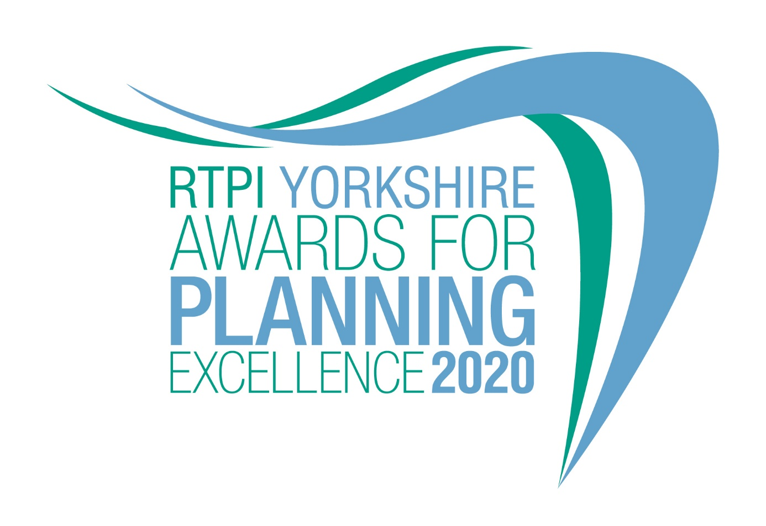

Awards for Planning Excellence
Entry Form and Category Information

Submission deadline: Friday 26 June 2020

The RTPI Yorkshire Awards for Planning Excellence 2020

The Awards champion the very best examples of planning and planners in Yorkshire. They demonstrate the positive impact planning has on our quality of life and celebrate professional expertise. The Awards are open to all planners, both members and non-members, and all other built environment professions and community groups. Winning or being shortlisted is a clear demonstration of high quality work and professionalism.

Entry into the awards is free.

Categories

Submissions to the RTPI Yorkshire Awards for Planning Excellence 2020 are invited relating to the following two categories:

- Excellence in Planning Delivery (Projects)
- Excellence in Plan Making (eg. Local Plans, Strategies, Neighbourhood Plans, Masterplans)
Eligibility

Planning work completed in 2018, through 2019 or completed during 2020 by the submission closing date 26 June 2020, is eligible for entry; even if the planners’ role was completed years prior. Particular care should be taken to avoid entering schemes prematurely before they can be satisfactorily assessed. Your entry needs to provide evidence that the plan is working on the ground and is delivering outcomes. For example, if your project has only receiving planning permission and no tangible benefits have yet been realised, this would be considered too premature or whilst your strategy has been adopted you are unable to show how it has been implemented.

An individual submission may be entered in one or both categories.

How to enter
1. Download and save this document..
2. Complete the entry form below and save.
3. Send your completed form and images of the project (please see below guidance on the images) to yorkshire@rtpi.org.uk by 5pm on Friday 26 June 2020.
4. Upon receiving your entry form and images RTPI Yorkshire will acknowledge receipt by close of play Friday 3 July 2020. If we do not receive a completed entry form and images entries will not be accepted.
5. An extension to the submission deadline must be agreed before the 26th June deadline.

Guidance for sending images

- Please send 3 images of the project with each image named as to what it shows.
- Each image must be a high resolution image. We recommend the file size is 1MB – 2MB.
- In the file name, please state the name of the project and organisation and who we need to credit the images to.
- Should you be shortlisted, these images will be used in the awards publicity campaign and during the ceremony

Entry form

Contact name (this should be the main point of contact for all correspondence relating the awards):

Contact job title:

Contact email:

Contact telephone:

Organisation(s) submitting this project (joint submissions are encouraged)

Organisation address(es):

Name of project (This name will be used in all publicity, so please ensure it is accurate):

Location of project (please also include a postcode if appropriate):

Please advise which (if any) other organisations you have worked with on this project (e.g. other planning consultants, local planning authorities):

Media/PR contact (name and email address):

Social media accounts (RTPI Yorkshire will engage with shortlisted and winning entries on social media. Please list accounts where possible):
Twitter:
Instagram:
Facebook:

Please confirm RTPI Yorkshire can share your contact details including email address with the Awards Judging Panel
☐ YES
☐ NO

Entry Category:

Please indicate the RTPI Yorkshire Category in which you wish your submission to be judged.
☐ Excellence in Planning Delivery
☐ Excellence in Plan Making Practice

The Judging Panel reserves the right to, in agreement with the entrant, vary the category in which the submission is judged from that indicated by the entrant

Please provide a 25 word and a 100 word overview of your project, written in the third person. Should the submission be shortlisted, the 25 word summary will feature on the RTPI Yorkshire website and in the Awards ceremony programme. For winners and commended submissions the 100 word summary will be available on the RTPI Yorkshire website.
(100 word summary)
(25 word summary)

Image/Video reference table:

Please complete the table for each image you have emailed together with your entry form, stating the image number/name followed by a brief description (max 15 words) so that each image can be identified easily.

Include the name of the photographer/artist/company to be credited in any publicity.

Number – File name | Short Description of Image | To be Credited
e.g. 1 – Aerial view | Aerial view of mixed housing types | Taylor Wimpey
1
2
3
4
5

You will need to critically evaluate the work carried out and must demonstrate the strengths of your project. Please highlight the specific role planning has played in the project and highlight any difficulties and constraints planners had to overcome.

It is crucial you demonstrate the planning value of the project throughout the submission.

Award criteria

1. Background
Please outline the background to the project:

- context
- timeline (including phase in project, eg. in recognition that some planning work may have been done earlier)

(insert your answer here – MAX 500 words)

2. Outcomes

Please outline what positive impacts the project has provided for:

- the local community
- the economy
- the environment
(insert your answer here – MAX 500 words)

- Planning contribution

Please outline how the project has benefitted from the involvement of a planner or planners:
- providing strong and effective leadership and vision
- working in partnership with others
- managing implementation and delivery
(insert your answer here – MAX 500 words)

- Sustainable development

Please outline how the project has supported:

- positive short, medium and long term public benefit
- a balance of economic, social and environmental objectives
- the UN’s Sustainable Development Goals
- aimed to prevent or mitigate climate change

(insert your answer here – MAX 500 words)

- Community benefit

Please outline how the project has provided:
- positive and constructive engagement and dialogue with local people and businesses
- a better quality of life for people, especially for disadvantaged communities
- tangible benefits for communities such as facilities, infrastructure, jobs, training etc
(insert your answer here – MAX 500 words)

- Leading practice

Please outline how the project:
- is creative and innovative
- is an exemplar that is transferable across the UK
- promotes equality and diversity

(insert your answer here – MAX 500 words)

For help with your submission, please view our ‘How to win’ guide here.

Judging process

Decisions on the giving of Awards and Commendations and on the Overall Winner will be taken by a Judging Panel of professional planners appointed by the RTPI Yorkshire Regional Management Board. This Panel will have complete discretion on these decisions.

The Judging Panel decisions are final.

Judging Timeline

RTPI Yorkshire will acknowledge receipt of submissions by Friday 3rd July

- All entrants will be informed of the outcome of the shortlisting in late July
- Results of the 2020 Awards will be announced at an Award Ceremony

Yorkshire Award Ceremony

The Award Presentation Ceremony, hosted by RTPI Yorkshire will take place in the late Autumn 2020. The format of this event will either take place at a venue, or virtually. Given the uncertainties with COV-19 the latter option may be taken.

Certificates will be presented to winners and commended projects. Individual plaques will also be presented to the organisations who are to be awarded ‘Overall Winner’, or ‘Highly Commended’. If the project is a joint entry, two plaques will be presented.

The RTPI Yorkshire Planning Excellence logo, with the wording ‘Finalist’, for use on a web site, emails, social media and promotional material will be issued to shortlisted entries. Those organisations who then go on to receive Awards will subsequently be provided with ‘replacement’ logos carrying appropriate wording.

The Overall Winning entry and the RTPI National Awards

The Overall Winning entry will automatically be shortlisted for the RTPI National Awards for Planning Excellence 2021 and entered into the relevant category.

Additional information may be requested or submitted in line with the relevant national entry requirements.
Please indicate if you wish your winning entry to go forward to the RTPI National Awards 2021, if you win.
☐ YES
☐ NO

Contact us
If you have any questions about entering the RTPI Yorkshire Awards for Planning Excellence, please contact yorkshire@rtpi.org.uk.

Terms and Conditions
- Full submissions must be received by us by Friday 26 June 2020.
- Without both the completed entry form and images the submission will not be considered.
- Word counts will be checked.
- The Judging Panel reserves the right to, in agreement with the entrant, vary the category in which the submission is judged from that indicated by the entrant
- The RTPI is not responsible for any lost or late entries. We will confirm receipt of all entries by close of play on Friday 3 July 2020.
- Should your submission be shortlisted, the entrant is invited to attend the Awards Presentation Ceremony
- RTPI Yorkshire reserves the right to use any images and logos you submit, for promotional purposes.
- RTPI Yorkshire reserves the right to share submissions with our member magazines, e-bulletins and The Planner.
- An entry will presume that there are no restrictions or fees payable for the reproduction of the photographs or any other submission materials.
- RTPI Yorkshire retains permission to publish all submitted material and particulars of successful entries, including the judges’ reports. This may include online and print publication, and successful entrants may be offered other promotional opportunities. Winning and shortlisted entries may feature as case studies in future RTPI work demonstrating best practice and the value of planning.
- Submitted material will be retained by the RTPI Yorkshire and will not be returned.
- RTPI Yorkshire is not liable for any costs you incur submitting this entry.
- The decisions of the judging panel are final and no correspondence will be entered into before or after the event.
- All information submitted is subject to the above terms and conditions and our Privacy Policy and GDPR Policy.

Appendix
The winner will be automatically shortlisted into the relevant national category for the RTPI national Awards for Planning Excellence in 2021.

We will seek to match the winning entry with the national categories, but to help with this process, please tick which category most relevant to your entry.

☐ Planning for a Successful Economy
☐ Planning for Health and Wellbeing
☐ Planning for Heritage and Culture
☐ Planning for the Natural Environment
☐ Planning to Deliver Homes – Small Schemes (up to 50 homes)
☐ Planning to Deliver Homes – Large Schemes (more than 50 homes)
☐ Tech Within Planning Practice

