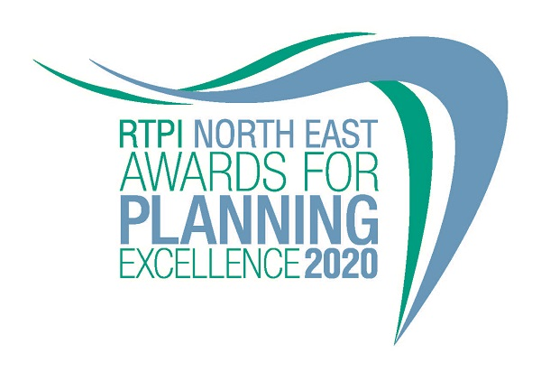

Awards for Planning Excellence
Entry Form and Category Information

Submission deadline: Friday 26 June 2020

The RTPI North East Awards for Planning Excellence 2020
The Awards champion the very best examples of planning and planners in the North East. They demonstrate the positive impact planning has on our quality of life and celebrate professional expertise. The Awards are open to all planners, both members and non-members, and all other built environment professions and community groups. Winning or being shortlisted is a clear demonstration of high quality work and professionalism.

Entry into the RTPI NE Awards is free.

Categories
Submissions to the RTPI North East Awards for Planning Excellence 2020 are invited relating to the following two categories:

- Award for Planning Excellence
- Chairs Award - Best response to climate emergency
Eligibility
Submissions must be located within the North East of England, comprising Northumberland, Tyne and Wear, County Durham and Tees Valley, Darlington, Hartlepool, Stockton-on-Tees, Middlesbrough, and Redcar and Cleveland.

All types of planning activity are eligible, including plans, processes, projects and completed schemes. Completed or virtually completed during the two years prior to the 1st June 2020 is eligible for entry but particular care should be taken not to enter projects prematurely before their impact and outcomes can be assessed satisfactorily. All projects should have had appropriate approvals in place e.g. planning permission, adoption of plans etc.

Who can enter:
- Planning consultancies
- Local planning authorities, community groups
- Architects and landscape architects
- Surveyors, engineers
- Developers and investors

The RTPI welcomes collaborative submissions involving different professions. It is not necessary to be an RTPI member to enter.

Work completed during 2018, 2019 and 2020 is eligible for entry. Particular care should be taken to avoid entering schemes prematurely before they can be satisfactorily assessed. We recommend projects are completed or substantially completed, in order to be assessed fully against all the judging criteria.

Projects or work which has previously won a RTPI Award for Planning Excellence may not be re-entered in the same category, but those shortlisted or commended may be re-entered.

How to enter
1. Download and save this document.
2. Complete the entry form below and save.
3. Send your completed form and images of the project (please see below guidance on the images) to northeast@rtpi.org.uk by 5pm on Friday 26 June 2020.
4. Upon receiving your entry form and images RTPI NE will acknowledge receipt by close of play Friday 3 July 2020. If we do not receive a completed entry form and images entries will not be accepted.
5. An extension to the submission deadline must be agreed before the 26th June deadline.

Guidance for sending images and videos
You may send us, separate from the text, up to 5 images/illustrations (minimum 3) + 1 optional video of the project. You may also include the same images in the body of the text to help illustrate the context of your response.
- These images will be used in the awards publicity campaign and during the ceremony.
- Videos may be sent using a file sharing site such as WeTransfer
- Complete the image/video reference sheet on the entry form.
- Images submitted need to meet the below requirements:
  - Orientation: Landscape
  - Width: at least 1920 pixels
  - Height: at least 1080 pixels
  - Dpi: at least 300

To view these properties of your image right click on the image and select properties.
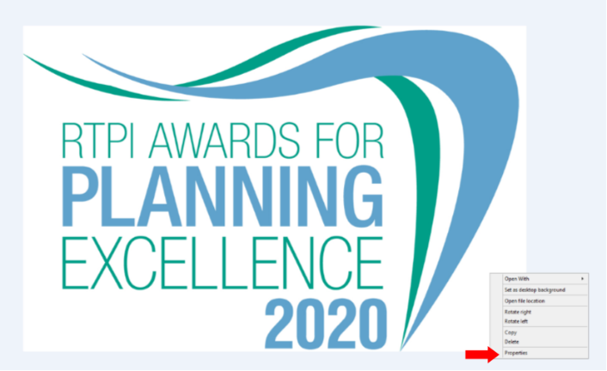

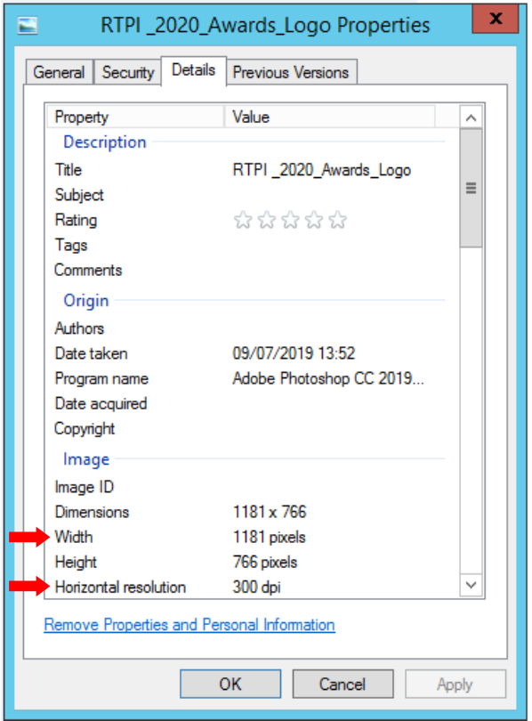

Entry form

Contact name (this should be the main point of contact for all correspondence relating the awards):

Contact job title:

Contact email:

Contact telephone:

Organisation(s) submitting this project (joint submissions permitted)

Organisation address(es):

Name of project (This name will be used in all publicity should you be shortlisted, so please ensure it is accurate):

Location of project (please also include a postcode if appropriate):

Please advise which (if any) other organisations you have worked with on this project (e.g. other planning consultants, local planning authorities):

Media/PR contact (name and email address):

Social media accounts (RTPI NE will engage with shortlisted and winning entries on social media. Please list accounts where possible):
Twitter:
Instagram:
Facebook:

Please confirm RTPI NE can share your contact details including email address with the Awards Judging Panel
☐ YES
☐ NO

Entry Category:
Please indicate the RTPI NE Category in which you wish your submission to be judged.
☐ Regional Award
☐ Chairs Award

Please provide a 25 word and a 100 word overview of your project, written in the third person. Should the submission be shortlisted, the 25 word summary will feature on the RTPI NE website and in the Awards ceremony programme. For winners and commended submissions the 100 word summary will be available on the RTPI North East website.
(100 word summary)
(25 word summary)

Image/Video reference table:

Please complete the table for each image/video you have emailed together with your entry form, stating the image number/name followed by a brief description (max 15 words) so that each image can be identified easily. Include the name of the photographer/artist/company to be credited in any publicity.

Number – File name | Short Description of Image | To be Credited
e.g. 1 – Aerial view | Aerial view of mixed housing types | Taylor Wimpey
1
2
3
4
5

You will need to critically evaluate the work carried out and must demonstrate the strengths of your project. Please highlight the specific role planning has played in the project and highlight any difficulties and constraints planners had to overcome. It is crucial you demonstrate the planning value of the project throughout the submission.

Award criteria

1. Background
Please outline the background to the project:

- Context
- Timeline (including phase in projects, eg. In recognition that some planning work may have been done earlier
(insert your answer here – MAX 500 words)

2. Outcomes
Please outline what positive impacts the project has provided for:
- the local community
- the economy
- the environment
(insert your answer here – MAX 500 words)

3. Planning contribution
Please outline how the project has benefitted from the involvement of a planner or planners:
- providing strong and effective leadership and vision
- working in partnership with others
- managing implementation and delivery
(insert your answer here – MAX 500 words)

4. Sustainable development
Please outline how the project has supported:
- positive short, medium and long term public benefit
- a balance of economic, social and environmental objectives
- the UN’s Sustainable Development Goals
- aimed to prevent or mitigate climate change
(insert your answer here – MAX 500 words)

5. Community benefit
Please outline how the project has provided:
- positive and constructive engagement and dialogue with local people and businesses
- a better quality of life for people, especially for disadvantaged communities
- tangible benefits for communities such as facilities, infrastructure, jobs, training etc
(insert your answer here – MAX 500 words)

6. Leading practice
Please outline how the project:
- is creative and innovative
- is an exemplar that is transferable across the UK
- promotes equality and diversity

(insert your answer here – MAX 500 words)

Regional Significance
- Importance of the project for the North East of England
(insert your answer here – MAX 500 words)

Chair’s Award

This year’s Chair's Award: Best response to climate emergency
(insert your answer here – MAX 500 words)

For help with your submission, please view our ‘How to win’ guide here.

Judging process
Decisions on the giving of Awards and Commendations and on the Overall Winner will be taken by a Judging Panel of professional planners appointed by the RTPI North East Regional Management Board. This Panel will have complete discretion on these decisions. The process the Judges follow are as follows:

- All the submissions are considered at the first meeting of the Judging Panel. Those submissions, assessed by the Panel as being potential examples of ‘Planning Excellence in the North East’, are shortlisted for further assessment.
- Shortlisted entries are then further assessed by the Panel and where additional information, clarification or questions required, a video/teleconference conference meeting with project representatives will be held.
- A final meeting of the Judging Panel is held and decisions are taken on the Awards and Commendations to be made including awards for Regional Winner’, ‘Chairs Award’ and ‘Commended’ .
- The Judging Panel decisions are final.
Judging Timeline and determination of shortlisted and winning entrants
- RTPI North East will acknowledge receipt of submissions by Friday 3rd July
- All entrants informed of the outcome of the shortlisting in September
- If required the Judging Chair will contact entrants to organise virtual meetings to take place during August and September.
- Results of the 2020 Awards announced at an Award Ceremony
North East Award Ceremony
The Awards Dinner, hosted by RTPI North East, takes place in late autumn 2020. The format of this event would normally take place at a venue however, the difficult decision, in order to provide absolute clarity to our members, to cancel all RTPI in-person events for volunteers and staff until the end of 2020, in light of announcements by UK Governments regarding Covid-19.Therefore this year’s Awards we will celebrate winners via a virtual platform instead.

Certificates will be presented to all the entrants who submitted shortlisted projects. The certificate will set out the organisation(s) that made the submission and also any other organisations which have significantly contributed to the successful planning processes involved in the project, as indicated on the entry form.
Individual plaques for retention will also be presented to the organisations who are to be awarded ‘Overall Winner’, ‘Chairs Award or ‘Commended’. If the project is a joint entry, two plaques will be presented.
The RTPI NE Awards for Planning Excellence logo, with the wording ‘Finalist’, for use on a web site, emails, social media and promotional material will be issued to all shortlisted entries. Those organisations who then go on to receive Awards will subsequently be provided with ‘replacement’ logos carrying appropriate wording (i.e.) Overall Winner, Chairs Award or Commended)

The Overall Winning entry and the RTPI National Awards
The Overall Winning entry will be automatically shortlisted into the relevant national category for the RTPI national Awards for Planning Excellence in 2021.

Please indicate if you wish your winning entry to go forward to the RTPI National Awards 2021, if you win.
☐ YES
☐ NO

Additional information may be requested or submitted in line with the relevant national entry requirements.

We will seek to match the winning entry with the national categories, but to help with this process, please tick which category most relevant to your entry:

☐ Planning for a Successful Economy
☐ Planning for Health and Wellbeing
☐ Planning for Heritage and Culture
☐ Planning for the Natural Environment
☐ Planning to Deliver Homes – Small Schemes (up to 50 homes)
☐ Planning to Deliver Homes – Large Schemes (more than 50 homes)
☐ Tech Within Planning Practice

Contact us
If you have any questions about entering the RTPI North East Awards for Planning Excellence, please contact northeast@rtpi.org.uk.

Terms and Conditions
- Full submissions must be received by us by Friday 26 June 2020.
- Without both the completed entry form and images the submission will not be considered.
- Word counts will be checked. In relation to the criteria responses the word maximum of 500 words must be adhered to.
- The RTPI North East is not responsible for any lost or late entries. We will confirm receipt of all entries by close of play on Friday 3 July 2020.
- Should your submission be shortlisted, the entrant is invited to attend the Awards Presentation Ceremony
- The RTPI North East reserves the right to use any images and logos you submit, for promotional purposes.
- The RTPI North East reserves the right to share submissions with our e-bulletin and The Planner.
- An entry will presume that there are no restrictions or fees payable for the reproduction of the photographs or any other submission materials.
- The RTPI North East retains permission to publish all submitted material and particulars of successful entries, including the judges’ reports. This may include online and print publication, and successful entrants may be offered other promotional opportunities. Winning and shortlisted entries may feature as case studies in future RTPI work demonstrating best practice and the value of planning.
- Submitted material will be retained by the RTPI North East and will not be returned.
- The RTPI North East is not liable for any costs you incur submitting this entry.
- The decisions of the judging panel are final and no correspondence will be entered into before or after the event.
- All information submitted is subject to the above terms and conditions and our Privacy Policy and GDPR Policy.
- The Judging Panel reserves the right to, in agreement with the entrant, vary the category in which the submission is judged from that indicated by the entrant.

