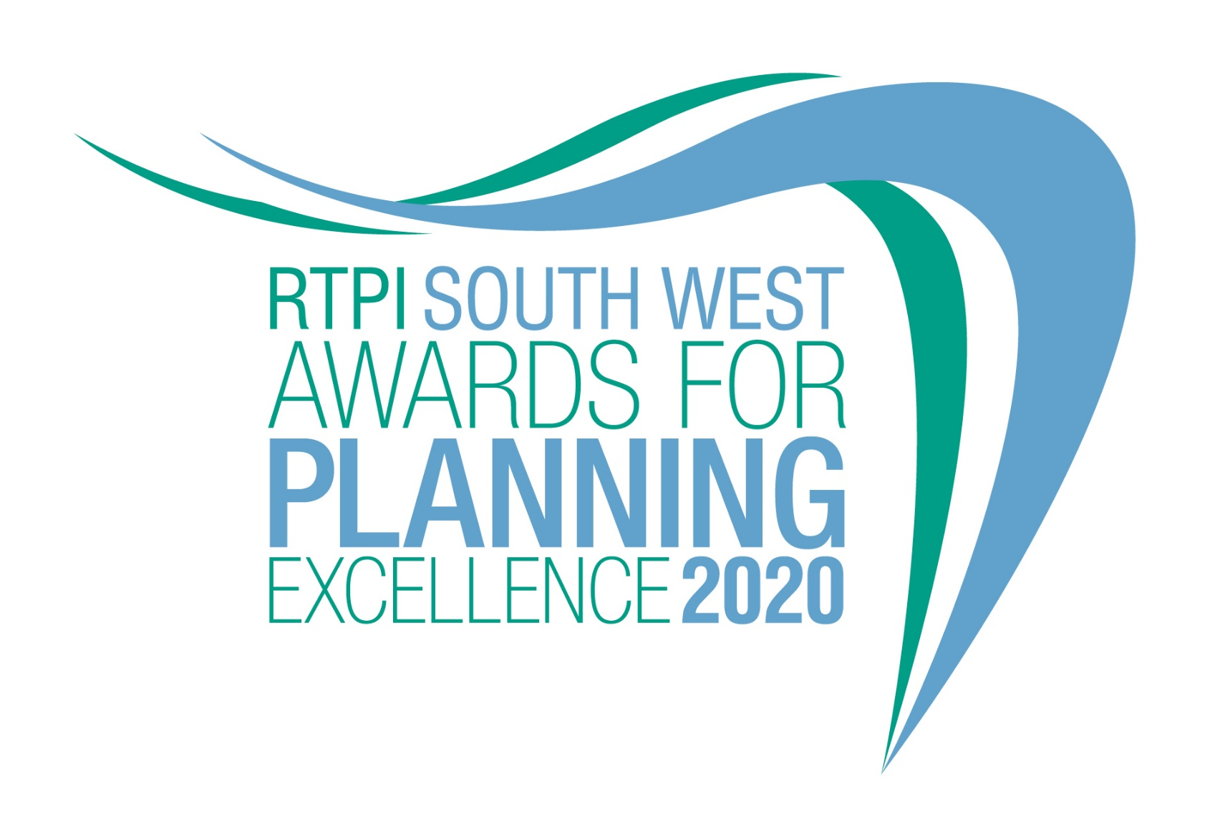

Young Planner of the Year
Category information and entry form

Submission deadline: Friday 26 June 2020

The RTPI South West Awards for Planning Excellence 2020
Our Awards champion the very best examples of planning and planners in our Region. They demonstrate the positive impact planning has on our quality of life and celebrate professional expertise. Entry to our Awards is free.

Being shortlisted or winning these awards is a clear demonstration of the high quality of your work and your professionalism. All shortlisted and winning entrants will be provided with an RTPI South West Awards for Planning Excellence logo, which can be used on your own website, email, social media and promotional materials. We wish you the best of luck!

Eligibility
This award seeks out the brightest RTPI members in the early stages of their careers. Potential candidates can work in any area of the industry. We are looking for outstanding Young Planners who can demonstrate a contribution to planning or significant career achievements in recent years.

Entrants must be in the first 10 years of post-qualification experience and be a current member of the RTPI. A candidate can nominate themselves or they can also be nominated by an employer, colleague or peer.

How to enter
- Download and save this document.
- Complete the entry form below and save.
- Send your completed form and images (please see below guidance on the images) to southwest@rtpi.org.uk by 5pm on Friday 26 June 2020.
- Upon receiving your entry form and images we will acknowledge receipt by close of play Friday 3 July 2020. If we do not receive a completed entry form and images entries will not be accepted.

Guidance for sending images

- Please send us 2 colour images of the nominee.
Images submitted need to meet the below requirements (to view these properties of your image right click on the image and select properties):
  - Orientation: Landscape
  - Width: at least 1920 pixels
  - Height: at least 1080 pixels
  - Dpi: at least 300
- Should you be shortlisted, these images will be used in the awards publicity campaign and during the ceremony.
- In the file name please state the name of the individuals and organisation name and who we need to credit the images to.

Entry form – Young Planner of the Year

Entrant name:

Job title:

Organisation

Organisation address:

Email:

Please confirm we can share your contact details including email address with the Awards judging panel and Awards committee members.
☐ YES
☐ NO
Telephone:

RTPI Membership Number:

Social media accounts (we will engage with shortlisted and winning entries on social media. Please list accounts where possible):
Twitter:
Instagram:
Facebook:

If you are nominating a Young Planner for this award, please fill in the below;

Nominator name

Job title

Organisation:

Email:

Please confirm we can share your contact details including email address with the Awards judging panel and Awards committee members.
☐ YES
☐ NO

Please provide a 25 word and a 100 word overview of the entrant, written in the third person. Should they be shortlisted, the 25 word summary will feature on our website and in the awards ceremony programme. For the winner and commended the 100 word summary will be available on the RTPI South West website post event.
(25 word summary)

(100 word summary)

Candidates will need to submit an 800 word submission outlining their experiences and achievements, particularly over recent years, which they feel qualifies them to be named our Young Planner of the Year.

Applicants may make reference to their careers as a whole and anything particular they want to share with the judges, but they must also ensure they outline how they meet the judging criteria.

The judges will be assessing the applications against the following criteria;

- Understanding of planning policy and the planning system they are working within
- The range, quality and variety of recent planning experience and achievements
- Their enthusiasm and originality of approach
- Their personal and team working skills
- Their commitment to continuing professional development and involvement with professional institutes, networks, events, outreach work or relevant voluntary activity. With particular reference to the RTPI.
- The extent to which they serve as a role model for other young professionals

(Insert submission here – MAX 800 words)

For help with your submission, please view our ‘How to win’ guide here.

Judging process
The awards are judged by a team of respected planning professionals in the Region. The judges will review all entries received and determine a shortlist. The shortlist will be announced on the RTPI’s website. Profiles of the shortlisted entrants will be taken from this entry form will be published on our website.
Winners’ presentation
The winners of the RTPI South West Awards for Planning Excellence 2020 will be announced at a presentation to be held in November/December. Details to be arranged.

Winning entry
The winner will automatically be entered to the RTPI Awards for Planning Excellence 2021 Additional information may be requested or submitted in line with the relevant entry requirements. Should you not wish your winning entry to go forward to the nationals please let us know. YES/NO

Contact us
If you have any questions about entering the RTPI South West Awards for Planning Excellence, please contact southwest@rtpi.org.uk.

Terms and Conditions
- Full submissions must be received by us by Friday 26 June 2020.
- Without both the completed entry form and images the submission will not be counted.
- Word counts will be checked. A variation of up to 10% will be allowed, but anything beyond that will not be considered by the judges.
- The RTPI South West are not responsible for any lost or late entries. We will confirm receipt of all entries by close of play on Friday 3 July 2020.
- Should your submission be shortlisted, the entrant is required to attend the Awards Ceremony.
- The RTPI South West reserves the right to use any images and logos you submit, for promotional purposes.
- The RTPI South West reserves the right to share submissions with our member magazine Branchout and The Planner.
- An entry will presume that there are no restrictions or fees payable for the reproduction of the photographs or any other submission materials.
- The RTPI South West retains permission to publish all submitted material and particulars of successful entries, including the judges’ reports. This may include online and print publication, and successful entrants may be offered other promotional opportunities. Winning and shortlisted entries may feature as case studies in future RTPI work demonstrating best practice and the value of planning.
- Submitted material will be retained by the RTPI XX and will not be returned.
- The RTPI XX is not liable for any costs you incur submitting this entry.
- The decisions of the judging panel are final and no correspondence will be entered into before or after the event.
- All information submitted is subject to the above terms and conditions and our Privacy Policy and GDPR Policy.

