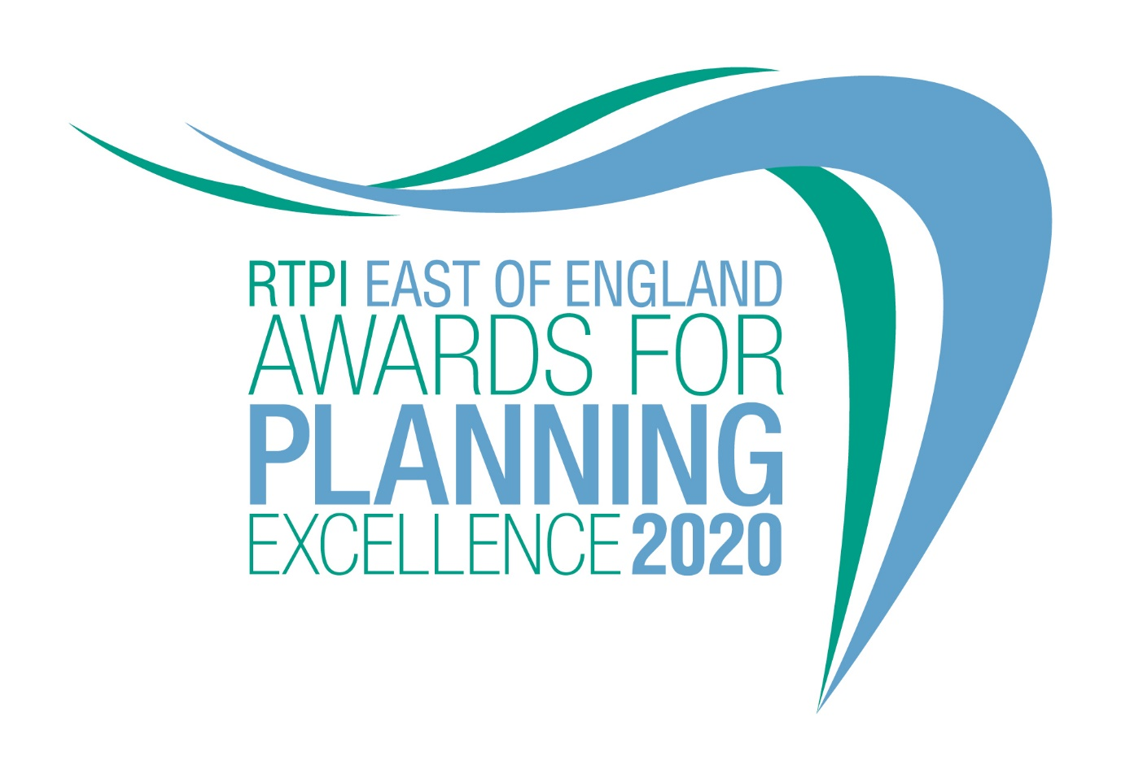

Young Planner of the Year
Category information and entry form

Submission deadline: Friday 26 June 2020

Our Awards champion the very best examples of planning and planners in our Region. They demonstrate the positive impact planning has on our quality of life and celebrate professional expertise. Entry to our Awards is free.

Being shortlisted or winning these awards is a clear demonstration of the high quality of your work and your professionalism. The winning entrant will be provided with an RTPI EE Young Planner of the Year Award logo, which can be used on your own website, email, social media and promotional materials. We wish you the best of luck!

How to enter
- Download and save this document.
- Complete the entry form below and save.
- Send your completed form and images (please see below guidance on the images) to eastofengland@rtpi.org.uk by 5pm on Friday 26 June 2020.
- Upon receiving your entry form and images we will acknowledge receipt by close of play Friday 3 July 2020. If we do not receive a completed entry form and images entries will not be accepted.

Guidance for sending images
Please send us 2 colour images of the nominee.

Images submitted need to meet the below requirements (to view these properties of your image right click on the image and select properties):
  - Orientation: Landscape
  - Width: at least 1920 pixels
  - Height: at least 1080 pixels
  - Dpi: at least 300
- Should you be shortlisted, these images will be used in the awards publicity campaign and during the ceremony.
- In the file name please state the name of the individuals and organisation name and who we need to credit the images to.

Entry form – Young Planner of the Year

This award seeks out the brightest RTPI members in the early stages of their careers. Potential candidates can work in any area of the industry. We are looking for outstanding Young Planners who can demonstrate a contribution to planning, significant career achievements in recent years and a commitment to the profession.

Entrants must be in the first 10 years of post-qualification experience and be a current member of the RTPI. A candidate can nominate themselves or they can also be nominated by an employer, colleague or peer.

Entrant name:

Job title:

Organisation:

Email:

Telephone:

Organisation:

RTPI Membership Number:

Social media accounts (we will engage with shortlisted and winning entries on social media. Please list accounts where possible):

Twitter:
Instagram:
Facebook:

If you are nominating a Young Planner for this award, please fill in the below;

Nominator name:

Job title:

Organisation:

Email:

Please confirm we can share your contact details including email address with the Awards judging panel and Awards committee members. YES/NO

Please provide a 25 word and a 100 word overview of the entrant, written in the third person. Should they be shortlisted, the 25 word summary will feature on our website and in the awards ceremony programme. For the winner and commended the 100 word summary will be available on the RTPI WM website post event.
(100 word summary)
(25 word summary)

Candidates will need to submit an 800 word submission outlining their experiences and achievements, particularly over recent years, which they feel qualifies them to be named our Young Planner of the Year.

Applicants may make reference to their careers as a whole and anything particular they want to share with the judges, but they must also ensure they outline how they meet the judging criteria.

The judges will be assessing the applications against the following criteria;

- Understanding of planning policy and the planning system they are working within
- The range, quality and variety of recent planning experience and achievements
- Their enthusiasm and originality of approach
- Their personal and team working skills
- Their commitment to continuing professional development and involvement with professional institutes, networks, events, outreach work or relevant voluntary activity., with particular reference to the RTPI
- The extent to which they serve as a role model for other young professionals
(Insert submission here – MAX 800 words)

For help with your submission, please view our ‘How to win’ guide here.

Judging process
Decisions on the giving of Awards and Commendations and on the Overall Winner will be taken by a Judging Panel of professional planners appointed by the RTPI East of England Chair. This Panel will have complete discretion on these decisions.

The Judging process will follow the following broad stages:

- All the submissions are considered and assessed by the Panel having regard to the Award Criteria to identify a shortlisted for further assessment.
- The Judging Panel will meet (in person/ via video conference) to discuss shortlisted submissions having regard to the Award Criteria and the decision will be taken on which submission to award the ‘RTPI East of England Young Planner of the Year Award’ to and to make any commendations.
- The Judging Panel decisions are final. However, feedback can be made available on request.
Judging Timeline and determination of shortlisted and winning entrants
- RTPI East of England will acknowledge receipt of submissions by Friday 3rd July
- All entrants informed of the outcome of the shortlisting in late July
- Results of the 2020 Awards announced at an Award Ceremony in September
West Midlands Award Ceremony
The Award Presentation Ceremony, hosted by RTPI East of England, will take place in September 2020. The format of this event will either take place at a venue, or virtually. Given the uncertainties with COV-19 the latter option may be taken.

A Certificate will be presented to the winning entrant. The certificate will set out the organisation(s) that made the submission and also any other organisations which have significantly contributed to the successful planning processes involved in the project, as indicated on the entry form.
The Overall Winner will also be presented with the RTPI EE Young Planner of the Year trophy.

The RTPI EE Young Planner of the Year logo, for use on a web site, emails, social media and promotional material will be issued to the winning entrant.

The Overall Winning entry and the RTPI National Awards
The Overall Winning entry will automatically be shortlisted for the RTPI National Awards for Planning Excellence 2021 and entered into the Young Planner of the Year category. Additional information may be requested or submitted in line with the relevant national entry requirements.

Please indicate if you wish your winning entry to go forward to the RTPI National Awards 2021, if you win.
☐ YES
☐ NO
Contact us
If you have any questions about entering the RTPI East of England Awards for Planning Excellence, please contact Eastofengland@rtpi.org.uk.

Terms and Conditions
- Full submissions must be received by us by Friday 26 June 2020.
- Without both the completed entry form and images the submission will not be considered.
- Word counts will be checked and must be adhered to.
- The RTPI West Midlands is not responsible for any lost or late entries. We will confirm receipt of all entries by close of play on Friday 3 July 2020.
- Should your submission be shortlisted, the entrant is invited to attend the Awards Presentation Ceremony
- The RTPI East of England reserves the right to use any images and logos you submit, for promotional purposes.
- The RTPI East of England reserves the right to share submissions with our member magazine, The Planner.
- An entry will presume that there are no restrictions or fees payable for the reproduction of the photographs or any other submission materials.
- The RTPI East of England retains permission to publish all submitted material and particulars of successful entries, including the judges’ reports. This may include online and print publication, and successful entrants may be offered other promotional opportunities. Winning and shortlisted entries may feature as case studies in future RTPI work demonstrating best practice and the value of planning.
- Submitted material will be retained by the RTPI East of England and will not be returned.
- The RTPI East of England is not liable for any costs you incur submitting this entry.
- The decisions of the judging panel are final and no correspondence will be entered into before or after the event.
- All information submitted is subject to the above terms and conditions and our Privacy Policy and GDPR Policy.

