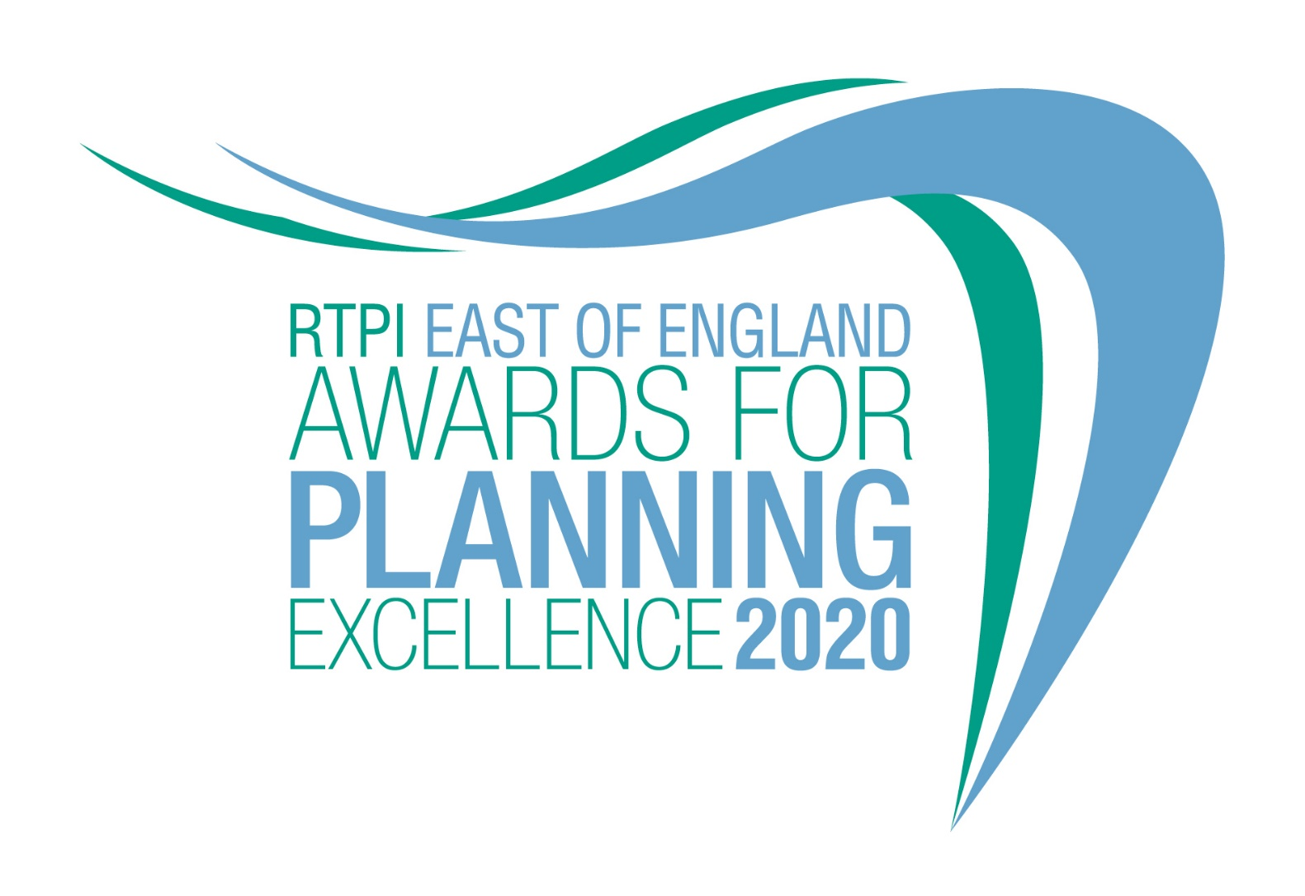

Award for Planning Excellence
Entry Form and Category Information

Submission deadline: Friday 26 June 2020

The RTPI East of England Awards for Planning Excellence 2020

The Awards champion the very best examples of planning and planners in the East of England. They demonstrate the positive impact planning has on our quality of life and celebrate professional expertise. The Awards are open to all planners, both members and non-members, and all other built environment professions and community groups. Winning or being shortlisted is a clear demonstration of high quality work and professionalism.

Entry into the RTPI EE Awards is free.

Categories
Submissions to the RTPI East of England Awards for Planning Excellence 2020 are invited relating to the following category:

- Award for Planning Excellence
Eligibility
Submissions must be located within the East of England, comprising Bedfordshire, Cambridgeshire, Essex, Hertfordshire, Norfolk, and Suffolk.

All types of planning activity are eligible, including plans, processes, projects and completed schemes. Work completed or virtually completed during the two years prior to the 1st June 2020 is eligible for entry but particular care should be taken not to enter projects prematurely before they can be assessed satisfactorily. Submissions should state at what stage in the planning process the project has reached, for example dates on which the planning application was submitted/approved, dates of consultation on/adoption of a Plan.

Who can enter:
- Planning consultancies
- Local planning authorities, community groups
- Architects and landscape architects
- Surveyors, engineers
- Developers and investors

The RTPI welcomes collaborative submissions involving different professions. It is not necessary to be an RTPI member to enter.

Work completed during 2018 and 2019 and 2020 is eligible for entry. Particular care should be taken to avoid entering schemes prematurely before they can be satisfactorily assessed. We recommend projects are completed or substantially completed, in order to be assessed fully against all the judging criteria.

Projects or work which has previously won a RTPI Award for Planning Excellence may not be re-entered in the same category, but those shortlisted or commended may be re-entered.

How to enter
1. Download and save this document
2. Complete the entry form below and save.
3. Send your completed form and images of the project (please see below guidance on the images) to eastofengland@rtpi.org.uk by 5pm on Friday 26 June 2020.
4. Upon receiving your entry form and images RTPI EE will acknowledge receipt by close of play Friday 3 July 2020. If we do not receive a completed entry form and images entries will not be accepted.
5. An extension to the submission deadline must be agreed before the 26th June deadline.

Guidance for sending images and videos
Please send us, separate from the text, a minimum of 3 images/illustrations (up to a maximum of 5) + 1 optional video of the project. You may also include the same images in the body of the text to help illustrate the context of your response.
- These images will be used in the awards publicity campaign and during the ceremony.
- Videos may be sent using a file sharing site such as WeTransfer.
- Complete the image/video reference sheet on the entry form.
- Images submitted need to meet the below requirements:
  - Orientation: Landscape
  - Width: at least 1920 pixels
  - Height: at least 1080 pixels
  - Dpi: at least 300

To view these properties of your image right click on the image and select properties.
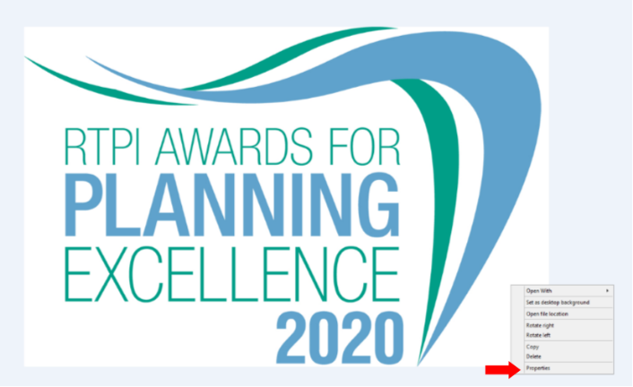

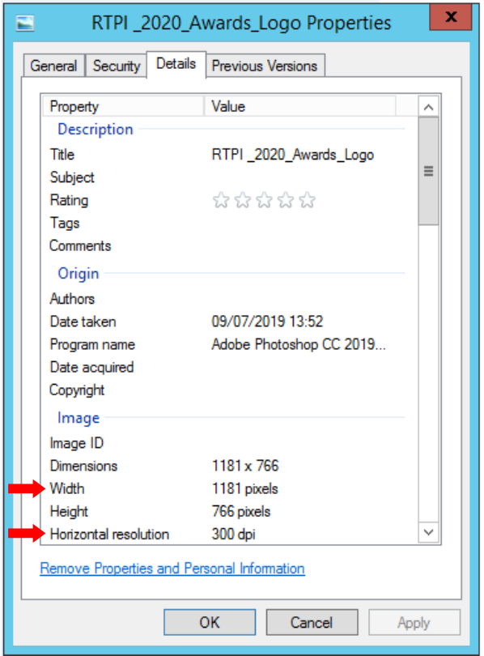

Entry form

Contact name (this should be the main point of contact for all correspondence relating the awards):

Contact job title:

Contact email:

Contact telephone:

Organisation(s) submitting this project (joint submissions permitted)

Organisation address(es):

Name of project (This name will be used in all publicity should you be shortlisted, so please ensure it is accurate):

Location of project (please also include a postcode if appropriate):

Please advise which (if any) other organisations you have worked with on this project (e.g. other planning consultants, local planning authorities):

Media/PR contact (name and email address):

Social media accounts (RTPI EE will engage with shortlisted and winning entries on social media. Please list accounts where possible):
Twitter:
Instagram:
Facebook:

Please confirm RTPI EE can share your contact details including email address with the Awards Judging Panel
☐ YES
☐ NO

Please provide a 25 word and a 100 word overview of your project, written in the third person. Should the submission be shortlisted, the 25 word summary will feature on the RTPI EE website and in the Awards ceremony programme. For winners and commended submissions the 100 word summary will be available on the RTPI East of England website.
(100 word summary)
(25 word summary)

Image/Video reference table:

Please complete the table for each image/video you have emailed together with your entry form, stating the image number/name followed by a brief description (max 15 words) so that each image can be identified easily. Include the name of the photographer/artist/company to be credited in any publicity.

Number – File name | Short Description of Image | To be Credited
e.g. 1 – Aerial view | Aerial view of mixed housing types | Taylor Wimpey
1
2
3
4
5

You will need to critically evaluate the work carried out and must demonstrate the strengths of your project.

Please highlight the specific role planning has played in the project and highlight any difficulties and constraints planners had to overcome. It is crucial you demonstrate the planning value of the project throughout the submission.

Award criteria

1. Background
Please outline the background to the project:

- context
- timeline (including phase in project, eg. in recognition that some planning work may have been done earlier)
(insert your answer here – MAX 500 words)

2. Outcomes
Please outline what positive impacts the project has provided for:
- the local community
- the economy
- the environment
(insert your answer here – MAX 500 words)

3. Planning contribution
Please outline how the project has benefitted from the involvement of a planner or planners:
- providing strong and effective leadership and vision
- working in partnership with others
- managing implementation and delivery
(insert your answer here – MAX 500 words)

4. Sustainable development
Please outline how the project has supported:
- positive short, medium and long term public benefit
- a balance of economic, social and environmental objectives
- the UN’s Sustainable Development Goals
- aimed to prevent or mitigate climate change
(insert your answer here – MAX 500 words)

5. Community benefit
Please outline how the project has provided:
- positive and constructive engagement and dialogue with local people and businesses
- a better quality of life for people, especially for disadvantaged communities
- tangible benefits for communities such as facilities, infrastructure, jobs, training etc.
(insert your answer here – MAX 500 words)
6. Leading practice
Please outline how the project:
- is creative and innovative
- is an exemplar that is transferable across the UK
- promotes equality and diversity
(insert your answer here – MAX 500 words)

For help with your submission, please view our ‘How to win’ guide here.

Judging process
Decisions on the giving of Awards and Commendations and on the Overall Winner will be taken by a Judging Panel of professional planners appointed by the RTPI East of England Chair. This Panel will have complete discretion on these decisions.

The Judging process will follow the following broad stages:

- All the submissions are considered and assessed by the Panel having regard to the Award Criteria to identify potential examples of ‘Planning Excellence in the East of England’ to be shortlisted for further assessment.
- The Judging Panel will meet (in person/ via video conference) to discuss shortlisted submissions having regard to the Award Criteria and the decision will be taken on which submission to award the ‘RTPI East of England Award for Planning Excellence’ to and to make any commendations.
- The Judging Panel decisions are final. However, feedback can be made available on request.
Judging Timeline and determination of shortlisted and winning entrants
- RTPI East of England will acknowledge receipt of submissions by Friday 3rd July
- All entrants informed of the outcome of the shortlisting in late July
- Results of the 2020 Awards announced at an Award Ceremony in September
East of England Award Ceremony
The Award Presentation Ceremony, hosted by RTPI East of England, will take place in September 2020. The format of this event will either take place at a venue, or virtually. Given the uncertainties with COV-19 the latter option may be taken.

A Certificate will be presented to the winning entrant. The certificate will set out the organisation(s) that made the submission and also any other organisations which have significantly contributed to the successful planning processes involved in the project, as indicated on the entry form.
The Overall Winner will also be presented with the RTPI EE Awards for Planning Excellence trophy.

The RTPI EE Awards for Planning Excellence logo, for use on a web site, emails, social media and promotional material will be issued to the winning entrant.

The Overall Winning entry and the RTPI National Awards
The winner of our Regional Excellence Award will be automatically shortlisted into the relevant national category for the RTPI national Awards for Planning Excellence in 2021.

Please indicate if you wish your winning entry to go forward to the RTPI National Awards 2021, if you win.
☐ YES
☐ NO

Additional information may be requested or submitted in line with the relevant national entry requirements.

We will seek to match the winning entry with the national categories, but to help with this process, please tick which category most relevant to your entry.

☐ Planning for a Successful Economy
☐ Planning for Health and Wellbeing
☐ Planning for Heritage and Culture
☐ Planning for the Natural Environment
☐ Planning to Deliver Homes – Small Schemes (up to 50 homes)
☐ Planning to Deliver Homes – Large Schemes (more than 50 homes)
☐ Tech Within Planning Practice

Contact us
If you have any questions about entering the RTPI East of England Awards for Planning Excellence, please contact Eastofengland@rtpi.org.uk.

Terms and Conditions
- Full submissions must be received by us by Friday 26 June 2020.
- Without both the completed entry form and images the submission will not be considered.
- Word counts will be checked. In relation to the criteria responses the word maximum of 500 words must be adhered to.
- The RTPI East of England is not responsible for any lost or late entries. We will confirm receipt of all entries by close of play on Friday 3 July 2020.
- Should your submission be shortlisted, the entrant is invited to attend the Awards Presentation Ceremony
- The RTPI East of England reserves the right to use any images and logos you submit, for promotional purposes.
- The RTPI East of England reserves the right to share submissions with our member magazine, The Planner.
- An entry will presume that there are no restrictions or fees payable for the reproduction of the photographs or any other submission materials.
- The RTPI East of England retains permission to publish all submitted material and particulars of successful entries, including the judges’ reports. This may include online and print publication, and successful entrants may be offered other promotional opportunities. Winning and shortlisted entries may feature as case studies in future RTPI work demonstrating best practice and the value of planning.
- Submitted material will be retained by the RTPI East of England and will not be returned.
- The RTPI East of England is not liable for any costs you incur submitting this entry.
- The decisions of the judging panel are final and no correspondence will be entered into before or after the event.
- All information submitted is subject to the above terms and conditions and our Privacy Policy and GDPR Policy.

