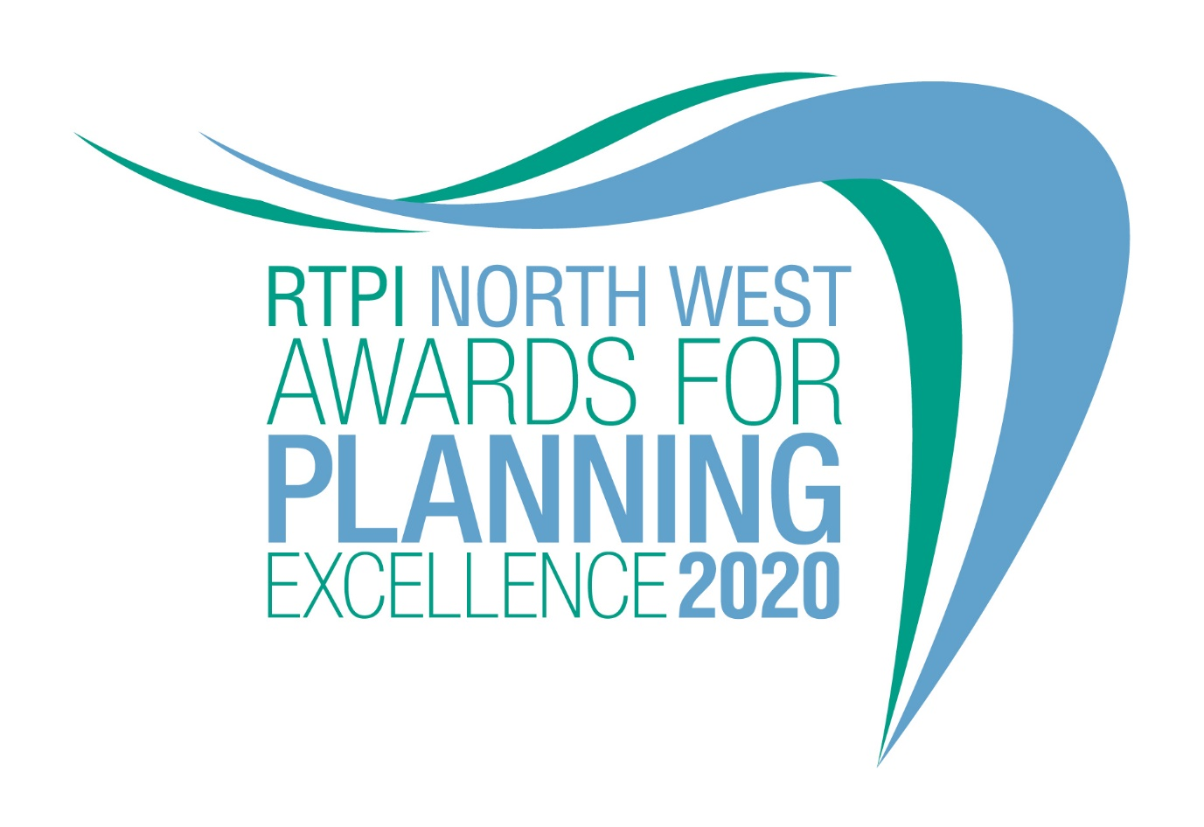

Local Authority Planning Team of the Year
Category information and entry form

Submission deadline: Friday 26 June 2020

Our Awards champion the very best examples of planning and planners in our Region. They demonstrate the positive impact planning has on our quality of life and celebrate professional expertise. The Awards are open to all planners, both members and non-members and all other built environment professions. Entry to our Awards is free.

Being shortlisted or winning is a clear demonstration of the high quality of your work and professionalism. Shortlisted and winning entrants will be provided with a RTPI North West Awards for Planning Excellence logo, which can be used on your own website, email, social media and promotional materials. We wish you the best of luck!

Eligibility
This award recognises the achievements of planning teams working within North West Local Authorities. The team must include at least one Chartered Town Planner (MRTPI or FRTPI).

Please refer to separate Criteria sheet for additional information on the range of planning teams eligible to apply.

How to enter
- Download and save this document (please make sure you have the document for the correct category, there are some slight variations)
- Complete the entry form below and save
- Send your completed form, as a Word document, and up to 2 images of your team (please see below guidance on the images) to beverley.watson@rtpi.org.uk by 5pm on Friday 26 June 2020
- Upon receiving your entry form and images we will acknowledge receipt by close of play Monday 29 June. If we do not receive an entry form and images, entries will not be accepted

Guidance for sending images
In the file name please state the organisation name and who we need to credit the images to.

Images submitted need to meet the below requirements:
- Orientation: Landscape
- Width: at least 1000 pixels
- Dpi: at least 300

To view these properties of your image right click on the image and select properties.
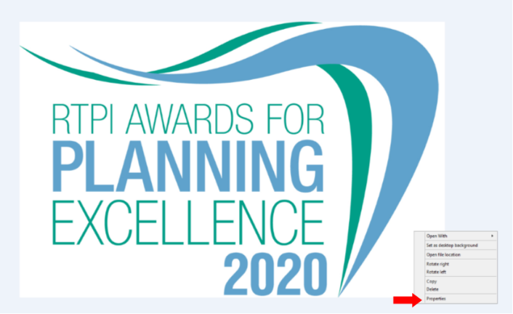

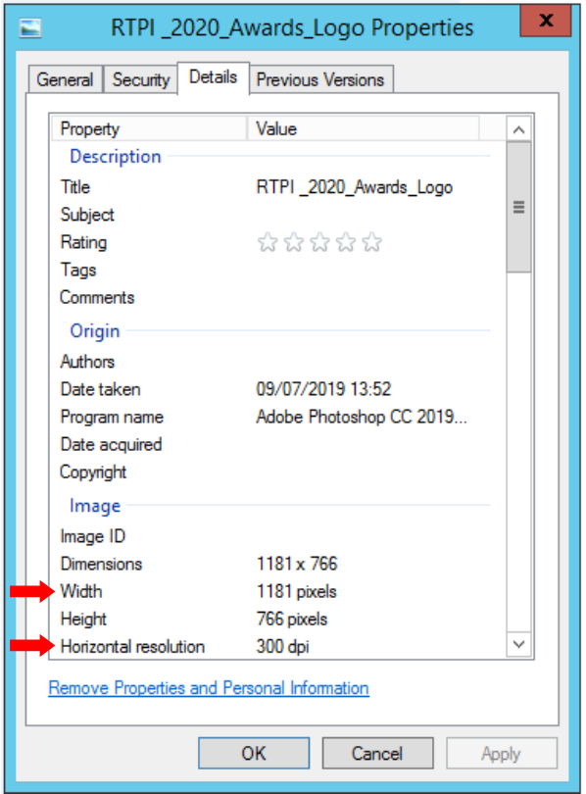

Entry form – Local Authority Planning Team of the Year

Contact name (this should be the main point of contact for all correspondence relating the awards):

Contact job title:

Contact email:

Contact telephone:

Organisation:

Organisation address:

Location of Head Office (please also include a postcode):

Number of planners working within the organisation:

Of the planners working within your organisation, please advise how many are Chartered Town Planners (MRTPI or FRTPI):

Media/PR contact (name and email address):

Social media accounts (we will engage with shortlisted and winning entries on social media. Please list accounts where possible):

Twitter:
Instagram:
Facebook:

Please provide a 25 word and a 100 word overview of your organisation and the role of the Planning Team, written in the third person. Should you be shortlisted the 25 word summary will feature on our website and in the awards ceremony programme. The 100 words will feature in our brochure for winners and commended, which will be available on the RTPI website post event.

(25 word summary)

(100 word summary)

In addressing the award criteria please use examples of specific projects on which significant planning input has been required during 2019 and 2020. The projects used in the submission should have been implemented or achieved planning consent by this date.

Development and application of imaginative approaches and techniques to achieve high quality planning solutions
May include: the scale and scope of an issue/project that the organisation was engaged in. What challenges were faced? What techniques or tools were used? How were problems overcome and decisions made? What actions were taken to ensure the successful outcome? How have these approaches improved the efficiency and effectiveness of the team and organisation?
(insert your answer here – MAX 500 words)

Customer/applicant/partners satisfied with the service provided
May include: timeliness, flexibility, and ability to respond imaginatively to a brief, quality of public engagement, presentation and communication. Consultation responses and feedback from the local authority to the planning agent or developer, and vice versa, could also be relevant.
(insert your answer here – MAX 500 words)

Ability of planners to manage multi-disciplinary projects or to work within a multi-disciplinary environment
May include: how practitioners influenced or led a project to conclusion, evidence of effective partnership working and mediation, as well as providing a value for money service for customers.
(insert your answer here – MAX 500 words)

Commitment to inclusive planning that enables everyone to participate equally, confidently and independently in everyday activities
May include: consultation with hard to reach groups, urban design that meets the needs of an ageing population, best practice in addressing equality and diversity issues.

(insert your answer here – MAX 500 words)

Commitment to staff development, business improvements and active participation in professional and educational activities
May include: staff training and quality assurance certification, opportunity for volunteering, representation on official or professional bodies or RTPI Regions, and links with educational institutions.
(insert your answer here – MAX 500 words)

Why should your organisation / team win this award?
How has the work of the team made a significant difference to the Quality of Place, the built or natural environment and the well-being of local residents?
How has the work of the team promoted town planning and raised the profile of planners within the region?
(insert your answer here – MAX 500 words)

Judging process
Decisions on the giving of Awards and Commendations and on the Overall Winner will be taken by a Judging Panel of professional planners appointed by the RTPI North West Regional Management Board. This Panel will have complete discretion on these decisions. The process the Judges follow are as follows:

- All the submissions are considered at the first meeting of the Judging Panel. Those submissions, assessed by the Panel as being potential examples of ‘Planning Excellence in the North West, are shortlisted for further assessment.
- Shortlisted entries are then further assessed by the Panel and where additional information, clarification or questions required, a video/teleconference conference meeting with project representatives will be held.
- A final meeting of the Judging Panel is held and decisions are taken on the Awards and Commendations.
- The Judging Panel decisions are final.
The judges will review all entries received and determine a shortlist. Shortlisted entrants will then be invited to give a presentation on Wednesday 9 September 2020.

The winner will be decided following the presentations on Wednesday 9 September. Category winners and unsuccessful entries will be notified by Friday 11 September. Category winners will be invited to the RTPI North West Annual Dinner on Friday 16 October, where the overall winner will be announced.

Winners’ presentation
The category winners will be invited to the RTPI NW Annual Dinner on Friday 16 October when the overall winner of the RTPI NW Regional Award for Planning Excellence will be announced. The format of this event may change to a virtual event given the uncertainties with COV-19.

The Regional Winning entry and the RTPI National Awards
The Overall Regional Winning entry will automatically be shortlisted for the RTPI National Awards for Planning Excellence 2021 and entered into the relevant category. Additional information may be requested or submitted in line with the relevant national entry requirements.

Please indicate if you wish your winning entry to go forward to the RTPI National Awards 2021, if you win.
☐ YES
☐ NO

The overall winner will also be invited to give a presentation at the RTPI North West AGM on Friday 4 December 2020.

Contact us
If you have any questions about entering the RTPI Awards for Planning Excellence, please contact beverley.watson@rtpi.org.uk

Terms and Conditions
- Full submissions must be received by the RTPI by Friday 26 June 2020.
- Without both the entry form and images the submission will not be counted.
- Word counts will be checked. A variation of up to 10% will be allowed, but anything beyond that will not be considered by the judges.
- The RTPI are not responsible for any undelivered emails or late entries. We will confirm receipt of all entries by close of play on Monday 29 June 2020.
- Should your submission be shortlisted, the entrant will be invited to the RTPI NW Annual Dinner on Friday 16 October 2020 at the Hilton Deansgate Manchester.
- The overall winner will automatically be entered into the National Awards for Planning Excellence for 2021.
- The RTPI reserves the right to use any images and logos you submit for promotional purposes.
- The RTPI reserves the right to share submissions with our member magazine The Planner.
- The RTPI reserves the right to share submissions and entry forms with our judging panel.
- An entry will presume that there are no restrictions or fees payable for the reproduction of the photographs or any other submission materials.
- The RTPI retains permission to publish all submitted material and particulars of successful entries, including the judges’ reports. This may include online and print publication, and successful entrants may be offered other promotional opportunities. Winning and shortlisted entries may feature as case studies in future RTPI work demonstrating best practice and the value of planning.
- Submitted material will be retained electronically by the RTPI NW.
- The Royal Town Planning Institute is not liable for any costs you incur submitting this entry.
- The decisions of the judging panel are final and no correspondence will be entered into before or after the event.

