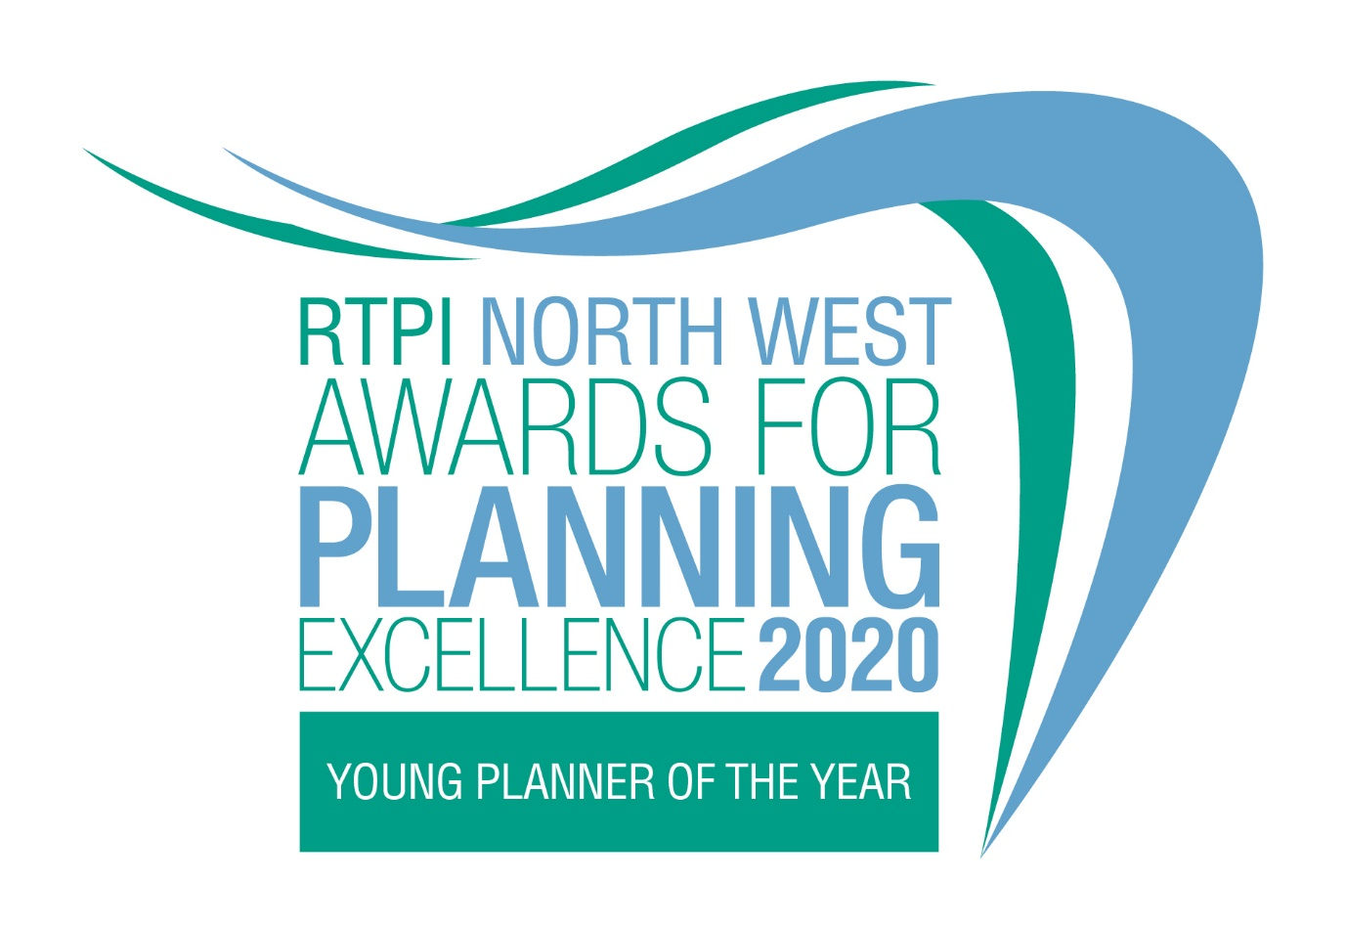

Young Planner of the Year
Category information and entry form

Submission deadline: Friday 26 June 2020

Our Awards champion the very best examples of planning and planners in our Region. They demonstrate the positive impact planning has on our quality of life and celebrate professional expertise. Entry to our Awards is free.

Being shortlisted or winning these awards is a clear demonstration of the high quality of your work and your professionalism. All winning entrants will be provided with an RTPI NW Awards for Planning Excellence logo, which can be used on your own website, email, social media and promotional materials. We wish you the best of luck!

Eligibility
This award seeks out the brightest RTPI members in the early stages of their careers. Potential candidates can work in any area of the industry. We are looking for outstanding Young Planners who can demonstrate a contribution to planning and/or significant career achievements in recent years.

Entrants must be in the first 10 years of post-qualification experience and be a current member of the RTPI. A candidate can nominate themselves or they can also be nominated by an employer, colleague or peer.

How to enter
- Download and save this document.
- Complete the appended entry form (Appendix 1) and submission/proforma (Appendix 2) and save.
- Send your completed form, images (please see below guidance on the images) and submission/proforma to beverley.watson@rtpi.org.uk 5pm on Friday 26 June 2019.
- All entries will be acknowledged. If we do not receive a completed entry form and images, entries will not be accepted.

Guidance for sending images
- Please send us 2 colour images of the nominee.
- Each image must be a high resolution image. We recommend the file size is 1MB – 2MB.
- Should you be shortlisted, these images will be used during the ceremony.
- In the file name please state the name of the individual and organisation name.

Submission Requirements
Candidates will need to submit an 800-word submission outlining their experiences and achievements, particularly over recent years, which they feel qualifies them to be named our Young Planner of the Year.

Applicants may make reference to their careers as a whole and anything particular they want to share with the judges, but they must also ensure they outline how they meet each of the judging criteria set out below.

- Understanding of planning policy and the planning system they are working within
- The range, quality and variety of recent planning experience and achievements
- Their enthusiasm and originality of approach
- Their personal and team working skills
- Their commitment to continuing professional development and involvement with professional institutes, networks, events, outreach work or relevant voluntary activity. With particular reference to the RTPI.
- The extent to which they serve as a role model for other young professionals

Alternatively, or if you are nominating a Young Planner for this award, please fill out the appended proforma, ensuring the total word count is not exceeded.

For help with your submission, please view our ‘How to win’ guide here.

Judging process
The awards are judged by a team of respected planning professionals in the Region. The judges will review all entries received and determine a shortlist and winner. Those that are shortlisted may be invited to an interview, at the panel’s discretion.

Winners’ presentation
The winners of the RTPI NW Awards for Planning Excellence 2020 will be announced at the Annual Dinner taking place at the Hilton Deansgate Manchester on Friday 16 October 2020.

Winning entry
The winner will automatically be entered to the RTPI National Awards for Planning Excellence 2021. Additional information may be requested or submitted in line with the relevant entry requirements.

Should you not wish your winning entry to go forward to the nationals please let us know.

YES/NO

Contact us
If you have any questions about entering the RTPI NW Awards for Planning Excellence, please contact beverley.watson@rtpi.org.uk

Terms and Conditions
- Full submissions must be received by us by Friday 26 June 2020.
- Without both the completed entry form and images the submission will not be counted.
- Word counts will be checked. A variation of up to 10% will be allowed, but anything beyond that will not be considered by the judges.
- RTPI NW are not responsible for any lost or late entries. All entries will be acknowledged by 5pm on Friday 26 June 2020.
- Should your submission be shortlisted you may be invited to attend the Annual Dinner on 16 October 2020.
- RTPI NW reserves the right to use any images and logos you submit, for promotional purposes.
- An entry will presume that there are no restrictions or fees payable for the reproduction of the photographs or any other submission materials.
- RTPI NW retains permission to publish all submitted material and particulars of successful entries.
- Submitted material will be retained by the RTPI NW and will not be returned.
- RTPI NW is not liable for any costs you incur submitting this entry.
- The decisions of the judging panel are final and no correspondence will be entered into before or after the event.
- RTPI NW reserves the right not to give the award if no submissions fully meet the judging criteria given
- All information submitted is subject to the above terms and conditions and our Privacy Policy and GDPR Policy.

Appendix 1 - Entry Form – Young Planner of the Year

Entrant name:

Job title:

Organisation:

Email:

Telephone:

Organisation:

RTPI Membership Number:

Social media accounts (please list where possible):

Twitter:
Instagram:
Facebook:

Please confirm we can share your contact details including email address with the Awards judging panel and Awards committee members. YES/NO

If you are nominating a Young Planner for this award, please fill in the below;

Nominator name:

Job title:

Organisation:

Email:

Please confirm we can share your contact details including email address with the Awards judging panel and Awards committee members. YES/NO

Please provide a 25 word and a 100 word overview of the entrant, written in the third person. Should they be shortlisted, the 25 word summary will feature in the awards ceremony. For the winner and commended the 100 word summary will be available on the RTPI NW website post event.

(25 word summary)

(100 word summary)

Appendix 2 – Written Submission – Young Planner of the Year

Please complete either Section 1 or 2 below.

Section 1 - Submission
(800 word submission)

Section 2 - Proforma

How have you/they demonstrated their understanding of planning policy and the planning system they are working within?

Please describe your/their range, quality and variety of recent planning experience and achievements

Please demonstrate your/their enthusiasm for planning and originality of approach

Please demonstrate your/their personal and team working skills

Please demonstrate your/their commitment to continuing professional development and involvement with professional institutes, networks, events, outreach work or relevant voluntary activity (with particular reference to the RTPI).

Please explain the extent to which you/they serve as a role model for other young professionals.

