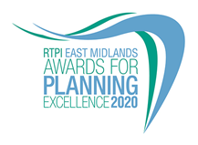

Planning Consultancy of the Year
Category information and entry form

Submission deadline: Friday 26 June 2020

Our Awards champion the very best examples of planning and planners in our Region. They demonstrate the positive impact planning has on our quality of life and celebrate professional expertise. The Awards are open to all planners, both members and non-members and all other built environment professions. Entry to our Awards is free.

Being highly commended or winning is a clear demonstration of the high quality of your work and professionalism. Winning entrants will be provided with a RTPI East Midlands Awards for Planning Excellence logo, which can be used on your own website, email, social media and promotional materials. We wish you the best of luck!

Categories

Please highlight which category you wish to enter.

Small Planning Consultancy of the Year
Planning Consultancy of the Year

Eligibility

Small Planning Consultancy : This award recognises the achievements of small planning consultancies with between one and five Chartered Town Planners (MRTPI or FRTPI).

Planning Consultancy: This award recognises the achievements of planning consultancies with over five Chartered Town Planners (MRTPI or FRTPI).

How to enter
- Download and save this document.
- Complete the entry form and save.
- Send your completed form, as a Word document, and up to 3 images of your team (please see below guidance on the images) to Suzanne.slack@rtpi.org.uk by 5pm on Friday 26 June.
- Upon receiving your entry form and images we will acknowledge receipt by close of play Thursday 2 July. If we do not receive an entry form and images, entries will not be accepted.

Guidance for sending images
In the file name please state the organisation name and who we need to credit the images to.

Images submitted need to meet the below requirements:
- Orientation: Landscape
- Width: at least 1920 pixels
- Height: at least 1080 pixels
- Dpi: at least 300

To view these properties of your image right click on the image and select properties.
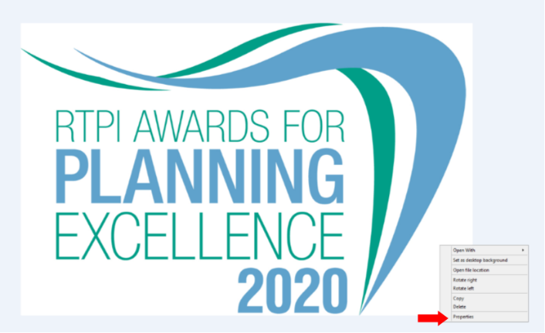

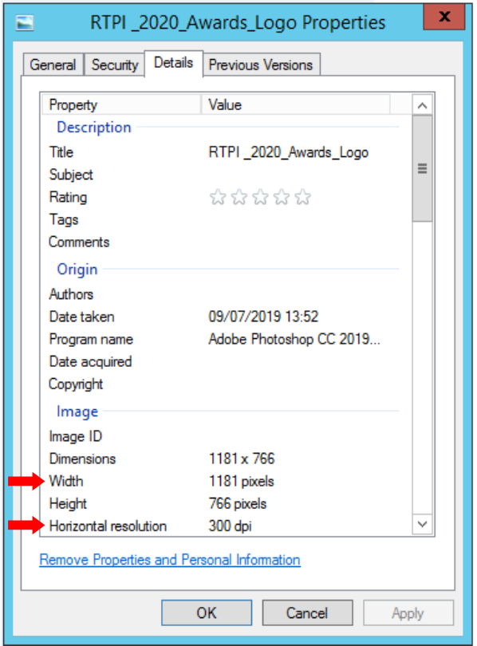

Entry form – Planning Consultancy of the Year
Category:

This award recognises the achievements of East Midlands based planning consultancies. They should demonstrate high levels of service, commitment to sustainable development and support for the planning profession.

Contact name (this should be the main point of contact for all correspondence relating the awards):

Contact job title:

Contact email:

Contact telephone:

Organisation submitting this project

Organisation address(es):

Number of planners working within in the organisation:

Of the planners working within your organisation, please advise how many are Chartered Town Planners (MRTPI or FRTPI):

Media/PR contact (name and email address):

Social media accounts (RTPI EM will engage with winning entries on social media. Please list accounts where possible):
Twitter:
Instagram:
Facebook:

Please confirm RTPI EM can share your contact details including email address with the Awards Judging Panel
☐ YES
☐ NO

Please provide a 25 word and a 100 word overview of your organisation, written in the third person. Should you be shortlisted the 25 word summary will feature in our awards presentation evening. The 100 words will feature on the RTPI website post event.

(25 word summary)

(100 word summary)

Award criteria

In addressing the criteria please use examples of specific projects on which significant planning input has been required during 2018, 2019 and 2020.

1. Development and application of imaginative approaches and techniques to achieve high quality planning solutions
May include: the scale and scope of an issue/project that the organisation was engaged in. What challenges were faced? What techniques or tools were used? How were problems overcome and decisions made? What actions were taken to ensure the successful outcome? How has efficiency and effectiveness been improved?
(insert your answer here – MAX 500 words)

2. Client/applicant/partners satisfied with the service provided
May include: timeliness, flexibility, and ability to respond imaginatively to a brief, quality of public engagement, presentation and communication. Consultation responses, and feedback from the local authority to the planning agent or developer, and vice versa could also be relevant.
(insert your answer here – MAX 500 words)

3. Ability of chartered town planners to manage multi-disciplinary projects or to work within a multi-disciplinary environment
May include: how practitioners influenced or led a project to conclusion, evidence of effective partnership working and mediation, as well as providing a value for money service for clients.
(insert your answer here – MAX 500 words)

4. Commitment to inclusive planning that enables everyone to participate equally, confidently and independently in everyday activities
May include: consultation with hard to reach groups, urban design that meets the needs of an ageing population, best practice in addressing equality and diversity issues.

(insert your answer here – MAX 500 words)

5. Commitment to staff development, business improvements and active participation in professional and educational activities
May include: staff training and quality assurance certification, opportunity for volunteering, representation on official or professional bodies or RTPI Regions, and links with educational institutions.
(insert your answer here – MAX 500 words)

6. Why should your organisation win this award?
(insert your answer here – MAX 500 words)

For help with your submission, please view our ‘How to win’ guide here.

Judging process
The awards are judged by a team of respected planning professionals in the region. The judges will review all entries received and determine a shortlist for each category.

Awards ceremony
The winners of the RTPI Awards for Planning Excellence 2020 will be announced at our presentation evening on 5 November at The Roundhouse in Derby. All entrants will be invited to book places at the event in due course.

Contact us
If you have any questions about entering the RTPI Awards for Planning Excellence, please contact Suzanne.slack@rtpi.org.uk.

Terms and Conditions
- Full submissions must be received by the RTPI by Friday 26 June 2020.
- Without both the entry form and images the submission will not be counted.
- Word counts will be checked. A variation of up to 10% will be allowed, but anything beyond that will not be considered by the judges.
- The RTPI are not responsible for any undelivered emails or late entries. We will confirm receipt of all entries by close of play on Thursday 2 July
- The winners will automatically be entered into the National Awards for Planning Excellence for 2021.
- The RTPI reserves the right to use any images and logos you submit for promotional purposes.
- The RTPI reserves the right to share submissions with our member magazine The Planner.
- The RTPI reserves the right to share submissions and entry forms with our judging panel.
- An entry will presume that there are no restrictions or fees payable for the reproduction of the photographs or any other submission materials.
- The RTPI retains permission to publish all submitted material and particulars of successful entries. This may include online and print publication, and successful entrants may be offered other promotional opportunities. Winning and highly commended entries may feature as case studies in future RTPI work demonstrating best practice and the value of planning.
- Submitted material will be retained electronically by the RTPI.
- The RTPI is not liable for any costs you incur submitting this entry.
- The decisions of the judging panel are final and no correspondence will be entered into before or after the event.
- All information submitted is subject to the above terms and conditions and our Privacy Policy and GDPR Policy.

