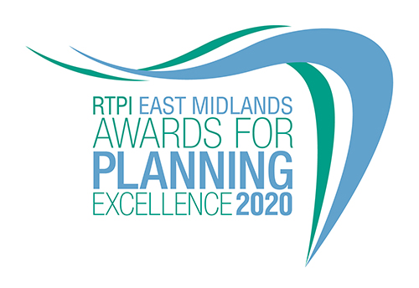

Excellence in Planning Practice
Category information and entry form

Submission deadline: Friday 26 June 2020

Our Awards champion the very best examples of planning and planners in our Region. They demonstrate the positive impact planning has on our quality of life and celebrate professional expertise. The Awards are open to all planners, both members and non-members and all other built environment professions. Entry to our Awards is free.

Being commended or winning is a clear demonstration of the high quality of your work and professionalism. Winning entrants will be provided with a RTPI East Midlands Awards for Planning Excellence logo, which can be used on your own website, email, social media and promotional materials. We wish you the best of luck!

Eligibility

Work completed during 2018 and 2019, or completed by the submission closing date for the 2020 Awards (26 June 2020), is eligible for entry; even if the planners’ role was completed years prior. Particular care should be taken to avoid entering schemes prematurely before they can be satisfactorily assessed. Your entry needs to provide evidence that the plan or project is working on the ground and is delivering outcomes. For example, if your project has only receiving planning permission and no tangible benefits have yet been realised, this would be considered too premature or whilst your strategy has been adopted you are unable to show how it has been implemented. We recommend projects are completed, or substantially completed, in order to be assessed fully against all the judging criteria and other submissions.

Please highlight the category you are entering and you may enter a project into more than one category, please ensure you tick the appropriate boxes below.

Projects or work that has previously won an RTPI Award for Planning Excellence may not be re-entered in the same category, but those shortlisted or commended may be re-entered.

Categories

Please highlight which category you wish to enter.

Excellence in Plan Making Practice
Excellence in Planning for Heritage and Culture
Excellence in Planning for the Natural Environment
Excellence in Planning to Deliver Homes
Excellence in Planning for a Successful Economy

Criteria

Plan Making Practice: In this category, we are inviting submissions that demonstrate excellent practice in plan making. For example, this can include both local plans, or associated guidance and masterplans. If submitting a local plan please outline through your submission how the local plan was unique and demonstrates outstanding best practice. The entry may focus on a particular aspect of the plan that you feel has demonstrated excellence or innovation. If submitting a masterplan, this needs to be endorsed or adopted by the local authority. Other examples of plan making practice are also welcome.

Heritage and Culture: We are inviting you to submit projects that have conserved or enhanced places and buildings with a particular historical, cultural or archaeological significance, for the benefit of the community and future generations. Submissions could include existing buildings that have been restored or new developments, as well as enhancements to the historic built environment.

Natural Environment: This category recognises projects that improve the natural environment through conservation, enhancement, restoration, adaptation or mitigation. For example, green and blue infrastructure, natural resource management or improving biodiversity.

Deliver Homes: This category recognises projects that deliver new housing or upgrade existing developments. Projects can integrate into the surrounding context, or be a new development in its own right. The projects must meet local need and also include infrastructure and facilities for communities. They should also offer a range of tenures and demonstrate high quality design of buildings and place.

Successful Economy: This category recognises projects that promote and support a successful prosperous economy. Projects could include, for example, minerals planning, industrial, commercial, town centre, infrastructure or regeneration schemes that contribute to sustainable economic growth.

How to enter
- Download and save this document (please make sure you have highlighted the category you are entering).
- Complete the entry form and save.
- Send your completed form, as a Word document, and up to 3 images of your project (please see below guidance on the images) to Suzanne.slack@rtpi.org.uk by Friday 26 June 2020
- Upon receiving your entry form and images we will acknowledge receipt by close of play Thursday 2 July. If we do not receive an entry form and images, entries will not be accepted.

Guidance for sending images
In the file name please state the organisation name and who we need to credit the images to.

Images submitted need to meet the below requirements:
- Orientation: Landscape
- Width: at least 1920 pixels
- Height: at least 1080 pixels
- Dpi: at least 300

To view these properties of your image right click on the image and select properties.
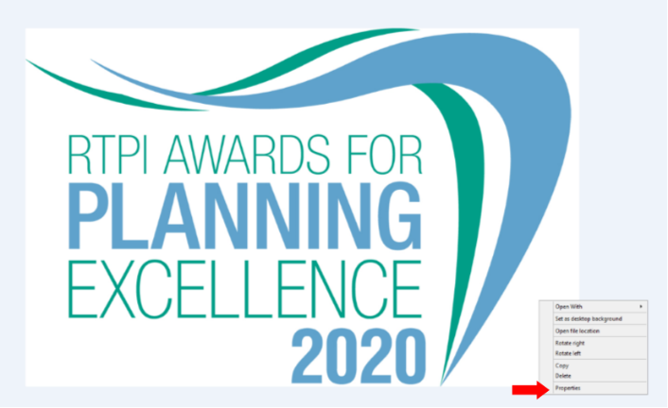

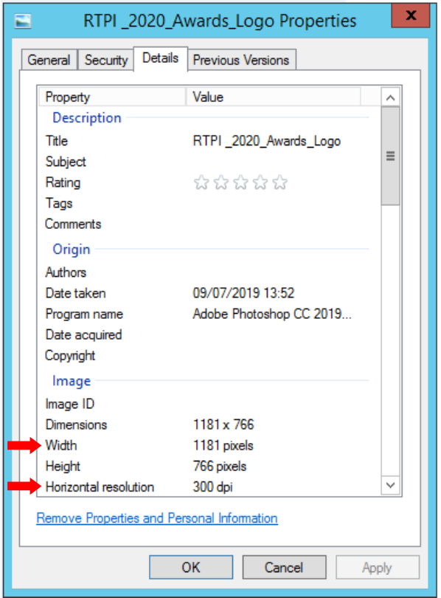

Entry form – Excellence in Planning Practice
Category:

Contact name (this should be the main point of contact for all correspondence relating the awards):

Contact job title:

Contact email:

Contact telephone:

Organisation(s) submitting this project (joint submissions permitted)

Organisation address(es):

Name of project (This name will be used in all publicity so please ensure it is accurate):

Location of project (please also include a postcode if appropriate):

Please advise which (if any) other organisations you have worked with on this project (e.g. other planning consultants, local planning authorities):

Media/PR contact (name and email address):

Social media accounts (RTPI EM will engage with winning entries on social media. Please list accounts where possible):
Twitter:
Instagram:
Facebook:

Please confirm RTPI EM can share your contact details including email address with the Awards Judging Panel
☐ YES
☐ NO

Please provide a 25 word and a 100 word overview of your project, written in the third person. Should your entry be shortlisted the 25 word summary will feature in the awards ceremony presentation. The 100 word summary be available on the RTPI website post event.

(25 word summary)

(100 word summary)

1. Background
Please outline the background to the project:

- Context
- Timeline

(insert your answer here – MAX 500 words)

2. Outcomes
Please outline what positive impacts the project has provided for:
- the local community
- the economy
- the environment
(insert your answer here – MAX 500 words)

3. Planning contribution
Please outline how the project has benefitted from the involvement of a planner or planners:
- providing strong and effective leadership and vision
- working in partnership with others
- managing implementation and delivery
(insert your answer here – MAX 500 words)

4. Sustainable development
Please outline how the project has supported:
- positive short, medium and long term public benefit
- a balance of economic, social and environmental objectives
- the UN’s Sustainable Development Goals
- aimed to prevent or mitigate climate change
(insert your answer here – MAX 500 words)

5. Community benefit
Please outline how the project has provided:
- positive and constructive engagement and dialogue with local people and businesses
- a better quality of life for people, especially for disadvantaged communities
- tangible benefits for communities such as facilities, infrastructure, jobs, training etc
(insert your answer here – MAX 500 words)

6. Leading practice
Please outline how the project:
- is creative and innovative
- is an exemplar that is transferable across the UK
- promotes equality and diversity

(insert your answer here – MAX 500 words)

For help with your submission, please view our ‘How to win’ guide here.

Judging process
The awards are judged by a team of respected planning professionals from the region.
The judges will review all entries received and determine a highly commended and winner for each category. The category winners will then be judged against each other to give an overall project winner.

Awards ceremony
The winning and highly commended projects will be announced at our Awards Presentation Evening on 5 November at The Roundhouse in Derby. All entrants will be invited to book places at the event in due course.

Contact us
If you have any questions about entering the RTPI East Midlands Awards for Planning Excellence, please contact suzanne.slack@rtpi.org.uk.

Terms and Conditions
- Full submissions must be received by the RTPI by Friday 26 June 2020.
- Without both the entry form and images the submission will not be counted.
- Word counts will be checked. A variation of up to 10% will be allowed, but anything beyond that will not be considered by the judges.
- The RTPI are not responsible for any undelivered emails or late entries. We will confirm receipt of all entries by close of play on Thursday 2 July 2020.
- The overall project winner, teams and young planner winners will automatically be entered into the National Awards for Planning Excellence for 2021.
- The RTPI reserves the right to use any images and logos you submit for promotional purposes.
- The RTPI reserves the right to share submissions with our member magazine The Planner.
- The RTPI reserves the right to share submissions and entry forms with our judging panel.
- An entry will presume that there are no restrictions or fees payable for the reproduction of the photographs or any other submission materials.
- The RTPI retains permission to publish all submitted material and particulars of successful entries, including the judges’ reports. This may include online and print publication, and successful entrants may be offered other promotional opportunities. Winning and highly commended entries may feature as case studies in future RTPI work demonstrating best practice and the value of planning.
- Submitted material will be retained electronically by the RTPI.
- The RTPI is not liable for any costs you incur submitting this entry.
- The decisions of the judging panel are final and no correspondence will be entered into before or after the event.
- All information submitted is subject to the above terms and conditions and our Privacy Policy and GDPR Policy.

