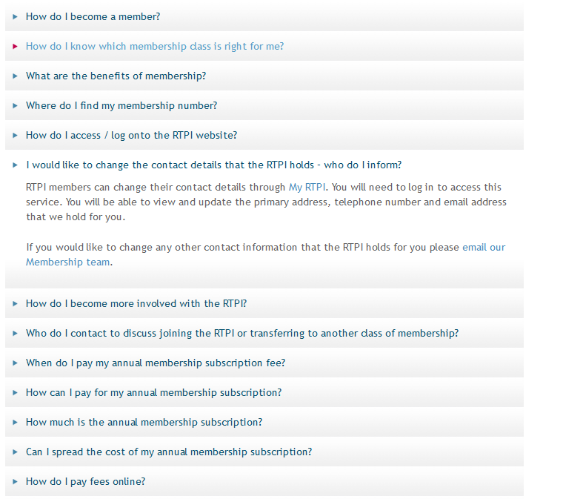
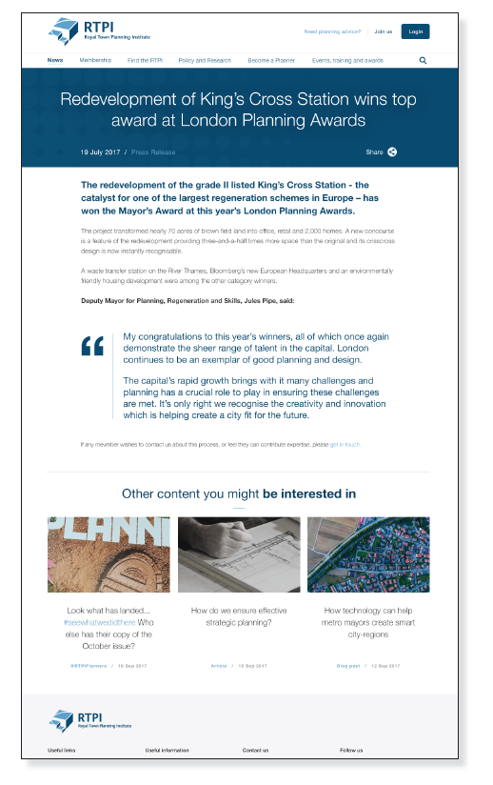
Accordion style
(can present content in this format within a content page)
Content Page Example
Body content
Page title
Intro text
Related content blocks

Content Page

CMS Property | Description | Content
Page Title - H1 | H1 - This is your first title on the page. To see real benefits for SEO it should include the keyword you want to focus on, e.g. ‘Awards’ | Professional Development Plan resources
Intro Text  (50 - 100 words max) | Introduction to the article | You must prepare a Professional Development Plan (PDP) at least once a year, unless you are an affiliate, student or retired member.
Body content  (250-300 words max) | Main article.  Save files which on this page in folder.  Source images and IDs.  Indicate if accordion format should be used. | When you join as an Associate, Legal Associate or Chartered Member, you must also prepare a PDP for formal assessment.  As an RTPI member you are required to annually spend time preparing a PDP identifying your development needs for the next 2 years. Use this template to prepare your PDP.  Example PDPs  These examples show you how to build a PDP. However please note they are not based on planning roles. This has been done so that you will need to carefully consider your own professional circumstances. Make sure you link your own PDP to planning.  - Example PDP 1  This plan is from someone who is moving to a managerial role in a new location. It includes preparing for the role and what they expect to cover during induction and beyond.  - Example PDP 2  This plan is from someone who is setting up their own (non-planning) consultancy. It includes, mixed work-based learning and self-study.  How to create a successful PDP  This document gives advice on how to create a successful PDP for a number of situations.  Common pitfalls  This document of common pitfalls covers ways PDPs can be unsuccessful so that you can avoid these mistakes. Used it with the standard CPD guidance and membership guidance documents if you are joining or upgrading your membership.  How to write a PDP  Take our short e-learning module refresher course on how to write a PDP. Go to RTPI Learn to register online and create an account, if you do not already have one. You will learn:  - Why we ask for a PDP  - How to approach the SWOT analysis  - How to create well-formed goals  - How to funnel your plan towards actions using objectives  - How to create SMART actions that work for you.  PDP podcasts  - Episode 1 – What is a Professional Development Plan?  - Episode 2 – The SWOT analysis  - Episode 3 – Goals and objectives  - Episode 4 – Action Plan  - Episode 5 – Top PDP tips  Contact us  - Email: cpd@rtpi.org.uk  - Tel: +44(0)20 7929 8174
Page tags | Tag 1
 | Tag 2
 | Tag 3
Related content blocks (max. 3) | This is currently automatically populated based on the tags applied to content items. | You do not need to complete this section as it will automatically pull in content with relevant tags – e.g. Yorkshire and Young Planners.  We are exploring a possible option to pin content as well as automatically pulling it through, but this has not been confirmed.  If we can pin content please feature:  Related links  - Planning and Recording CPD  - Membership events  - Core CPD Framework  - APC info?  CTA for PDP module on RTPI Learn?
Featured video
Image | Please add shutterstock id or put image in folder
Related event blocks (max. 3) | This is currently automatically populated based on the tags applied to content items. | You do not need to complete this section as it will automatically pull in content with relevant tags.  We are exploring a possible option to pin content as well as automatically pulling it through, but this has not been confirmed.
Custom URL | If this page already has a custom URL keep it the same (check umbraco). If it doesn’t create one if required.
SEO Page title | This is not the title on your page, it is the page title that will appear in your tab. From an SEO point of view, your page title should include the main keyword that you would like to target on that page. | Professional Development Plan Resources
SEO Meta Description | This is not visible to a user visiting your page. This text should be a description of what the content on the page is about. Think of this as a short paragraph that will tell Google what your page is about. Your meta description should include the same keyword as your Page Title. | RTPI members need to write Professional Development Plans. The RTPI has a range of PDP resources including an online learning module and case study examples.

