Spatial Approaches to Local Energy Planning (SALEP)

Case study: Perth and Kinross

# The Royal Town Planning Institute (RTPI)

The RTPI champions the power of planning to create prosperous places and vibrant communities. We have over 27,000 members in the private, public, academic and voluntary sectors. Using our expertise and research we bring evidence and thought leadership to shape planning policies and thinking, putting the profession at the heart of society's big debates. We set the standards of planning education and professional behaviour that give our members, wherever they work in the world, a unique ability to meet complex economic, social and environmental challenges. We are the only body in the United Kingdom that confers Chartered status to planners, the highest professional qualification, sought after by employers in both private and public sectors.

# This resource is part of the Spatial Approaches to Local Energy Planning (SALEP) suite

This resource is part of the RTPI’s SALEP (Spatial Approaches to Local Energy Planning) suite of guidance, analysis and in-depth case studies on integrating energy planning with town planning across the UK. It was produced in collaboration with Regen.

For more information and access to the rest of the suite, please visit the [SALEP webpage](https://www.rtpi.org.uk/policy-and-research/spatial-approaches-to-local-energy-planning-resource-suite-salep/case-study-belfast/).

# Authors

This document was produced by Regen with input from the RTPI.

# Cover image

Credit: [yevtony](https://www.gettyimages.co.uk/search/photographer?photographer=yevtony)

Royalty free.

# Contents

The Royal Town Planning Institute (RTPI) 1

This resource is part of the Spatial Approaches to Local Energy Planning (SALEP) suite 1

Authors 1

Cover image 1

Contents 2

1. Case study summary 3

2. Context: Local Heat and Energy Efficiency Strategies (LHEES) in Scotland 3

3. Development of the LHEES and Local Area Energy Plans (LAEPs) 3

3.1 LHEES 3

3.2 LAEP 4

4. Collaborative governance during the LHESS and LAEP development 5

4.1 The role of internal and external stakeholders 6

4.2 Ongoing alignment 7

5. Role of local authority planners in preparing the LHEES and LAEP 7

5.1 Integration of LHEES and LAEP with the emerging Local Development Plan (LDP) 7

5.2 Evidence-based planning for energy, heat, and cooling 8

5.3 Heat decarbonisation 9

6. Key recommendations from this case study 9

6.1 Timing and alignment of the LHEES and LAEP with the local plan 9

6.2 Consideration of alignment with national town planning policy 9

6.3 The need for future investment in renewable energy and heat projects 9

RTPI - Royal Town Planning Institute 10

# 1. Case study summary

* Perth and Kinross Council have published both a Local Heat and Energy Efficiency Strategy (LHEES) and a Local Area Energy Plan (LAEP). They are now in the process of updating their local development plan.
* This case study illustrates the benefits of fully involving the local authority planning team in the development of the LHEES and LAEP.
* The example provides useful recommendations regarding the need to align energy and spatial plans and the need for closer alignment with national town planning policy.

# 2. Context: Local Heat and Energy Efficiency Strategies (LHEES) in Scotland

Perth and Kinross Council, along with all other local authorities in Scotland, has a statutory duty to develop a LHEES and update it every five years. The LHEES is intended to provide a long-term framework for enhancing energy efficiency and lowering greenhouse gas emissions from heating systems in buildings and to align with both national and local targets. A LHEES must include both a strategy and a delivery plan, ensuring a structured approach to achieving these goals. Although LAEPs are not a statutory requirement, Perth and Kinross Council opted to develop a LAEP alongside the LHEES to support a more comprehensive approach to local energy planning.

# 3. Development of the LHEES and Local Area Energy Plans (LAEPs)

## 3.1 LHEES

The statutory requirement to develop a LHEES, with a December 2023 deadline, accelerated the council’s development of work in this area and raised the strategy’s priority within the council. The strategic timeframe for the LHEES spans from 2024 to 2045, with a focused delivery plan for 2024 to 2029, ensuring that the delivery aligns with both immediate targets and long-term objectives.

The strategic priorities for the LHEES included improving building energy efficiency and decarbonising through a focus on both heat networks and heat pumps. In alignment with Scottish Government priorities, the local authority participated in heat network zoning initiatives. Initial assessments for zoning were conducted by the Scottish Government, with further refinements made at the local level through internal working groups. This coordination allowed for the customisation of the heat network zones to better fit local needs and infrastructure. The state of housing stock emerged as a significant concern during the development of the LHEES, highlighting the necessary scale of investments required for decarbonisation.

## 3.2 LAEP

The development of the LAEP for Perth and Kinross was largely driven by the recognition of the need to look beyond heat, at the whole energy system, so this process was started shortly after the LHEES. The council published its LAEP in January 2024. The document covers the period 2024-2029 setting out a vision of what a net-zero carbon energy system could look like for the area, including priority interventions and recommended actions.

The LAEP was created in alignment with the LHEES and outlines five key priority intervention areas:

* Improving the energy efficiency of existing buildings
* Decarbonising heat
* Reducing transport demand
* Decarbonising transport
* Deploying local renewable energy generation and storage

For each priority area, the LAEP includes a high-level roadmap identifying recommended actions to support the preferred pathway, all within the context of broader policy targets and strategic decisions (see figure 1 below).

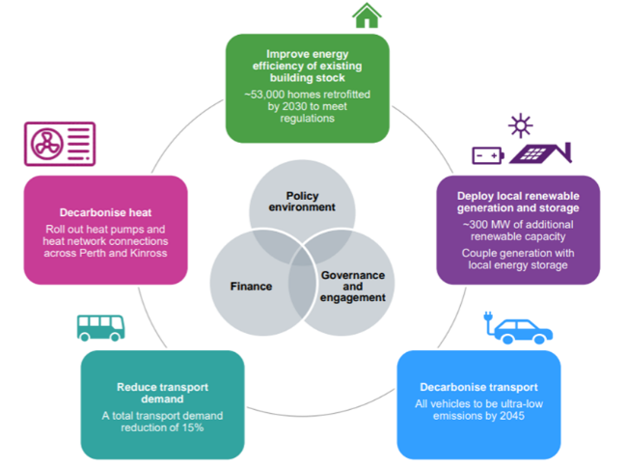*Figure 1: LAEP Priority intervention areas (from* [*Perth and Kinross Council Local Area Energy Plan 2024-2029*](https://www.pkclimateaction.co.uk/files/LAEP-240130-FINAL-ISSUE_2024-07-26-171311_snvj.pdf)*)*

Both the LAEP and LHEES are using the innovative Local Energy Net Zero Accelerator (LENZA) planning tool, which provides access to up-to-date network capacity, building stock data, and modelling tools to support decision making.

# 4. Collaborative governance during the LHESS and LAEP development

From the outset, Perth and Kinross Council opted to develop the LHEES and the LAEP as a unified initiative, promoting a comprehensive *"whole energy systems"* perspective (see figure 2 below). This framework facilitated critical considerations such as grid constraints and planning, thereby enabling a more integrated view of local energy systems.

The governance structure established for the LAEP and LHEES has proven to be highly effective. By integrating these two initiatives under a single delivery framework, directly linking to the council’s decarbonisation plan, Perth and Kinross Council was able to ensure that all related work aligned. This holistic approach allowed for a cohesive strategy that addressed various energy-related challenges and fostered collaboration across different teams within the council.

*Figure 2: Overview of LHEES and LAEP (from* [*Perth and Kinross Council Local Heat & Energy Efficiency Strategy 2024-2045)*](https://www.pkclimateaction.co.uk/files/LHEES-Strategy_PKC_10.07.24.pdf)

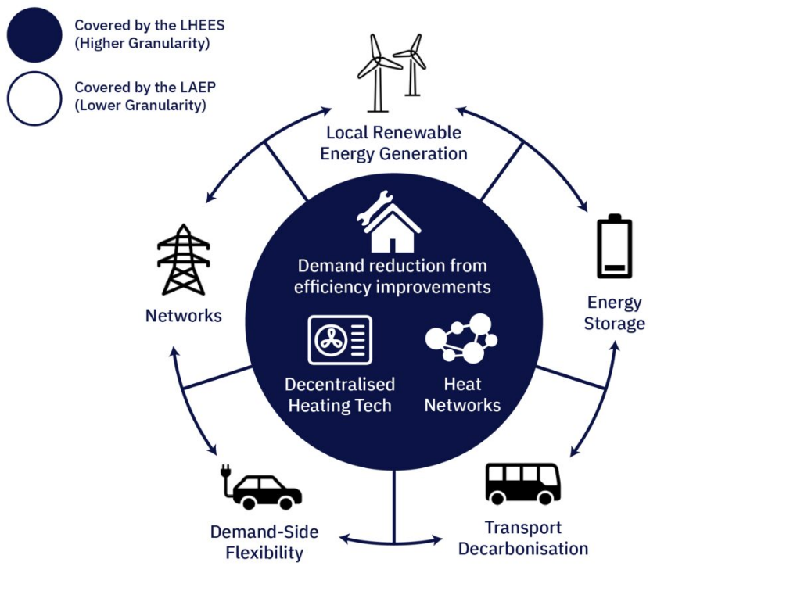

## 4.1 The role of internal and external stakeholders

To manage and drive the LHEES and LAEP effectively, both internal and external steering groups were established and involved from the inception of the project. This included a coordinated *“team of teams”* approach across various council departments including town planning, alongside partnerships with external delivery partners, such as Scottish & Southern Electricity Networks Transmission (SSEN), the NHS, housing associations, and other stakeholders. As part of this process, the council hosted a series of eight workshops. The involvement of these external partners from the outset facilitated early buy-in, allowing stakeholders to gain an understanding of the importance of the plans, identify potential opportunities, and provide input across various phases—from evidence gathering to scenario planning and deployment. This collaborative governance structure has proven valuable in gaining wider support and ensuring that the strategy benefits from diverse expertise and input.

## 4.2 Ongoing alignment

As the council moves into the next phase of LHEES and LAEP implementation, there is a recognised need to strengthen partnerships with external delivery partners. While the council has established solid internal alignment, the next steps will focus on expanding collaboration with steering group partners and effectively linking various workstreams through a delivery framework. Aligning with policies including the emerging Local Development Plan (LDP) (discussed below) and the mobility strategy is also recognised as key.

This integration exemplifies the added value of LAEP as a planning tool, building on the foundation LHEES provides but extending into actionable pathways for the broader energy system transformation. LAEP supplies the route map needed to address system-wide decarbonisation, which will be increasingly critical for local authorities aiming to meet net-zero.

# 5. Role of local authority planners in preparing the LHEES and LAEP

In developing both the LHEES and the LAEP, Perth and Kinross Council emphasised the need for alignment between energy planning and the broader town planning system. Notably, alignment was identified as a priority early in the process, indicating strong internal awareness of the importance of synergy between energy strategies and town planning policies.

To facilitate this, planners from the council’s town planning policy team were included in the LHEES and LAEP project team. The LHEES process requires a policy review and strategy, which proved a useful process in terms of identifying linkages with both national and local policies. The involvement of planners in the LAEP and LHEES process was also valuable in terms of providing an in-depth understanding of the factors influencing the siting of renewables. This enabled town planning constraints to be taken into consideration, providing more certainty on the suitability of land for renewables.

## 5.1 Integration of LHEES and LAEP with the emerging Local Development Plan (LDP)

The current LDP (LDP2), adopted in 2019, includes a low-carbon spatial strategy that highlights key opportunities for developing renewable and low-carbon energy sources for transport fuel, electricity, and heat. The council is now in the information-gathering phase for the upcoming LDP3. According to the development programme, the new LDPs will be *“place-based”* documents, emphasising maps, site briefs, and masterplans while using minimal policy wording. Policies and proposals in the LDP will focus on specific places and locations, with National Planning Framework 4 (NPF4) providing the overarching thematic policies to guide decision-making. The evidence underpinning the heat and renewable energy policies in LDP3 will ensure that the plan is more detailed, clear and evidence-based than the previous plan, helping it to become a facilitator for low carbon development.

Perth and Kinross Council are actively integrating the findings of the LHEES and LAEP with the development of LDP3. The council noted that traditionally, planning benefitted from a *“survey, analysis, plan”* approach, which emphasised in-depth data gathering and analysis before action. The LHEES and LAEP processes has enabled this to happen again and to a more detailed extent, through integrating rigorous data collection and analysis from the outset, providing a whole systems understanding to heat and energy. This has ensured that the LDP is informed by a strong evidence base.

The simultaneous timing of LDP3 development and the publication LHEES/LAEP work has proven advantageous, allowing the council to integrate critical energy and heat priorities directly into emerging town planning policies. As a result, the LDP, with its place-based approach, can be seen as the essential delivery tool for both the LHEES and LAEP.

## 5.2 Evidence-based planning for energy, heat, and cooling

To support the development of LDP3, the council has prepared an Energy, Heat, and Cooling topic paper, setting out the key information to be covered by LDP3 to ensure that the plan will be aligned with national and local energy goals. This paper is essentially the tool used to ensure that the LHEES and LEAP directly inform the development of LPD3. By using LHEES and LAEP data, the LDP3’s spatial strategy can more effectively account for future renewable energy developments and heat networks, fulfilling NPF4’s expectations for local energy systems.

## 5.3 Heat decarbonisation

Heat decarbonisation and the development of district heating networks are recognised as being a key opportunity within the emerging LDP3. Data and analysis from the LHEES prioritise areas within Perth and Kinross with high potential for efficient heat networks. The local authority recognises the value that the LHEES has provided in terms of capturing the data that shows what needs to be done, enabling heat network zoning to inform site allocations and assessments within the local plan.

However, the local authority identified the need for further guidance from the Scottish Government, regarding ensuring clarity in policy for both heat network zoning and how this feeds into the local plan. This will be particularly necessary for local authorities who are not updating their local plan at a similar time to their LHEES.

# 6. Key recommendations from this case study

## 6.1 Timing and alignment of the LHEES and LAEP with the local plan

LHEES and LDPs are both statutory requirements in Scotland and clearer guidance is needed on how these documents should be linked. The timing of the LDP update in Perth and Kinross was fortunate, enabling the integration of the LHEES and LAEP within broader town planning initiatives. For other authorities, where these updates may not align as closely, integrating energy priorities into local plans could present a significant challenge.

## 6.2 Consideration of alignment with national town planning policy

As local authorities seek to align their heat, energy and town planning policies with national policies, closer alignment with NPF4 will be crucial. There is room for further clarity and integrated guidance to ensure that energy, planning, and development priorities are cohesive.

## 6.3 The need for future investment in renewable energy and heat projects

The structured approach to gathering data provided by the LHEES and LAEP enables more informed planning for strategic investment and helps integrate local and national priorities. Yet successful outcomes also rely on deeper collaboration with the private sector, as ongoing investment and technical partnerships will be essential.

# RTPI - Royal Town Planning Institute

[research@rtpi.org.uk](mailto:research@rtpi.org.uk)

Royal Town Planning Institute.

41 Botolph Lane, London EC3R 8DL.

Registered Charity in England (262865) & Scotland (SC037841)