Are developers in England delivering ecological enhancements required by planning permissions?

The Royal Town Planning Institute (RTPI)
The RTPI champions the power of planning to create prosperous places and vibrant communities. We have over 27,000 members in the private, public, academic and voluntary sectors. Using our expertise and research we bring evidence and thought leadership to shape planning policies and thinking, putting the profession at the heart of society's big debates. We set the standards of planning education and professional behaviour that give our members, wherever they work in the world, a unique ability to meet complex economic, social and environmental challenges. We are the only body in the United Kingdom that confers Chartered status to planners, the highest professional qualification, sought after by employers in both private and public sectors.

About this briefing
This RTPI research briefing summarises research originally conducted by Kiera Chapman and Malcolm Tait for the charity Wild Justice. This was published on 12 December 2024 as Lost Nature.

Authors
Kiera Chapman is Postdoctoral Researcher in Attention, Flourishing, and the Humanities at Oxford University, and Co-Investigator on the ESRC-funded Planning for Nature project. Her work ranges across the arts and humanities, social sciences, and science, asking questions about suburbia, housing, and the vision of nature that gets realised in space. She is also an established nature writer and author of Nature’s Calendar: The British Year in 72 Seasons, published by Granta, with a subsequent book on time, ritual, and folklore to follow in 2026.
Kiera can be contacted at: kiera.chapman@ell.ox.ac.uk
Malcolm Tait is Professor of Planning at the University of Sheffield (an accredited RTPI planning school), and Principal Investigator on the ESRC-funded Planning for Nature project. His work focuses on studying the impacts of the planning system on biodiversity loss, and the (non)-integration of planning with Local Nature Recovery Strategies. He has recently coauthored two books about the culture of professional work in planning, exploring the implications of the rise of private sector consultancy: What Town Planners Do and The Future for Planners, both published by Policy Press.
Malcolm can be contacted at: m.tait@sheffield.ac.uk
The authors would like to thank Sarah Postlethwaite for her contribution to the research and analysis, and to Mark Avery, Chris Packham, and Ruth Tingay at Wild Justice for supporting the original research.

Contents
The Royal Town Planning Institute (RTPI) 1
About this briefing 1
Authors 1
Contents 3
Executive summary 4
Context 4
Key recommendations 4
Background 5
BNG and the nature emergency 5
Methods 5
Findings 6
Why is developer compliance so low? 7
What role does landscape maintenance play in this picture? 8
But won’t Biodiversity Net Gain solve this? 8
We need to pay more attention to post-consent processes 9
Full recommendations 9
Central government should… 9
Planners and LPAs should… 10
RTPI - Royal Town Planning Institute 12

Executive summary

Context
The UK is one of the most nature-depleted countries in the world. In response, over the last 15 years policies in England have encouraged development to enhance nature. In 2024, this commitment was strengthened with the introduction of ‘Biodiversity Net Gain’, a statutory requirement for developers to prove that their developments, with some exceptions, will deliver a 10% increase in biodiversity value of on-site habitat.
However, very little research has explored whether these legislative and policy commitments are making a difference on the ground.
This briefing summarises research led by the University of Sheffield’s planning school, which surveyed 42 completed developments across 5 Local Planning Authorities in England that were granted planning permission after 2012.
The researchers looked at nearly 6,000 houses and over 291 hectares of land. They searched for 4,654 trees and 868 bird and bat boxes. They surveyed many hectares of what were promised to be wildflower grasslands, ponds, and hedgerows.
They found that only half of the ecological features - 53% - that had been conditioned were present. When they excluded newly planted trees, this fell to a third - just 34%.

Key recommendations
These findings suggest that urgent action is needed to ensure that the planning system better protects biodiversity.
Central government should ensure adequate resources are in place to operate the increasingly important post-consent planning process, especially for enforcement/compliance teams.
Central government should put in place procedures to ensure that ecological enhancements on new housing estates are adopted and managed by local authorities and over the long term.
Local authorities should set out plans to resource post-consent planning processes, ensure that conditions are worded clearly, and provide all plans and documents that comprise the consented scheme in one easy-to-access location.

Background

BNG and the nature emergency
We are currently in the midst of a global ‘nature emergency’, in which the UK now features as one of the most nature-depleted countries in the world. The causes are many and complex, but urban development is a known driver.
The government has committed to reforming the planning system, promising to build 370,000 houses per year in England. The gambit is that nature will be protected by ecological mitigation and enhancement policies, most notably through statutory Biodiversity Net Gain, which came into place in 2024. This makes it mandatory that a wide range of developments implement strategies to achieve a 10% uplift in biodiversity.
However, there has been very little research to explore whether these written commitments translate into better outcomes on the ground. A key question is whether the ecological enhancements and mitigations that have been secured through planning consents in the past have actually been implemented in real life.

Methods
Between June and August 2024, a research team based in the University of Sheffield’s planning school visited 42 new housing estates across five Local Planning Authorities in England. For each site, they compared what was consented through the planning process with what was present on the ground.
The researchers looked at completed major housing developments (comprising more than ten houses) that were granted planning permission after 2012, when the National Planning Policy Framework first required developments to demonstrate a net gain for biodiversity. Though the current statutory framework for BNG was not in place at this point, finding out whether required ecological enhancements were delivered gives insights into how successful the current approach to BNG is likely to be.
They ensured that sites represented the outputs of a range of housebuilders from SMEs to regional and national firms. They investigated different sizes of development, from 10 to 500 houses, across a range of urban and rural locations, with varying levels of housing need and different local ecosystems and habitat designations.
They downloaded the documentation for each site and listed all of the ecological features that formed part of the planning consent. They visited each development site at least once, and in the majority of cases, two researchers visited. They walked through every street and across all publicly-accessible areas and compared what was conditioned to what was present in real life. They did not survey ornamental non-native plantings around houses, anything in private gardens, and any areas that couldn’t be accessed.

Findings
Only half of the ecological enhancements - 53% - that were required were present on the ground. When newly planted trees were excluded, this fell to a third - just 34%.
- 82% of woodland edge seed mixes and 73% of woodland edge plug plantings (of perennials) were missing;
- 60% of the areas of wet grassland that are supposed to be sown were missing or had been mown so that species richness had been reduced;
- 59% of wildflower grasslands had either not been sown correctly, or had been mown incorrectly so that their species richness had been reduced;
- 48% of native hedges that should have been planted were missing;
- 39% of trees on planting plans were missing or dead; and
- 39% of native thicket/scrub plantings that were supposed to be provided were missing.
In terms of species enhancements and mitigations:
- 75% of bird boxes were missing;
- 75% of bat boxes had not been installed;
- 83% of hedgehog highways were not in place;
- 85% of hibernacula and refugia for reptiles were not in place; and
- 100% of invertebrate boxes were not in place.
The researchers found very little variation in the compliance of sites by type of developer, size of development (number of houses), area of the development site (in hectares), or geography (area of the country).
Given that the methodology looked at local, regional, and national housebuilders, this lack of variation is surprising. It suggests a systemic issue across the planning and development system as a whole.

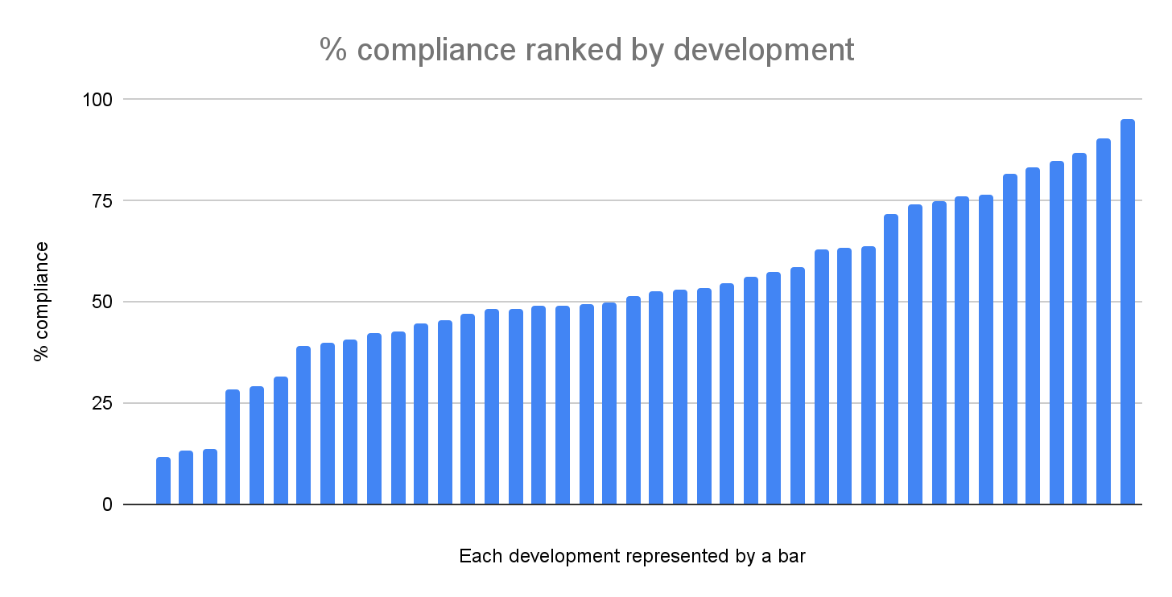

Why is developer compliance so low?
The research uncovered a range of factors that can be at play, including:
- Poorly-worded conditions, meaning that expectations are not clear;
- Weak local policy guidance on biodiversity;
- Poor-quality Landscape and Ecology Management Plans, leading to vague requirements regarding the implementation and maintenance of ecological features; and
- Housebuilders not factoring in construction of ecological features in their site building practices.
However, a lack of effective enforcement was the key factor.
As RTPI research has demonstrated, local authority enforcement teams have experienced significant cuts over the past 14 years, meaning that they often do not enforce ecological consents and conditions. Many view ecological mitigations as a low priority and some also lack the requisite skillset to monitor ecological features. This creates a context in which developers may risk not installing ecological mitigations, in the knowledge that enforcement is unlikely to happen, leading to a ‘death by a thousand cuts’ as multiple smaller mitigations are not delivered or enforced.

What role does landscape maintenance play in this picture?
Landscape maintenance on new build estates is very piecemeal, with the research suggesting that the companies who are responsible are frequently failing to manage ecological features correctly.
Part of the problem is that local authorities, due to resource pressures, are increasingly refusing to adopt public open space and drainage systems in new housing developments. Over 80% of such spaces are now managed by estate management companies, who charge residents a fee and subcontract maintenance work to landscaping contractors - a situation which the Competition and Markets Authority has described as lacking in transparency and oversight.
Looking at the current framework for BNG, the ability to offload estate management costs onto residents may also be a factor driving developers to pursue onsite Biodiversity Net Gain strategies, as opposed to purchasing offsite credits, the price of which includes maintenance for 30 years.
This situation introduces potential conflicts between people and nature, as residents faced with cost of living pressures may seek to reduce expensive maintenance bills for ecological features. With increasingly complex BNG enhancement plans, there is also a real risk that landscaping companies do not have the skills, financial incentives, or oversight necessary to achieve this important policy objective.

But won’t Biodiversity Net Gain solve this?
Many onsite mandatory Biodiversity Net Gain plans will be secured by Section 72 conditions - the same mechanism used for the 42 developments surveyed. Whilst some additional monitoring may be written into future Habitat Management and Monitoring Plans, this work shows that housebuilders and management companies are often not complying with this kind of ecological condition. In the absence of effective enforcement, there is no reason to think that the introduction of Biodiversity Net Gain will change this tendency. Even where section 106 agreements are used to secure financial resources for monitoring ecological features, enforcement remains a key challenge.
Current BNG policy distinguishes between ‘significant’ onsite enhancements, which require 30 years of management, and ‘non-significant’ enhancements which do not. However, the difference is vaguely defined in policy and law, which may lead to some ecological features being poorly protected in the longer term. The research shows a high proportion of failure in enhancements that are secured for a short length of time, such as five years.
Finally, the complexity of many legal agreements for habitat creation through Biodiversity Net Gain is likely to mean that there will be many grey areas that make enforcement difficult: Defining the ecological condition that habitats must achieve over a 30 year period is likely to be particularly tricky and open to challenge.

We need to pay more attention to post-consent processes
The planning system tends to focus on the process of securing planning permission. But increasingly important decisions are now being taken after permission has been granted, including the details of ecological enhancements and mitigations via BNG. More attention and resources need to be dedicated to this key stage of planning if outcomes on the ground are to be improved.

Full recommendations

Central government should…
Put effective and adequately resourced ecological enforcement in place
Extra resources must be provided to Local Planning Authorities to deal with post-consent processes including monitoring, compliance and enforcement, either through direct funding, changes to planning fees, or via planning obligations. These should be targeted towards the recruitment of specialist planner-ecologists to deal with the complexities of ecological enhancement schemes. This will create capacity for more proactive monitoring and enable Local Planning Authorities to comply with the biodiversity duty.
Fund local authorities to take on the management of public space on new build housing estates
Local authorities must be adequately funded so that they can adopt and manage public space. Government should seek to tighten regulations and require developers to pay a commuted sum or bond to fund on-site maintenance for 30 years, mirroring payment for the long-term management of off-site biodiversity offsets. This would include funds to pay for replacing mitigations and enhancements that fail or die.
Ensure clarity as to what constitutes a ‘significant’ BNG enhancement
Government should provide clarity on the definition of ‘significant’ enhancements, so that loopholes cannot be exploited and that all meaningful ecological enhancements are maintained for the long term.
Support industry-wide CPD on ecology for planners
The government could fund the Planning Advisory Service or other providers to deliver specific training on ecology, and principles of enhancement/mitigation. This is not intended to replace specialist ecology roles, but will enable the interface between planning and ecology to work more effectively.

Planners and LPAs should…
Ensure that LPAs have adequate inhouse ecological support
A dedicated ecology team is now necessary to assess ecological enhancement plans. This requires specialist expertise of a kind that cannot be adequately backfilled by other professionals.
Ensure that there is robust local policy and guidance to protect biodiversity in place, supplementing national standards and guidance
Local Planning Authorities should consider setting clear local policy and guidance to maximise outcomes for nature. In particular, there needs to be a focus on improving the quality of work done by key private sector consultants in the planning process, including ecologists (for example, producing a standard list of the data sources to be consulted for preliminary appraisals), and landscape architects (for example. producing lists of invasive plants that are to be excluded from planting schemes). Local Planning Authorities could consider a certification process for ecology reports, which would also provide a valuable source of revenue to help fund ecology teams.
Ensure that landscape and management plans are maximally ambitious, setting high goals for ecological mitigation and enhancement
Opportunities to do much more for nature are being missed. For example, replacing ecologically low value planting around houses with equally attractive but more ecologically valuable native species could significantly boost the amount of habitat that new build estates provide.
Write precise and enforceable conditions
Conditions should use precise language on the position and condition of ecological enhancements and mitigations, with clear instructions as to how their implementation will be proved before discharge (for example, photos supplied). It may be necessary to split conditions into two elements, one for construction, the other for ongoing management. Where an application is decided at appeal, there needs to be significant attention paid to the wording of ecological conditions, rather than seeing these as an afterthought. The research suggests that the Planning Inspectorate should look into this as a priority, as the wording of conditions on appeal was a significant weak point.
Ensure clear presentation of all consented plans for each scheme
Local Planning Authorities and planning application portal providers should consider presenting all consented documents and plans separately to enable clarity. This would aid communities, developers, and local authority staff (including enforcement officers) to access the relevant materials simply and easily.
Manage post-consent planning processes, particularly enforcement
Local Planning Authorities should set up robust systems to ensure consistency of decision making post-consent, including resourcing dedicated to this stage of the planning process, including specialist ecological compliance officers.

For more information, please visit:
https://www.rtpi.org.uk/policy-and-research/research-and-practice/

RTPI - Royal Town Planning Institute
research@rtpi.org.uk

Royal Town Planning Institute.
41 Botolph Lane, London EC3R 8DL.
Registered Charity in England (262865) & Scotland (SC037841)

