Introduction 2
Background and English planning context 2
This report 2
Planning funding 3
Planning performance 4
Planning authorities in 2025 6
Resourcing and skills gaps 6
Demographics 11
Ways of working 12
Planners in 2025 16
Career stage and plans 16
Area of planning 16
Career stage 16
Resourcing and skills gaps 19
Skills, knowledge and training 19
Capacity and challenges 21
Greatest challenges 22
Wellbeing 24
Working and volunteering practices 27
Who responded 29
Geography 29
Demographics 29
Conclusion: what does this mean for the English planning profession? 31
Appendices 33
Appendix A – Methodology 33
Appendix B – Data sources 34
Appendix C – References 35

Introduction

Background and English planning context
Planning has become an increasingly salient policy area in England in recent years. It featured prominently in party manifestos during the 2024 general election and has become a key priority of the current government’s agenda. Planning is vital to addressing a number of key policy challenges, including the housing crisis, ageing infrastructure, the transition to net-zero, and encouraging the development that will underpin economic growth. Major changes have been made to key planning documents and processes, notably, the National Planning Policy Framework (NPPF; which was updated in December 2024 and is expected to undergo further updates this year), and through the reintroduction of strategic planning, abolished by the last government in 2010. In addition, planning is a key component of multiple nationwide plans and strategies, like the 10-year Infrastructure Strategy, the Industrial Strategy, and the Long-Term Housing Strategy, which is expected in the coming months. Forthcoming reforms in other areas will also have an impact on planning, namely devolution and local government reorganisation.
These reforms, while presenting challenges, also provide significant opportunities to strengthen the role of planning in coordinating national priorities, unlocking investment, and shaping resilient, inclusive places for the future. Ambitious targets have been set to address these challenges, including building 1.5 million new homes in the current parliament, to break ground on a new generation of new towns, initiating 150 Nationally Significant Infrastructure Projects (NSIPs), and to deliver clean power by 2030. However, with an unfavourable economic position, global instability and multiple domestic crises competing for the government’s attention, it is unclear if the level of funding, resourcing and training promised by the government for the planning sector will measure up to this.
Against this backdrop, understanding the capacity, skills, plans and wellbeing of planners themselves is crucial. This report explores how planners across England are experiencing this period of transition, and highlights the challenges, opportunities, and priorities that will shape the future of the profession.

This report
Given the provided context, and in a rapidly shifting planning landscape in England, this report will assess the ‘State of the Profession’ in 2025. Using a survey of Local Planning Authorities (LPAs), and working members of the RTPI, it will give an insight into the recruitment, skills need, working practices and demographics of LPAs, and the career experiences, career plans, wellbeing and demographics of member respondents.

Planning funding
Funding levels have shown how planning was affected by budget cuts in the 2010s and beyond. Adjusted for inflation, the total expenditure on planning, including development management and other planning policy, has decreased by 16.6% since the financial year ending (FYE) 2010. At the same time, the total income from planning in FYE 2025 was 16.7% higher than in FYE 2010 in real terms (figure 1).
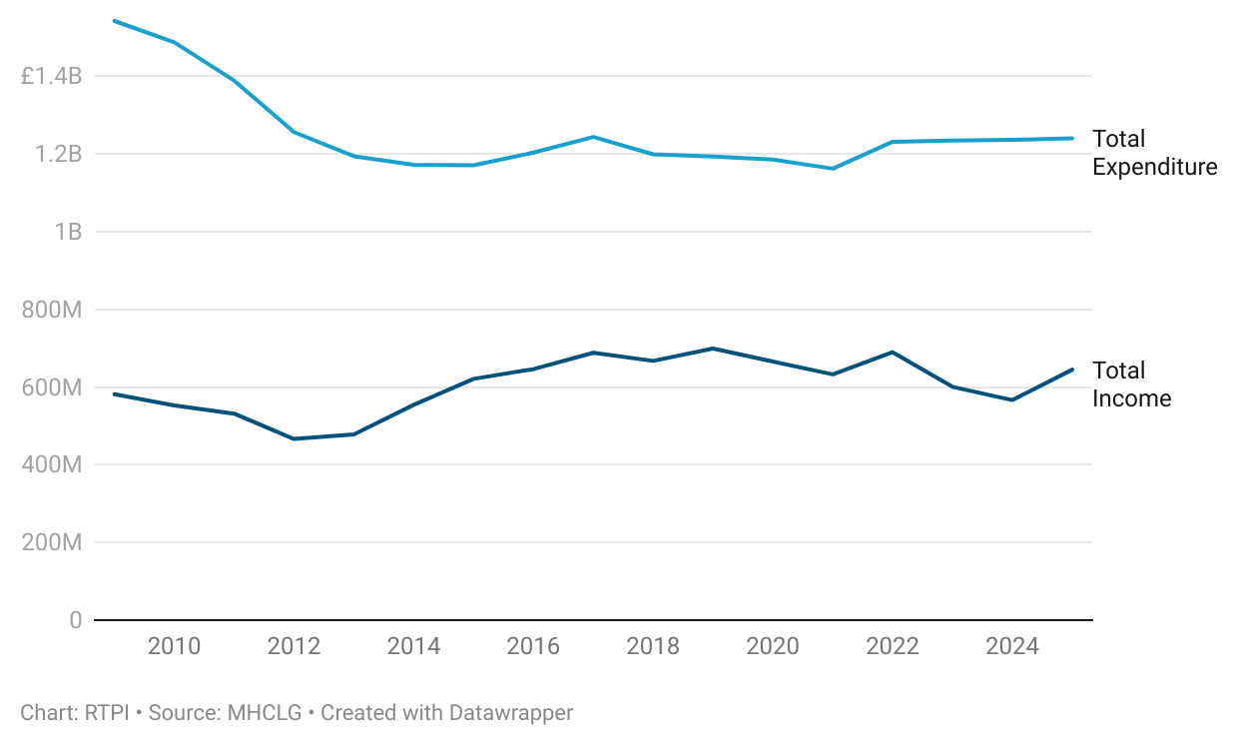
Figure 1. Spending on planning in England has decreased since 2010 and plateaued in recent years.

The individual planning functions show similar patterns, with expenditure cut significantly through the early 2010s, but showing a levelling off in recent years. Spending on development management in FYE 2025, for example, was 9.6% less than in 2010 in real terms. Planning policy was hit the hardest, with spending in FYE 2025 28.8% less than in FYE 2010 (figure 2, below).
The scale of ambition shown by the government when it comes to planning may be difficult to realise with planning spending at its current level. Delivering 1.5m new homes and starting on 150 NSIPs will be tough without adequate funding and training for local authority planning services, and without a variety of accessible routes into the profession. These are all concerns raised by respondents in our 2025 State of the Profession survey.
Figure 2. Development management and planning policy expenditure.
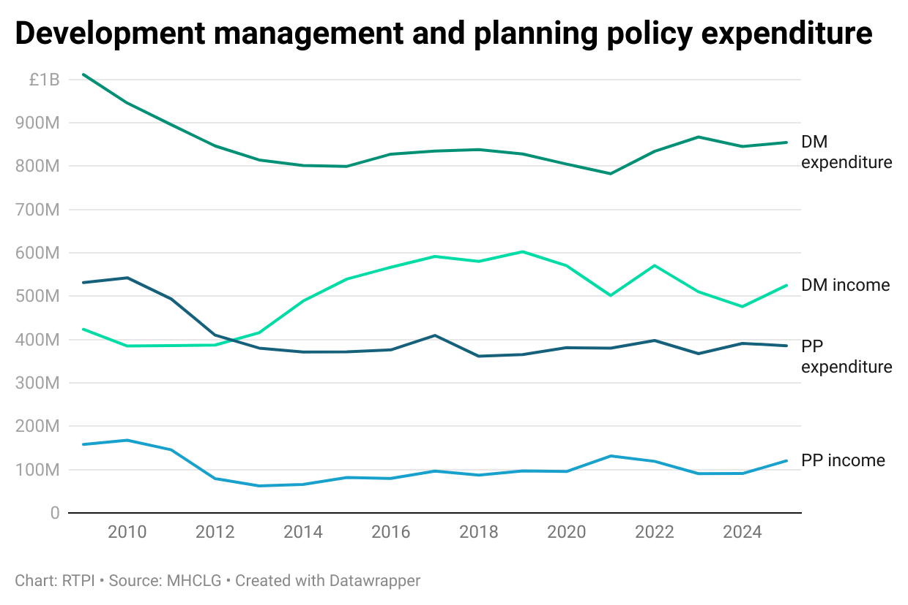

Planning performance
Planning performance data in England shows a mixed picture. The proportion of application decisions made on time has steadily risen from 63% in 2000 to 90% in 2025 (figure 3). At the same time, however, the percentage of applications involving a performance agreement has risen noticeably since data started being collected in 2013/14.
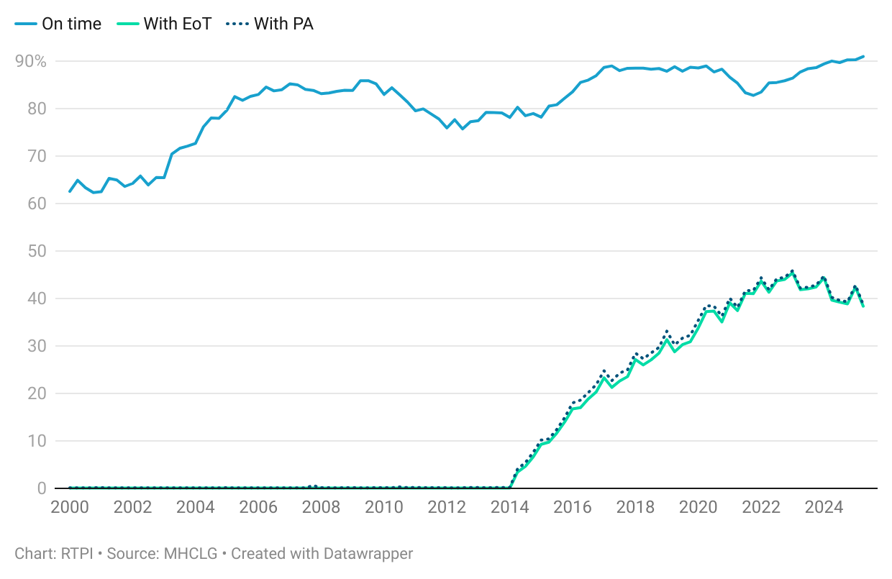
Figure 3. Proportion of applications decided on time has increased, alongside performance agreement usage.

As the above graph shows, the majority of these were Extension of Time (EoT) agreements. Though these agreements are often used legitimately to help deal with complexity in planning applications, they have increasingly been used to extend the timeframe of an application when the relevant authority does not have the capacity to issue a decision on time, as RTPI funded research on Planning Time and Performance has shown [1].
Moreover, the number of planning applications on hand at the end of the quarter (those awaiting a decision) as a proportion of decisions made has risen steadily over recent years, standing at 1.44 in the most recent data.
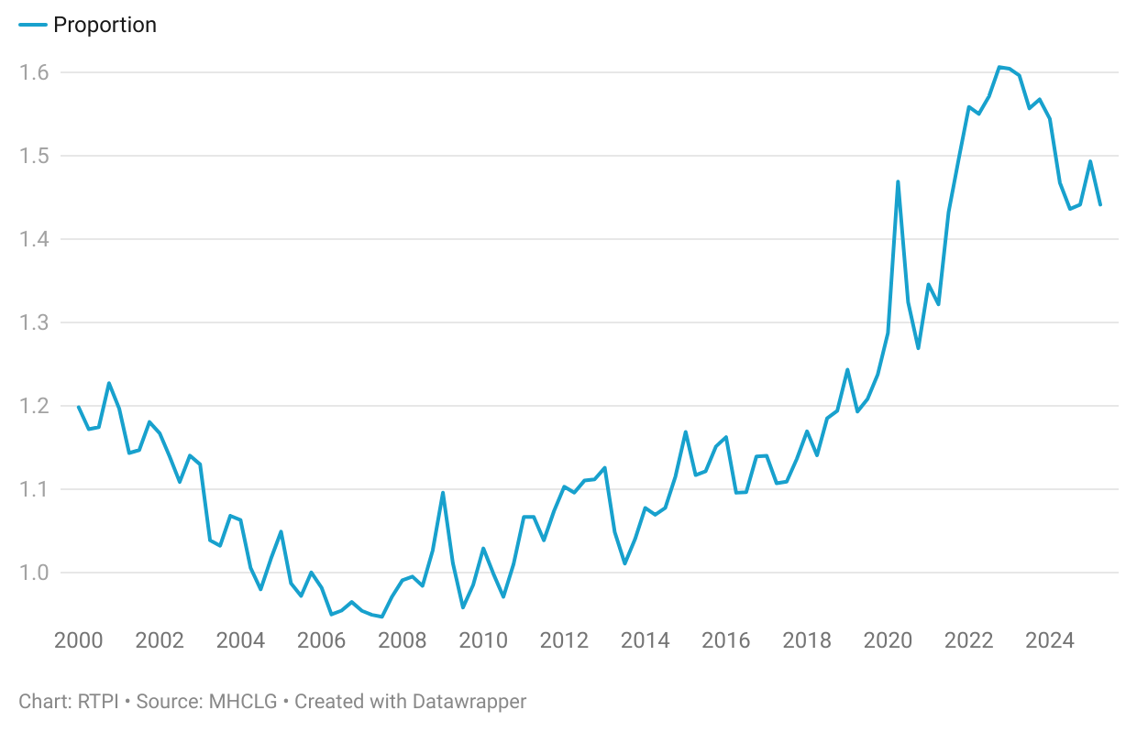
Figure 4. Number of applications on hand was consistently higher than number of decisions made in recent years.

This means that there were 44% more applications awaiting a decision than the number of decisions made in the second quarter of 2025. While several external factors could contribute to this, such as the increased complexity of planning applications, it does suggest that significant measures will be needed to return to pre-2010 levels of decision-making.
The recent uptick in planning applications received by LPAs in the latest quarter underscores this (figure 5). Data on applications decided does tend to follow the number received at a small lag, suggesting that we should expect to see decisions rise in future data releases.
However, planning authorities will not just be dealing with more applications, but also with implementing planning reforms, additional duties, the return of strategic planning, and implications of devolution and local government reform. On top of this, the government has proposed a revised 30-month local plan preparation timeframe and ambitions to achieve full local plan coverage, with details to be consulted on in the coming months. According to Savills, as of spring 2025, only 29% of English LPAs held up to date local plans, and plans take on average 7 years to adopt [2]. The RTPI have concerns that the levels of funding and resourcing allocated for planning will not measure up to stated ambitions.
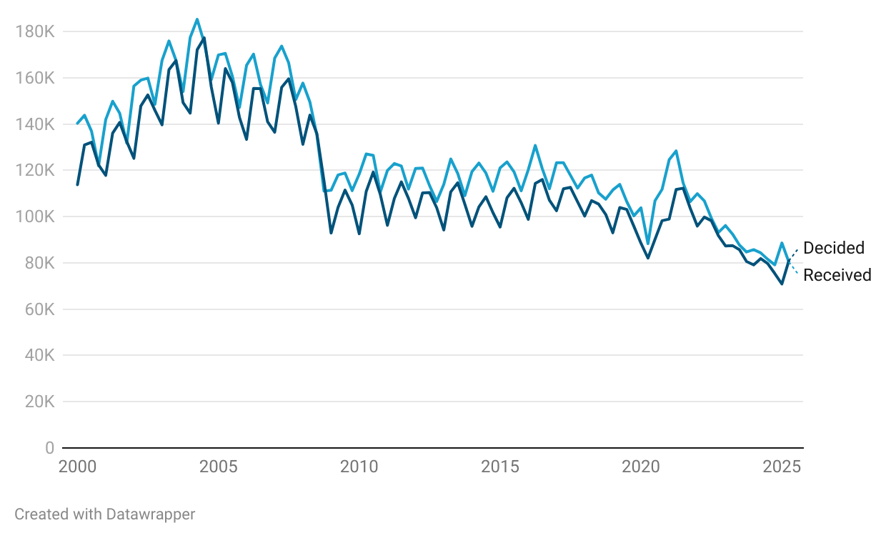
Figure 5. Number of planning applications received and decided is at lowest since 2000 but looks set to rise.

Planning authorities in 2025
This section will outline findings from the survey of Local Planning Authorities concerning resourcing and skills gaps, demographics and ways of working. There were 65 responses to the survey from planning authorities in England.

Resourcing and skills gaps
Figure 6. Most respondent planning authorities had one or more vacancies.
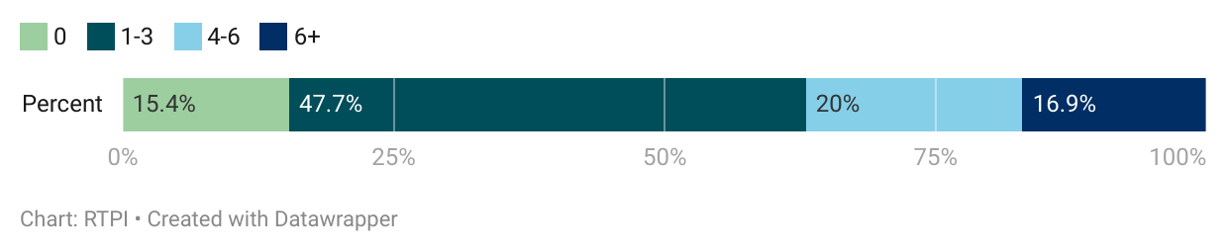

Almost half of Local Planning Authority (LPA) respondents reported their teams having between 1 to 3 vacancies at the time of the survey (47.7%). An additional 16.9% held more than 6 vacancies. The impact of these vacancies will differ between authorities, depending on the seniority of the vacancies, the size of their team, and their workload. Around 6% of authorities had a number of vacancies that equated to a third or more of their current staff count.
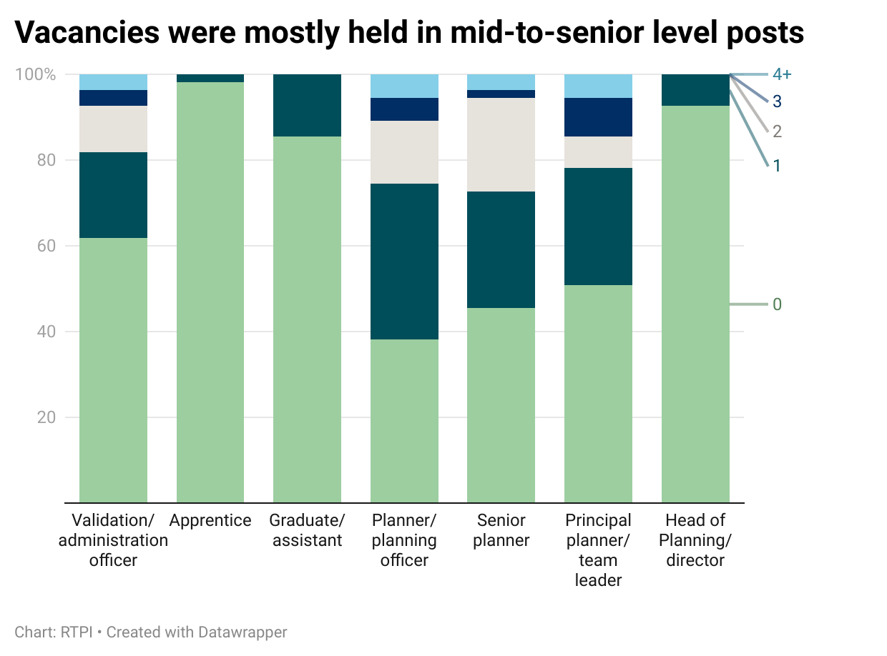
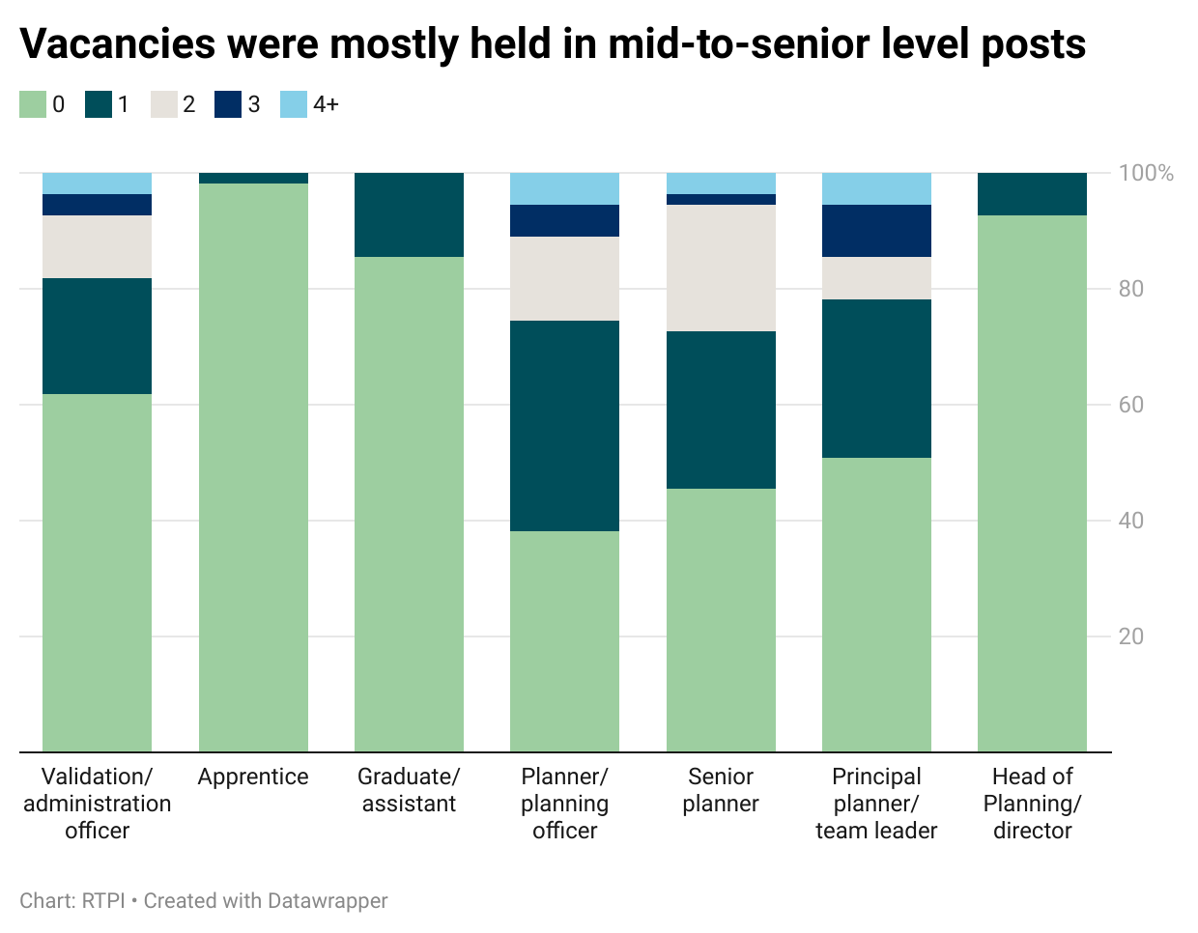
Figure 7. Vacancies were mostly held in mid-to-senior level posts.

Most vacancies occurred at the mid or senior levels, within the planning officer, senior planning officer and principal planning officer positions. This correlates with the level of difficulty LPA respondents report having when recruiting for these positions. Most difficulty recruiting was reported at the principal planning officer or team leader level, with 96.9% of LPAs reporting these difficult or very difficult to recruit. This was closely followed by senior planner (90.8%) and head of planning (86.2%; figure 8, below). Currently, apprentices and graduate or assistant planners are the easiest positions to recruit for.

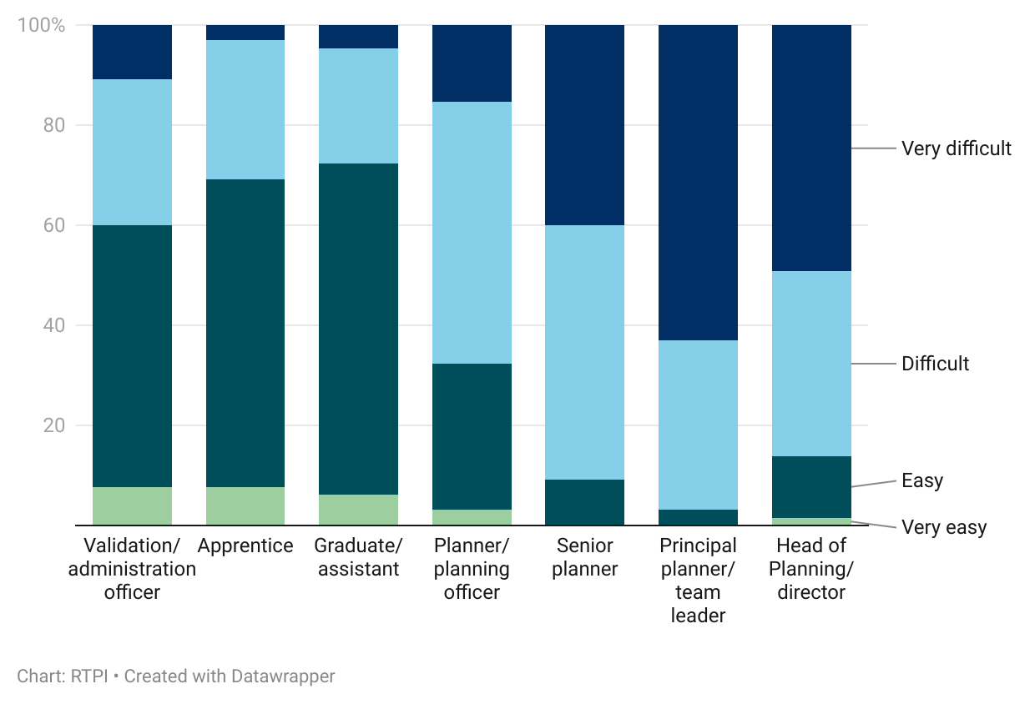
Figure 8. Mid- and senior-level posts were also the most difficult to recruit for.

However, the funding changes made by the government to Level 7 apprenticeships, and the financial challenges facing universities may adversely affect the delivery of planning education, and thus the ability to fill entry-level positions. Numerous respondents working in LPAs highlighted that a significant cohort of older planners is set to retire in the coming years without adequate programmes to replace them – this is discussed further below.
When asked to select up to three areas of planning that they had had trouble recruiting for, over 75% of authorities reported some difficulty recruiting in the areas provided.
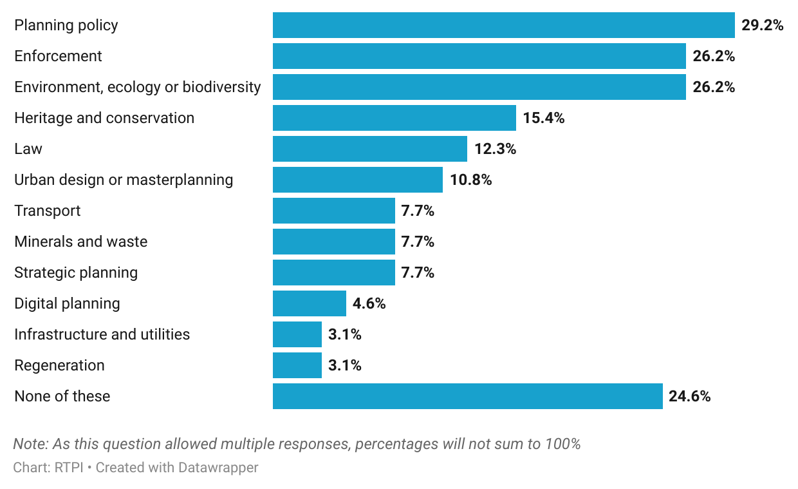
Figure 9. Areas most difficult to recruit for included planning policy, enforcement and ecology.

The most chosen specialist areas were environment, ecology and biodiversity (26.2%), heritage and conservation (15.4%), and planning law (12.3%).
Day-to-day planning functions were also affected; 29.2% had difficulty recruiting for planning policy roles, and 26.2% for enforcement. Heads of planning additionally reported having difficulty recruiting in development management (DM), with one respondent to the member survey commenting that a “significant lack of LPA capacity in DM” was “driving people out of the profession”. Another reported having “a problem retaining experienced DM Officers… which places more demands on consultees, management etc”. Around a quarter of LPA respondents had no difficulty recruiting in any of these areas of planning (24.6%).
The knock-on effect of vacancies on local government planning teams was further described by a member respondent who contended that “due to financial limits and talent drain we are now expected to be fully conversant in drainage, flooding, ecology, conservation… instead of combining the work of specialists, we often now have to be that specialist as well”.
Of note, is that some areas with little or no reported recruitment difficulty were also those where a high proportion of survey respondents identified knowledge or skills gaps. No authorities indicated difficulty recruiting for marine planning, and energy or renewables, while just 4.6% had difficulty finding digital planning specialists. For more on this, see the resourcing and skills gaps section of the member survey findings, below.
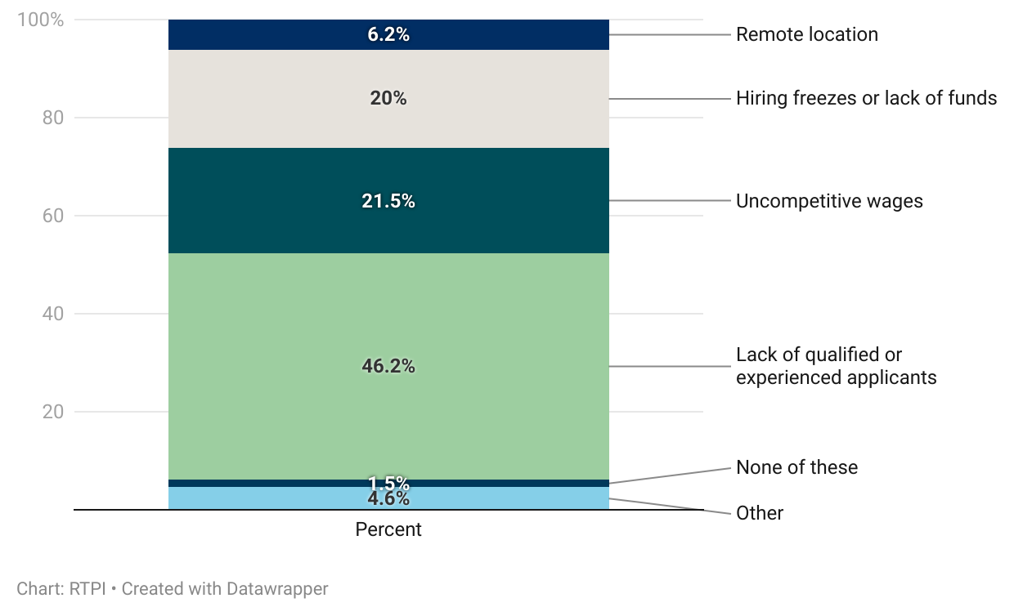
Figure 10. The recruitment pool and funding-related issues were largest barriers to filling vacancies.

Nearly half of LPA respondents reported that their greatest barrier to filling vacancies was a lack of qualified or experienced applicants (46.2%; figure 10). A further 41.5% of LPAs reported funding-related reasons as their greatest barrier to recruitment. These included uncompetitive wages (21.5%) and hiring freezes or lack of funds (20%). Those who selected ‘other’ expressed that a mixture of these factors contributed to their difficulty recruiting. One LPA respondent contended that the public sector cannot compete with the attraction of working in the private sector or agencies; “planners are increasingly signing up to agencies” for “a significant hourly rate; far greater than local authorities can offer”. Where recruitment difficulties occur, authorities may turn to agency staff to fill gaps, which 67.7% of LPA respondents reported doing.
Adding to recruitment challenges is the government’s changes to the Level 7 apprenticeship programme. From January 2026, Level 7 apprenticeships will only be government-funded for people aged 21 and under, care leavers, or those with an Education Health and Care Plan who are under 25. Given that this is a master’s degree level apprenticeship, and the majority of undergraduates complete their degree at 21, this is counterintuitive. It also makes it harder for people to enter the profession through a mid-career change, and means planning is less likely to benefit from the skills, knowledge and life experience these people provide.
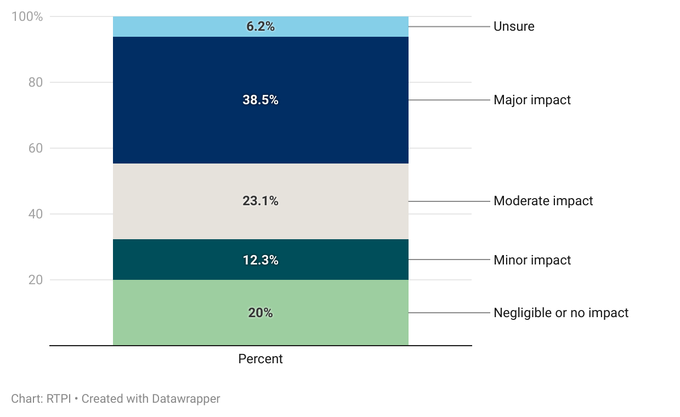
Figure 11. Most authorities anticipate a moderate or major impact from changes to Level 7 apprenticeships.

As our letter to the Minister for Housing and Planning in July 2025 made clear, the Department for Education’s own estimates suggest that just 17% of those currently on a Chartered Town Planner L7 apprenticeship programme would still be eligible under the new rules [3]. As approximately 70% of Chartered Town Planner L7 apprentices are working and training within local government, these changes will have a disproportionate impact on local planning, intensifying pressure on an already overstretched system. LPA respondents largely anticipate this; almost three quarters (73.9%) expect the changes to have some impact on their services, with 61.6% anticipating a major or moderate impact (figure 11). The RTPI have called for the government to reinstate funding for L7 apprenticeships for those aged over 21, or at a minimum, to provide funding to enable planning schools to continue recruiting L7 apprentices in the short-term.

Demographics
The age profile of local government respondents to the members’ survey in figure 12 below indicates that middle and older age groups are more strongly represented than younger age groups. This reflects a widely reported concern across public and private sectors that there are too few young planners entering the profession, with a significant cohort expected to retire in the coming years. Of respondents working in local government who shared their age band, there were a higher proportion aged over 45 (57.5%) than under 45 (42.5%).
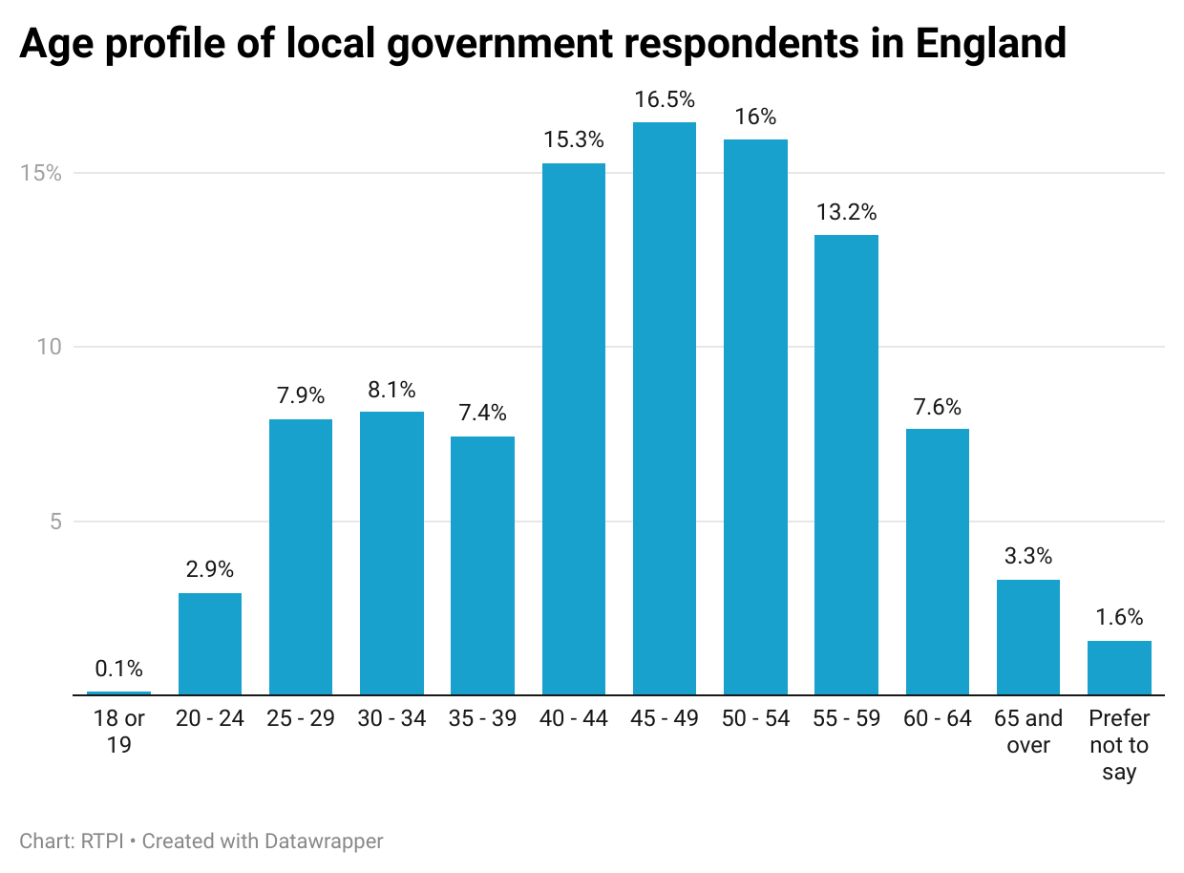
Figure 12. Age profile of local government respondents in England.

Over time, the demographic trend of an increasing proportion of older local government planners could have further implications for local planning authorities. These include the expertise of later-career planners being lost, increased difficulty with succession planning in LPAs, and overall fewer planners entering the profession to help enact government housebuilding and infrastructure objectives.
The gender split of local government respondents was even, with 50.5% identifying as female, 47.7% as male, and 1.8% preferring not to say.
The ethnicity profile of respondents to the member survey working in local government is shown in figure 13. Of local government respondents, a large majority (89.7%) were White, 3.5% were Asian, Asian British, 1.7% Black, Black British, 1.2% of Mixed or Multiple ethnic groups and with 0.6% of another ethnic group. These proportions are in line with the average broad ethnic profile reported by LPA respondents but compare less favourably with data from the 2021 Census, where the proportion of people identifying as White was 81%, with 9.6% Asian or Asian British, 4.2% Black or Black British, 3% of Mixed or Multiple ethnic groups, and 2.2% an Other ethnic group. This suggests that though slightly more diverse than the overall member response, local government planning teams are less diverse than the English population as a whole.
Figure 13. Broad ethnic group of respondents working in local government.
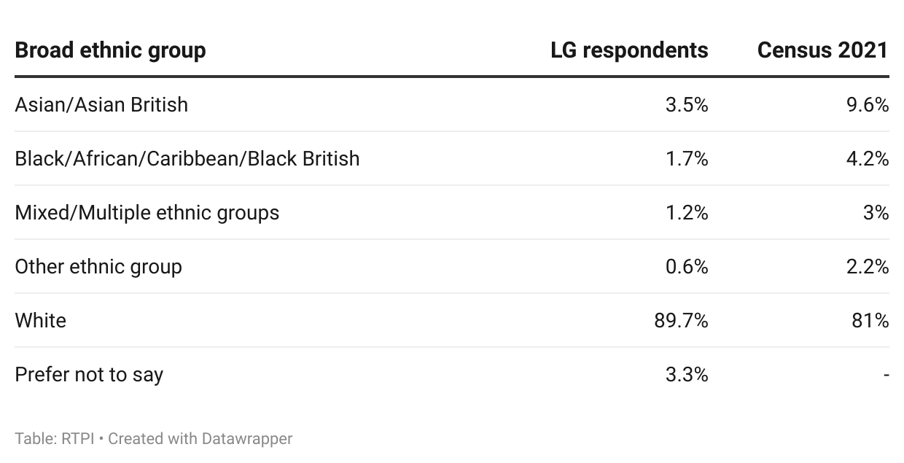

Ways of working
A local planning authority’s structure plays a key role in how effectively the different parts of the planning system work together, and how well planning integrates with wider local government functions. With this in mind, we asked LPA respondents about their authority’s structures and working practices.
More than a quarter (26.2%) reported that their authority does not have a Chief Planning Officer in place to oversee planning operations. Having a CPO is a statutory requirement in Scotland and Australia and is something that the RTPI has advocated for to also become a statutory requirement in England. Remaining LPA respondents did have a Chief Planning Officer (70.8%) or were not sure if they had one (3.1%).
CPOs are intended to act as an important interface between planning teams and elected representatives and are well placed to provide impartial advice to those representatives, building the relationships necessary for collaborative and transparent local decision-making. Making CPOs statutory would help standardise the job description and remit of the position, ensuring that planning is represented at the corporate level in local government, empowered to give strategic advice, broker stakeholder relationships, and manage resourcing and training needs. Moreover, proposals from government for a new national scheme of delegation places Chief Planning Officers as integral to decision-making on delegation alongside Planning Committee conveners, further highlighting the key role they play within the delivery of planning functions.
In nearly 10% of respondent authorities, the development management function did not sit in the same directorate as policy (9.2%) or enforcement (7.7%). Proximity of these functions can help prevent silos and encourage closer working between policy teams and those acting on policies, leading to better decision making, and better drafted and implemented planning policy at a local level. Conversely, splitting of these functions has been shown to have a detrimental impact on planning performance [4].
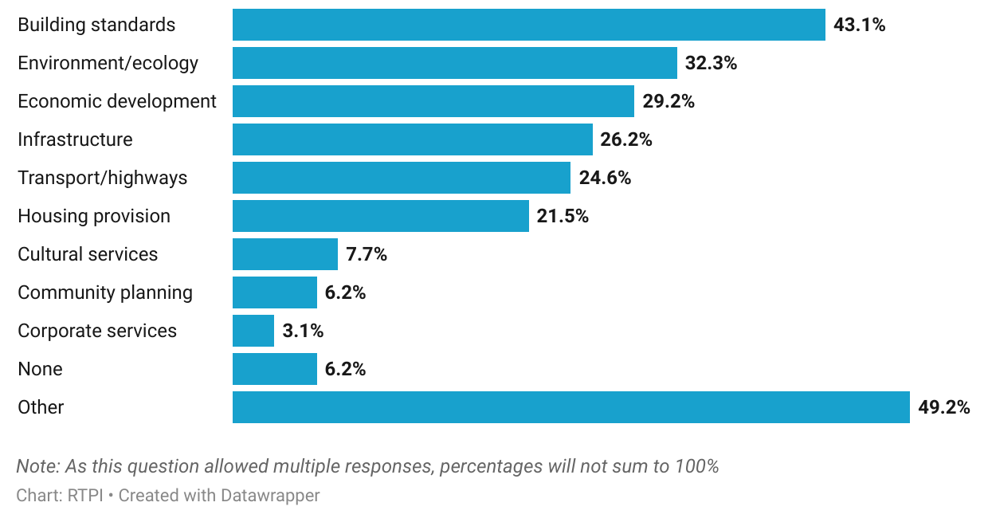
Figure 14. Building standards, environment and economic development were most likely to sit in the same directorate as planning.

Our research shows that the services most reported as being in the same directorate as planning were building standards (43.1%), environment and ecology (32.3%), and economic development (29.2%). Other services frequently sitting with planning included infrastructure (26.2%), transport or highways (24.6%) and housing provision (21.5%). Nearly half of responding authorities specified ‘other’ functions in the same directorate as planning, the most reported of which were regeneration, heritage and conservation, trees, and land charges.
With the government’s ambitious housing, infrastructure and economic development plans, making planning services more efficient and innovative is important, and something that is reflected in the numerous digital planning programmes and pilots run by MHCLG. A large majority of LPAs were supportive of the push for increasing digital innovation, with 73.9% of planning services intending to make use of specialist digital planning tools or AI.
Figure 15. Almost three quarters intend to use digital planning technology or AI.
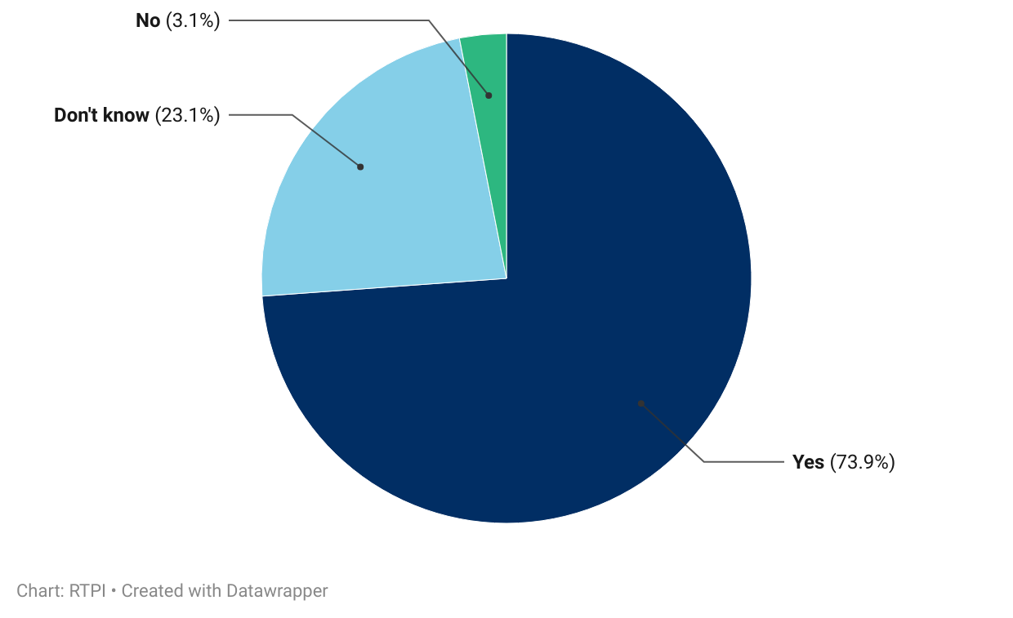

When LPA respondents were asked how they planned to make use of such tools, the most mentioned use was for public engagement and consultation (by 26.7%; such as summarising local plan consultation responses), followed closely by validation (24.4%). Use of AI programmes like copilot for administrative tasks was reported by 17.8%, often in the context of increasing efficiency, and freeing up officer time – though one authority referred to its use to “plug staffing gaps”. Data gathering or sharing, and report writing were other uses cited by multiple authorities (13.3%, 8.9%, respectively).
There were, however, several respondents who were unsure, or still working out how best to use technology and AI. Multiple mentioned partaking in or wanting to be part of government guided programmes like the PropTech fund and Open Digital Planning (ODP). Local Government Reorganisation (LGR) was also mentioned by some as being a factor in their decisions around whether and what technologies to use. One senior local government planner was concerned about “reorganisation at [a] time where there is significant pressure on teams to manage ever evolving complexity and change from national policy arrangements”; they thought that “digital structures and internal processes lack clarity and efficiency and will take a few years to manage”. While, as this respondent points out, integration of different council systems is likely to be a costly and complicated task, it could also be an opportunity to review working practices, and how more efficient, technology enabled processes could be embedded in new unitary authorities from the beginning. Given the appetite for programmes like PropTech and ODP, this is something the government should seriously consider integrating into LGR.
Beyond the way LPAs are structured, working arrangements play a role in their ability to attract talent. All LPA respondents reported operating a hybrid model, split between working from home and office- or site-based work. Moreover, 100% also report offering flexible working options, allowing staff a better work-life balance. Of these, most (90.8%) operated a flexi time scheme, with a large proportion also offering compressed hours and job-sharing (69.2%, 43.1% respectively. Annualised hours and a 4-day week without loss of pay were less common but still present among responding authorities.
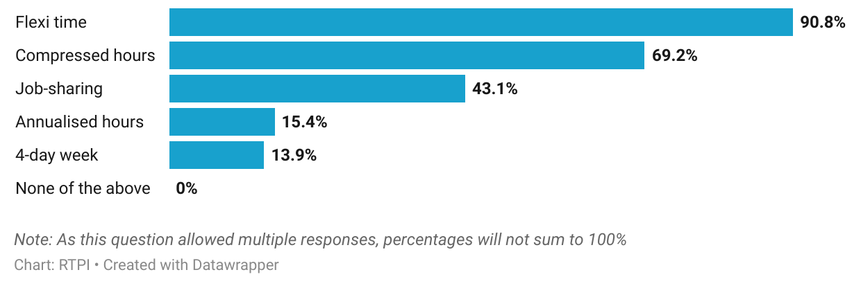
Figure 16. All respondent authorities offered at least one flexible working option.

Planners in 2025
This section will outline findings from the survey of members of the RTPI working in England. Topics addressed included career stage and plans, resourcing and skills gaps, wellbeing, working and volunteering practices, and the geography and demographics of respondents. The member survey had 2,217 respondents who reported working primarily in England.

Career stage and plans

Area of planning
Just under half (46.1%) of respondents reported working in local government, with 37.8% in the private sector. Other sectors, including the third sector, public sector arm’s length bodies and central government were less well represented, with under 5% of respondents each.
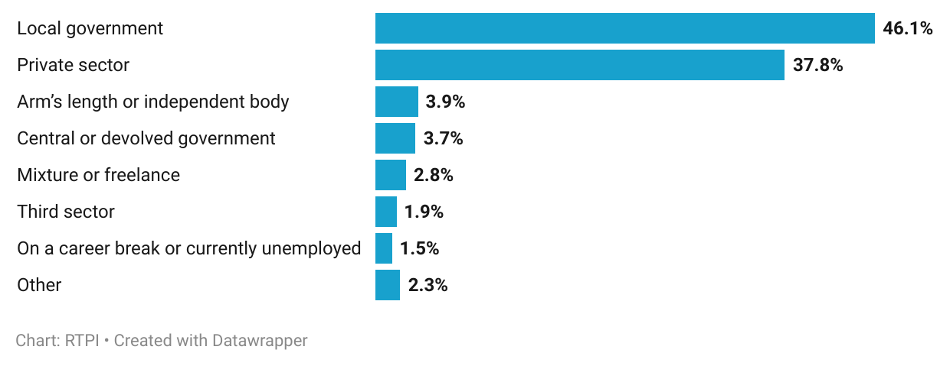
Figure 17. Most respondents working in England were in local government or the private sector.

When asked which area of planning they primarily worked in, development management accounted for 29.6% of responses, followed by planning policy (15.3%) and housing (11.1%). ‘All of the above’ (for example, at a statutory consultee body, or head of service) was selected by 4.7%, while ‘other’ was selected by 6.9%. When assessing the areas specified as ‘other’, infrastructure and ‘multiple of the above’ featured highly (accounting for 1% and 2.17% of the overall response, respectively). Other areas specified included neighbourhood planning and rural or agricultural planning.

Career stage
Just over half of respondents were experienced planners; 55.2% of respondents had 21 or more years of experience in planning (figure 18). In line with this, most respondents also reported being at a mid or senior level of employment, with associate planners, principal planner or team leaders, and heads of planning accounting for 54.4% of respondents.
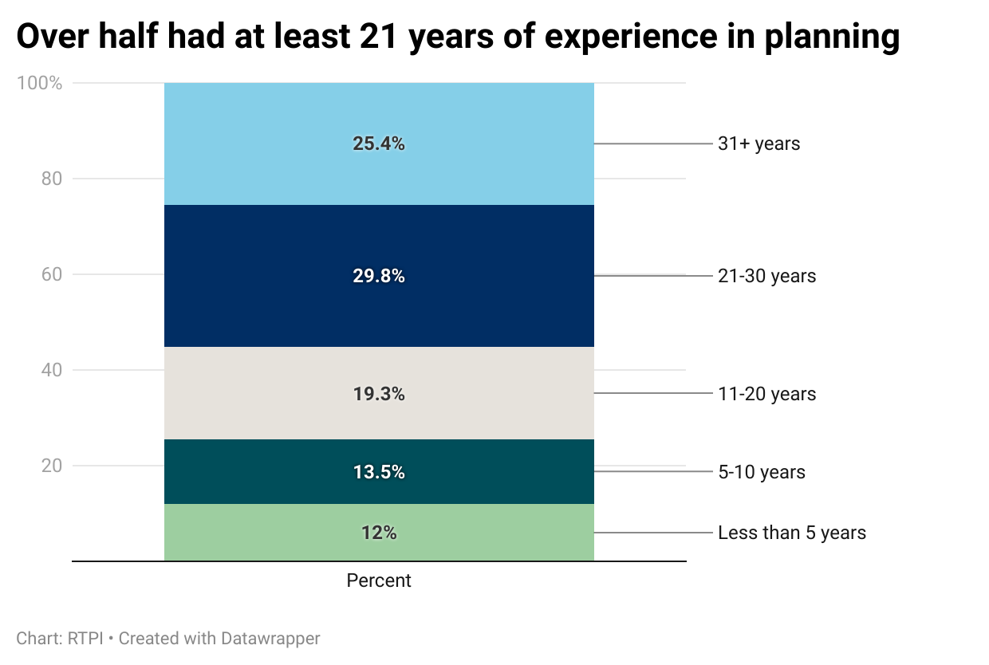
Figure 18. Over half of respondents had at least 21 years of experience in planning.

A majority also reported earning £40,000 or above, with £40,001 to £50,000 the most selected salary band (at 22%). Public and private sector differ here, with planners in the former most commonly reporting salaries in the same £40,001 to £50,000 band, while those in the latter were most likely to report salaries of over £80,000.
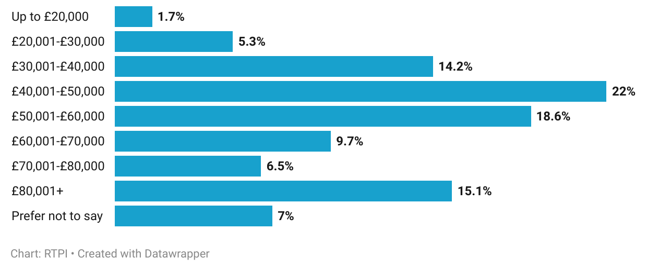
Figure 19. The modal salary band among respondents was £40,001 to £50,000.

This highlights the disparity in pay between the public and private sectors, a contributing factor to the level of difficulty some LPAs face when recruiting for experienced planners. In the words of a respondent working in local government, “private sector pays triple the wage therefore experienced officers are hard to come by”. Another suggested there was a “flood” of local planning authority staff “leaving for better career progression, benefits and salary” in the private sector.
Most respondents were happy with their salary, with 60% being somewhat or very satisfied, compared to 24.6% unsatisfied (and 15.5% neither; figure 20).
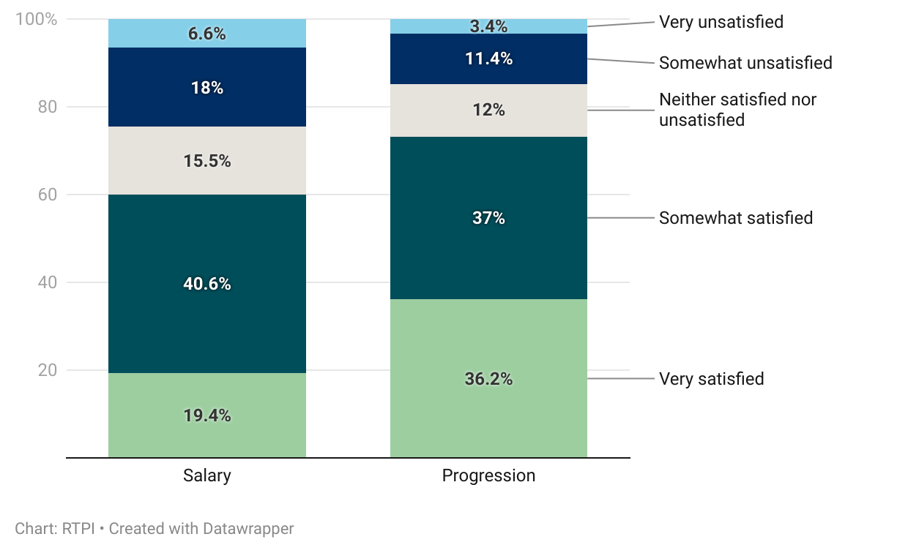
Figure 20. Salary satisfaction was lower than satisfaction with career progression.

However, this differed when broken down by sector, and by level of seniority. As noted above, public sector planners generally earned less than private sector planners, and although a majority of them (55.6%) still reported being satisfied with their salary, this was compared to 67.7% of private sector planners. By seniority, a lower proportion of those in graduate planner, planning officer, and senior planning officer positions reported satisfaction with their salaries (at 52.2%, 51.2%, 51.5%) than principal planners and heads of planning (60%, 71.5%, respectively).
Satisfaction with career progression was higher, with 73.2% of respondents somewhat or very satisfied, compared to 14.8% unsatisfied (and 12% neither). This was similarly higher among private (88.2%) than public sector (68.6%) planners. Like salary, satisfaction with progression was lower among junior than senior respondents. As in the three other nations surveyed as part of this work, salary satisfaction was lower than career progression satisfaction.
In line with most respondents being satisfied with their salary and progression, when asked what they would most likely consider doing in their career over the next three years, almost half intended to remain with their current employer (either in their current role, 39.1%; or another, 10.8%; figure 21).

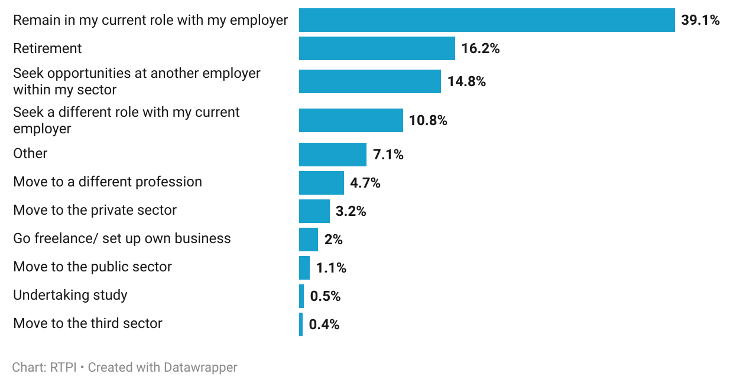
Figure 21. Almost half were likely to remain with their current employer in the next three years.

Remaining in a current role was the intention for a higher proportion of private sector planners (43.4%) than public sector (38.9%). The next most reported career plan was retirement, at 16.2%, which similarly, was higher in the private (19.3%) than public sector (12.4%). In addition to retirements, the 4.7% intending to move to a different profession suggests that around 21% of respondents in England will be leaving the planning profession in the coming three years.
For the 7.1% who reported ‘other’, a number intended to move abroad, while some were unsure. A notable share of those who expressed uncertainty about their future career plans associated it with the programme of local government reorganisation that is currently getting underway.

Resourcing and skills gaps

Skills, knowledge and training
Few respondents (11%) felt they had no gaps in skills or knowledge relating to a range of specialist areas within planning. Chief among the areas planners felt they did have a gap in was digital, data and GIS (47.3%; figure 22). The government have done well promoting schemes like the Open Digital Planning and PropTech in a push to make planning more efficient, however, to implement these technologies to their full potential, it is crucial that planners have access to training for them.

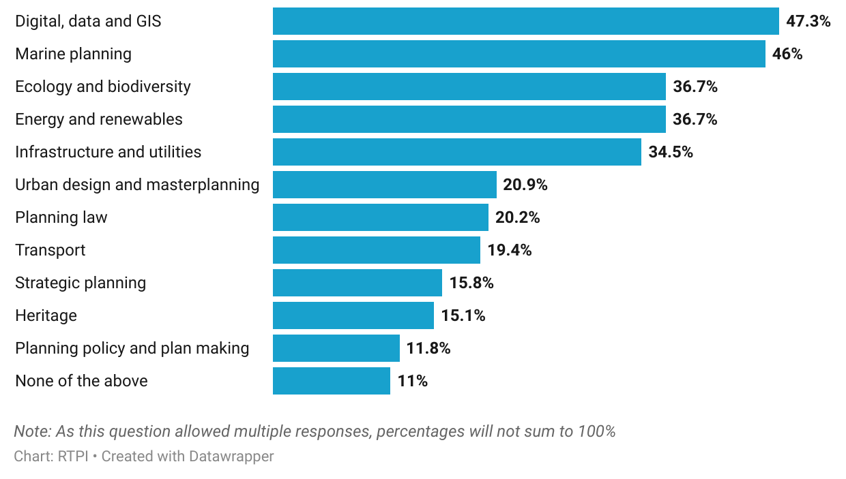
Figure 22. Nearly half had a skill or knowledge gap in digital, data and GIS, and marine planning.

Consistent with the increasing relevance of the worsening climate crisis and its impact on planning, the next most reported gaps in skills or knowledge were marine planning (46%), ecology and biodiversity, and energy and renewables (both 36.7%). Despite these gaps, overall, more planners were satisfied than unsatisfied with the training opportunities available to them (56.9% satisfied, 21.4% unsatisfied).
Over a third of English planners felt that they had a good grasp of generalist skills they might need in their day-to-day job. When asked if they had a skills or knowledge gap in a range of generalist areas, 35.1% felt they had none (figure 23). That said, almost a third (32.2%) felt they had a gap concerning business development, and over a fifth around project management, negotiation and mediation, and people management (22.1%, 21.2%, 20.7%, respectively).
Figure 23. Business development, project management and negotiation were top reported generalist skill or knowledge gaps.
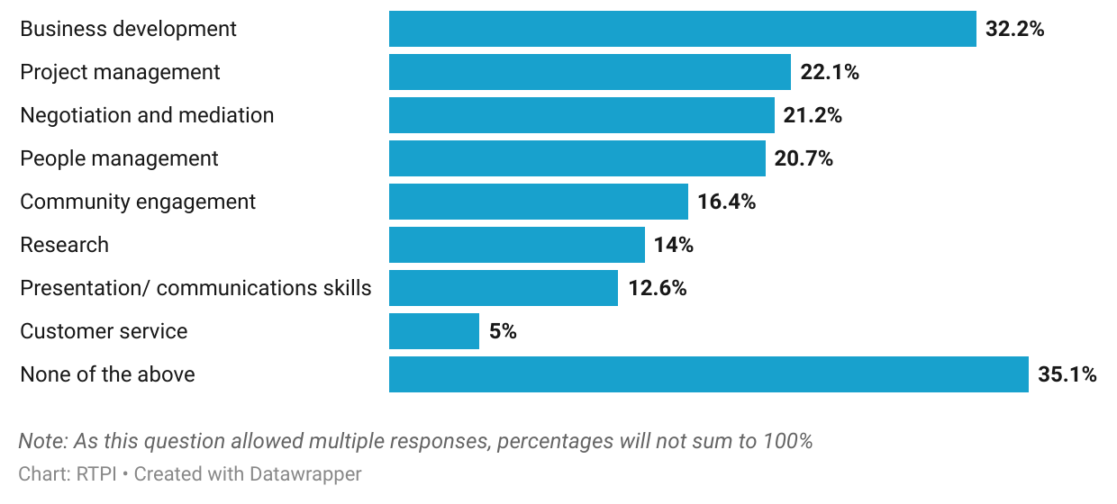

Capacity and challenges
Given the increasing policy salience of planning, and the raft of reforms making their way through parliament, planners are busier than ever. Respondents felt this, with 50.5% reporting that their team lacked capacity to meet demand frequently or all the time (38.8% felt this occasionally, and 10.7% never; figure 24).
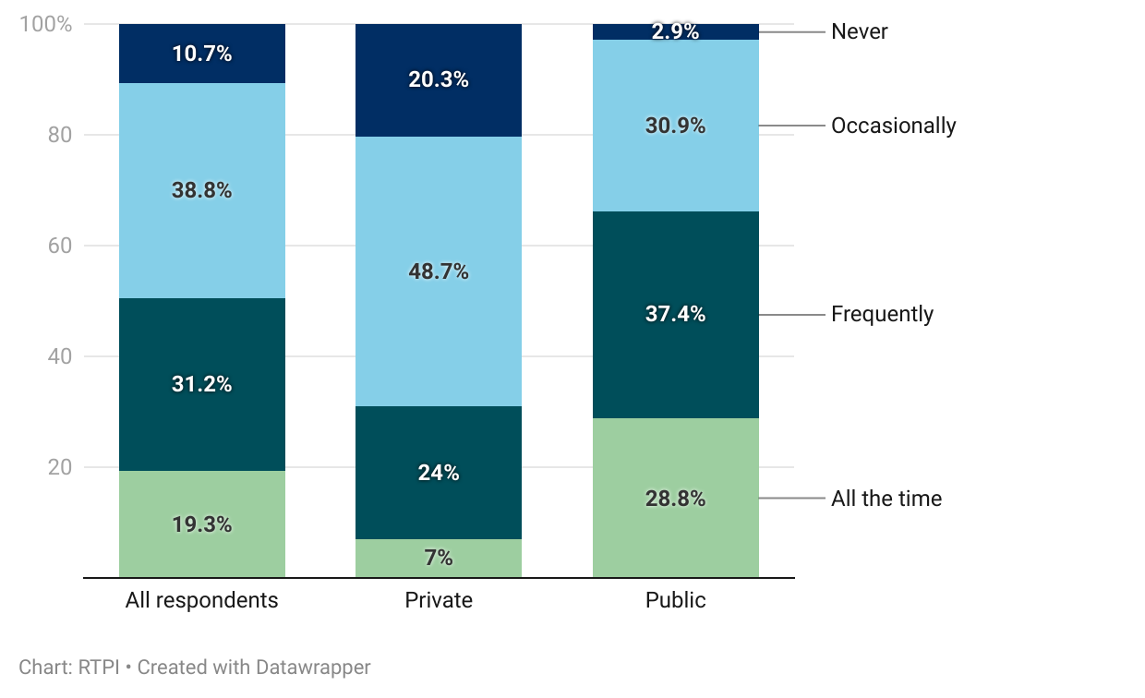
Figure 24. Public sector planning teams were more likely to lack capacity to meet demand.

Of concern is that public sector planners were more than twice as likely as private sector counterparts to report their team lacking capacity frequently or all the time (66.2% compared to 31%). With the responsibility for implementing the government’s planning policy on the ground, such capacity issues within the public sector are concerning, and likely to hinder reforms.
When asked what they thought the main reasons for capacity issues were, almost a third of respondents who reported lacking capacity to meet demand cited a high workload (32.4%). A further 22.6% attributed capacity issues to the increased complexity of planning, 20.7% to recruitment difficulties and 20.1% to under-funding. External factors, such as delays with statutory consultees, planning committees, or other stakeholders also featured significantly, selected by 16.1%.

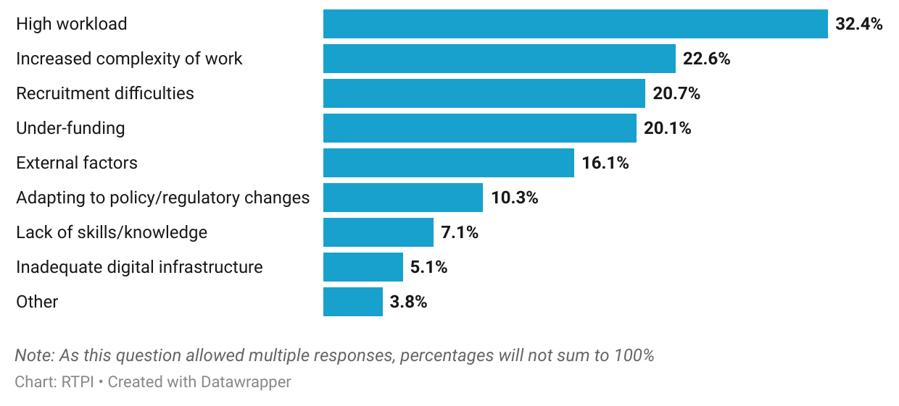
Figure 25. High workload and increased complexity were the most cited reasons for lacking capacity.

Reflecting the issues discussed above (and in the wellbeing section of this report, below), 51.6% of planners felt pessimistic about the future direction of the English planning system. Split by sector, public sector planners were slightly more likely to report pessimism than private sector planners (55%, compared to 48.3%).

Greatest challenges
Respondents were invited to comment on what they thought would be the greatest challenge faced by the English planning system in the coming year. Some of the themes already discussed in this report featured heavily among concerns mentioned, including recruitment and retention. One planner working in development management thought that in the public sector, “recruiting experienced professionals and paying people what they are worth set against a backdrop of underfunding” would be a particular challenge. In addition to difficulties recruiting experienced planners, the loss of them to retirement was cited by many. A private sector planner highlighted that “lots of experienced… planners will be retiring in coming years which will lead to a significant loss of knowledge”. On top of difficulties recruiting “skilled mid-tier planners in public and private sector”, this could prove detrimental to knowledge sharing. Compounding this is the widely recognised difficulty of attracting young people into the profession. Without a concerted effort to shore up both the early- and mid-career pipeline of planners, valuable knowledge will be lost, and succession planning made difficult.
Recruitment difficulties adversely affect staff capacity, with “high workloads and high demands placed on planners”. These issues were something that private sector planners noted, with one consultant commenting that “resourcing at LPAs has been poor especially in the last five years or so”, impacting speed of decisions and development timelines. Indeed, public sector planners recognised this themselves; a local government planner saw “increasing workload and complexity in public sector negatively affecting timeliness and quality of decision making” as the key challenge in the next year. The pressures on both sides of the planning process can be difficult to recognise as another consultant notes; “the perception of both sides is more polarised than ever… this needs to be a more collaborative process between both parties”.
There was cross-sectoral acknowledgement of the additional complexities introduced into the planning system by reforms made in recent years. Numerous respondents suggested that additional duties added over the past decade like biodiversity net gain, nutrient neutrality and flooding have made planning into more of a ‘box-ticking exercise’ than a proactive, place-shaping endeavour. Furthermore, the volume and rate of reforms were thought by some to “create an environment of uncertainty”. Additional upcoming reforms may add further to this. Chief among those raised was local government reorganisation (LGR) and devolution, which a local government planner described as “unsettling”, adding that it’s “difficult to career plan if you don't know which authorities will exist”. Another noted that LGR and devolution could impact the momentum of other reforms including local plan making and strategic planning. However, one transport planner noted, that impact could well be positive; devolution is “very exciting and is the biggest opportunity in short term but brings with it new challenges so [we] must flex [and] adapt accordingly”.
The structural changes of LGR and devolution are occurring in parallel with a demanding policy agenda. The government’s goals, from tackling the housing crisis and improving infrastructure to rolling out renewable energy will test the resilience of the planning system. An energy planner commented that “without a strong public sector to work with, getting large infrastructure projects to run to programme is getting increasingly more difficult”. Housing was another key policy area highlighted – planners cited the impact of economic conditions on building costs, and fiscal constraints on the level of LPA resourcing. Additionally, opposition to development was also emphasised, where one respondent thought it would be a challenge to reconcile housing and renewables plans with “the significant local opposition these schemes usually encounter”. Balancing these numerous complex policy issues will rely heavily on an effective and well-resourced planning system.

Even a well-resourced planning system cannot operate in isolation from the wider political context, however. Several respondents expressed concern about the effect political uncertainty at both national and local levels would have on the effectiveness and durability of current reforms. At the national level, the potential for a change of government before current reforms have had a chance to take root raised fears of yet more planning policy churn. At the local level, political contention was thought by some to be prolonging LDP processes, impacting decision timelines of development, and ultimately undermining the profession. Misinformation in social and conventional media was also thought to be contributing to the challenge of political contention over planning. Political contention, misinformation, and a “lack of public awareness and understanding of the planning system” were three key factors cited by respondents as impacting on the system’s legitimacy, and “how planning is viewed by the general public”. This is discussed in further detail below.

Wellbeing
Positively, a majority of respondents said they were somewhat (38.4%) or very (17.3%) happy working in planning (compared to 18.2% somewhat, and 6.6% very unhappy; figure 26). Some expressed pride at being a planner; “helping to shape places and improve the environment we live in is rewarding”. However, as this respondent continued, “the pressures of the job are considerable and rewards can feel modest, especially with increasing inflation”.
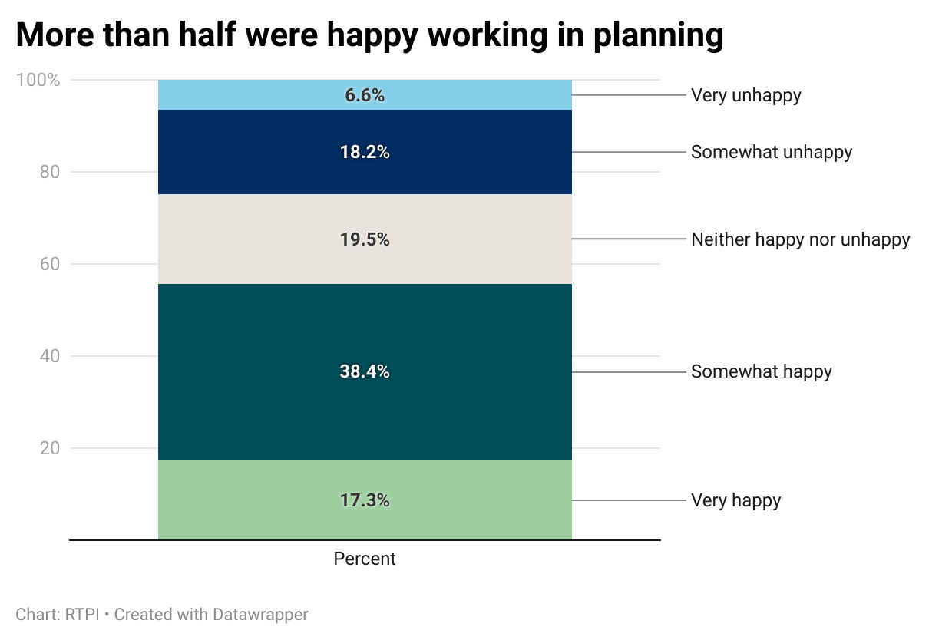
Figure 26. More than half were happy working in planning.

Reflecting this, 57.4% of respondents reported feeling personally overstretched frequently, or all the time (figure 27; 37.5% occasionally and 5.1% never). This was significantly higher in the public sector (67.8%) than the private sector (45.4%). Respondents identifying as female were notably more likely to report feeling overstretched frequently or always than those identifying as male (65.1% compared to 51.5%).
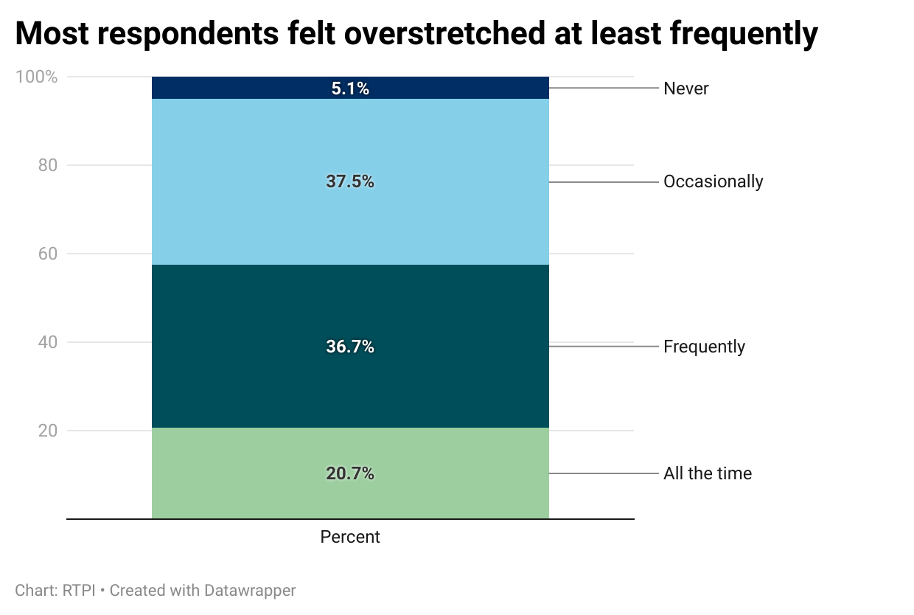
Figure 27. Most respondents felt overstretched at least frequently.

When asked about public perception of planning, most thought this was either somewhat (51%) or very unfavourable (32%). Many identified the emotive nature that local planning issues sometimes have, but the most common comment in relation to this was a feeling that there was a lack of understanding among some members of the public about what planning is and what planners are there to do.
As a consequence, 54% reported that the negative public perception impacted their wellbeing somewhat or very negatively. Likely also contributing to this is the level of abuse faced by planners. A significant majority of 66.9% said that they had experienced abuse either in person or online (29.7% hadn’t, and 3.4% preferred not to disclose; figure 28). This was more commonly reported by public sector than private sector respondents (72.4%, compared to 61.6%).

Figure 28. Around two thirds had experienced abuse.
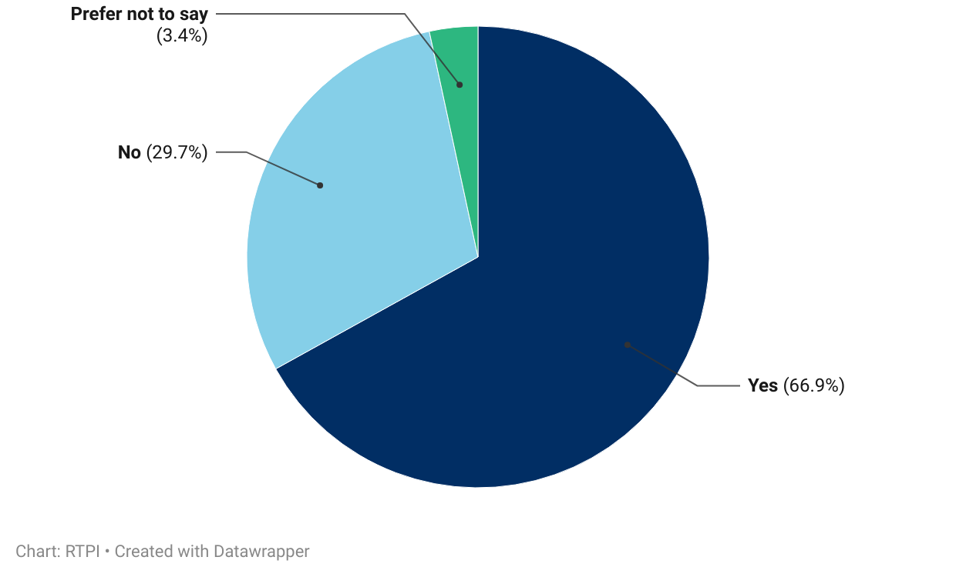

Respondents were invited to expand on the topics discussed in the wellbeing section. Some noted with varying levels of acceptance how people responding to development consultations or decisions with rude and sometimes abusive behaviour now “is part of the job”. However, it was also thought that “more recently the ease of personal criticism in social media has amplified this”. As such, one private sector planner commented that they understood why some development management planners might be reluctant to “answer the phone or meet the public anymore” because “social media has taken public perception from mildly negative, to positively aggressive in recent years”.
This state of wellbeing is not helped when teams are “understaffed and overworked”, as another private sector planner described it. Public sector planners corroborated this, reporting that they were “being asked to do more and more with less and less”, feeling “unable to make sufficient headway into high workloads”, and often lacking “the influence to guide the highest quality service”. The knock-on impact of planners struggling with workloads was felt across sectors, with numerous public sector planners recounting unhappy, sometimes abusive applicants or local residents when granting, refusing, or even just considering developments. Equally, private sector planners reported sometimes being caught between these issues, where “clients get increasingly frustrated and… we as the appointed agent often bear the brunt of that frustration”.
Specific areas of planning like enforcement, compliance, and development management were mentioned as being prone to unpleasantness from landowners, applicants, and their neighbours. In these roles, mentions one local government planner “you are dealing with difficult situations and disgruntled customers… so you need to be thick skinned and persistent”. Public consultation events were also an element of the job emphasised by many, which could “come with heightened emotions” meaning people could “forget that some of us are just there to be complete the job we've been asked to do”.
A perceived public misunderstanding about the role of planning was a source of frustration. A planner working in the third sector noted that there can be a lack of “understanding that we are working with legislation and regulation set by central and local government”. In addition, “the multi-faceted balancing that planning has to take, giving account to the unique circumstances of each site [or] proposal” was felt not to be widely understood by the public, and sometimes by stakeholders in other professions related to planning.
Occasional misinformation and conspiracy theories also impact planners. One planner working in ecology recalled being approached by people accusing them of wanting to “to lock people into districts” (relating to 15-minute cities) and criticised for “supporting climate change adaptation requirements”. Accusations of corruption appeared in a lot of responses, and it was felt that negative rhetoric in conventional and social media had stoked this perception.
However, where recent reforms have increased the salience of planning, media and social media can be useful tools for changing perceptions and increasing understanding. An experienced local government planner commented that they had taken to LinkedIn “to try and change the narrative around planning and to highlight the value of the profession”. While they thought that the strength of negative perception was challenging, it had nonetheless “opened up positive conversations”. Another planner thought that “ideally teaching kids about planning at school” would help increase understanding and appeal of the profession more broadly – this is something that respondents’ reported routes into the profession (outlined below) indicate is worth considering.

Working and volunteering practices
Nearly three quarters of respondents followed a hybrid working model, with 74.1% splitting their time between home and office or onsite. Fully remote working and fully office-based working were both less common (14.7% and 11.2% respectively).
Flexi time was the most common flexible working practice used in England, with 44.2% of respondents using it. Other flexible working practices like compressed hours (7.7%) and a 4-day week (3.9%) were much less commonly used, and 46.6% of respondents reported using no flexible working practices.
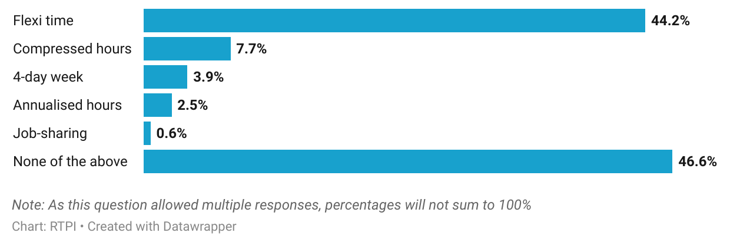
Figure 29. Use of flexible working practices among respondents working in England.

A little under a fifth (18%) of respondents had volunteered in their capacity as a planner. Of those, 39.9% were a member of a committee or board (such as a committee of the RTPI). Almost a third (31.3%) acted as a mentor, while a quarter (25.1%) did pro-bono planning work. Just over a fifth worked with Planning Aid (21.6%) or engaged in careers outreach at schools or universities (20.3%).
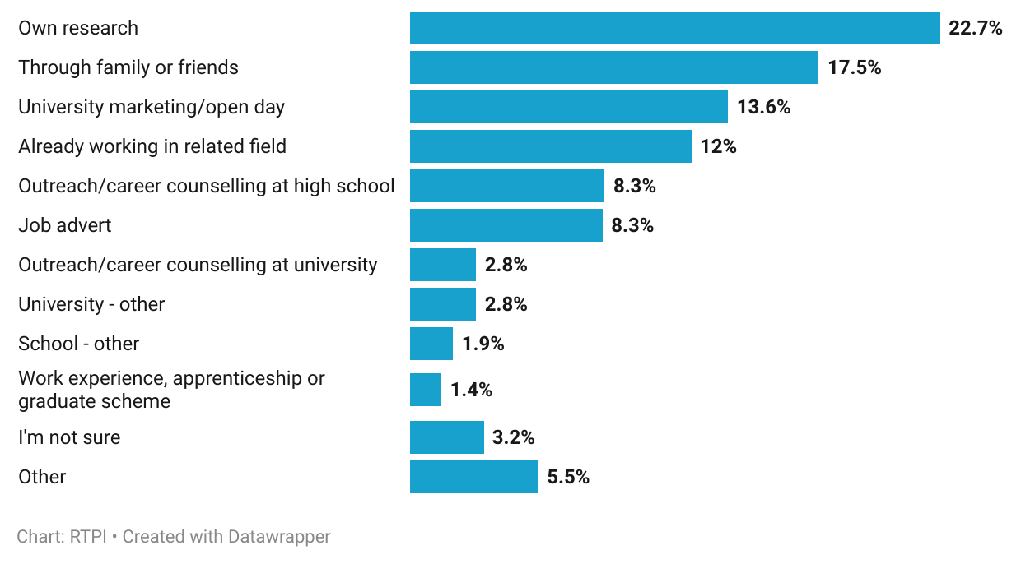
Figure 30. Most respondents learned about planning as a career through their own research, word of mouth, or education.

The most reported ways respondents became aware of the planning profession was with their own research (22.7%), or through family and friends (17.5%). However, a cumulative 29.4% became aware through their school or university education, making educational outreach a particularly impactful mode of volunteering within the profession.

Who responded

Geography
When respondents were asked which region they do most of their work in, the most reported was the South East (22%). This was followed by South West (13.2%), London (12.2%) and the East of England (10.8%). The north and the midlands were less well represented with 9.7% working primarily in the North West, 8.7% in the West Midlands, 7.8% in the East Midlands, 5.2% in Yorkshire and 3.7% in the North East.
Those doing work at a national level, such as on Nationally Significant Infrastructure projects, or national planning policy accounted for 6.8% of responses. Caution is advised here, as ‘national’ was mistakenly omitted as a response option initially, meaning early respondents to the survey were not able to select it where they perhaps would have, if available.
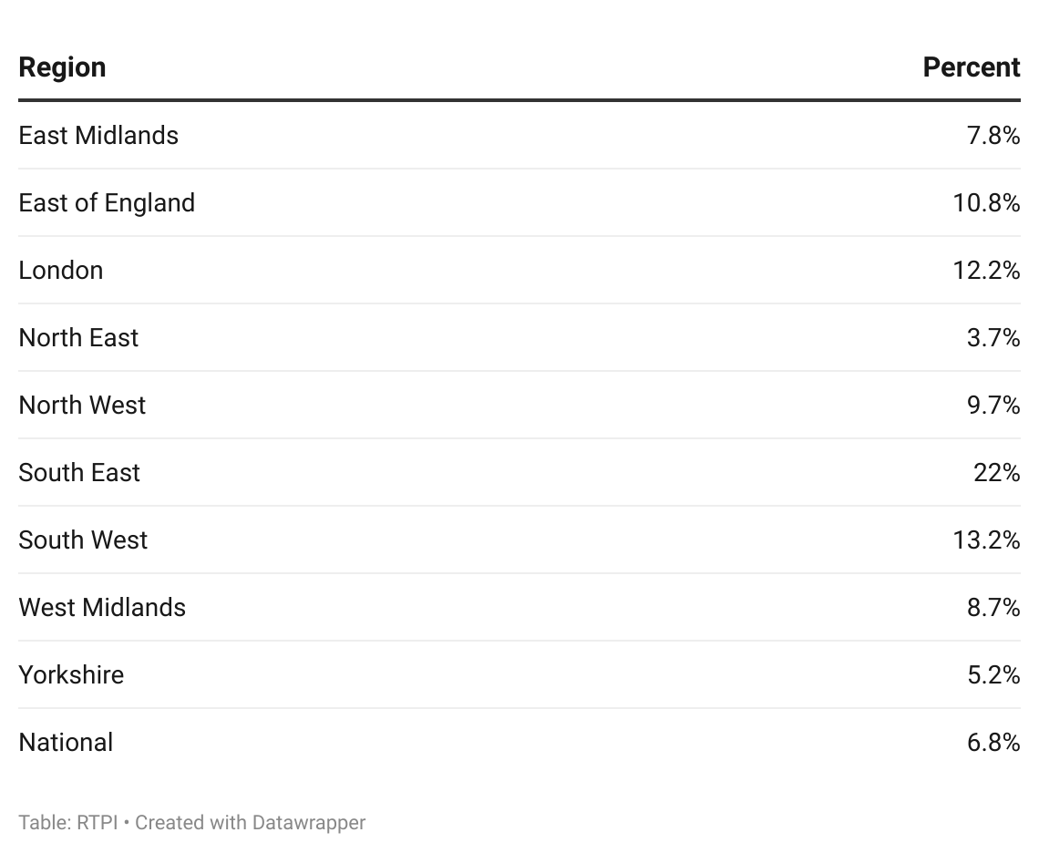
Figure 31. English region respondents primarily worked in.

Demographics
The age profile shown in the figure below shows that younger age groups accounted for a smaller proportion of responses than older age groups. Of all respondents who shared their age band, there were fewer under 45 (40.6%) than over (59.4%).

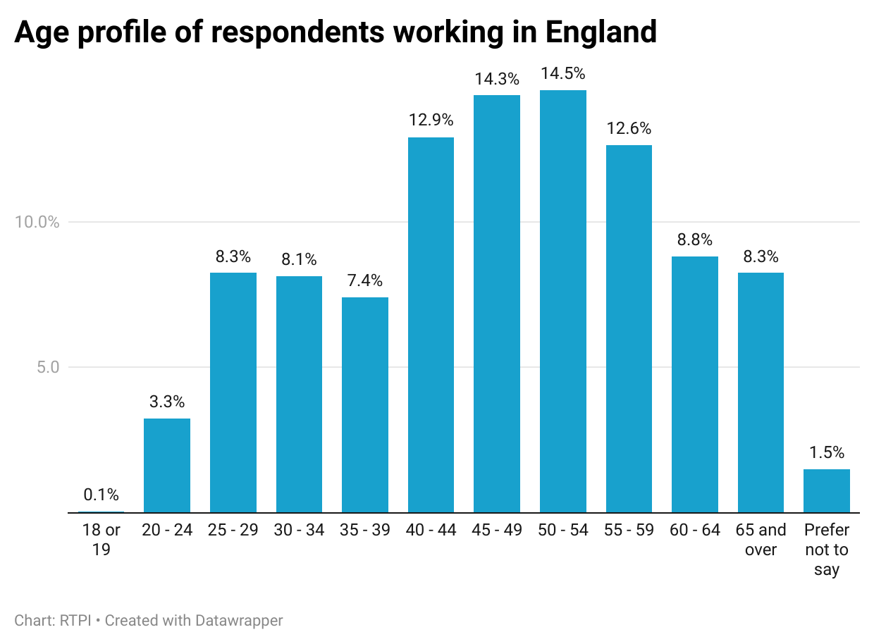
Figure 32. Age profile of respondents working in England.

The gender profile of respondents was relatively evenly split, with 54.2% identifying as male and 44.1% as female. Remaining respondents used another term than male or female or did not wish to disclose (0.2% and 1.5%, respectively).
A large majority of respondents (90.3%) reported their ethnic group being White, with the next largest broad ethnic group being Asian or Asian British (3.2%). This was followed by Black or Black British (1.4%), Mixed or Multiple ethnic groups (1.1%), and an Other ethnic group (0.5%). When compared to 2021 Census there is a higher proportion of people identifying as White in planning, while all other racial and ethnic identities are underrepresented. This suggests that more work needs to be done to encourage and support underrepresented groups into the planning profession.
In similar proportions to other UK nations, 8% of respondents reported being disabled, or having an impairment, condition or access need.
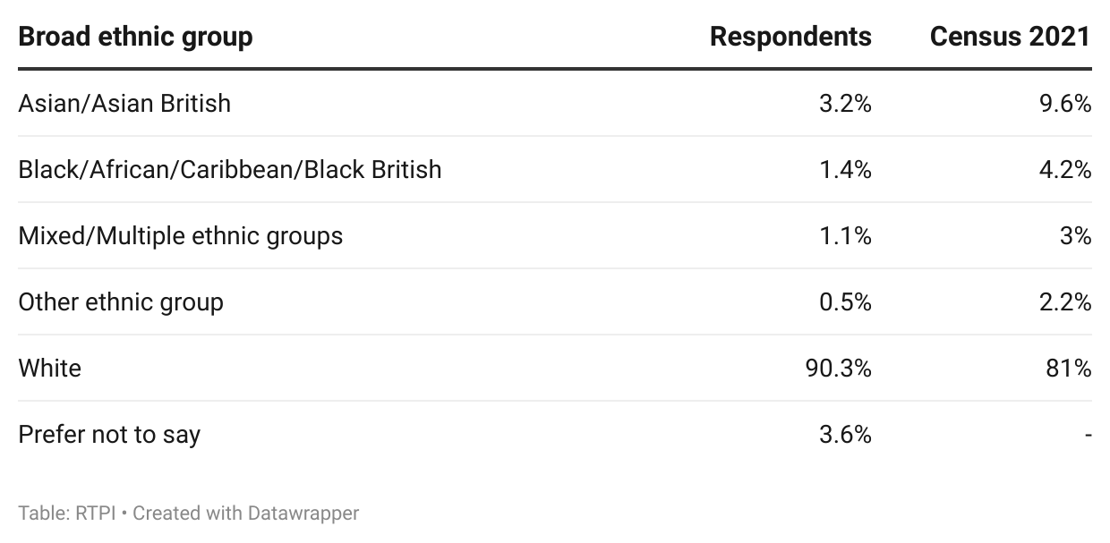
Figure 33. Broad ethnic group of respondents working in England.

Conclusion: what does this mean for the English planning profession?
Planning underpins a large part of the government’s ambitious policy agenda. Yet despite its rising policy importance, the evidence in this report highlights a system that is under strain. The government’s commitments on homes, nationally significant infrastructure, and net-zero (among many others) depend on a planning system that is sufficiently resourced and staffed. However, as the decrease in planning spending outlined in the introduction shows, this has increasingly not been the case over the past 15 years. Evidence from LPAs and members of the RTPI in England paints a picture of a sector contending with various challenges, including resourcing and funding pressures, recruitment and retention, impacts to training pipelines, capacity and workload, and wellbeing and public perception. These challenges are complex and interlinked; funding pressures constrain recruitment, with resultant staffing shortfalls increasing workloads for existing staff, and lengthening decision-making timelines. This sustained pressure erodes wellbeing and is further detrimental to retention, creating a cycle that risks undermining the delivery of national priorities.
The public sector is increasingly less attractive than the private sector to both younger and more experienced planners, with the latter offering higher pay and a better work-life balance, while some LPAs are reliant on agency staff to plug gaps. These pressures are compounded by the changes made to Level 7 apprenticeships, and financial challenges faced by the universities sector, both of which risk further erosion of the professional pipeline for the whole planning profession. The loss of the expertise of older planners foreseen by many respondents accentuates the need for a comprehensive skills plan and a workforce strategy to increase entry into the profession and facilitate succession planning.
In addition, high workloads and limited capacity, and public misunderstanding have created an environment where 57% of respondents working in England report feeling personally overstretched frequently or all the time, and where almost two thirds have experienced abuse. Such findings underline the human impact of systemic under-resourcing and the need for cultural and institutional change to better support those delivering essential planning services.
Despite these challenges, the report also reveals a profession showing adaptability, innovation, and resilience. There is growing appetite for digital transformation, with nearly three quarters of LPAs planning to deploy digital or AI tools, particularly for validation, data analysis, and consultation. These technologies offer real potential to ease administrative burdens and improve transparency – though only if planners are equipped with the necessary digital skills and resources to use them effectively. Furthermore, ongoing local government reorganisation and devolution present both challenges and opportunities around embedding digital capability, strategic planning, and inter-authority collaboration from the outset, which will succeed if accompanied by the right support and investment.
The findings in this report paint a complex picture of a profession under pressure, but rich in potential. The planning system’s resilience will be a defining factor in whether the government can meet its housing, infrastructure, and climate ambitions. Without sustained investment in people, skills, and systems, this resilience, and these ambitions risk being undermined by capacity constraints and institutional fatigue. Planning is not a cost; it is an investment in the nation’s future. With appropriate support and reform, England’s planners can translate political ambition into delivery: shaping places that are sustainable, inclusive, and resilient for generations to come. The challenge now is to ensure the system is equipped to do so.

Appendices

Appendix A – Methodology
The data in this report were collected using a survey of working RTPI members, and senior Local Planning Authority officials in England. The RTPI commissioned Research by Design, a market research firm to conduct the two surveys in parallel. Research by Design provided final survey data to the RTPI anonymised, to maintain respondents’ confidentiality.
Survey questions were designed in part to give similar or related outputs to the key outputs from the 2023 State of the Profession report, as well as to provide a baseline for future State of the Profession survey reports. The 2023 State of the Profession report used Office for National Statistics (ONS) Labour Force Survey (LFS) data, but due to a combination of occupation recoding by ONS, and low survey response rates for the LFS, the RTPI decided to design its own surveys to investigate the State of the Profession.
Members
The member’s survey ran for a month over summer 2025. The survey was sent to 22,382 members, and received 2,808 responses, which equates to a 12.5% response rate.
There were 2,217 responses from members working primarily in England, 78.9% of the overall response. As we wanted to survey working planners with current experience of the planning system, retired members and full-time students were screened out.
For country reports, survey responses were filtered on a question asking “Which RTPI nation is the majority of your planning work for?” and only responses related to the relevant country analysed. Where relevant, responses were broken down by the broad sector that respondents reported working in (public, private, third, other), their level of seniority, or their gender.
Members were asked questions about their career stage and career plans, personal skills gaps, resourcing in their workplace, working and volunteering practices, about their personal wellbeing, and demographics. Survey results represent a snapshot in time, and the survey was self-selecting, meaning responses may not be representative of the wider population.
Local Planning Authorities
The LPA survey ran parallel to the members’ survey in Summer 2025. We decided to keep this survey open slightly longer than initially planned to improve the response. The LPA survey was sent to 337 planning authority contacts in England and received 65 responses, amounting to a 19.3% response rate.
LPA respondents were asked about the current size and number of vacancies in their authority, as well as the number of vacancies and how much difficulty they have recruiting at each level of seniority. Respondents were also asked to report the specialist areas they had most difficulty recruiting for, barriers to recruitment, and the structure, working practices and demographic makeup of their planning authority.

Appendix B – Data sources
Figures 1, 2: Local authority revenue expenditure and financing, MHCLG
https://www.gov.uk/government/collections/local-authority-revenue-expenditure-and-financing
Table RO5 – cultural, environmental, regulatory and planning services
UK GDP deflator
https://www.gov.uk/government/statistics/gdp-deflators-at-market-prices-and-money-gdp-september-2025-quarterly-national-accounts
Revenue Outturn figures in figures 1, and 2 were adjusted for inflation as measured with the GDP deflator, rather than the headline Consumer Price Index or CPI. The GDP deflator measures base inflation in the economy, while CPI relates to the prices of consumer goods.

Figures 3, 4, 5: Planning application statistics live tables, MHCLG
https://www.gov.uk/government/statistical-data-sets/live-tables-on-planning-application-statistics
Tables PS1 and PS2 (full dataset)

Figures 13, 32: Census 2021 broad ethnic group statistics
https://www.nomisweb.co.uk/datasets/c2021ts021
TS021 - Ethnic group

Appendix C – References
[1] Agreements made between a planning authority and applicant to extend the timeframe within which a decision must be made, typically beyond the statutory time limits of 8 (minor) or 13 (major) weeks. See Dr Mark Dobson’s research on EoTs, supported by the RTPI, at https://www.rtpi.org.uk/policy-and-research/research-and-practice/rtpi-research-grants/completed-projects/planning-time-and-performance/
[2] https://www.savills.co.uk/research_articles/229130/372336-0
[3] https://www.rtpi.org.uk/media/3f4oq1hx/letter-from-the-rtpi-to-minister-matthew-pennycook-mp.pdf
[4] https://tandridge.moderngov.co.uk/documents/s4234/Appendix%20A%20-%20Development%20Management%20Review.pdf

Contact information
For feedback or queries, contact analysis@rtpi.org.uk

